SUPPLEMENTARY FIGURES

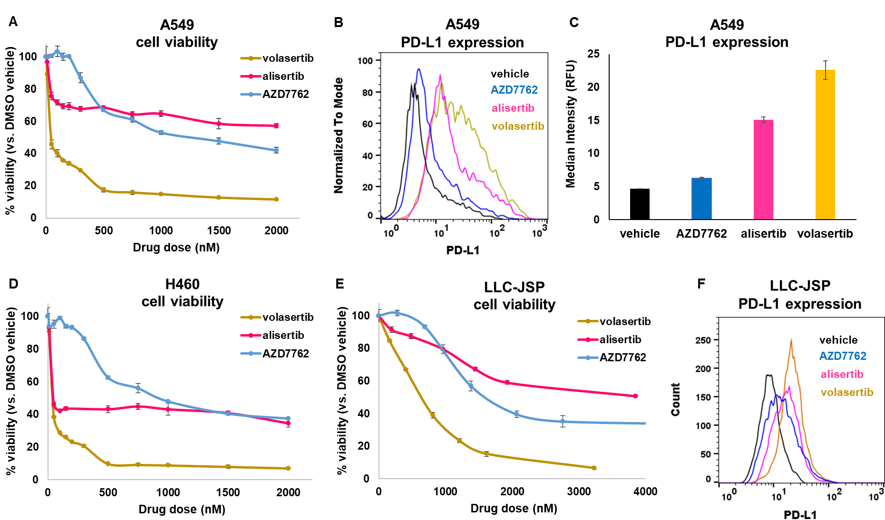
Supplementary Fig. 1 Treatment effects of MKIs. (A) 3-day cell viability dose response of A549 cells treated with volasertib, alisertib, or AZD7762 with indicated doses. (B-C) PD-L1 expression levels of A549 cells treated with vehicle control (0.1% DMSO in PBS), AZD7762500 (500 nM), alisertib (200 nM), or volasertib (100 nM); (B) Representative histogram and (C) MFI quantification; data presented as mean ± SD from biological duplicates, 10,000 events per sample. (D) 3-day cell viability dose response of H460 cells treated with volasertib, alisertib, or AZD7762 with indicated doses. (E) 3-day cell viability dose response of LLC-JSP murine lung cancer cells treated with volasertib, alisertib, or AZD7762 with indicated doses. (F) PD-L1 expression levels of LLC-JSP cells treated with vehicle control (0.1% DMSO in PBS) or 500 ng/ml of each drug (~1250 nM AZD7762, ~950 nM alisertib, or ~800 nM volasertib); 10,000 events per sample. Viability data presented as mean ± SD from 3-4 independent samples.

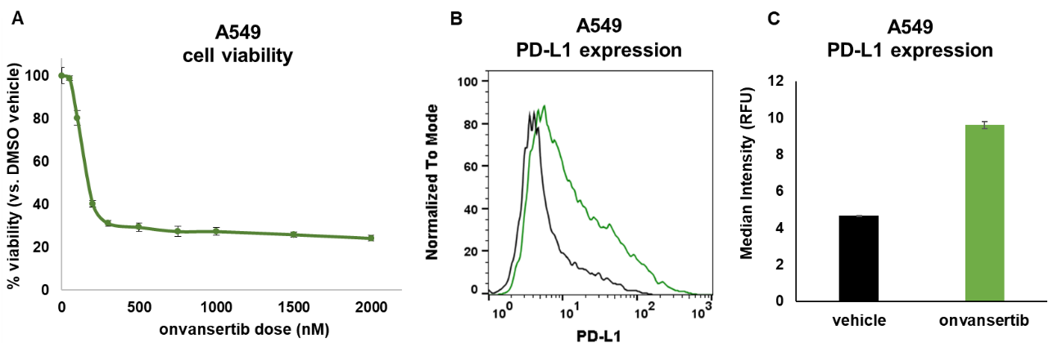
Supplementary Fig. 2 Treatment effects of onvansertib (PLK1 inhibitor). (A) 3-day cell viability dose response of A549 cells treated with onvansertib with indicated doses. (B-C) PD-L1 expression levels of A549 cells treated with vehicle control (0.1% DMSO in PBS) or onvansertib (100 nM); (B) Representative histogram and (C) MFI quantification; data presented as mean ± SD from biological duplicates, 10,000 events per sample.

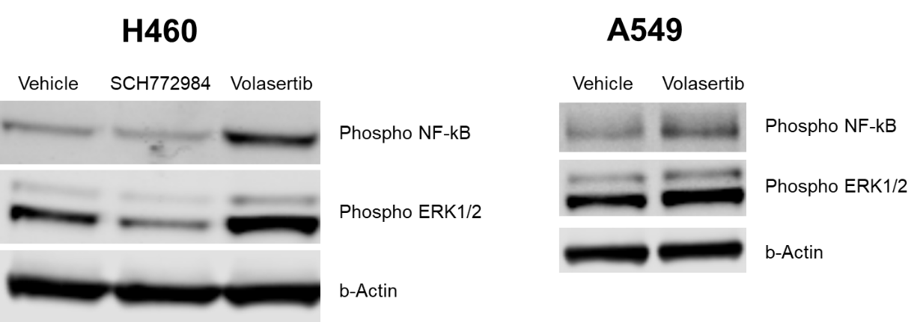
Supplementary Fig. 3 NSCLC cells downstream protein expressions. Protein expression of phosphorylated NF-kB p65 (Ser536) (93H1), phosphorylated p44/42 MAPK (ERK1/2) (Thr202/Tyr204), and β-Actin (8H10D10) 3 days post treatment. (Left) H460 NSCLC cells treated with vehicle control (0.1% DMSO in PBS), SCH772984 (1 uM), or volasertib (100 nM). (Right) A549 NSCLC cells treated with vehicle control (0.1% DMSO in PBS) or volasertib (100 nM).

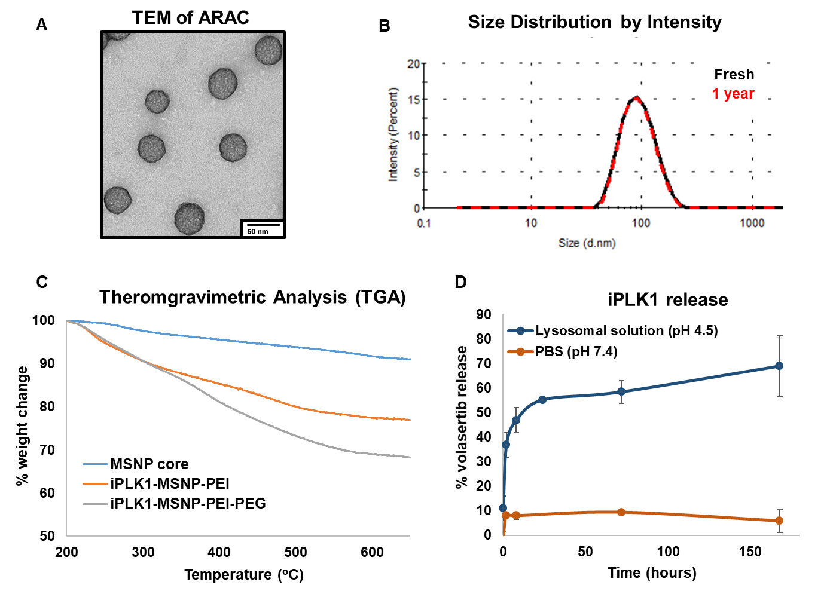
Supplementary Fig. 4 Nanoparticle characterization. (A) TEM image of final ARAC construct. (B) Hydrodynamic size of ARAC post-synthesis (fresh) or after 1 year storage at -80ºC. (C) Thermogravimetric curves of bare MSNP core, iPLK1-MSNP-PEI, and iPLK1-MSNP-PEI-PEG (ARAC) used to determine polymer loading. (D) iPLK1 (volasertib) release (quantified by UV-vis absorbance at 330 nm) from the nanoconstruct in lysosomal solution (pH 4.5) or PBS (pH 7.4) over time.

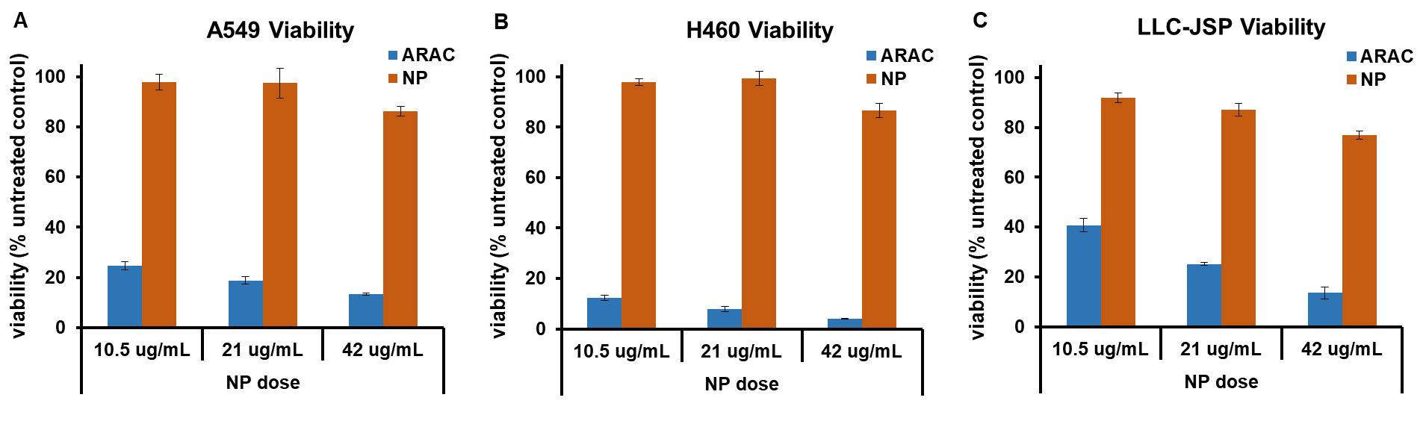
Supplementary Fig. 5 ARAC efficacy in NSCLC cells. 3-day cell viability of (A) A549, (B) H460, and (C) LLC-JSP cells treated with ARAC or bare nanoparticle (NP, containing no APIs) at specified doses of nanoparticle. Nanoconstructs were stored for 5 months at -80ºC prior to treatment. Data presented as mean ± SD from 4 independent samples.

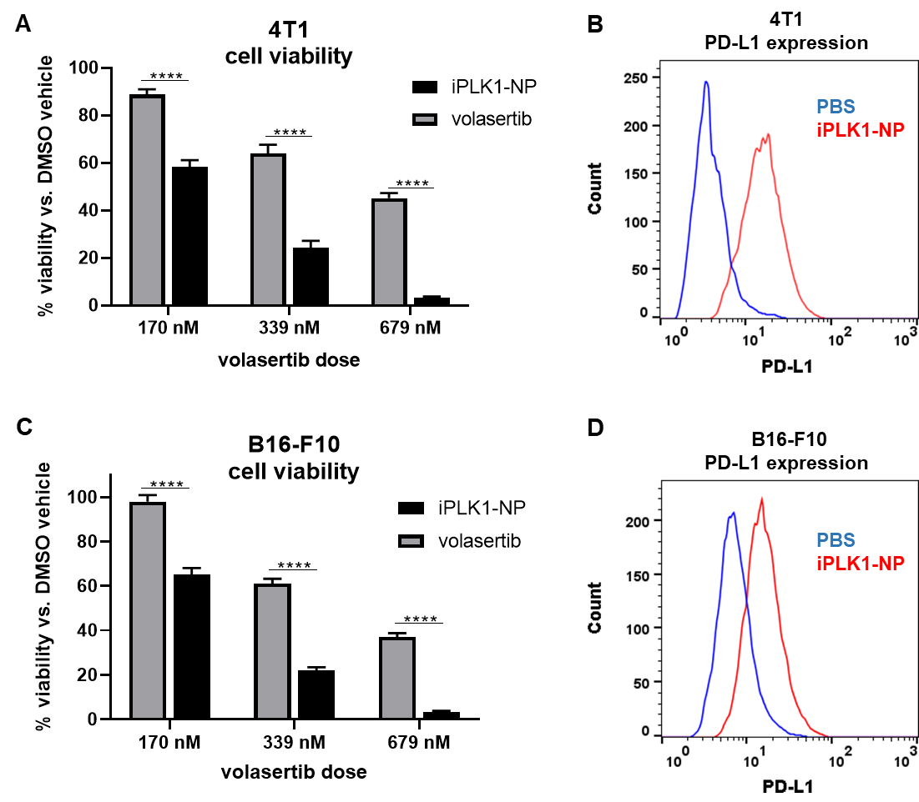

Supplementary Fig. 6 Nanoparticle delivery of PLK1 inhibitor volasertib (iPLK1-NP). Viability of (A) 4T1 breast cancer or (C) B16-F10 melanoma cells treated with volasertib (in 1%DMSO/PBS), iPLK1-NP (in PBS), or 1%DMSO/PBS for 3 days. Data presented as mean ± SD from 4 independent samples; ****P<0.0001. PD-L1 surface expression of (B) 4T1 or (D) B16-F10 cells treated with PBS or iPLK1-NP (42 μg/ml NP, 210 ng/ml volasertib).
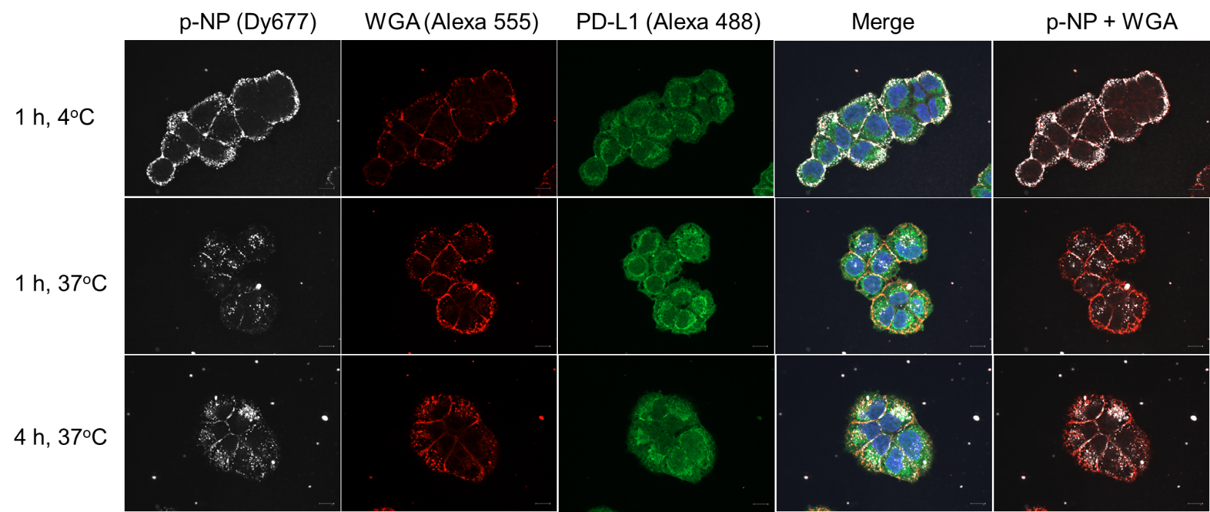
Supplementary Fig. 7 PD-L1 antibody-conjugated nanoparticle (p-NP) uptake in NSCLC cells. H460 NSCLC cells were treated with p-NP carrying a fluorescent dye (Dy677) for 1 h at 4ºC, 1 h at 37ºC, or 4 h at 37ºC. Cells were then fixed and stained for WGA (Alexa 555), PD-L1 (Alexa 488), and DAPI prior to imaging with Zeiss CellObserver Spinning Disk confocal microscope, using 63x1.4 NA lens and Hamamatsu Orca Flash 4 v2 camera. Individual channels and merged images are shown for each condition.

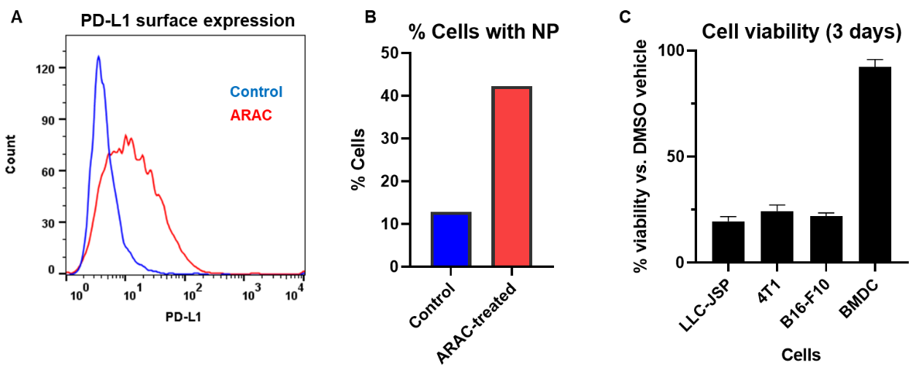
Supplementary Fig. 8. Targeting and treatment specificity of ARAC. (A) PD-L1 expression of 4T1 cells 4-day post treatment of ARAC. Cells (PBS-treated (control) and ARAC-treated) were harvested and incubated with ARAC tagged with dye-tagged siRNA for 1 hr; 10,000 events per sample. (B) Cellular uptake of ARAC after 1 hr. (C) Cell viability of murine cancer cells (LLC-JSP, 4T1, B16-F10) and murine bone marrow-derived dendritic cells (BMDC) treated with ARAC. Data presented as mean ± SD from 3-4 independent samples.

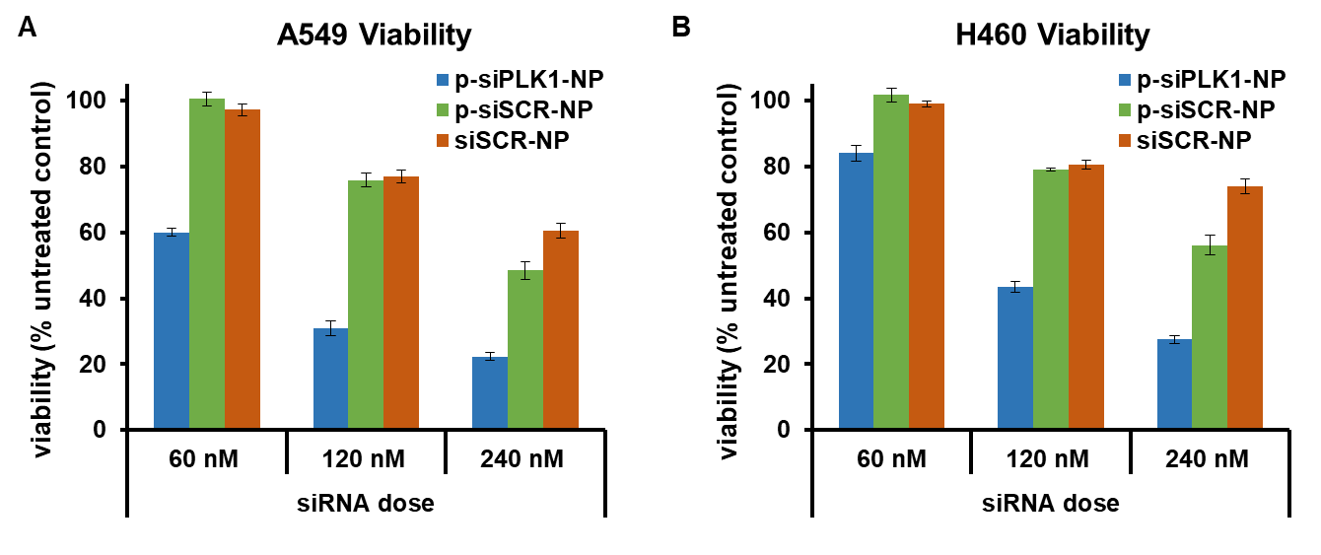
Supplementary Fig. 9. p-siPLK1-NP efficacy in NSCLC cells. 3-day cell viability of (A) A549 and (B) H460 cells treated with PD-L1 antibody-conjugated NP (p-NP) with siRNA against PLK1 (siPLK1) or scrambled non-target siRNA (siSCR) at varying doses of siRNA. siRNA was loaded at 4 wt.% of NP. Data presented as mean ± SD from 4 independent samples.

