Metabolite changes in Vitis vinifera (L.) cv Garganega leaves and berries after 501 biodynamic treatment
Mario Malagoli^{1,}* Stefania Sut¹, Gourav Kumar² and Stefano Dall’Acqua²
¹DAFNAE Department of Agronomy Animal Foods Natural resources and Environment University of Padova - Viale dell'Università, 16, 35020 - Legnaro PD - Italy
²DSF Department of Pharmaceutical and Pharmacological Sciences, University of Padova - via Marzolo 5 35121 - Padova - Italy
*corresponding author: mario.malagoli@unipd.it

Supplementary data
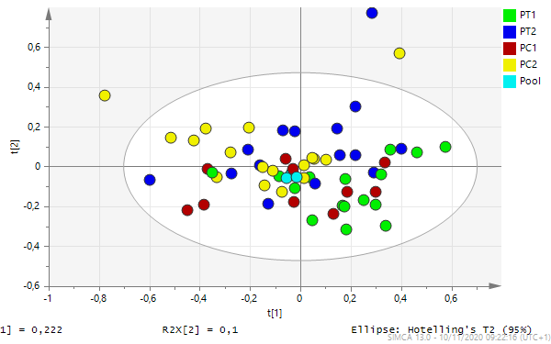
Figure A1. PCA analysis of the dataset related to Paiele leaves samples. P- Paiele; Pool- created mixing equal aliquots of all the samples. C- control; T- treated with 501; 1- sampling date May 10; 2- sampling date May 21.
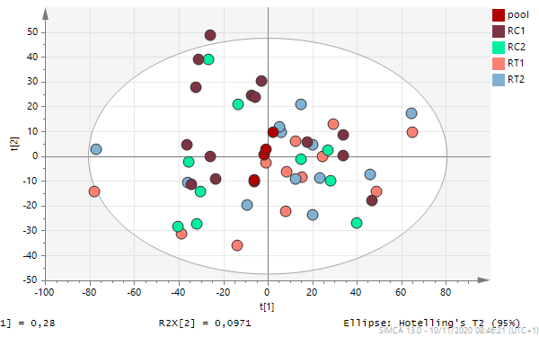
Figure A2. PCA analysis of the dataset related to Roncaje leaves samples. R- Roncaie Pool- created mixing equal aliquots of all the samples. C- control; T- treated with 501; 1- sampling date May 10; 2- sampling date May 21.

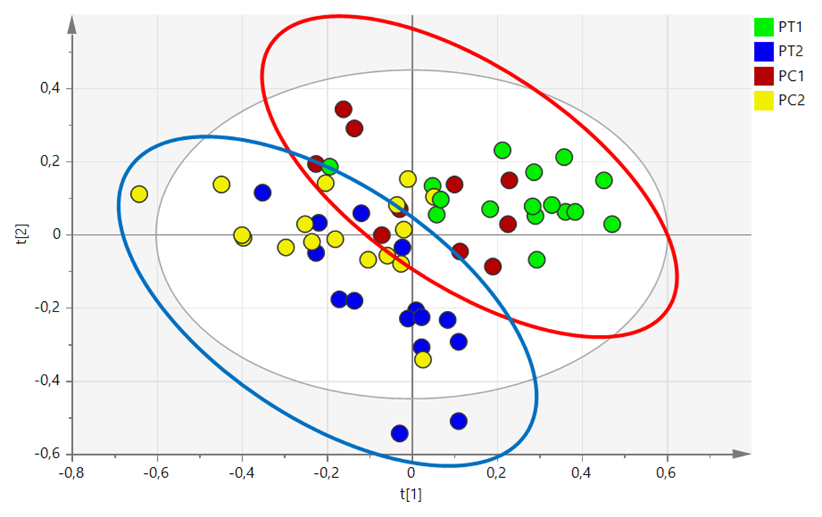
Figure A3. PCA of 501-treated leaves compared to control in Paiele vineyard. P- Paiele; C- control; T- treated with 501; 1- sampling date May 10; 2- sampling date May 21. Red ellipsoid groups samples at sampling time 1 and blue ellipsoid samples at sampling time 2.

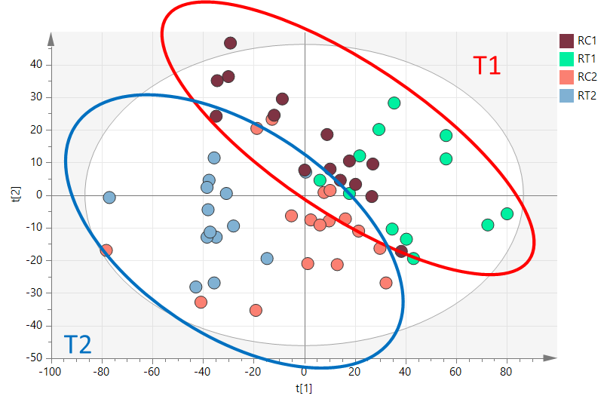

Figure A4. PCA of 501-treated leaves compared to control in Roncaie vineyard. P- Paiele; C- control; T- treated with 501; 1- sampling date May 10; 2- sampling date May 21. Red ellipsoid groups samples at time sampling 1 and blue ellipsoid samples at time sampling 2.

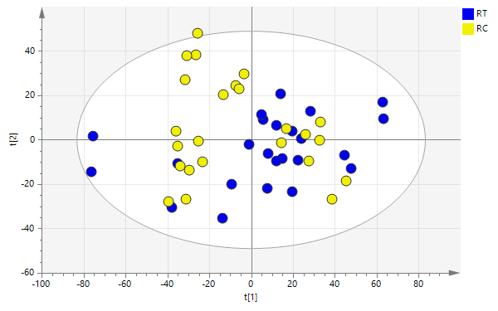

Figure A5. PCA analysis of the whole dataset related to Roncaie berries. C- Control; T- treated with 501.

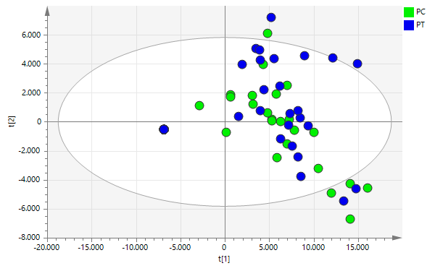
Figure A6. PCA analysis of the whole dataset related to Paiele berries. C- Control; T- treated with 501.

Table A1. Main physical and chemical characteristics of the soil (0–30cm) at the two sites. Data are reported on a dry weight basis.
 | Paiele (P) | Roncaie (R)
Clay % | 21.8 | 35.8
Silt % | 16 | 24
Sand % | 62.2 | 40.2
pH | 8.04 | 8.16
Total nitrogen % | 0.20 | 0.16
Total carbon % | 1.93 | 2.62
Organic carbon % | 1.87 | 1.68
Ca (mg kg⁻¹) | 8984.23 | 9715.03
K (mg kg⁻¹) | 735.17 | 466.64
Mg (mg kg⁻¹) | 2346.81 | 1800.29
Na (mg kg⁻¹) | 15.74 | 18.78

Table A2. Sulfur (S), Carbon (C) and Nitrogen (N) content in berries. P- Paiele; R- Roncaie; C- control; T- treated with 501. Data in percent dry weight. Means of n=6 ± st dev.
sample | S% | C% | N%
PCh | 0.189±0.081 | 40.148±0.227 | 0.357±0.066
PTh | 0.203±0.079 | 39.836±0.593 | 0.414±0.175
RCh | 0.141±0.065 | 40.529±0.427 | 0.443±0.083
RTh | 0.163±0.046 | 40.154±0.567 | 0.485±0.059

