Electronic Supplementary Material

Sexual segregation in the foraging distribution, behaviour, and trophic niche of the endemic Boyd’s shearwater (Puffinus lherminieri boydi)
Ivo dos Santos^{1*}, Jaime A. Ramos¹, Filipe R. Ceia¹, Isabel Rodrigues^{1,2}, Nathalie Almeida^{1,2}, Stefan Antunes², Ana R. Carreiro¹, Diana M. Matos¹, Ricardo J. Lopes^{3,4}, Pedro Geraldes⁵, Vítor H. Paiva¹

Affiliations
¹ University of Coimbra, MARE – Marine and Environmental Sciences Centre, Department of Life Sciences, Calçada Martim de Freitas, 3000-456 Coimbra, Portugal;
² Biosfera Cabo Verde, Rua de Moçambique 28, Mindelo, caixa postal 233, São Vicente, Cabo Verde
³ CIBIO, Centro de Investigação em Biodiversidade e Recursos Genéticos, InBIO Laboratório Associado, Campus Agrário de Vairão, 4485-661 Vairão, Portugal.
⁴ MHNC-UP, Museu de História Natural e da Ciência da Universidade do Porto, Praça de Gomes Teixeira, 4099-002 Porto, Portugal.
⁵ SPEA - Sociedade Portuguesa para o Estudo das Aves, Av. Columbano Bordalo Pinheiro, 87, 3º Andar, 1070-062 Lisboa, Portugal.

* corresponding author (e-mail: ivonobredossantos@gmail.com)
ORCID: 0000-0001-8415-1700 (Ivo dos Santos)

Figures
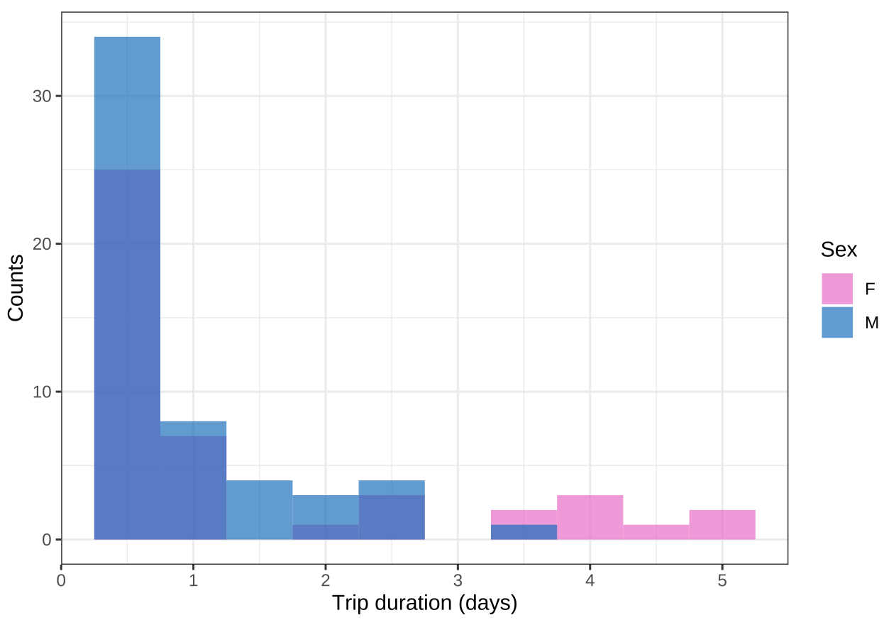
Fig. S1 Histogram of the frequency of occurrence (counts) of trip duration (days) for male (blue) and female (pink) Boyd’s shearwater, breeding at Raso islet, Cabo Verde, identifying short trips (< 1 day) and long trips (≥ 1 day).

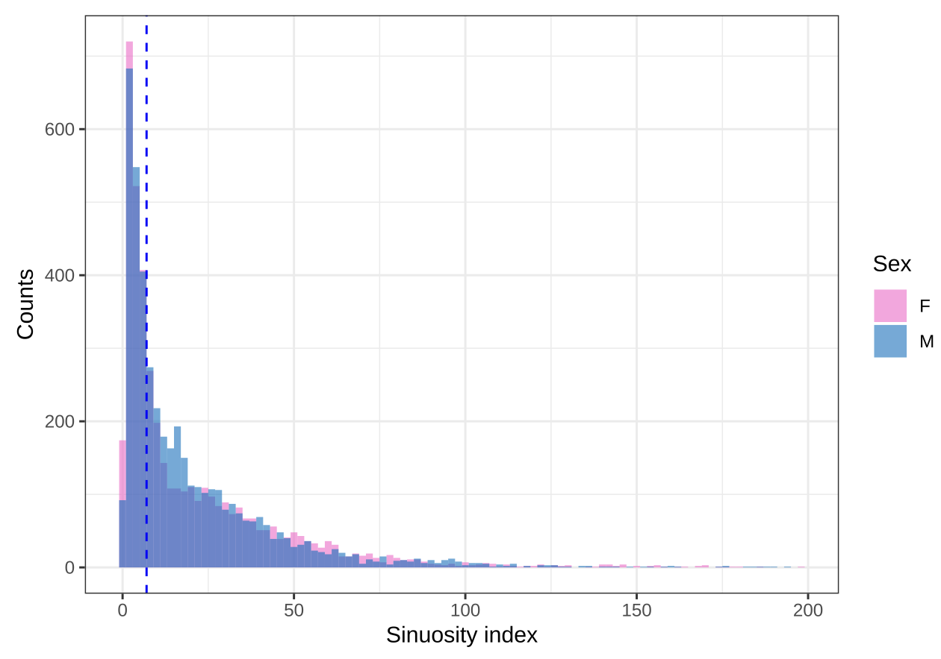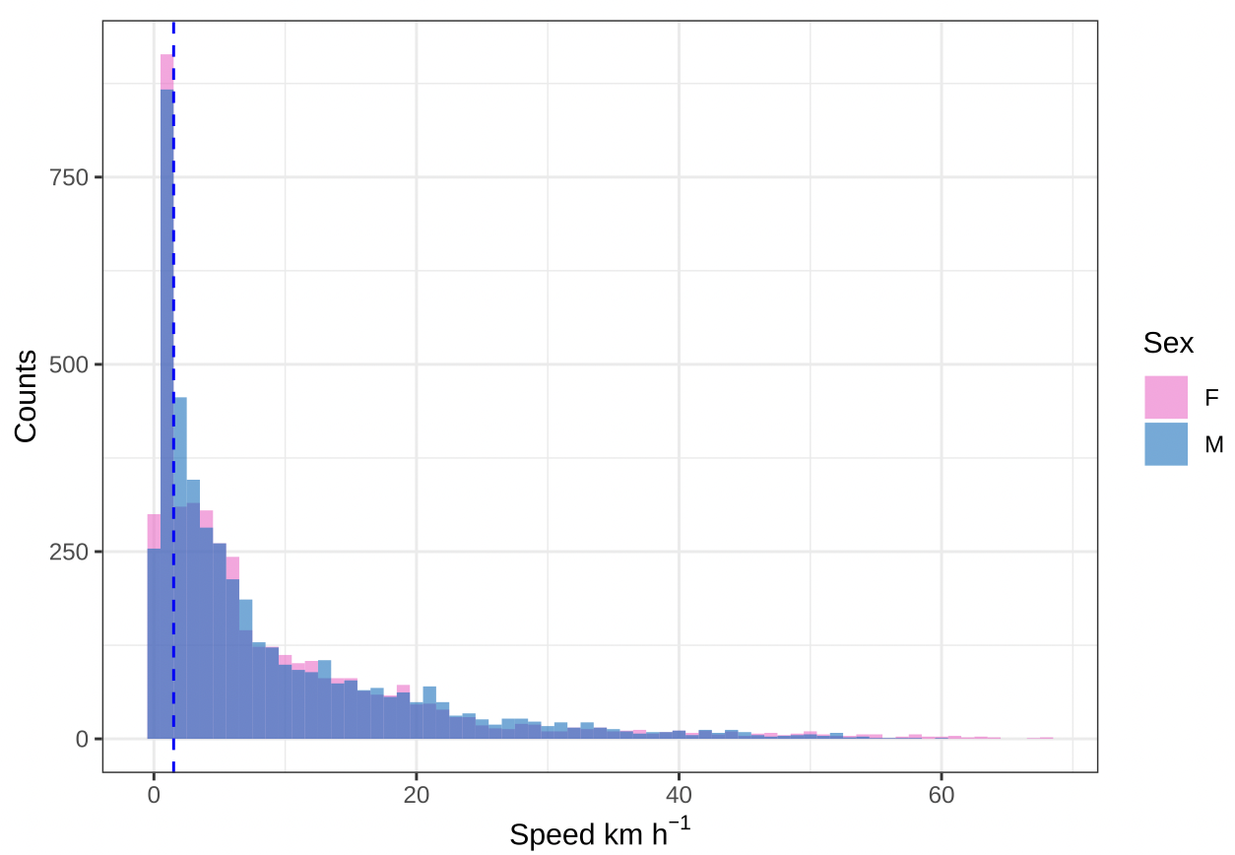
Fig. S2 Histogram of the frequency of occurrence (counts) of instantaneous speed (km h⁻¹, top panel) and of path sinuosity (calculated as the ratio of instantaneous flight speed given the speed between every third positions, bottom panel) for male (blue) and female (pink) Boyd’s shearwater, breeding at Raso islet, Cabo Verde. Dashed blue vertical lines identify the break-off values used for behavioural classification, i.e., 2 km h⁻¹ (for speed) and 7 (for path sinuosity).

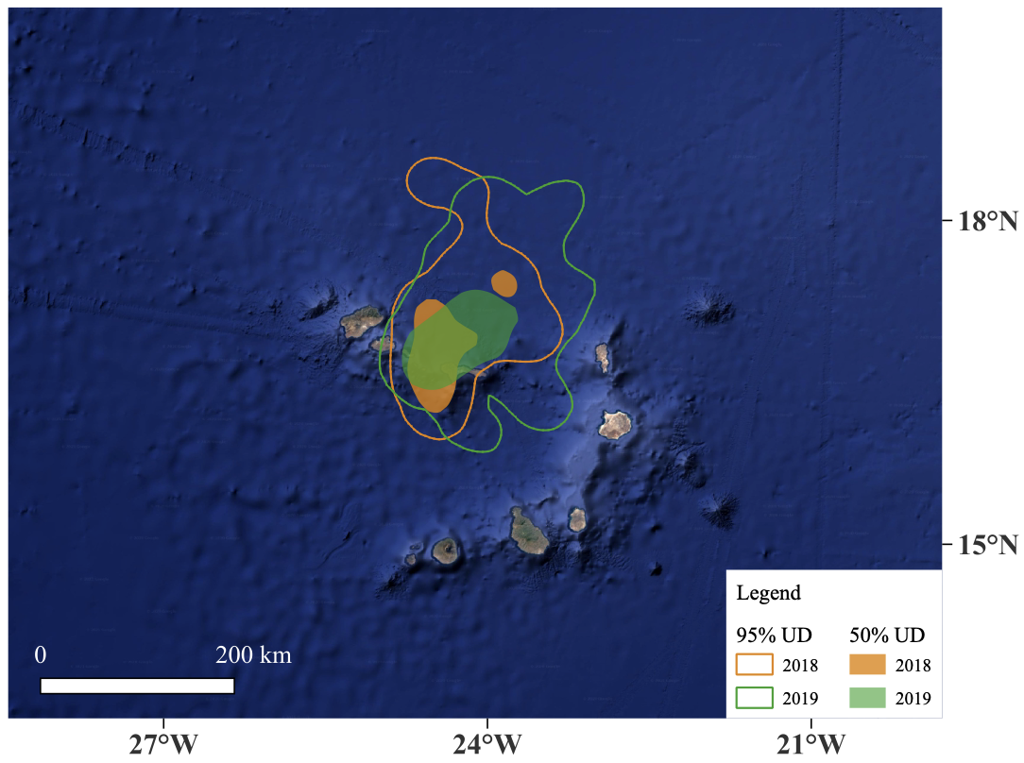
Fig. S3 Foraging distribution (filled areas; 50% Kernel UDs) and home range (solid lines; 95% Kernel UDs) of Boyd’s shearwater from Raso Islet, Cabo Verde, during 2018 (orange) and 2019 (green) breeding seasons. Bathymetric relief in the background.

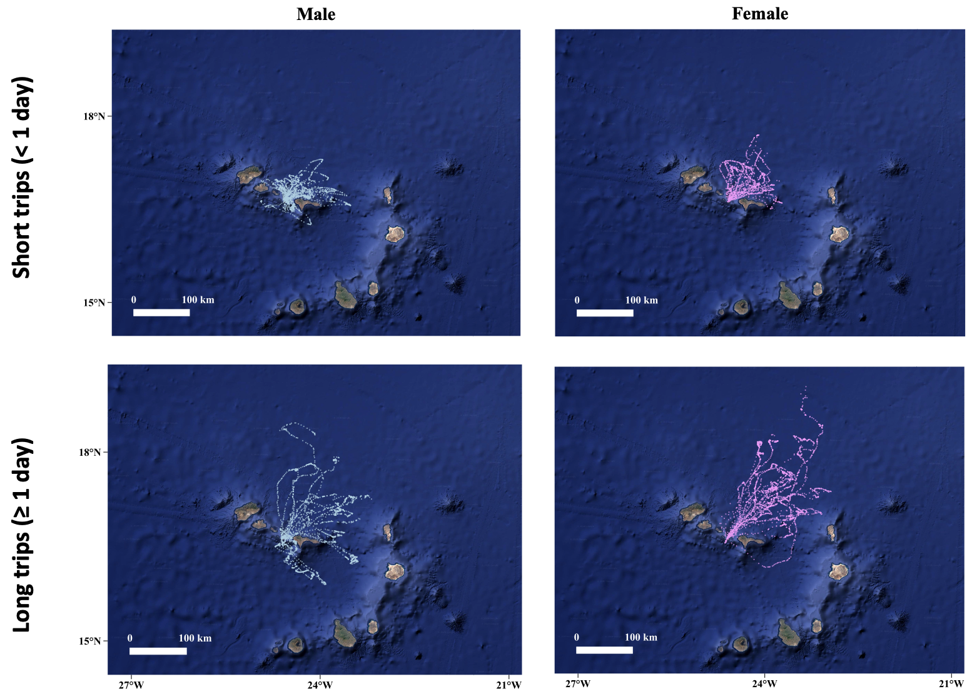
Fig. S4. Foraging distribution of male (blue) and female (pink) Boyd’s shearwaters engaging in short (≤ 1 day; top panels) and long (> 1 day; bottom panels) foraging trips during the breeding season of 2018 and 2019. Bathymetric relief in the background.

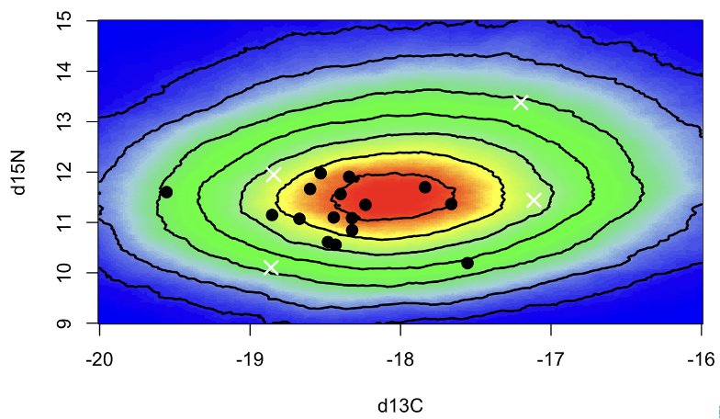
Fig. S5 The simulated mixing region of the consumers (black dots: adult Boyd’s shearwaters) and the average signatures of prey groups (white crosses: epipelagic fish, mesopelagic fish, squid, and fingerlings) used in stable isotope mixing models. The outermost contour of the mixing region represents 5% level and increases at every 10% towards the innermost region (95% level).

Tables

Table S1. Additional methods used on molecular sexing of individual Boyd’s shearwaters and metabarcoding analysis of prey DNA reference collection.

Molecular sexing
DNA was extracted from breast feather samples using a proteinase K digestion followed by a thermal shock step (95ºC to -20ºC). DNA was then used in polymerase chain reactions (PCR), following Griffiths et al. (1998). The set of primers used (P2 and P8) amplify the CHD-W and CHD-Z genes. The PCR protocol consists of 5 μL of Mytaq (Bioline, UK), 0.5 μL of each primer, and 2 μL of DNA template for a total volume of 10 μL. The conditions were as follows: 15 min at 95°C, 35 cycles of 30s at 95°C, 30s at 55°C, and 80s at 72°C, followed by 10min at 72 °C. PCR products were then separated on ABI 3130 xl Genetic Analyzer (Applied Biosystems, USA) and results visualised in software GeneMapper V5.0 (Applied Biosystems, USA). Individuals showing double (ZW) and single (ZZ) bands are identified as females and males, respectively.

DNA reference collection
Reference collection samples were extracted using a DNA Isolation Kit (Norgen Biotek Corporation) following the manufacturer's protocol. All samples were amplified through PCR with a mtDNA COI general invertebrates primer set mlCOIintF-XT/ jgHCO2198 (GGWACWRGWTGRACWITITAYCCYCC / TAIACYTCIGGRTGICCRAARAAYCA, (Wangensteen et al. 2018). PCR reactions were carried‐out in volumes of 10 μl, comprising 5 μl of QIAGEN Multiplex PCR Master Mix, 0.2 μl of each 10 mM primer, 3.4 μl of ultra‐pure water, and 1 μl of DNA extract. Cycling conditions used an initial denaturing at 95ºC for 15 min, followed by 40 cycles of denaturing at 94ºC for 30s, annealing at 45ºC for 45s and extension at 72ºC for 60s, with a final extension at 72ºC for 10 min. Fish samples were also amplified with a mtDNA 12S Osteichthyes specific primer set MiFish-U (GTCGGTAAAACTCGTGCCAGC/ CATAGTGGGGTATCTAATCCCAGTTTG, (Miya et al. 2015) allowing this way to confirm dubious taxonomic assignments. These PCR reactions were the same as for COI primer set, and cycling conditions used an initial denaturing at 95ºC for 15 min, followed by 35 cycles of denaturing at 94ºC for 30s, annealing at 58ºC for 30s and extension at 72ºC for 45s, with a final extension at 72ºC for 10 min. All PCR products were subjected to a second PCR with p5 and p7 indexes, which allowed to label each sample with an unique combination of forward and reverse barcodes. PCR products were purified using Agencourt AMPure XP beads (Beckman Coulter), and subsequently quantified using an Epoch Microplate Spectrophotometer (BioTek, Winooski, VT, USA). Purified and normalised PCR products were pooled per marker into libraries. Each of these were individually quantified using qPCR (KAPA Library Quant Kit qPCR Mix; Bio‐Rad iCycler) and diluted to 4 nM. Libraries were pooled equimolarly and then sequenced in a v3 MiSeq run (Illumina).
The resulting paired-end reads were aligned using PEAR (Zhang et al. 2014), discarding single and unassembled reads, as well as alignments with overlapping quality score <26. Further processing of reads was done using OBITools (Boyer et al. 2016). Reads were assigned to samples and primer sequences were removed using ‘ngsfilter’, allowing a total of four mismatches to the expected primer sequence. In each sample, the haplotype with most reads was considered the correct sequence for the tissue of the reference collection. Then, the taxonomic assignment was either confirmed or enhanced by performing a BLAST match algorithm against global repositories of genetic resources (BOLD and GenBank nucleotide databases for COI and only GenBank for 12S). Haplotypes were assigned to the lowest possible taxonomic level (e.g., family, order, species) for which hits with an identical match in BLAST clustered monophyletically, higher than any other taxa.

Table S2. Variation inflation factor (VIF) of oceanographic variables extracted within Boyd’s shearwater foraging range. Bold values indicate variables which were excluded based on VIF value (VIF > 2.5) and which were highly correlated (r > 0.6) with other predictors , and thus, not used to build habitat suitability models. Spatial gradients of each environmental predictor were calculated using an estimating proportional change within a 3 x 3 cell grid, computed with the ‘aggregate’ function of raster package (Hijmans 2022).

Environmental predictor | VIF
Bathymetry | 5.88
Chlorophyll a concentration | 1.40
Ocean mixed layer thickness | 1.78
Sea surface height | 2.37
Sea surface temperature | 1.82
Gradient of bathymetry | 1.57
Gradient of chlorophyll a concentration | 2.83
Gradient of ocean mixed layer thickness | 1.38
Gradient of sea surface height | 1.81
Gradient of sea surface temperature | 1.28

Table S3. Estimates of model fit (AUC) and relative contributions of non-redundant environmental predictors used for habitat suitability models. Models were conducted separately for each sex within short or long foraging trips, recorded from adult Boyd’s shearwaters during the 2018 and 2019 breeding seasons, at Raso islet, Cabo Verde. Variables with higher contribution to the ensemble model (≥ 15%) are shown in bold. CHL: chlorophyll a concentration; OMLT: ocean mixed layer thickness; SSH: sea surface height; SST: sea surface temperature; BATG: gradient of bathymetry (proportional change on a 3 x 3 cell grid); OMLTG: gradient of ocean mixed layer thickness; SSHG: gradient of sea surface height; SSTG: gradient of sea surface temperature.

Trip type | Sex | AUC | CHL | OMLT | SSH | SST | BATG | OMLTG | SSHG | SSTG
Short Trips | Males | 0.94 | 4.92 | 2.60 | 18.78 | 33.11 | 19.85 | 6.37 | 3.68 | 10.70
 | Females | 0.93 | 4.85 | 3.06 | 23.26 | 34.40 | 15.59 | 2.89 | 5.44 | 10.52
Long Trips | Males | 0.88 | 7.42 | 5.34 | 34.80 | 21.59 | 11.19 | 3.61 | 3.53 | 12.51
 | Females | 0.91 | 15.35 | 3.70 | 41.29 | 16.29 | 11.11 | 2.68 | 2.66 | 6.91

References
Boyer F, Mercier C, Bonin A, Le Bras Y, Taberlet P, Coissac E (2016) obitools: A unix-inspired software package for DNA metabarcoding. Mol Ecol Resour 16:176–182. doi: 10.1111/1755-0998.12428
Griffiths R, Double MC, Orr K, Dawson RJG (1998) A DNA test to sex most birds. Mol Ecol 7:1071–1075.
Hijmans R (2022) raster: Geographic Data Analysis and Modeling. R package version 3.5–15. In: https:// CRAN.R-project.org/package=raster.
Miya M, Sato Y, Fukunaga T, Sado T, Poulsen JY, Sato K, Minamoto T, Yamamoto S, Yamanaka H, Araki H, Kondoh M, Iwasaki W (2015) MiFish, a set of universal PCR primers for metabarcoding environmental DNA from fishes: Detection of more than 230 subtropical marine species. R Soc Open Sci. doi: 10.1098/rsos.150088
Wangensteen OS, Palacín C, Guardiola M, Turon X (2018) DNA metabarcoding of littoral hardbottom communities: High diversity and database gaps revealed by two molecular markers. PeerJ 2018:1–30. doi: 10.7717/peerj.4705
Zhang J, Kobert K, Flouri T, Stamatakis A (2014) PEAR: A fast and accurate Illumina Paired-End reAd mergeR. Bioinformatics 30:614–620. doi: 10.1093/bioinformatics/btt593

