Supporting Information
CrO_{x}-mediated Performance Enhancement of
Ni/NiO-Mg:SrTiO₃ in Photocatalytic Water Splitting

Kai Han^{1,†,‡} , Diane M. Haiber^{2,‡}, Julius Knöppel^{3,4}, Caroline Lievens,⁴ Serhiy Cherevko³, Peter Crozier², Guido Mul^{1,}*, Bastian Mei^{1,}*
¹Photocatalytic Synthesis Group, Faculty of Science & Technology of the University of Twente, PO Box 217, Enschede, The Netherlands.
²Arizona State University, School for Engineering - Matter Transport & Energy,
Tempe, AZ 85287, USA.
³Forschungszentrum Jülich GmbH, Helmholtz Institute Erlangen-Nürnberg for Renewable Energy (IEK-11), Egerlandstr. 3, 91058 Erlangen, Germany
⁴Department of Chemical and Biological Engineering, Friedrich-Alexander-Universität Erlangen-Nürnberg, Egerlandstr. 3, 91058 Erlangen, Germany

Figure S1. Stability measurement: Photocatalytic activity of CrO_{x}-modified Ni/NiO_{x}-Mg:SrTiO₃ during three cycles mimicking day/night operation. Reaction conditions: 25 mg catalyst in 25 mL DI water. 365 nm LED-light was used as illumination source. Note that fluctuations at longer measurement times are due to instabilities in the GC-detection.

Figure S2. Hydrogen and oxygen yields obtained with (CrO_{x}-modified) Ni/NiO_{x}-Mg:SrTiO₃ using (simulated) solar (left) and LED light illumination (right). Reaction conditions: 25 mg catalyst in 25 mL DI water.

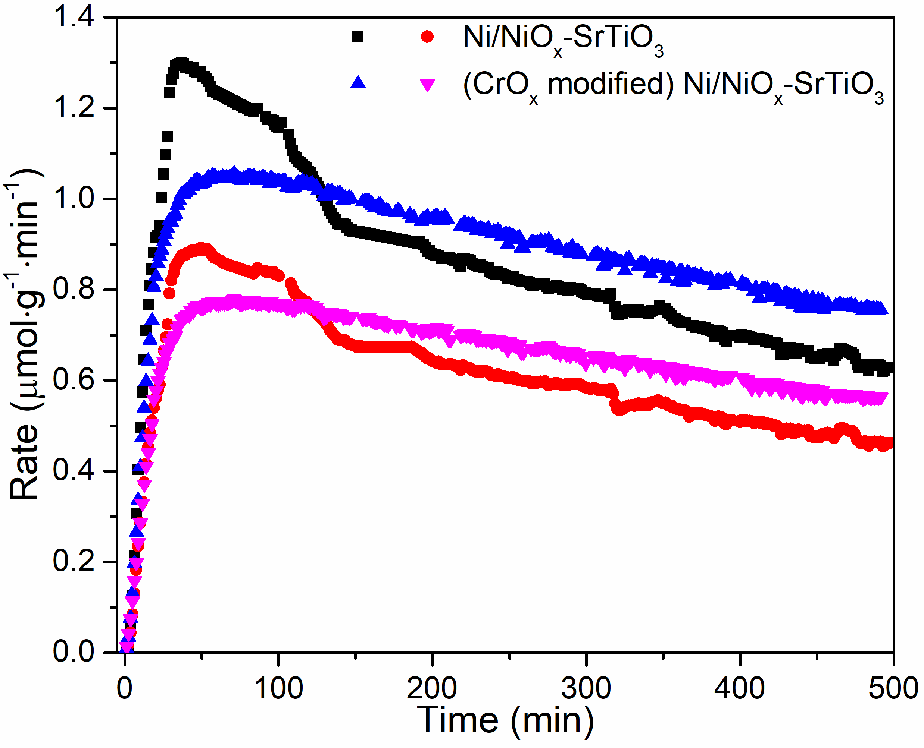
Figure S3. Comparison of Ni/NiO_{x}-SrTiO₃ and (CrO_{x} modified) Ni/NiO_{x}-SrTiO₃ under 365 nm LED light illumination.
Figure S4. Photocatalytic activity of CrO_{x}-modified Ni/NiO_{x}-Mg:SrTiO₃ with introduction of 80 ppm of H₂, O₂ and N₂ between 150 minutes and 300 minutes. Reaction conditions: 25 mg catalyst in 25 mL DI water. 365 nm LED-light was used as illumination source.

Figure S5. Photocatalytic activity of Ni/NiO_{x}-Mg:SrTiO₃ (a,b) and CrO_{x}-modified Ni/NiO_{x}-Mg:SrTiO₃ (c,d) at variable purge gas rates. (a,c) the measured concentration of H₂ and O₂ in ppm, (b,d) the corresponding rate. Reaction conditions: 25 mg catalyst in 25 mL DI water and 365 nm LED-light was used as illumination source.

Characterization
Structural characterization of different material compositions by XRD is shown in Figure S5. The X-ray diffraction patterns of Mg:SrTiO₃ are consistent with the typical SrTiO₃ cubic structure. After deposition of NiO_{x} and CrO_{x} on the surface, the cubic phase remains, illustrating that incorporation of NiO_{x} or CrO_{x} in the lattice is minimized. The Raman spectra of various composites are shown in Figure S6. Two typical SrTiO₃ bands center in the 200-400 cm⁻¹ and 600-800 cm⁻¹ ranges¹⁷, indicative of SrTiO₃, while features of NiO_{x} and CrO_{x} remain undetected.

Figure S6. XRD patterns of pristine Mg:SrTiO₃, Ni/NiO_{x}-Mg:SrTiO₃ and CrO_{x}-modified Ni/NiO_{x}-Mg:SrTiO₃ composite photocatalysts.

Figure S7. Raman spectra of Ni/NiO_{x}-Mg:SrTiO₃ and CrO_{x}-modified Ni/NiO_{x}-Mg:SrTiO₃ composite photocatalysts.
Figure S8. XPS spectra of the Ni2p_{3/2} signal of Ni/NiO_{x}-Mg:SrTiO₃ (a) and CrO_{x}-modified Ni/NiO_{x}-Mg:SrTiO₃ (b): (both fresh and measured samples).

Figure S9. XPS spectra in the O1s region of both fresh and measured samples of Ni/NiO_{x}-Mg:SrTiO₃ (a) and CrO_{x}-modified Ni/NiO_{x}-Mg:SrTiO₃ (b).

TEM analysis
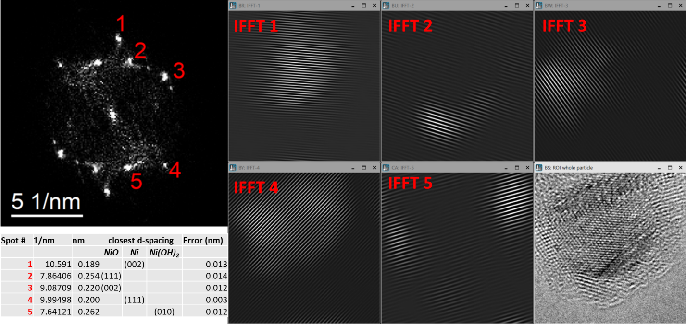
Figure S10. Inverse FFT analysis and phase identification applied to a NiO_{x} particle from CrO_{x}-modified Ni/NiO_{x}-Mg:SrTiO₃ (fresh).
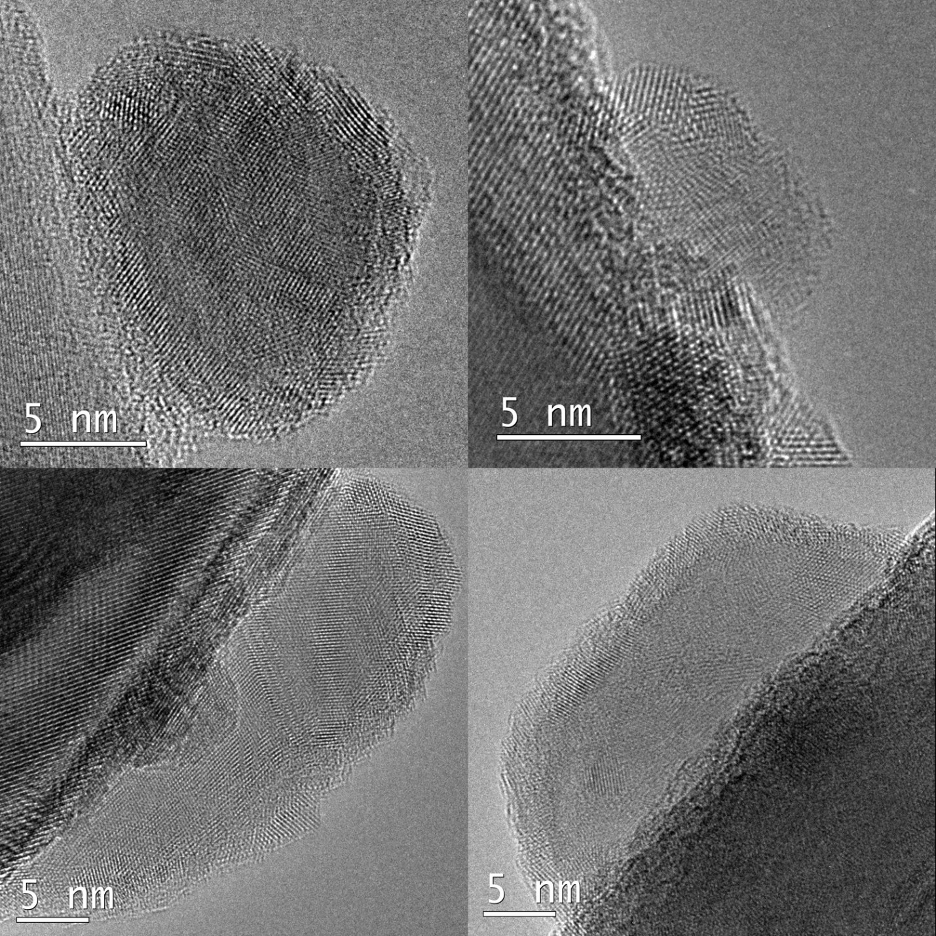
Figure S11. Additional HRTEM images of NiO_{x} particles on CrO_{x}-modified Ni/NiO_{x}-Mg:SrTiO₃ (fresh).

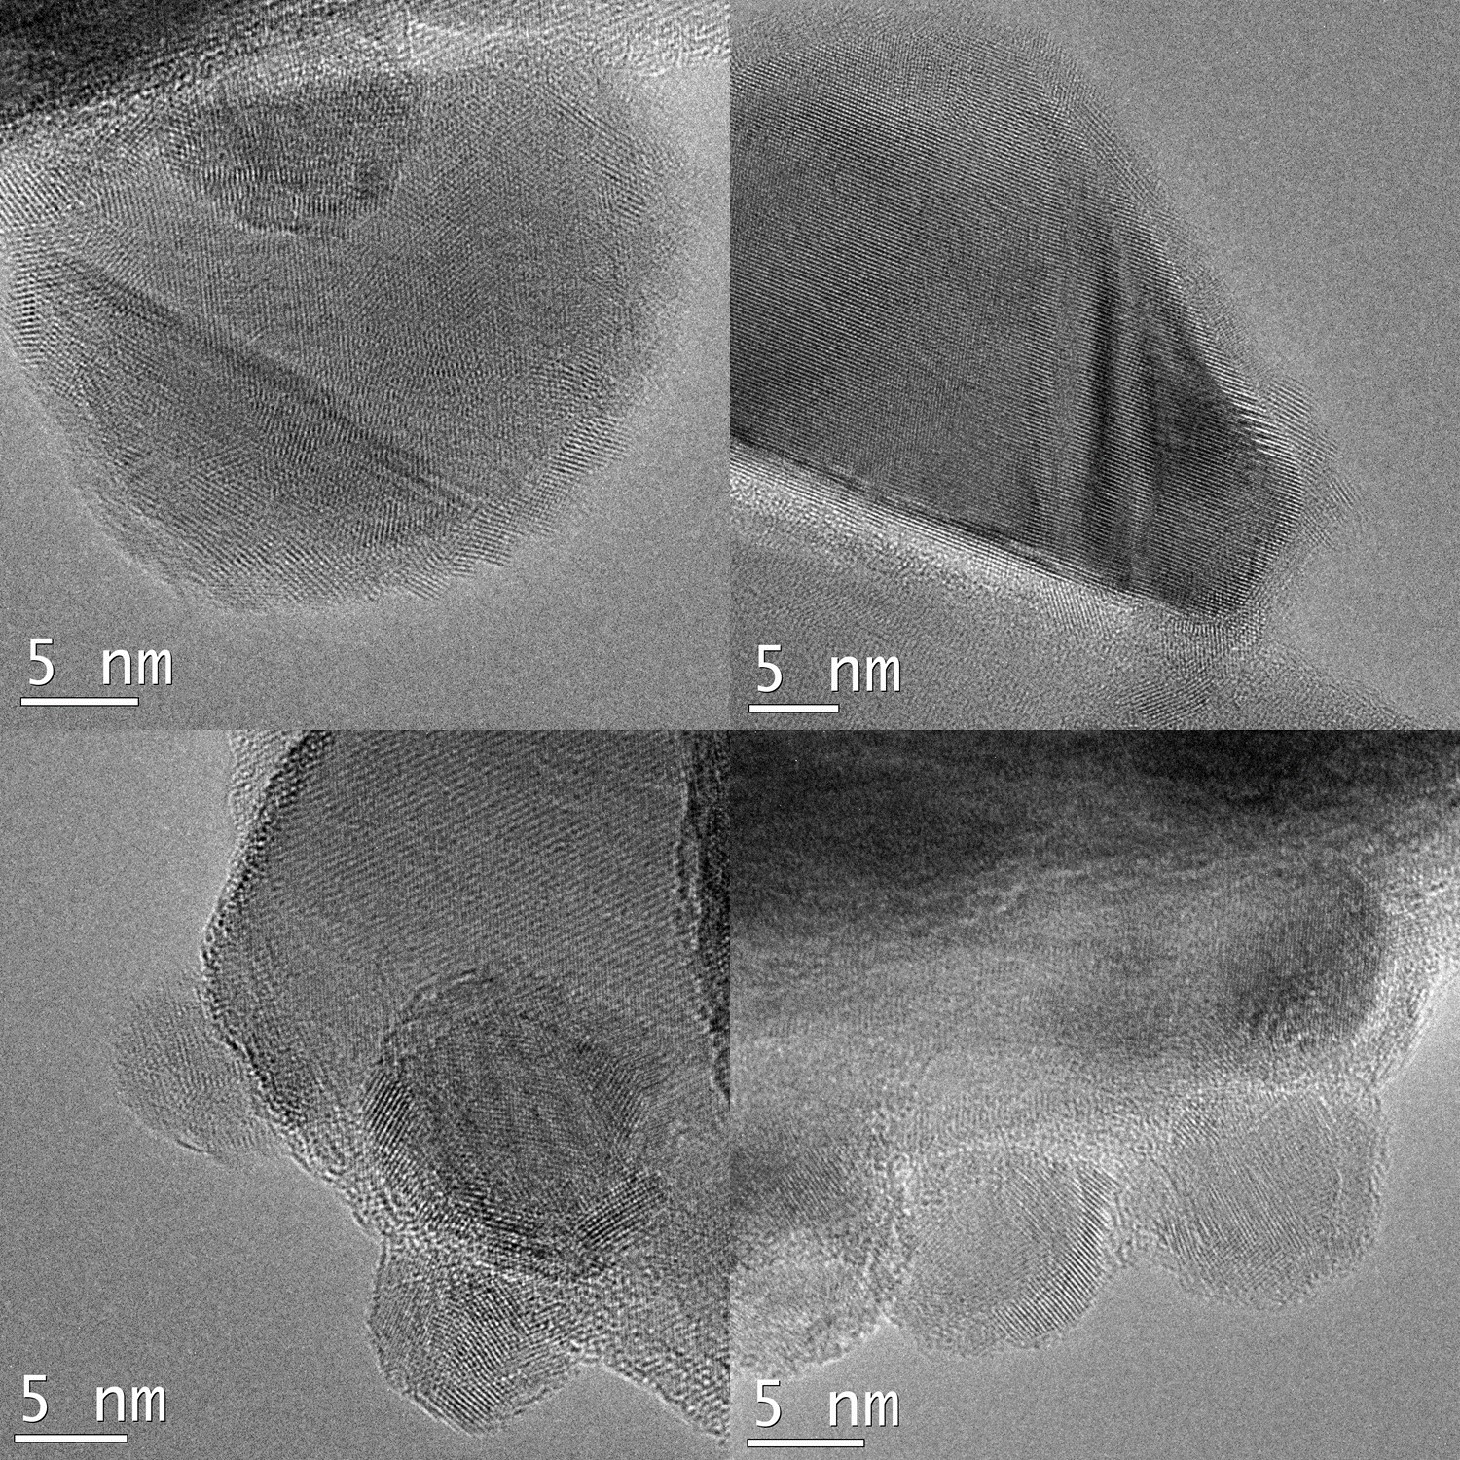
Figure S12. HRTEM images of NiO_{x} particles on Ni/NiO_{x}-Mg:SrTiO₃ (fresh).
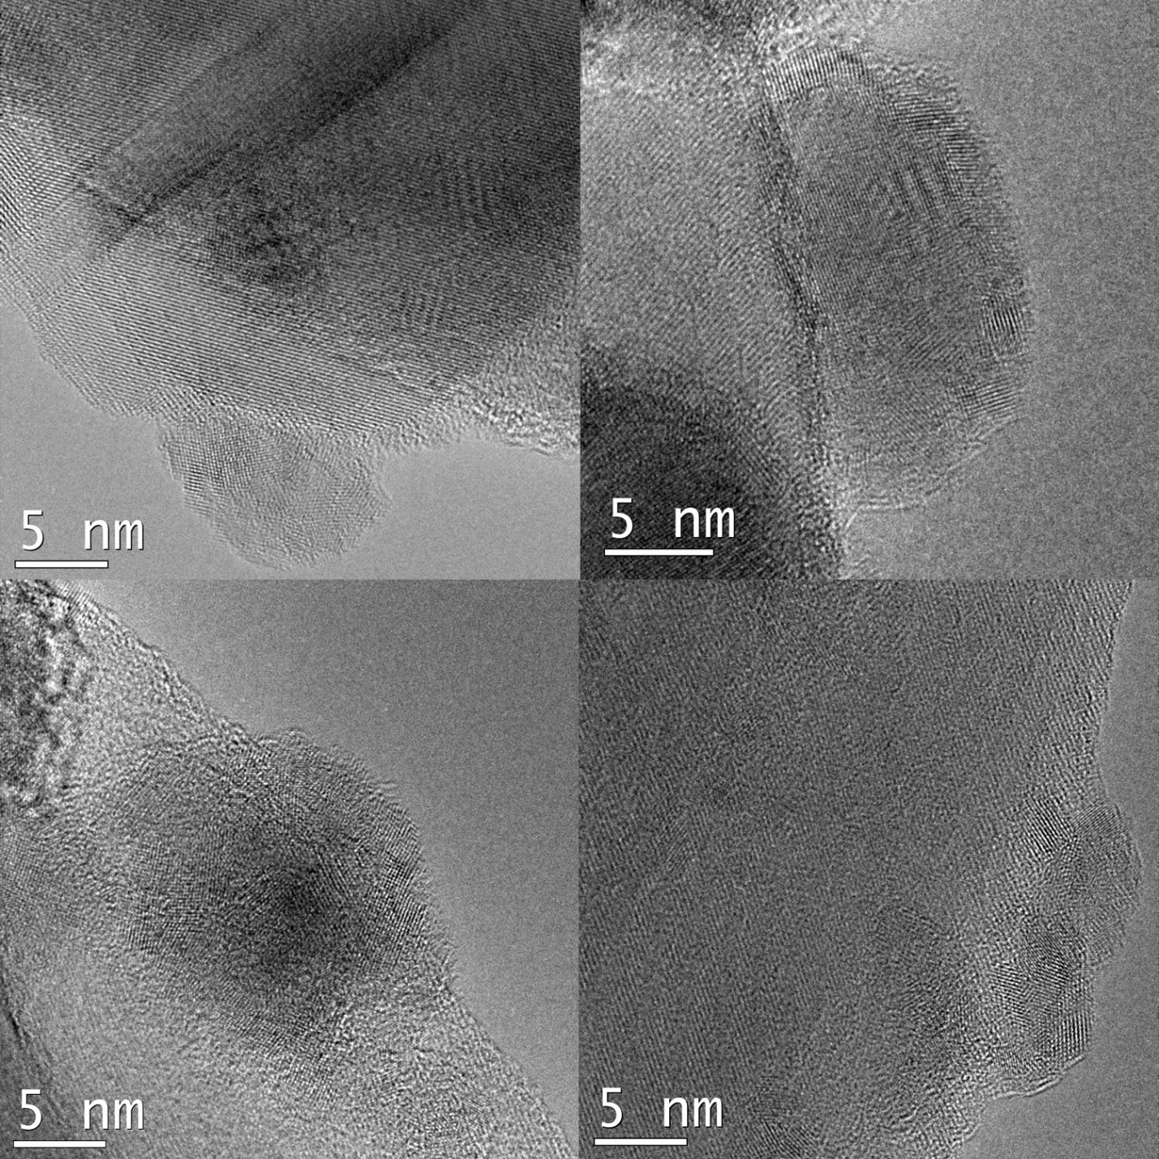
Figure S13. HRTEM images of NiO_{x} particles on CrOx-modified Ni/NiOx Mg:SrTiO₃-NiO_{x} (used).
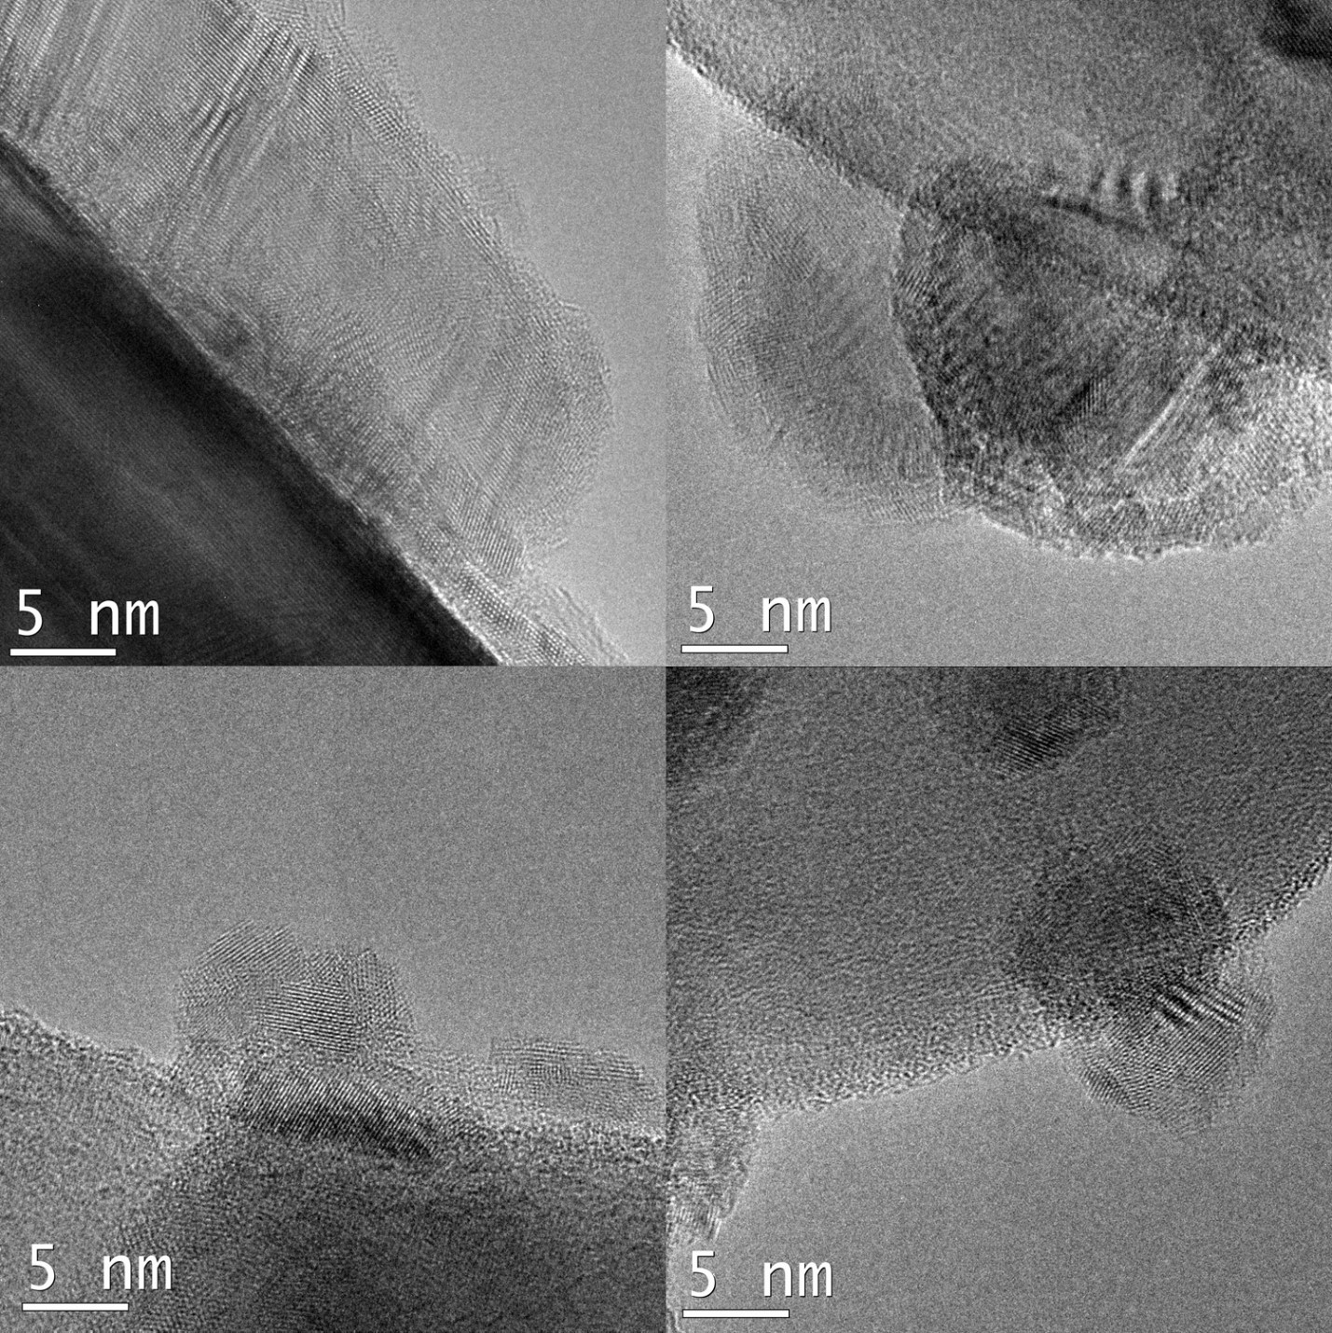
Figure S14. HRTEM images of NiO_{x} particles on Ni/NiO_{x}-Mg:SrTiO₃ (used).

STEM-EELS
The surface of the as-prepared CrO_{x}-modified Ni/NiO_{x}-Mg:SrTiO₃ was further investigated using STEM-EELS. A representative core-loss spectrum is show in Figure S14. Despite the higher scattering cross sections making Cr potentially easier to detect, no Cr-L_{2,3} peak is visible. One explanation for the lack of a Cr signal in the EELS analysis of individual particles is that particles with Cr may have a very small relative amount of Cr which is below the detectability limit of EELS, despite the higher scattering cross sections. The advantage of the EDX is that the background is very low allowing larger areas, containing many Ni/NiO_{x} particles on the thick Mg:SrTiO₃ support to be analyzed, which apparently enhanced the Cr signal enough to be detectable. Another explanation is that the electron dose rates required for creating sufficient signal in the EELS analysis of individual particles was high enough to drive Cr out of the surface due to radiation damage.

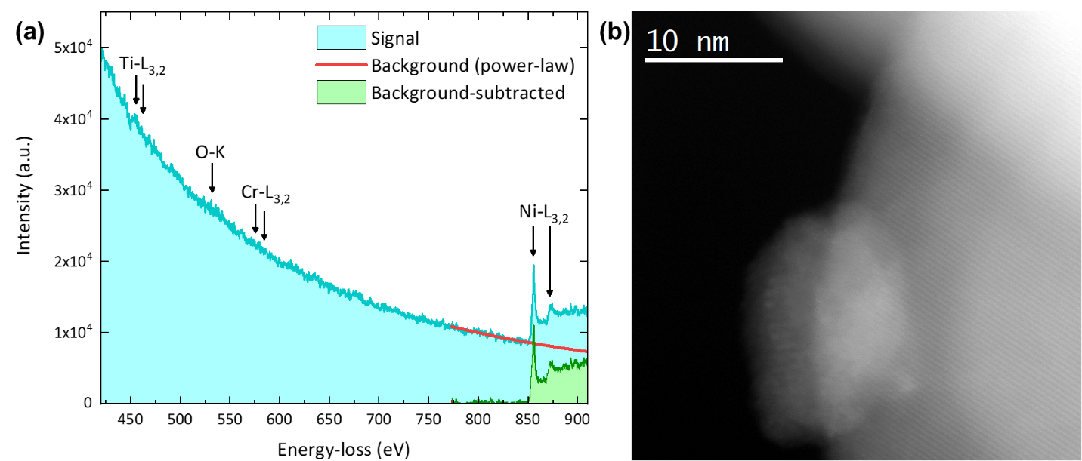
Figure S15. (a) Representative core-loss EELS spectrum from the fresh and Cr-treated Mg:SrTiO₃-NiO_{x} showing the presence of Ni and absence of Cr. The energy-loss spectra were obtained by scanning the beam over the NiO_{x} particles only. (b) A typical STEM image, produced from the annular dark field detector, of a supported NiO_{x} particle.

STEM-EDX
In the electron microscope, the pole piece (containing Cr and Fe) is constantly excited by X-rays emitted from the sample (resulting from ionization of the sample by fast electrons), therefore each spectrum will contain a baseline Cr and Fe signal. Thus, if Cr is present (and detectable) on the NiO_{x} particles, the Cr/Fe ratio should increase in regions containing these particles. To assess whether the Cr signals present in regions containing Ni/NiO_{x} were statistically significant above the pole piece contribution, the relative intensity of the Cr, Ni, and Fe peaks of each individual spectra were normalized to the Sr-Kα line at 14.14 keV, which suffers minimally from thickness-dependent absorption effects.

Figure S16. EDX signal analysis: Cr/Fe integrated peak intensity ratios found for each spectrum from the bulk (left graph), supported NiO_{x} particles (middle graph), and the bare Mg:SrTiO₃ surface (right graph). Similarly, the mean and average error (0.721 ± 0.309) associated with bulk (i.e., pole piece contribution) is marked in maroon/light red.

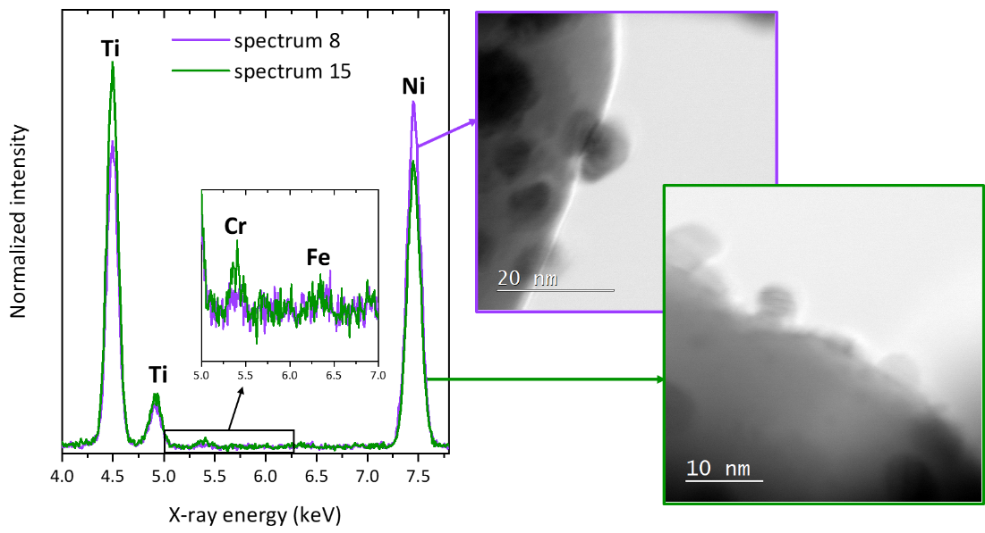
Figure S17. Comparison of EDX spectra 8 and 15 from regions containing NiO_{x} particles. Both spectra exhibit high Ni content but only one (spectrum 15) shows significant Cr signal above the pole piece contribution.

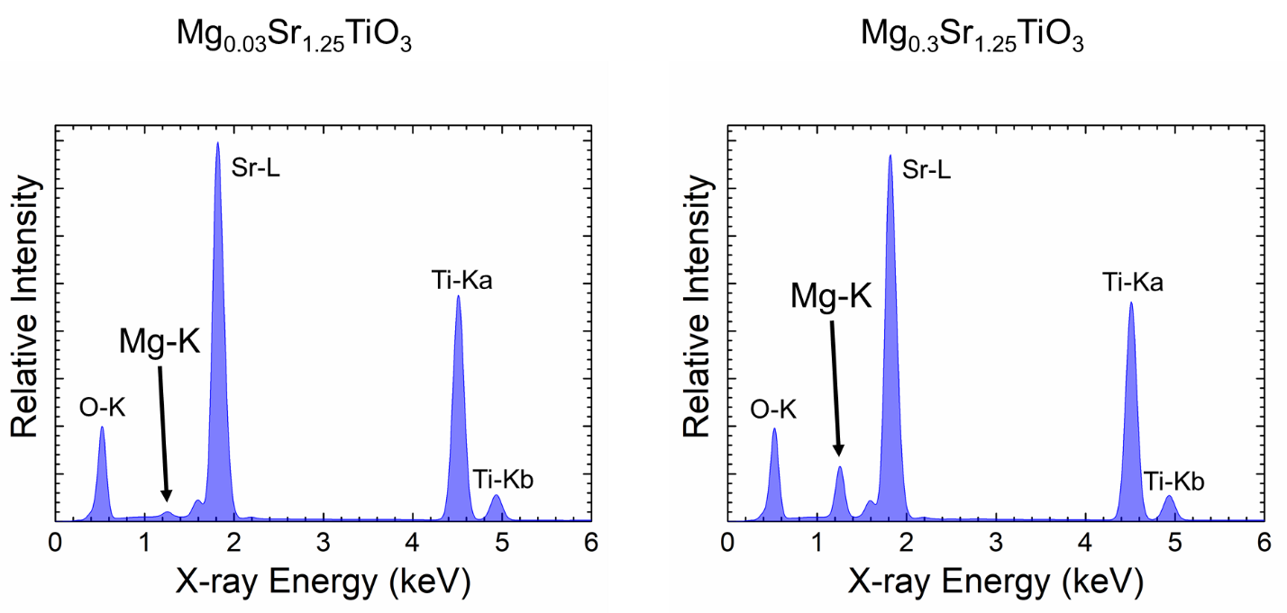
Figure S18. Simulated EDX spectra of Mg_{0.03}Sr_{1.25}TiO₃ (left) and Mg_{0.3}Sr_{1.25}TiO₃ (right) produced using NIST’s DTSA-II software.

Stability: ICP studies

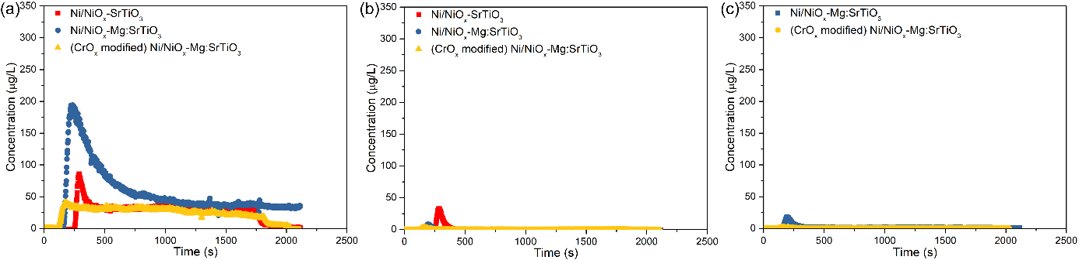
Figure S19. Experimental dissolution data obtained for the photocatalysts examined. Dissolution is measured constantly over time for Sr (a), Ni (b), Mg (c).
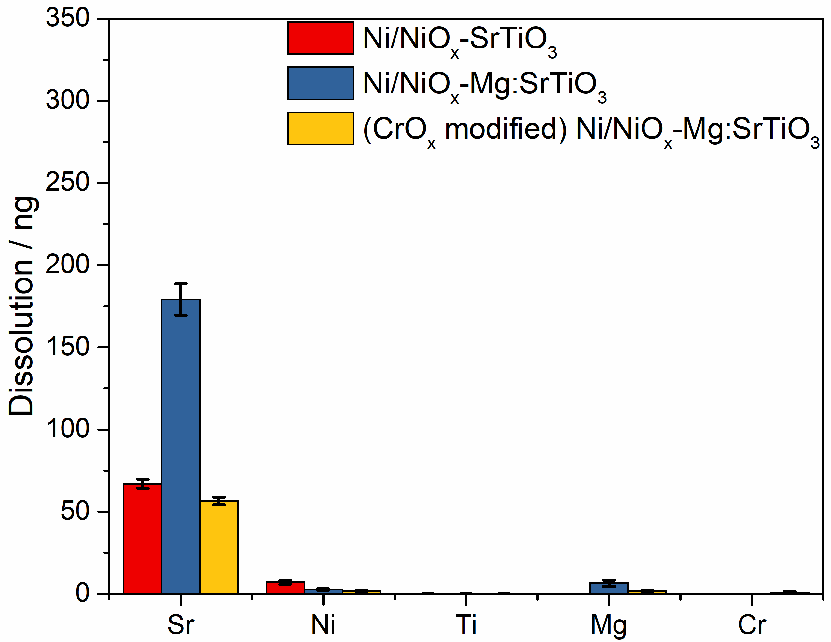
Figure S20. Accumulated amounts during the first 10 minutes of contacting with the aqueous flow.

