Supplementary material

Supplementary Figure 1. Prevalence of serious adverse events

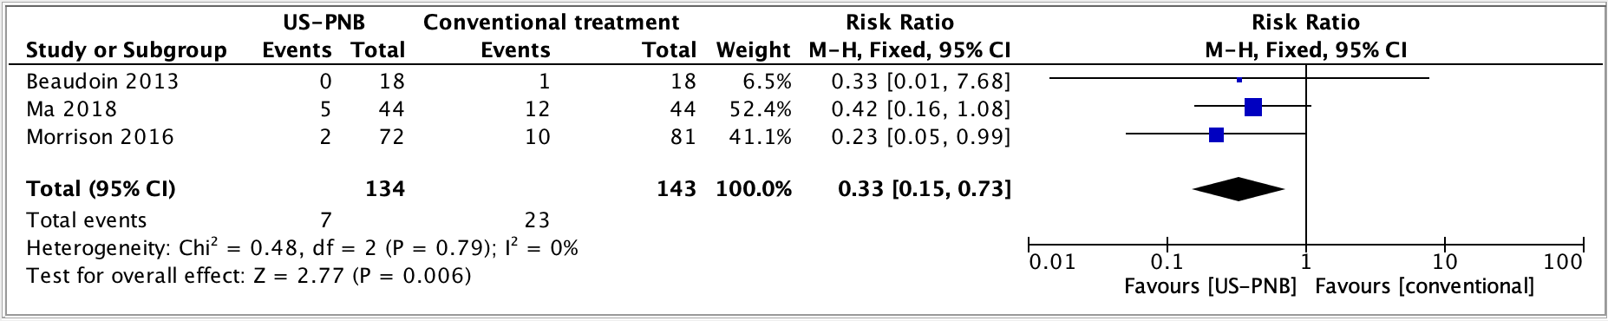
Forest plot of serious adverse events after preoperative ultrasound guided peripheral nerve blocks compared to systemic analgesia in hip fracture patients.
US-PNB, ultrasound-guided peripheral nerve block.

Supplementary Figure 2. Patient satisfaction

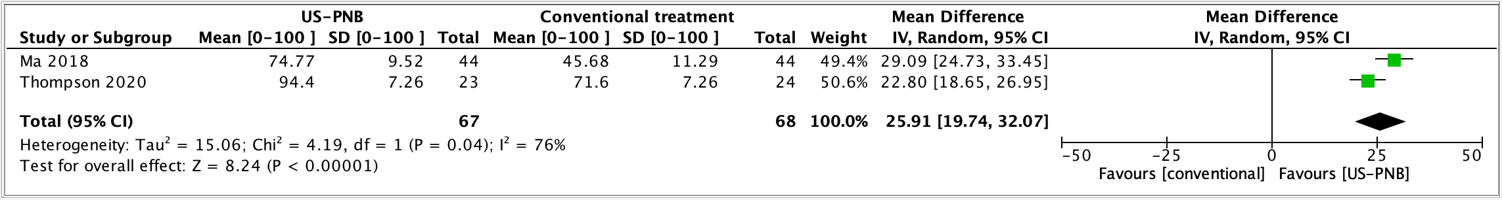
Forest plot of patient satisfaction after preoperative ultrasound guided peripheral nerve blocks compared to systemic analgesia in hip fracture patients. Mean and SD are presented at 0-100 scale, 100 being the highest satisfaction.
US-PNB, ultrasound-guided peripheral nerve block.

Supplementary Figure 3. Prevalence of delirium

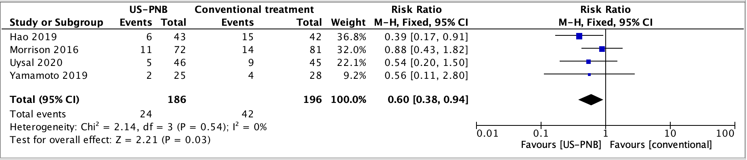
Forest plot of prevalence of delirium after preoperative ultrasound guided peripheral nerve blocks compared to systemic analgesia in hip fracture patients.
US-PNB, ultrasound-guided peripheral nerve block.

Supplementary Figure 4. Length of stay

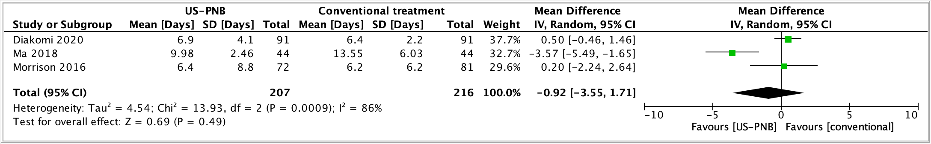
Forest plot of length of stay after preoperative ultrasound guided peripheral nerve blocks compared to systemic analgesia in hip fracture patients. Mean and SD are presented in number of days.
US-PNB, ultrasound-guided peripheral nerve block.

Supplementary Figure 5. Mortality

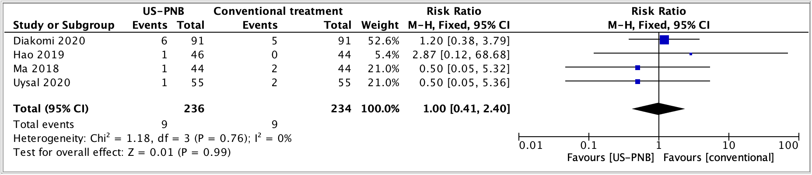
Forest plot of mortality after preoperative ultrasound guided peripheral nerve blocks compared to systemic analgesia in hip fracture patients.
US-PNB, ultrasound-guided peripheral nerve block.

