Microparticles Immobilized Tamarindus indica Extract Bioremediates Toxic Chromium in Tannery Effluent and Contaminated Soil
Babangida Sanusi Katsayal¹; Aliyu Muhammad¹; Ambi Ahmed^{1, 2} and Abdullahi Balarabe Sallau¹
List of Plates

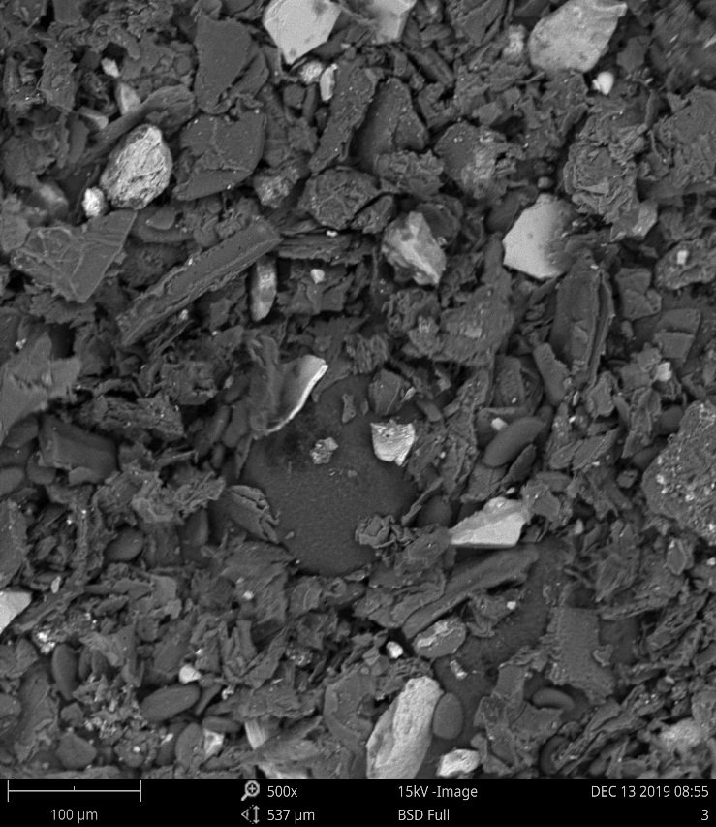
Plate 1: Morphological Appearance of Tamarindus indica Methanolic Leaves Extract-loaded Microparticles. (Magnification x500).

