Supplemental Information (SI)
- Model description
Figure S-1 presents the regions from ReEDS that are used in the subnational analysis (the different colors denote the balancing areas).
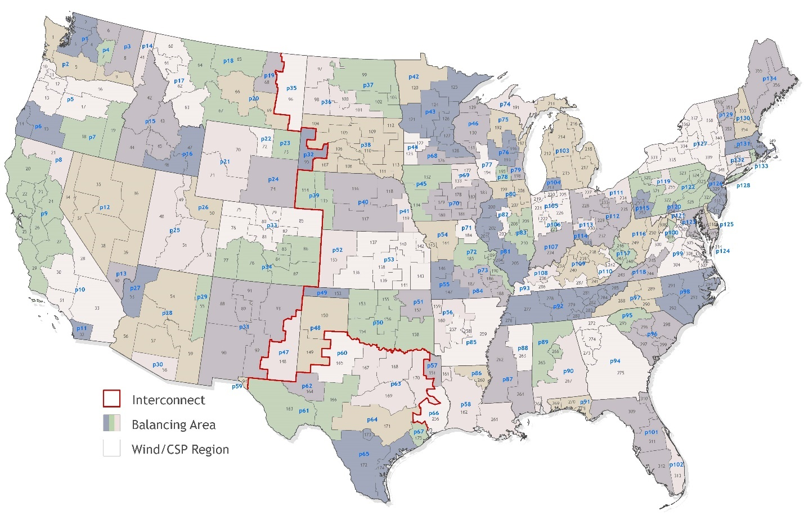
Figure S-1: ReEDS regions used in model evaluation with interconnects (red lines), balancing areas (fill colors, blue text), and wind/CSP resource regions (gray lines, gray text) identified⁵.
Other than carbon policy implementations, no changes were made to the ReEDS' Mid_Case' inputs defined in the model inputs. The ReEDS' Mid_Case' uses the middle price assumptions for technologies. Relevant ReEDS 'Mid_Case' inputs and assumptions include: sequential solve (solve one year before continuing to the next), price assumptions for all technologies are from the US Energy Information Administration (EIA) 's Annual Energy Outlook (AEO) reference and mid-case, and current policy assumptions (AB32, CSAPR, wind Production Tax Credit (PTC), RGGI, state RPS). These cost, policy, and solve assumptions stay the same throughout all the scenarios. See the ReEDS documentation for a more thorough explanation of assumptions and inputs⁵.
Table S-1 describes the carbon cap, national RPS, and low carbon technology mandates as input into ReEDS for each corresponding scenario.
Table S-1: Description of carbon cap (Mt CO₂eq./year), renewable portfolio standards (percent renewable energy generation per year), and low carbon technology mandates (percent low carbon technology generation per year) for each scenario.
 | No carbon policies | Carbon cap (Mt CO₂eq./year) |  | Renewable energy generation mandate (%) |  |  | Low carbon generation mandate (%)
Year | A | B | C | D | E | F | G | H
2010 | - | 4,808 | 4,808 | 0 | 0 | 0 | 0 | 0
2011 | - | 4,808 | 4,808 | 0 | 0 | 0 | 0 | 0
2012 | - | 4,808 | 4,808 | 0 | 0 | 0 | 0 | 0
2013 | - | 4,808 | 4,808 | 0 | 0 | 0 | 0 | 0
2014 | - | 4,808 | 4,808 | 0 | 0 | 0 | 0 | 0
2015 | - | 4,808 | 4,808 | 0 | 0 | 0 | 0 | 0
2016 | - | 4,808 | 4,808 | 0 | 0 | 0 | 0 | 0
2017 | - | 4,808 | 4,808 | 0 | 0 | 0 | 0 | 0
2018 | - | 4,808 | 4,808 | 0 | 0 | 0 | 0 | 0
2019 | - | 4,808 | 4,808 | 0 | 0 | 0 | 0 | 0
2020 | - | 1,341 | 1,341 | 20 | 20 | 20 | 20 | 20
2021 | - | 1,427 | 1,405 | 22 | 25 | 23 | 25 | 23
2022 | - | 1,329 | 1,258 | 24 | 31 | 25 | 31 | 25
2023 | - | 1,221 | 1,168 | 26 | 36 | 28 | 36 | 28
2024 | - | 1,116 | 1,092 | 28 | 41 | 31 | 41 | 31
2025 | - | 1,002 | 979 | 30 | 47 | 33 | 47 | 33
2026 | - | 973 | 889 | 32 | 52 | 36 | 52 | 36
2027 | - | 951 | 775 | 34 | 57 | 39 | 57 | 39
2028 | - | 928 | 649 | 36 | 63 | 41 | 63 | 41
2029 | - | 896 | 524 | 38 | 68 | 44 | 68 | 44
2030 | - | 844 | 464 | 40 | 73 | 47 | 73 | 47
2031 | - | 802 | 402 | 42 | 79 | 49 | 79 | 49
2032 | - | 766 | 323 | 44 | 84 | 52 | 84 | 52
2033 | - | 734 | 245 | 46 | 89 | 55 | 89 | 55
2034 | - | 700 | 178 | 48 | 95 | 57 | 95 | 57
2035 | - | 668 | 167 | 50 | 100 | 60 | 100 | 60
2036 | - | 637 | 160 | 52 | 100 | 63 | 100 | 63
2037 | - | 610 | 154 | 54 | 100 | 65 | 100 | 65
2038 | - | 586 | 146 | 56 | 100 | 68 | 100 | 68
2039 | - | 575 | 137 | 58 | 100 | 71 | 100 | 71
2040 | - | 582 | 126 | 60 | 100 | 73 | 100 | 73
2041 | - | 589 | 114 | 62 | 100 | 76 | 100 | 76
2042 | - | 594 | 103 | 64 | 100 | 79 | 100 | 79
2043 | - | 601 | 92 | 66 | 100 | 81 | 100 | 81
2044 | - | 608 | 80 | 68 | 100 | 84 | 100 | 84
2045 | - | 613 | 69 | 70 | 100 | 87 | 100 | 87
2046 | - | 619 | 57 | 72 | 100 | 89 | 100 | 89
2047 | - | 624 | 46 | 74 | 100 | 92 | 100 | 92
2048 | - | 629 | 34 | 76 | 100 | 95 | 100 | 95
2049 | - | 634 | 23 | 78 | 100 | 97 | 100 | 97
2050 | - | 639 | 11 | 80 | 100 | 100 | 100 | 100

- Emission Rates
The emissions rate sources for each technology type included in the environmental sustainability analysis are shown in Table S-2.
Table S-2: Emission rates sources.
 | Operating Emission Rates
 | CO₂eq. | NO_{x} | SO₂ | PM_{2.5}
Biopower | ⁵ | ⁵ | ⁵
Solar photovoltaic | ⁵ | ⁵ | ⁵
Concentrated solar power (CSP) | ⁵ | ⁵ | ⁵
Onshore wind | ⁵ | ⁵ | ⁵
Offshore wind | ⁵ | ⁵ | ⁵
Nuclear | ⁵ | ⁵ | ⁵
Natural gas combustion turbine (CT) | ⁵ | ⁵ | ⁵ | ⁵³
Natural gas combined cycle (CC) | ⁵ | ⁵ | ⁵ | ⁵³
Natural gas CCS | ⁵ | ⁵ | ⁵ | ⁵³
Hydropower | ⁵ | ⁵ | ⁵
Geothermal | ⁵ | ⁵ | ⁵
Oil-Gas-Steam | ⁵ | ⁵ | ⁵ | ⁵³
Coal | ⁵ | ⁵ | ⁵ | ⁵³
IGCC | ⁵ | ⁵ | ⁵ | ⁵³
Coal CCS | ⁵ | ⁵ | ⁵ | ⁵³
Battery storage | ⁵ | ⁵ | ⁵
Pumped hydropower | ⁵ | ⁵ | ⁵

Table S-3 presents the heat rates for each fossil fuel plant used to estimate the emissions rate. Since renewable technologies do not convert fuel to electricity, they do not have a heat rate.
Table S-3: Heat rates for power plants in MMBtu/MWh.⁵
Technology | Heat Rate [MMBtu/MWh]
Coal | 9.669
Cofire | 10.112
Coal CCS | 10.157
Coal IGCC | 7.920
Gas CC | 6.341
Gas CCS | 7.505
Gas CT | 9.36
Oil-Gas-Steam | 10.648
Biopower | 13.5
Nuclear | 10.461

- InMAP specifications
InMAP uses area-weighting to distribute emissions at the ReEDS level (134 regions) to the InMAP level (squares with 1 to 48 km sides). Equations S-10a and S-10b display the two-step process for area-weighting ⁵⁴. In Equation S-10a, the areal weight for each InMAP region is calculated, where $W_{I,i}$ is the areal weight for the InMAP region i (in km²), $A_{I,i}$ is the area of the InMAP region (in km²), and $A_{R,j}$ is the area of the ReEDS region j. Equation S-10b calculates the areal weighted air pollution value in each InMAP region, where $E_{I,i}$ is the estimated air pollution magnitude in each InMAP region and $Q_{R,j}$ is the PM, NO_{x}, or SO₂ air pollution (in kilograms) in each ReEDS region j.
$W_{I,i}=\frac{A_{I,i}}{A_{R,j}}$ (Eq. S-1a)
$E_{I,i}=W_{I,i}*Q_{R,j}$ (Eq. S-1b)
InMAP requires emissions inputs in shapefile form at the ReEDS region to perform this area weighting. Figure S-2(a-c) below shows the NO_{x}, SO₂, and PM emissions inputs, respectively (in metric tonnes) for InMAP, which show the total emissions in each region in 2020, 2035, and 2050.
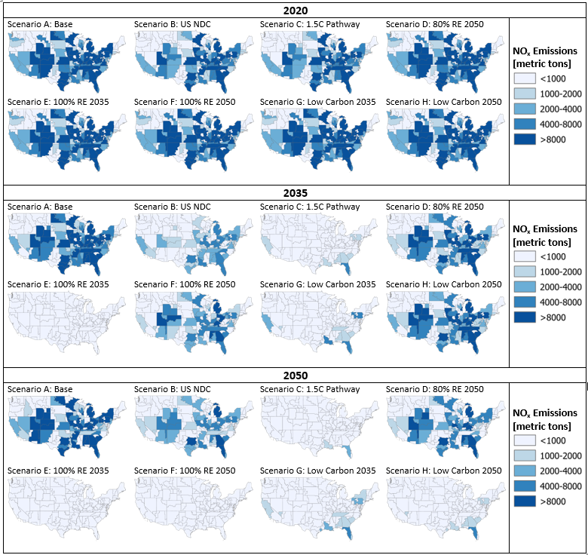
(a) NO_{x}
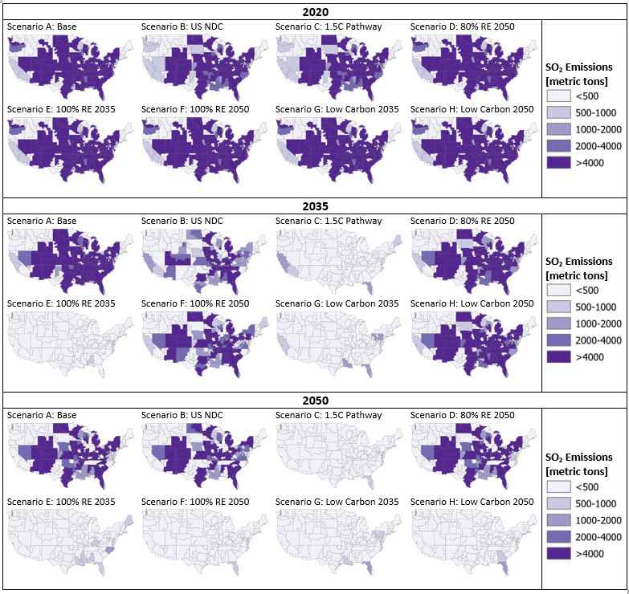
(b) SO₂
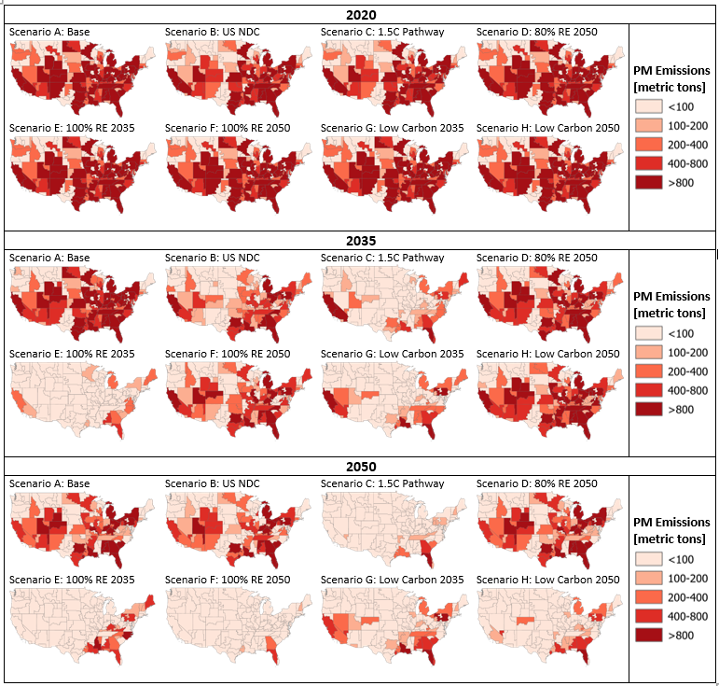
(c) PM
Figure S-2: Total emissions in each ReEDS region 2020, 2035, and 2050 for each scenario.

- Generation
Table S-4 summarizes the percent of annual generation and the magnitude of generation for the main technologies across scenarios and by decade.
Table S-4: Summary of percent and magnitude of generation from main technologies by year and scenario.
 |  | 2010 |  | 2020 |  | 2030 |  | 2040 |  | 2050
 | Technology | % | PWh | % | PWh | % | PWh | % | PWh | % | PWh
A: Base | Coal | 50.6 | 2.05 | 26.3 | 1.10 | 23.9 | 1.07 | 18.6 | 0.91 | 7.46 | 0.41
 | Natural Gas | 18.7 | 0.76 | 35.1 | 1.46 | 32.6 | 1.46 | 26.5 | 1.29 | 19.9 | 1.08
 | Natural Gas CCS | 0.0 | 0.00 | 0.0 | 0.00 | 0.0 | 0.00 | 0.0 | 0.00 | 0.0 | 0.00
 | Nuclear | 19.7 | 0.80 | 17.7 | 0.74 | 15.1 | 0.68 | 12.0 | 0.58 | 6.9 | 0.37
 | Solar PV | 0.1 | 0.00 | 3.6 | 0.15 | 7.9 | 0.35 | 14.1 | 0.69 | 20.9 | 1.14
 | CSP | 0.0 | 0.00 | 0.06 | 0.0 | 0.24 | 0.01 | 0.52 | 0.03 | 0.48 | 0.03
 | Onshore Wind | 2.6 | 0.11 | 8.4 | 0.35 | 10.6 | 0.48 | 19.1 | 0.93 | 33.8 | 1.83
 | Offshore Wind | 0.0 | 0.00 | 0.0 | 0.00 | 1.3 | 0.06 | 1.6 | 0.08 | 3.1 | 0.17
B: US NDC | Coal | 50.6 | 2.05 | 16.2 | 0.67 | 5.5 | 0.25 | 1.7 | 0.08 | 4.7 | 0.25
 | Natural Gas | 18.7 | 0.76 | 40.3 | 1.68 | 35.2 | 1.58 | 27.5 | 1.35 | 19.7 | 1.07
 | Natural Gas CCS | 0.0 | 0.00 | 0.0 | 0.00 | 0.0 | 0.00 | 0.0 | 0.00 | 0.0 | 0.00
 | Nuclear | 19.7 | 0.80 | 17.7 | 0.74 | 15.0 | 0.68 | 11.9 | 0.58 | 6.9 | 0.37
 | Solar PV | 0.1 | 0.00 | 3.9 | 0.16 | 9.6 | 0.43 | 14.8 | 0.73 | 20.3 | 1.11
 | CSP | 0.0 | 0.00 | 0.1 | 0.00 | 0.2 | 0.01 | 0.8 | 0.04 | 0.7 | 0.04
 | Onshore Wind | 2.6 | 0.11 | 13.0 | 0.54 | 24.5 | 1.10 | 33.8 | 1.66 | 37.0 | 2.01
 | Offshore Wind | 0.0 | 0.00 | 0.0 | 0.00 | 1.3 | 0.06 | 1.6 | 0.08 | 3.1 | 0.17
C: 1.5C Pathway | Coal | 50.6 | 2.05 | 16.2 | 0.67 | 0.2 | 0.01 | 0.0 | 0.00 | 0.0 | 0.00
 | Natural Gas | 18.7 | 0.76 | 40.3 | 1.68 | 26.8 | 1.21 | 6.1 | 0.30 | 0.2 | 0.01
 | Natural Gas CCS | 0.0 | 0.00 | 0.0 | 0.00 | 0.0 | 0.00 | 7.1 | 0.35 | 3.1 | 0.17
 | Nuclear | 19.7 | 0.80 | 0.74 | 17.7 | 0.68 | 15.0 | 11.5 | 0.58 | 5.5 | 0.30
 | Solar PV | 0.1 | 0.00 | 3.9 | 0.16 | 14.1 | 0.64 | 19.5 | 0.97 | 27.8 | 1.55
 | CSP | 0.0 | 0.00 | 0.1 | 0.00 | 0.2 | 0.01 | 1.2 | 0.06 | 1.4 | 0.08
 | Onshore Wind | 2.6 | 0.11 | 13.0 | 0.54 | 33.7 | 1.52 | 44.2 | 2.21 | 49.9 | 2.78
 | Offshore Wind | 0.0 | 0.00 | 0.0 | 0.00 | 1.2 | 0.06 | 1.7 | 0.09 | 4.2 | 0.23
D: 80% RE 2050 | Coal | 50.6 | 2.05 | 26.3 | 1.10 | 18.4 | 0.83 | 7.7 | 0.38 | 2.6 | 0.14
 | Natural Gas | 18.7 | 0.76 | 35.1 | 1.46 | 26.5 | 1.19 | 20.2 | 0.99 | 10.8 | 0.60
 | Natural Gas CCS | 0.0 | 0.00 | 0.0 | 0.00 | 0.0 | 0.00 | 0.0 | 0.00 | 0.0 | 0.00
 | Nuclear | 19.7 | 0.80 | 17.7 | 0.74 | 15.0 | 0.68 | 11.9 | 0.58 | 6.3 | 0.35
 | Solar PV | 0.1 | 0.00 | 3.6 | 0.15 | 10.2 | 0.46 | 16.5 | 0.81 | 22.1 | 1.22
 | CSP | 0.0 | 0.00 | 0.1 | 0.00 | 0.3 | 0.01 | 0.7 | 0.03 | 0.6 | 0.03
 | Onshore Wind | 2.6 | 0.11 | 8.4 | 0.35 | 19.8 | 0.89 | 33.4 | 1.64 | 44.9 | 2.49
 | Offshore Wind | 0.0 | 0.00 | 0.0 | 0.00 | 1.3 | 0.06 | 1.6 | 0.08 | 4.4 | 0.24
E: 100% RE 2035 | Coal | 50.6 | 2.05 | 26.3 | 1.10 | 0.9 | 0.04 | 0.0 | 0.00 | 0.0 | 0.00
 | Natural Gas | 18.7 | 0.76 | 35.1 | 1.46 | 15.83 | 0.73 | 0.0 | 0.00 | 0.0 | 0.00
 | Natural Gas CCS | 0.0 | 0.00 | 0.0 | 0.00 | 0.0 | 0.00 | 0.0 | 0.00 | 0.0 | 0.00
 | Nuclear | 19.7 | 0.80 | 17.7 | 0.74 | 9.7 | 0.44 | 0.0 | 0.00 | 0.0 | 0.00
 | Solar PV | 0.1 | 0.00 | 3.6 | 0.15 | 16.8 | 0.77 | 35.0 | 1.84 | 31.0 | 1.78
 | CSP | 0.0 | 0.00 | 0.1 | 0.00 | 0.4 | 0.02 | 9.6 | 0.51 | 9.8 | 0.56
 | Onshore Wind | 2.6 | 0.11 | 8.4 | 0.35 | 45.9 | 2.10 | 45.3 | 2.39 | 48.4 | 2.78
 | Offshore Wind | 0.0 | 0.00 | 0.0 | 0.00 | 1.2 | 0.05 | 1.5 | 0.08 | 3.5 | 0.20
F: 100% RE 2050 | Coal | 50.6 | 2.05 | 26.3 | 1.10 | 13.0 | 0.59 | 2.1 | 0.11 | 0.0 | 0.00
 | Natural Gas | 18.7 | 0.76 | 35.1 | 1.46 | 25.2 | 1.14 | 13.7 | 0.68
 | Natural Gas CCS | 0.0 | 0.00 | 0.0 | 0.00 | 0.0 | 0.00 | 0.0 | 0.00 | 0.0 | 0.00
 | Nuclear | 19.7 | 0.80 | 17.7 | 0.74 | 15.0 | 0.68 | 10.7 | 0.53 | 0.0 | 0.00
 | Solar PV | 0.1 | 0.00 | 3.6 | 0.15 | 10.8 | 0.49 | 16.8 | 0.83 | 35.9 | 2.05
 | CSP | 0.0 | 0.00 | 0.1 | 0.00 | 0.3 | 0.01 | 1.1 | 0.05 | 3.3 | 0.19
 | Onshore Wind | 2.6 | 0.11 | 8.4 | 0.35 | 25.7 | 1.16 | 45.7 | 2.26 | 49.3 | 2.81
 | Offshore Wind | 0.0 | 0.00 | 0.0 | 0.00 | 1.3 | 0.06 | 1.7 | 0.08 | 4.6 | 0.26
G: Low Carbon 2035 | Coal | 50.6 | 2.05 | 26.3 | 1.10 | 4.8 | 0.22 | 0.0 | 0.00 | 0.0 | 0.00
 | Natural Gas | 18.7 | 0.76 | 35.1 | 1.46 | 21.8 | 0.98 | 0.0 | 0.00 | 0.0 | 0.00
 | Natural Gas CCS | 0.0 | 0.00 | 0.0 | 0.00 | 0.2 | 0.01 | 13.7 | 0.69 | 11.0 | 0.61
 | Nuclear | 19.7 | 0.80 | 17.7 | 0.74 | 15.0 | 0.68 | 11.4 | 0.58 | 6.5 | 0.36
 | Solar PV | 0.1 | 0.00 | 3.6 | 0.15 | 14.0 | 0.63 | 22.7 | 1.15 | 23.7 | 1.32
 | CSP | 0.0 | 0.00 | 0.1 | 0.00 | 0.2 | 0.01 | 1.3 | 0.07 | 1.2 | 0.07
 | Onshore Wind | 2.6 | 0.11 | 8.4 | 0.35 | 34.2 | 1.54 | 40.1 | 2.03 | 45.1 | 2.52
 | Offshore Wind | 0.0 | 0.00 | 0.0 | 0.00 | 1.2 | 0.06 | 1.6 | 0.08 | 3.8 | 0.02
H: Low Carbon 2050 | Coal | 50.6 | 2.05 | 26.3 | 1.10 | 22.3 | 1.00 | 6.1 | 0.30 | 0.0 | 0.00
 | Natural Gas | 18.7 | 0.76 | 35.1 | 1.46 | 31.0 | 1.39 | 20.5 | 1.00 | 0.0 | 0.00
 | Natural Gas CCS | 0.0 | 0.00 | 0.0 | 0.00 | 0.0 | 0.00 | 0.0 | 0.00 | 6.7 | 0.37
 | Nuclear | 19.7 | 0.80 | 17.7 | 0.74 | 15.1 | 0.68 | 11.9 | 0.58 | 5.7 | 0.32
 | Solar PV | 0.1 | 0.00 | 3.6 | 0.15 | 7.8 | 0.35 | 15.5 | 0.76 | 26.5 | 1.48
 | CSP | 0.0 | 0.00 | 0.1 | 0.00 | 0.3 | 0.01 | 0.8 | 0.04 | 0.8 | 0.05
 | Onshore Wind | 2.6 | 0.11 | 8.4 | 0.35 | 13.9 | 0.62 | 35.8 | 1.75 | 47.7 | 2.67
 | Offshore Wind | 0.0 | 0.00 | 0.0 | 0.00 | 1.3 | 0.06 | 1.6 | 0.08 | 4.4 | 0.24

- National Emissions
Operating emissions. Figures S-3 – S-6 display the national operating emission by technology 2010 – 2050 across each scenario and for each pollutant. For operating emissions, natural gas and coal technologies contribute most emissions. For SO2 and PM emissions, coal technologies contribute to 99% of operating emissions across all technologies.
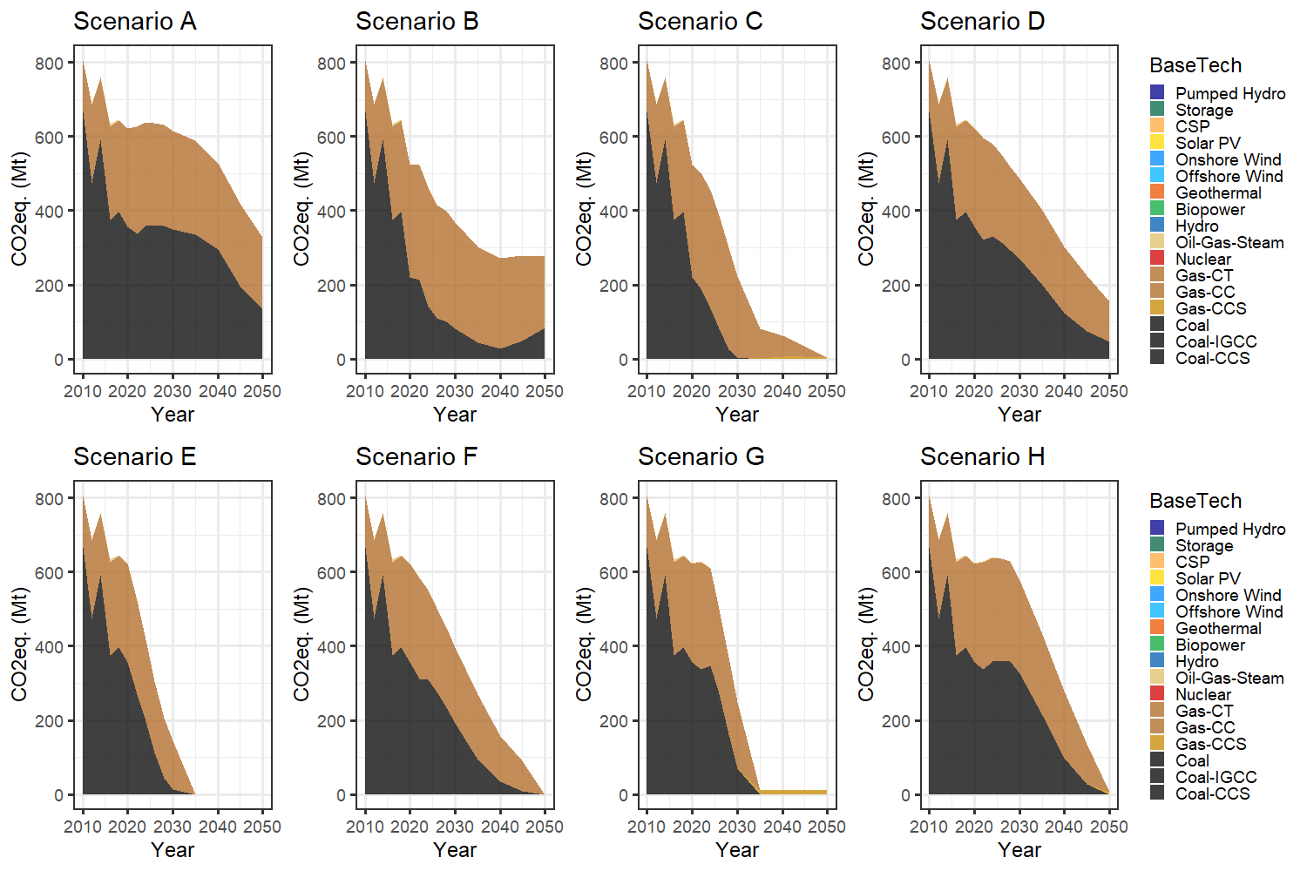
Figure S-3: National operating CO₂eq. emissions by technology 2010 – 2050.
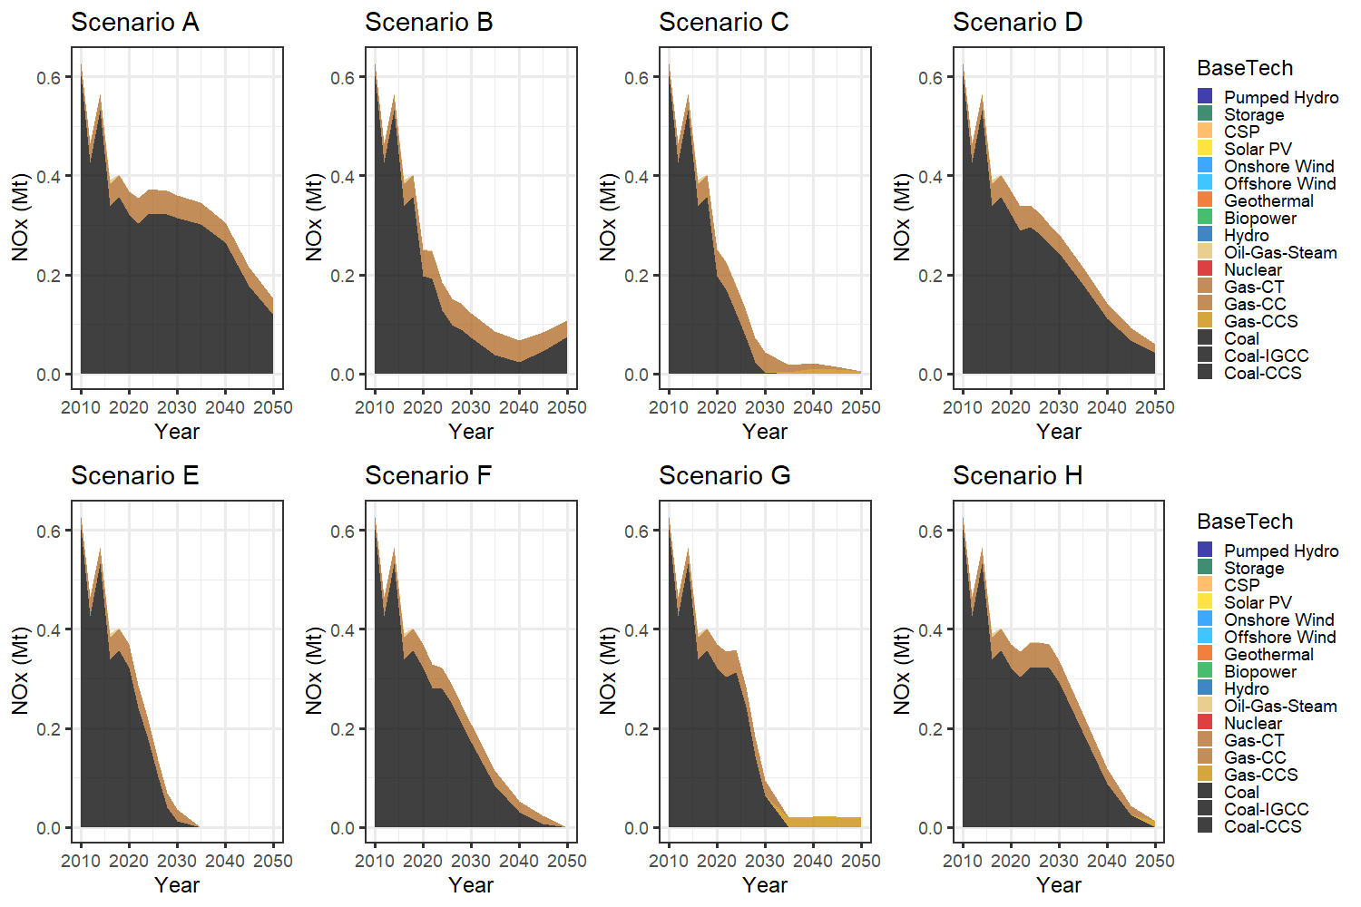
Figure S-4: National operating NOx emissions by technology 2010 – 2050.
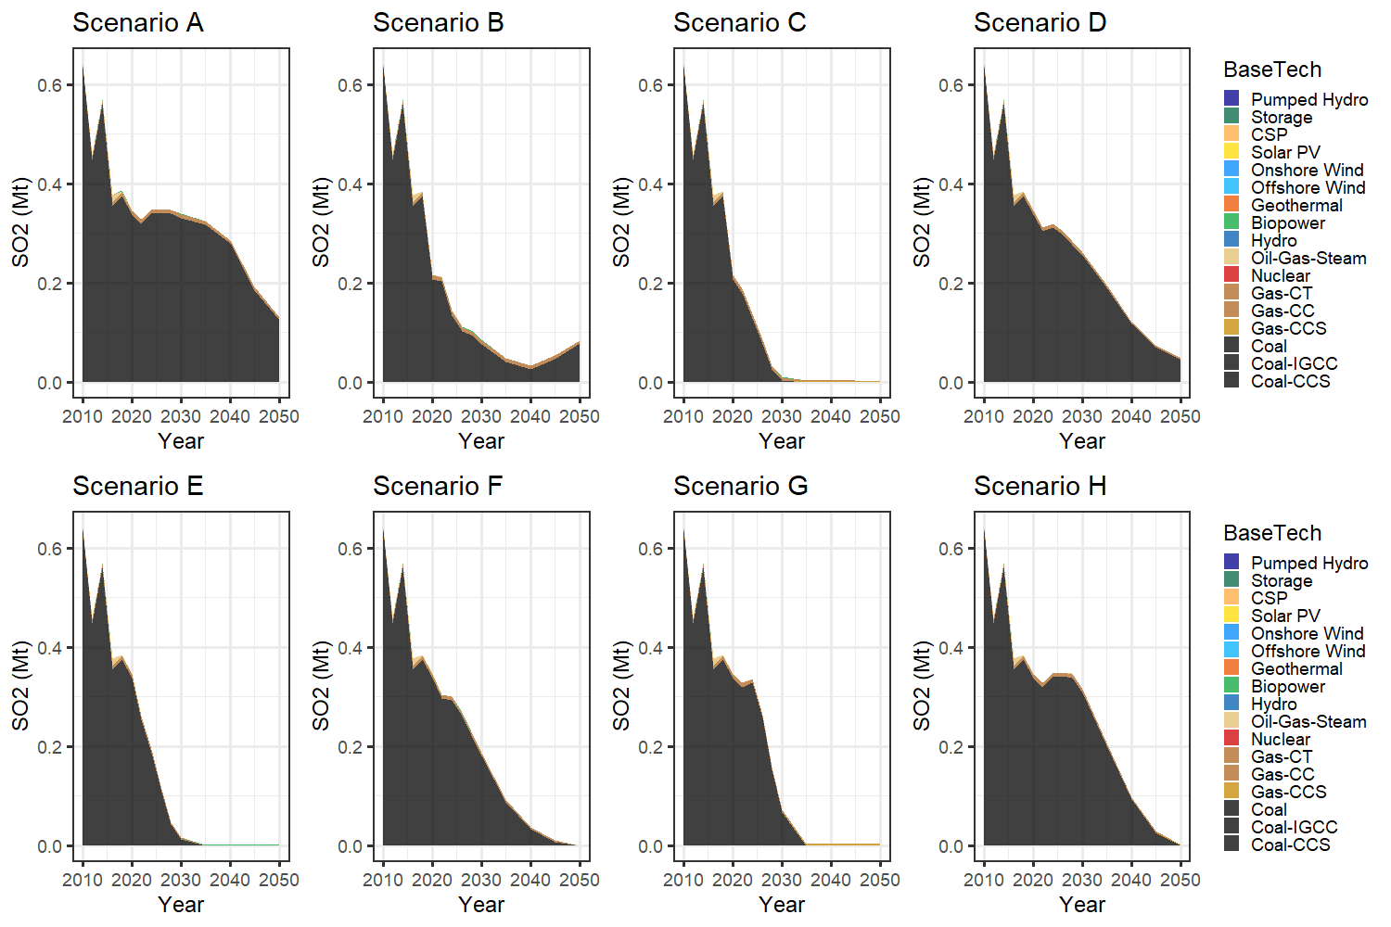
Figure S-5: National operating SO₂ emissions by technology 2010 – 2050.
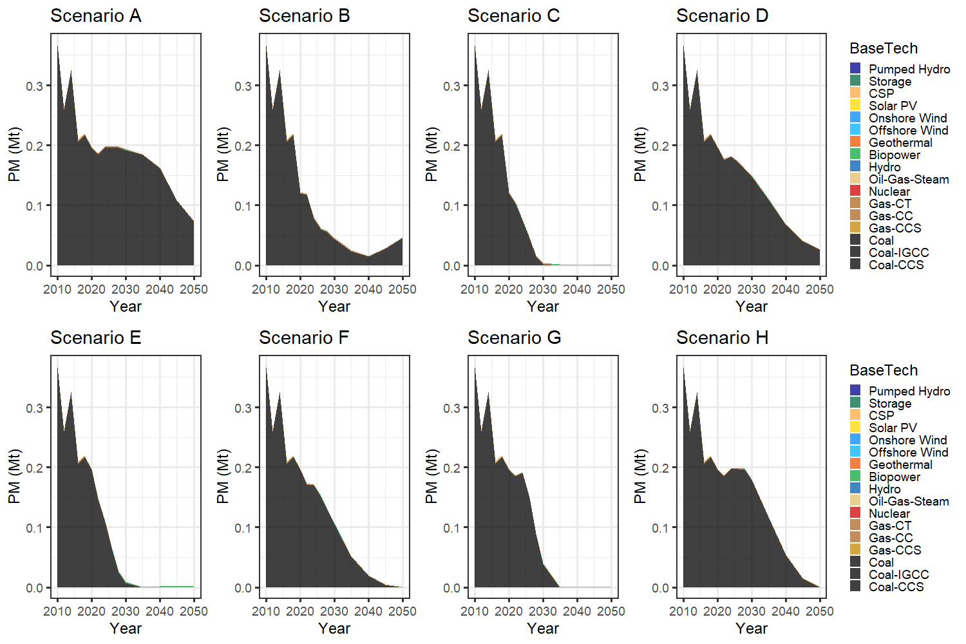
Figure S-6: National operating PM emissions by technology 2010 – 2050.

- Regional Air Pollution Analysis
Figures S-7 and S-8 show the NO_{x} and SO₂ emissions distribution in 2020, 2035, and 2050.
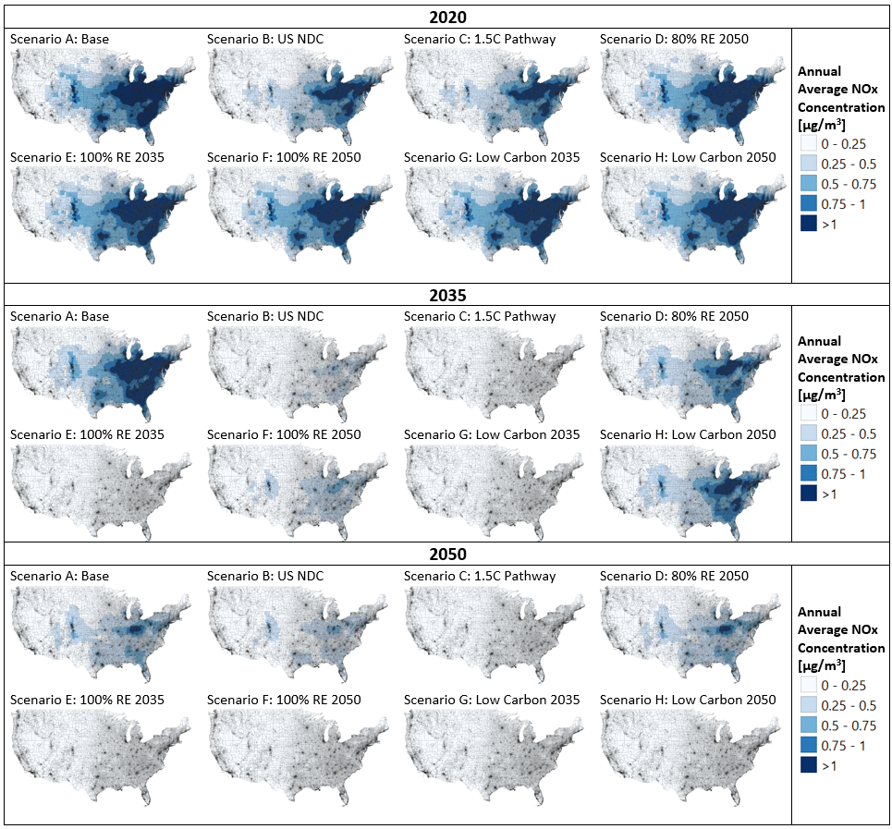
Figure S-7: Distribution of NO_{x} emissions 2020, 2035, and 2050.

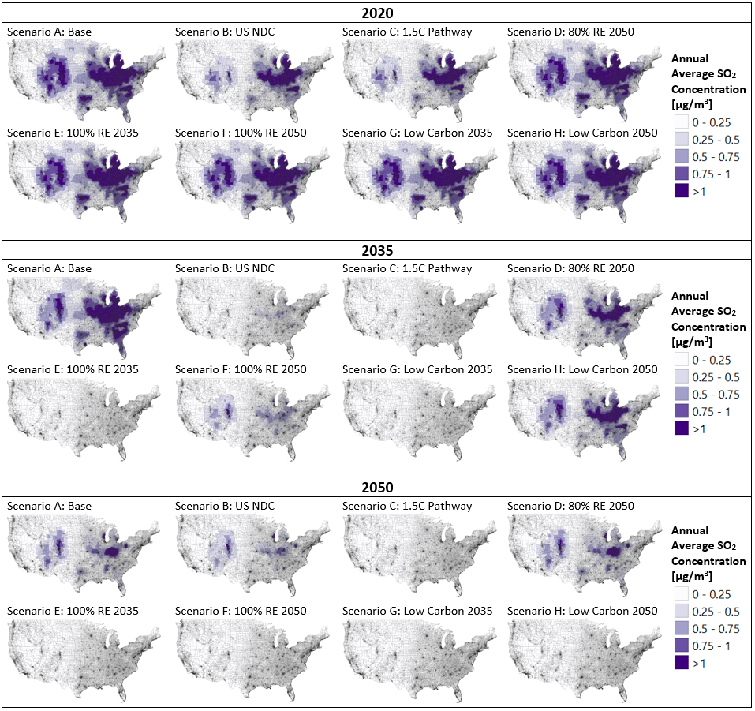Figure S-8: Distribution of SO₂ emissions 2020, 2035, and 2050.

- Air Pollution Equality Assessments
Table S-5 shows the groups and respective sample sizes for the equality analysis.
Table S-5: Equality groups and their respective sample sizes. Emission concentrations were averaged over these groups to get the mean concentration in each group.
 | Groups |  | Sample size
Population of a Race or Ethnicity (%) |  | [0, 10%]  (10%, 20%]  (20%, 30%]  (30%, 50%]  (50%, 70%]  (70%, 100%] |  | White  2,814  1,779  2,130  6,846  11,746  46,695 | Black  48,589  8,423  4,111  4,194  2,338  3,973 | Latinx/  Hispanic  44,448  10,748  5,059  5,269  3,220  3,170 | Asian  62,970  4,849  1,519  1,089  348  87 | Indigenous  69,805  411  113  64  40  130
Population below the Poverty Line (%) |  | [0, 10%]  (10%, 20%]  (20%, 30%]  (30%, 50%]  (50%, 70%]  (70%, 100%] |  | 26,850  22,897  11,611  8,621  1,389  189
Median Income |  | [0, $25k]  ($25k, $50k]  ($50k, $75k]  ($75k, $100k]  ($100k, $125k]  ($125k, $150k]  ($150k, ] |  | 4,458  29,389  22,710  8,942  3,843  1,294  890

Figure S-9 shows the average PM_{2.5} concentration across racial or ethnic groups in all scenarios for the years 2020, 2035, and 2050. The x-axis shows groups of percentages population in a census tract that is of a certain race or ethnicity. The y-axis shows the average concentration of PM_{2.5} within the percentage groups. Figures S-10 and S-11 show the same trends for NO_{x} and SO₂ respectively. Figure S-12 shows the average concentration of PM2.5, NOx, and SO2 across all scenarios and the years 2020, 2035, and 2050.
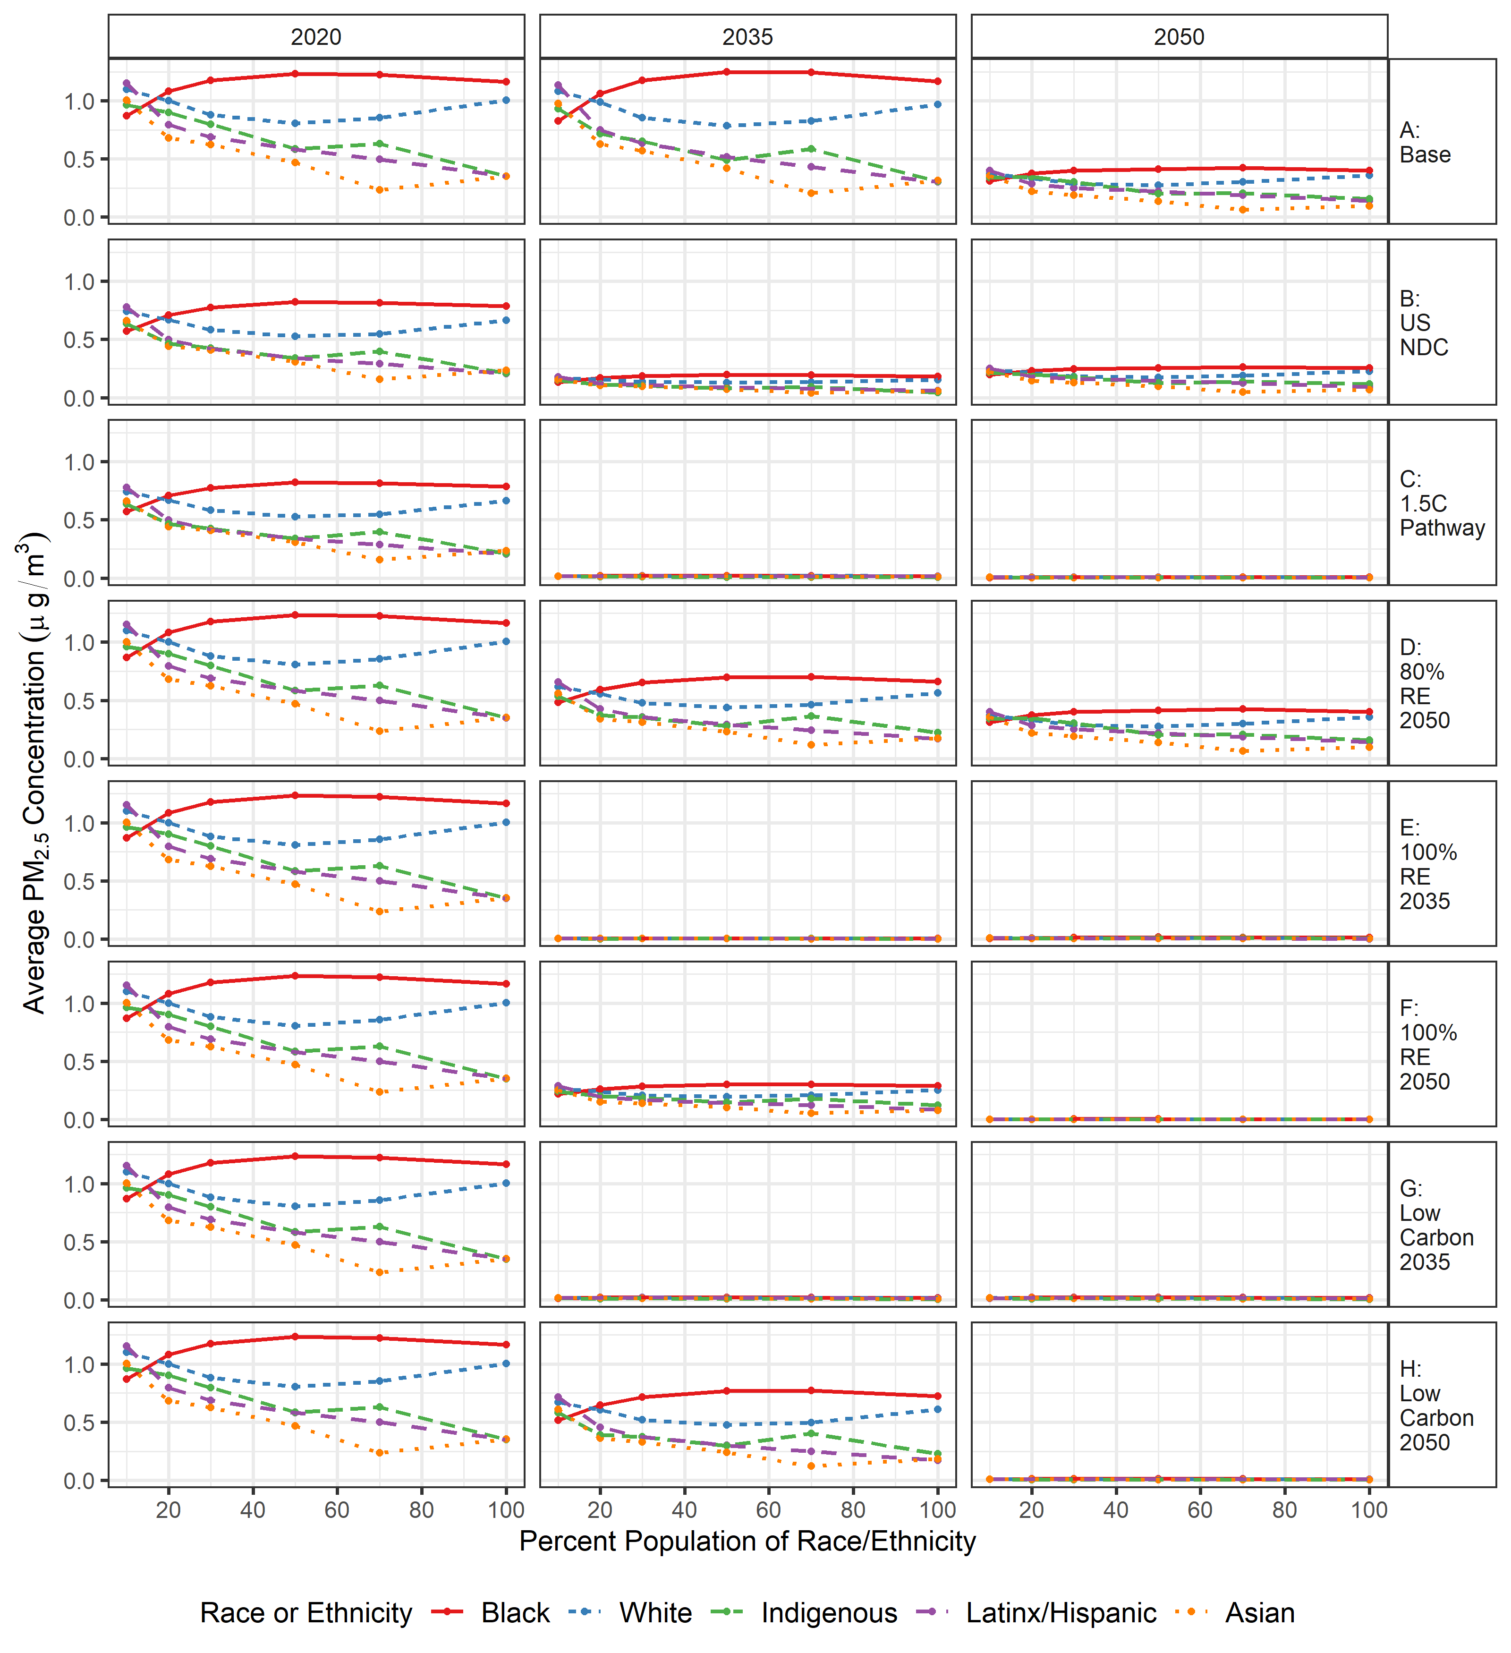
Figure S-9: Average PM_{2.5} concentration across different racial or ethnic groups in all scenarios 2020, 2035, and 2050.
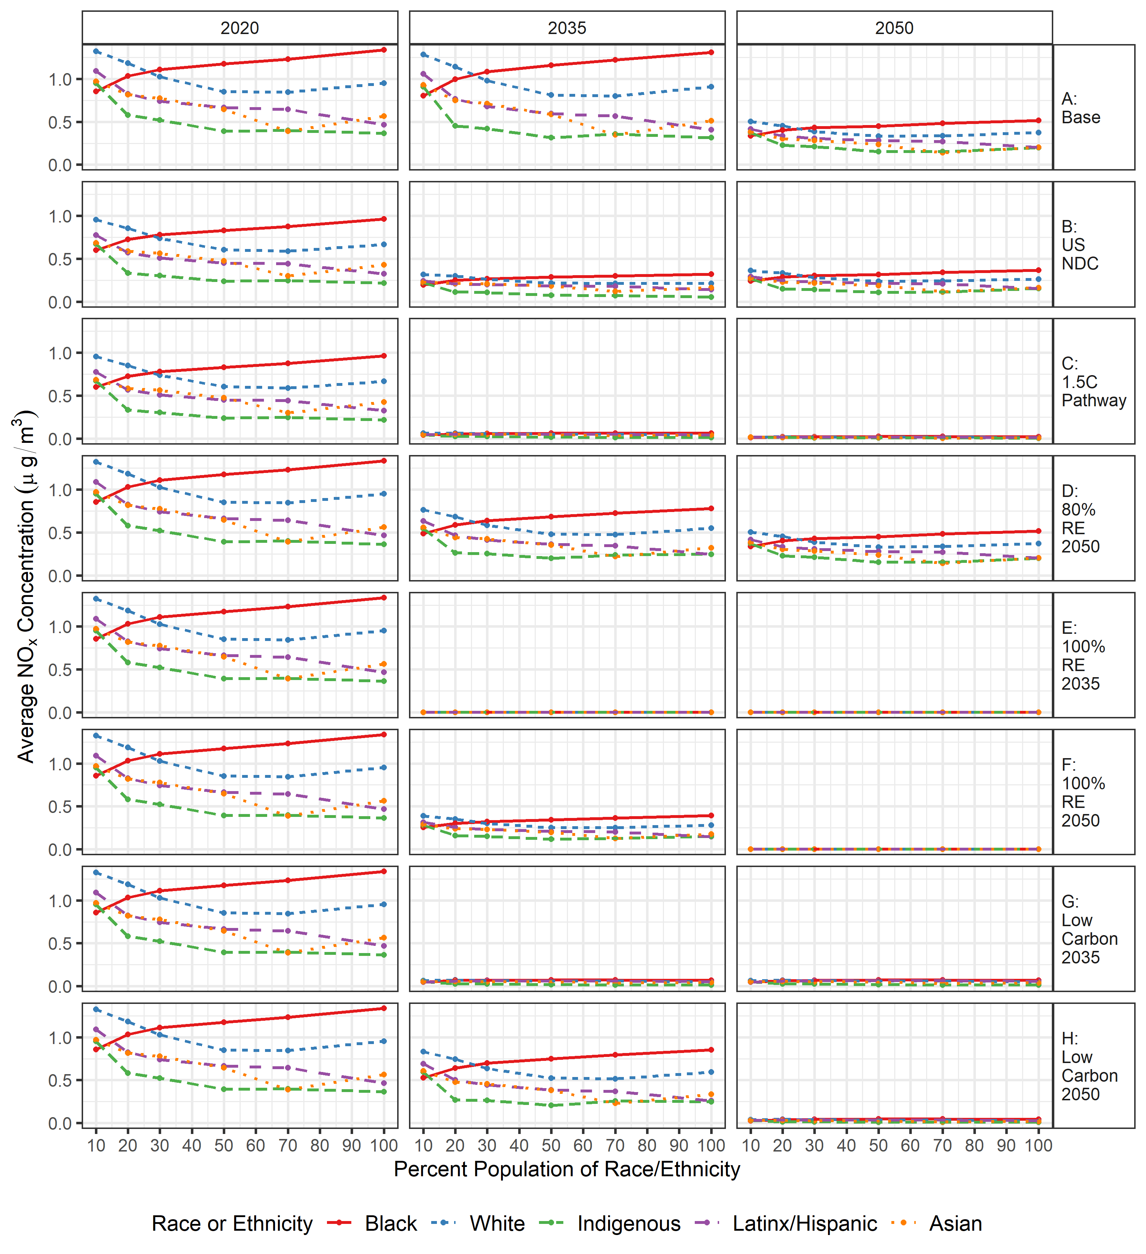
Figure S-10: Average NO_{x} concentration (µg/m³) based on the percentage of the population of a specified race or ethnicity within census tracts across years 2020, 2035, and 2050 for each scenario.
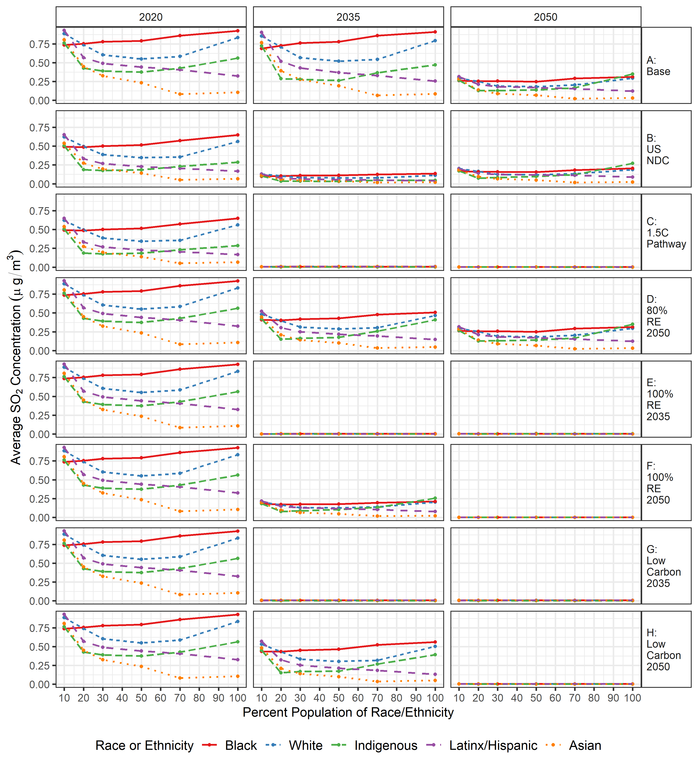
Figure S-11: Average SO₂ concentration (µg/m³) based on the percentage of the population of a specified race or ethnicity within census tracts across years 2020, 2035, and 2050 for each scenario.

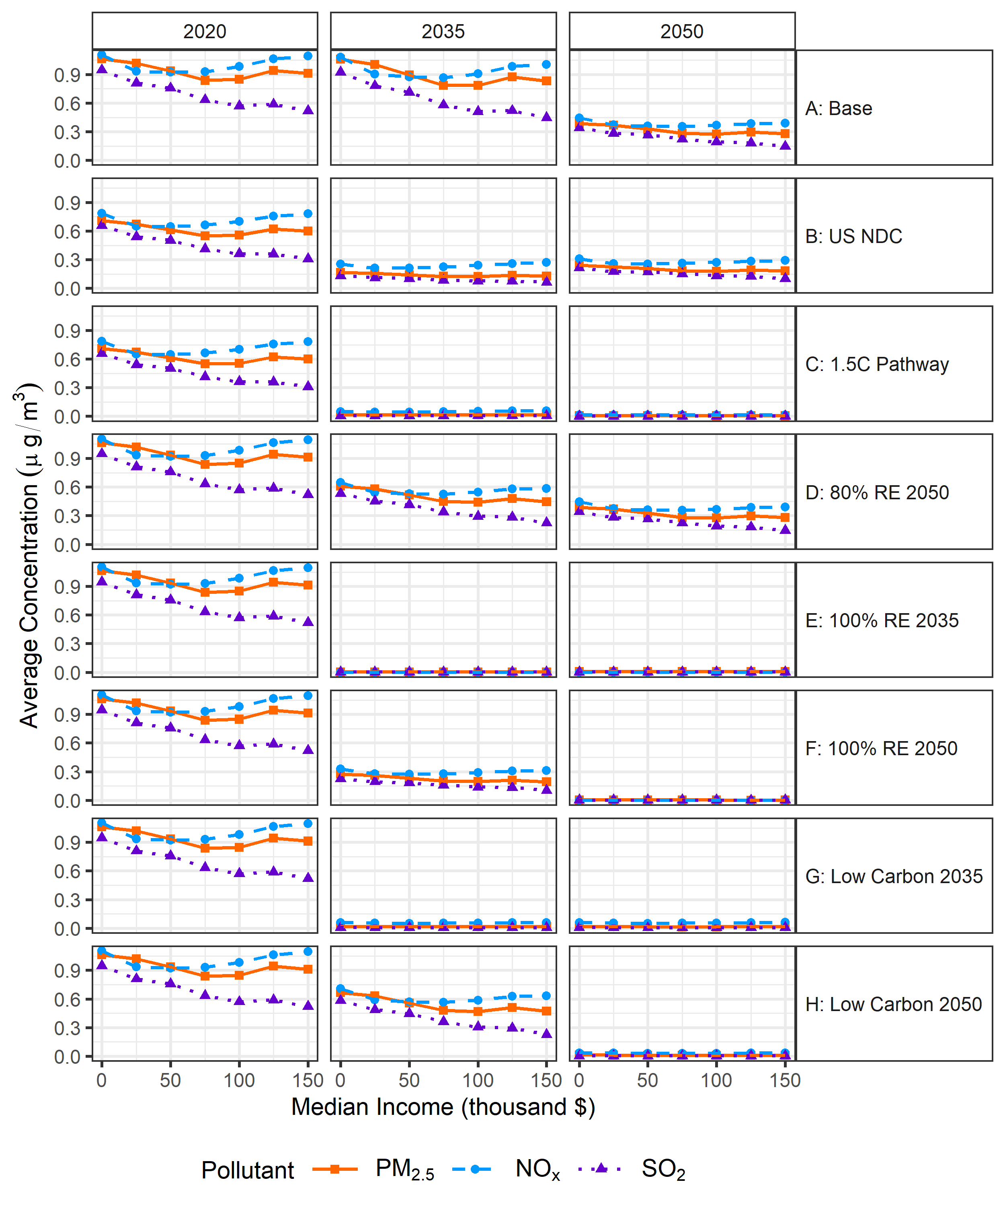
Figure S-12: All scenarios, the average concentration of PM_{2.5}, NO_{x}, and SO₂ (µg/m³) over time versus median income groups.

In addition to median income, percent of poverty within a region can identify regional vulnerability. Poverty groups were identified by the percent of the population in a region experiencing poverty, which the US Office of Management and Budget classifies as a family under a certain threshold given their family makeup⁵⁵. Figure S-13 summarizes the average annual PM_{2.5} concentration versus the percent of a population in poverty (<10%, 10-20%, 20-30%, 30-50%, 50-70%, and >70% poverty) for the years 2020, 2035, and 2050 across each scenario. In 2020, regions with a population over 50% in poverty had higher amounts of PM_{2.5}. In Scenario A, where no carbon policies are implemented, there is no change in magnitude of PM_{2.5} across percent poverty groups, with regions with over 50% of poverty exposed to more PM_{2.5}. Alternatively, across scenarios that implement a carbon cap or technology mandate (B – H), PM_{2.5} decreases across all poverty groups in 2035 and 2050, with PM_{2.5} exposures across poverty groups flattening out to not have much difference across groups.
Figure S-14 shows the average concentration of PM_{2.5}, NO_{x}, and SO₂ across percent rural groups, each scenario, and across the years 2020, 2035, and 2050.

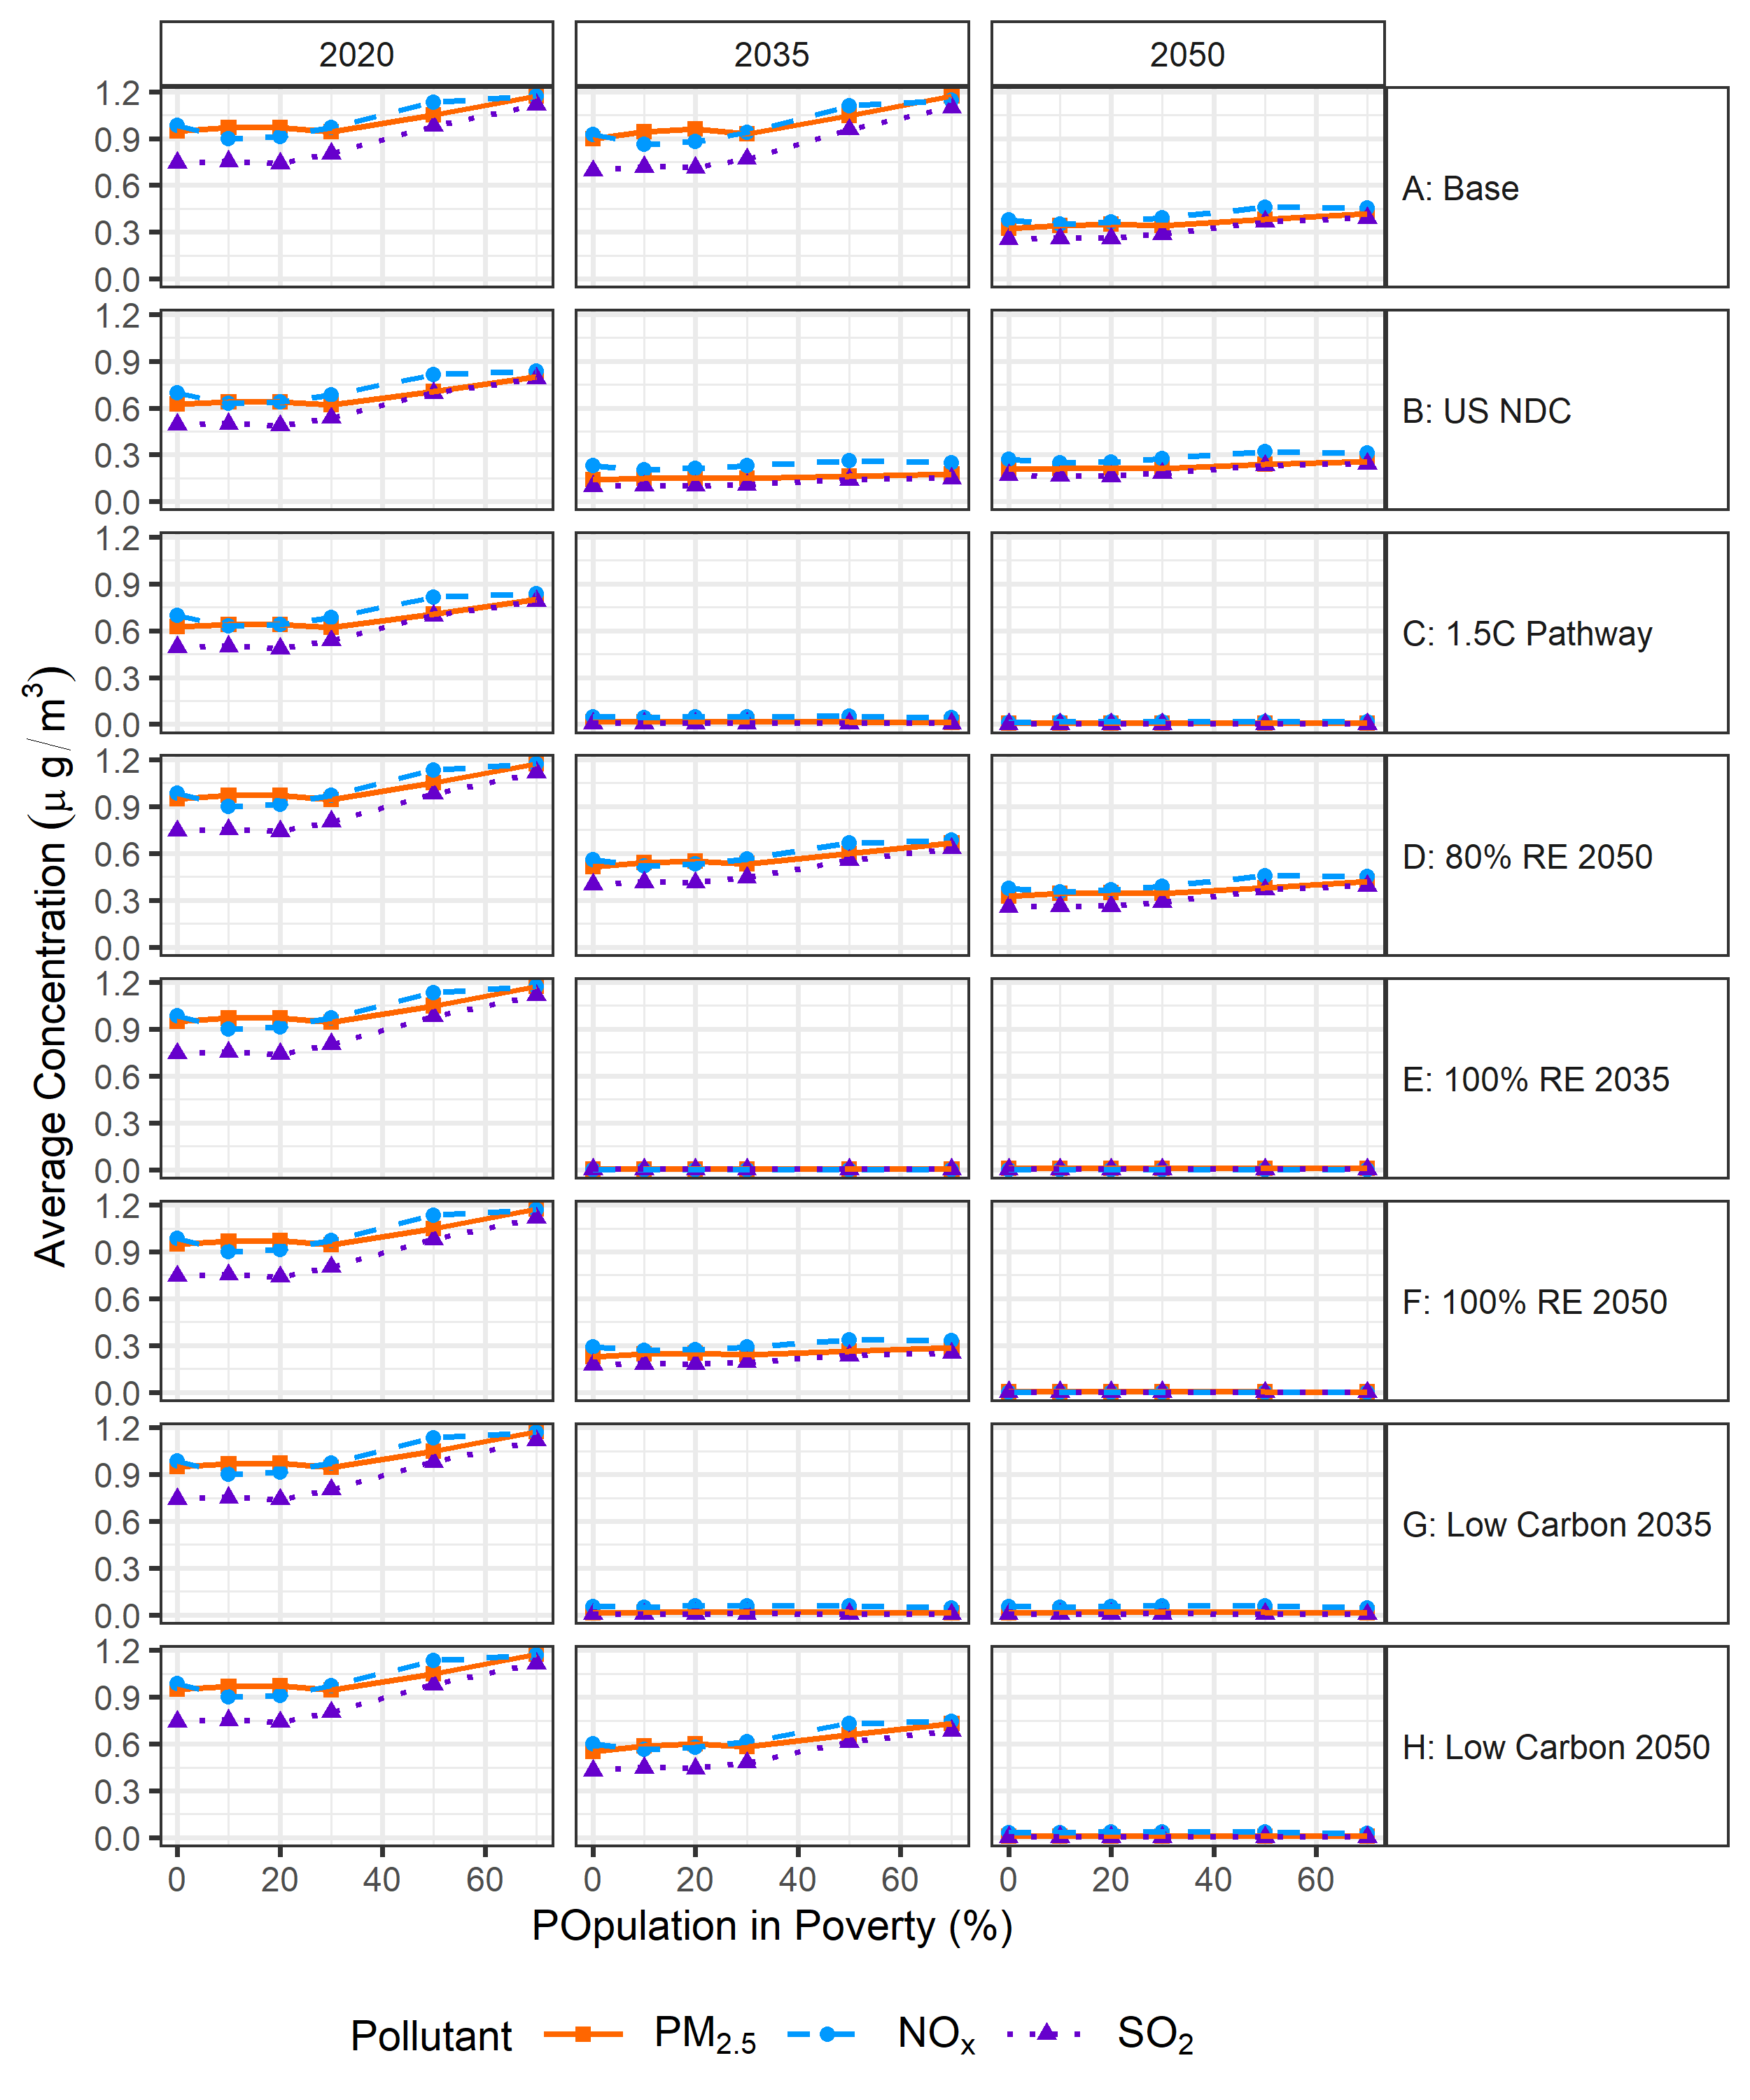Figure S-13: Average concentrations (µg/m³) across regions with different levels of poverty shown for 2020, 2035, 2050 across each scenario.

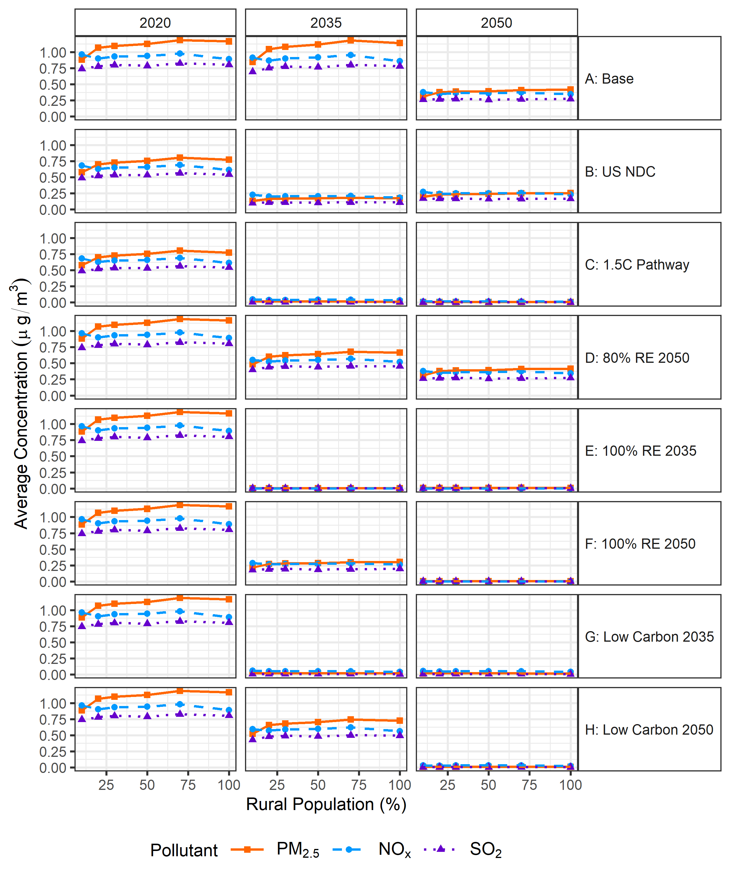
Figure S-14: Rural population vs. pollutant concentration (µg/m³) across scenarios and the years 2020, 2035, and 2050.

