Supplimentary Materials

Method

The anisotropy of linearly elastic medium is generally expressed with an elasticity tensor of 21 independent components, but it is practically impossible to retrieve the 21 components37. Although the elasticity tensor may be analytically decomposed into a sum of orthogonal tensors corresponding to various symmetry classes38, these decompositions remains difficult to be put in real utilization.

Inspired by the observed pattern of P-wave residuals22,23 as well as the stress-aligned cracks 19, 39, we relate the stress tensor directly with a new symmetrical tensor describing the seismic anisotropy of medium by defining a slowness deviation tensor (SD tensor). In this case, the residual in observed travelling time and the deviance in slowness of medium may be linked with the distance between source and receiver as follows

$$∆t^{(r)}=\vec{r}∙[{\vec{n}}^{(r)}∙∆\overset{⃡}{S}]$$

Or

$$∆t^{(r)}=r_{i}n_{j}^{(r)}\left(∆S_{ij}\right)$$

Where $∆\overset{⃡}{S}$ denotes the SD tensor, a symmetrical tensor describing the deviance in slowness, $\vec{r}$ and ${\vec{n}}^{(r)}$ refer to the vector from source to receiver and its unit vector, respectively, and $∆t^{(r)}$ is the travel-time residual observed at the $\vec{r}$ receiver. The above formula indicates that the SD tensor is resolvable by the least-squared technique provided that measurements of travel-time residuals are available at different 6 or more receivers, which means that slowness or velocity anisotropy will become known if there are sufficient observational stations around a radiating source.

**Test for the stability of the SD tensor and stress tensor inversion**

A total of 891 rays or travel-time residuals, much more than the counts of the unknowns, were available between the cluster and stations for us to invert for the 6 elements of the SD tensor. To test for the inversion stability, we repeated the inversion process 50 times with 700 samples randomly selected from a dataset of 891 travel-time residuals. We noticed only small variations when the inversions were repeated (Figs.S1a and S1b). Also we tested for the effect of the datum amount, and found that the inversion was always stabilized at an acceptable level till down to 200 samples (Fig. S2a). These tests indicate that our SD tensor inversion was very stable. Furthermore, such a stable inversion strongly suggests an existence of 3-axis anisotropy with inclined symmetrical axis as well as the rationality of the new methodology and the practicability of the inversion technique.

Comparing to the data of travel-time residuals, we had only 70 FMSs available to invert for the stress tensor. However, we adopted the same strategy as above while testing for the stability of the stress tensor inversion. Only 50 FMSs, randomly selected from the dataset of 70 solutions, were utilized to repeat the inversion process each time. Repeating 50 times produced 50 results, which had ignorable deviations from the average (Fig.S1c and Fig.S1d). Similar to the SD-tensor-stability testing, the datum amount to be inverted were gradually reduced while the inversion process was repeated. We found that the uncertainty would become unacceptable (Fig. S2b) when the counts of the inverted FMSs were less than 35. Clearly, although the stability of the stress tensor inversion was not so excellent as that of the SD tensor inversion, the stress tensor still was reliable.

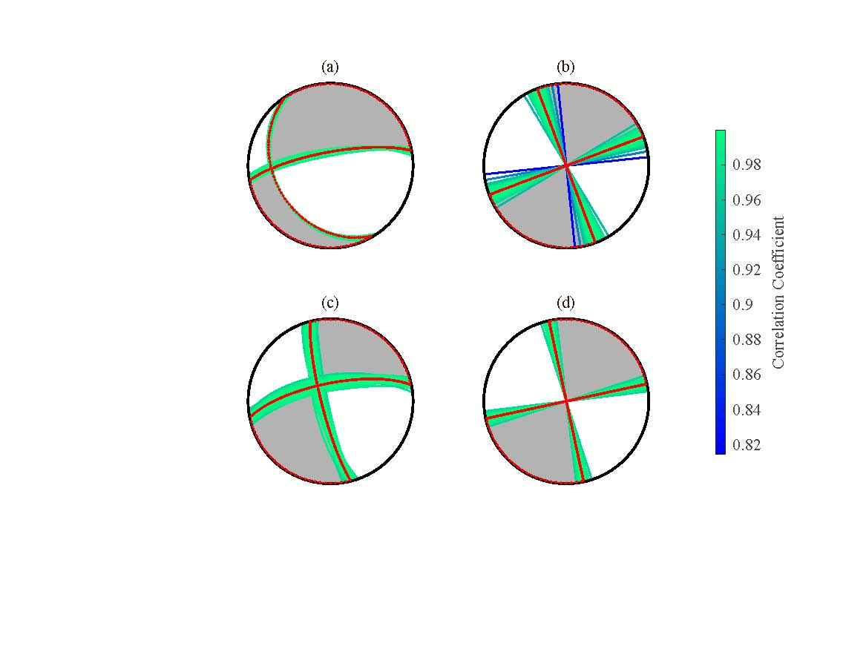

Fig. S1 Comparison of the SD tensor with the stress tensor. Colors show the uncertainty defined with the correlation coefficients between individuals and their average. (a) SD tensor without constraints; (b) SD tensor with constraint of vertical N-axis. (c) Stress tensor without constraints; (d) Stress tensor with constraint of vertical B-axis.

figS1.emf

Fig. S2 Tests for the inversion stability of the SD tensor and the stress tensor

(a) The variation of the correlation coefficient with the number of the rays (Ray-number) or the travel-time residuals (TTRs) inverted for the SD tensor. A total of 7 tests were conducted. In these tests, the number of the TTRs was decreased 100 by 100, but the inversion was always repeated 50 times using the TTRs selected randomly from the 891 TTRs. Firstly, we defined the BEST SOLUTION (BS) by averaging the 50 tensors after repeating 50 times of the inversions based on 700 TTRs randomly selected from the total 891 TTRs. Then, we evaluated two correlation coefficients (CCs): the first one between the BS and the average of the 50 solutions after repeating the inversion 50 times (blue filled circles), and the second one between the BS and the individual solution which deviates most from the BS while repeating the inversion 50 times (purple squares). It is noticed that the second CC would fall below 0.8 only when the Ray-number was decreased to less than 200. The comparison of the two CCs indicates that the SD tensor resolved after repeating the inversion 50 times using 700 TTRs was sufficiently stable.

(b) The variation of the correlation coefficient with the number of the focal mechanism solutions (Focal-Mechanism Number: FMN) inverted for the stress tensor. A total of 7 tests were conducted. In these tests, the FMN was decreased 5 by 5, but the inversion was always repeated 50 times using the focal mechanism solutions (FMSs) selected randomly from the 70 FMSs. Firstly, we defined the BEST SOLUTION (BS) by averaging the 50 tensors after repeating 50 times of the inversions based on 50 FMSs randomly selected from the total 70 FMSs. Then, we evaluated two correlation coefficients (CCs): the first one between the BS and the average of the 50 solutions after repeating the inversion 50 times (blue filled circles), and the second one between the BS and the individual solution which deviates most from the BS while repeating the inversion 50 times (purple squares). It is noticed that the second CC would fall below 0.8 only when the FMN was decreased to less than 35. The comparison of the two CCs indicates that the stress tensor resolved after repeating the inversion 50 times using 50 FMSs was sufficiently stable.

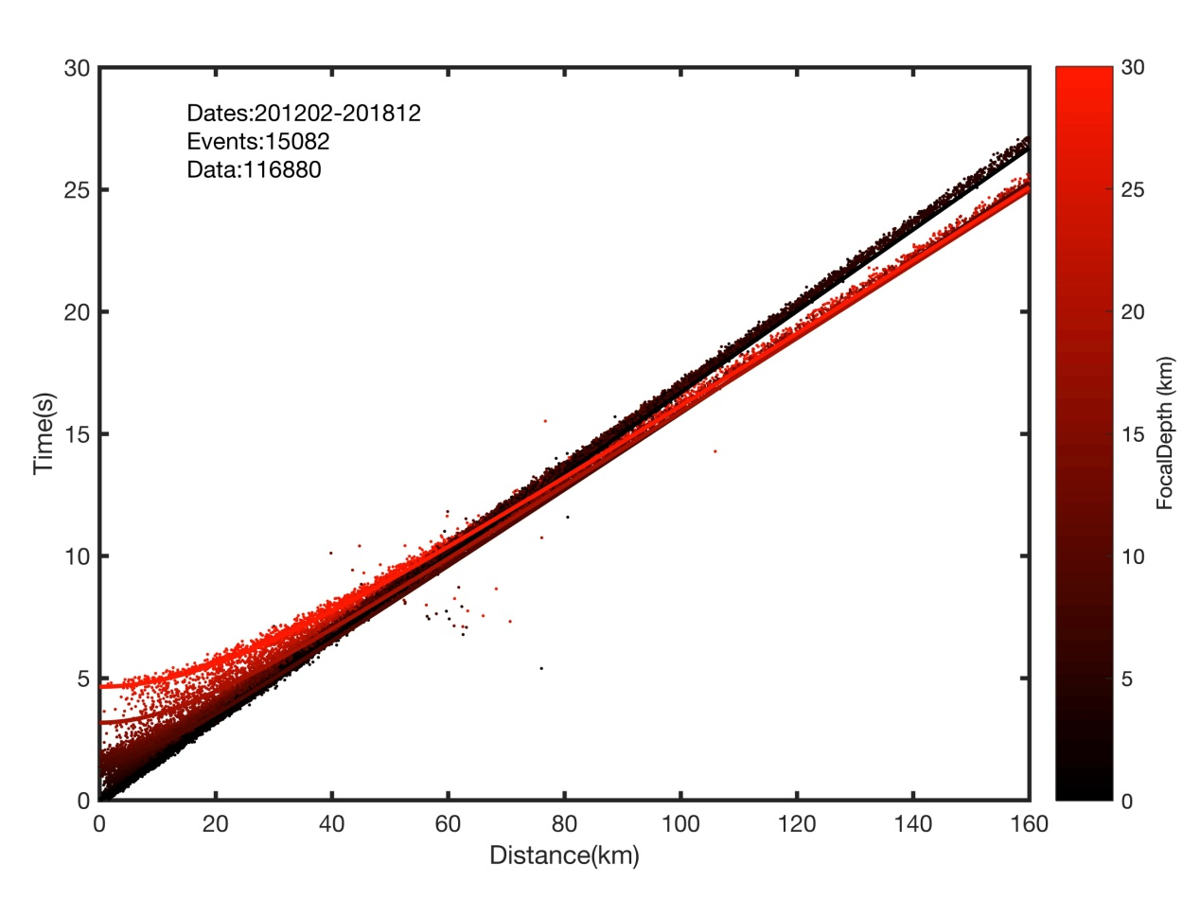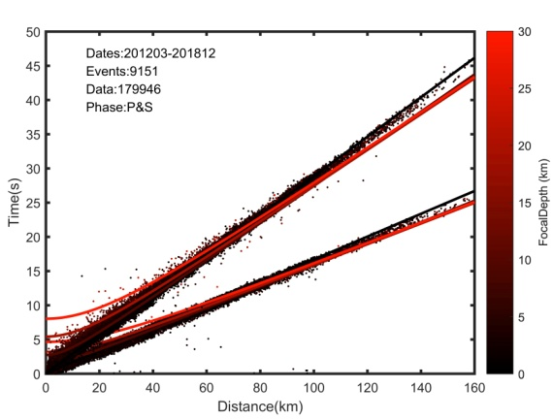

Fig. S3 Comparison of the observed travelling times (dots) with the theoretical ones (lines). Colors indicate focal depths. The left subplot is drawn only based on the P arrivals while the right one is based on the P-arrivals and S-arrivals both. Note that the observed travelling times are much closer to the theoretical ones when pure P-arrivals are used to locate the hypocenters, indicating that the seismic events are located more accurately.

Table S1. Parameters (eigenvalue, azimuth and plunge) of the solution shown in Fig.2

|  |  |  |  |
| --- | --- | --- | --- |
| Axis | Value(s/km) | Azimuth(°) | Plunge(°) |
| S-Axis | 0.0120 | 15 | 24 |
| N-Axis | -0.0031 | 272 | 28 |
| F-Axis | -0.0192 | 139 | 52 |

Table S2. Parameters (eigenvalue, azimuth and plunge) of the solution shown in Fig.3

|  |  |  |  |
| --- | --- | --- | --- |
| Axis | Value(s/km) | Azimuth(°) | Plunge(°) |
| S-Axis | 0.0074 | 196 | 0 |
| N-Axis | 0 | * | 90 |
| F-Axis | -0.0074 | 286 | 0 |

Table S3. Parameters (eigenvalue, azimuth and plunge) of the average solution shown in Fig.S1a

|  |  |  |  |
| --- | --- | --- | --- |
| Axis | Value(s/km) | Azimuth(°) | Plunge(°) |
| S-Axis | 0.0130 | 12 | 26 |
| N-Axis | -0.0028 | 267 | 29 |
| F-Axis | -0.0183 | 137 | 50 |

Table S4. Parameters (eigenvalue, azimuth and plunge) of the average solution shown in Fig.S1b

|  |  |  |  |
| --- | --- | --- | --- |
| Axis | Value(s/km) | Azimuth(°) | Plunge(°) |
| S-Axis | 0.0087 | 204 | 0 |
| N-Axis | 0 | * | 90 |
| F-Axis | -0.0087 | 294 | 0 |

Table S5.Principal-axis parameters of the stress tensor and the SD tensor without the constraint.

|  |  |  |  |  |  |  |  |
| --- | --- | --- | --- | --- | --- | --- | --- |
|  | Stress Tensor | | |  | SD Tensor | | |
| T-axis | B-Axis | P-Axis | S-axis | N-Axis | F-Axis |
| Azimuth(/°) | 213 | 320 | 121 |  | 12 | 267 | 137 |
| Plunge(/°) | 6 | 70 | 19 |  | 26 | 29 | 50 |

Note: S-axis means that slow-wave axis, F-axis means fast-wave axis, and N-axis represents that axis between the S-axis and the F-axis.

Table S6. Principal-axis parameters of the stress tensor and the SD tensor with the constraint.

|  |  |  |  |  |  |  |  |
| --- | --- | --- | --- | --- | --- | --- | --- |
|  | Stress Tensor | | |  | SD Tensor | | |
| T-axis | B-Axis | P-Axis | S-axis | N-Axis | F-Axis |
| Azimuth(/°) | 213 | * | 303 |  | 204 | * | 294 |
| Plunge(/°) | 0 | 90 | 0 |  | 0 | 90 | 0 |