Figure Supplement. Monocyte Distribution Width (MDW) Sensitivity Versus Specificity by Abnormal Cutoff for SARS-CoV-2 and Influenza
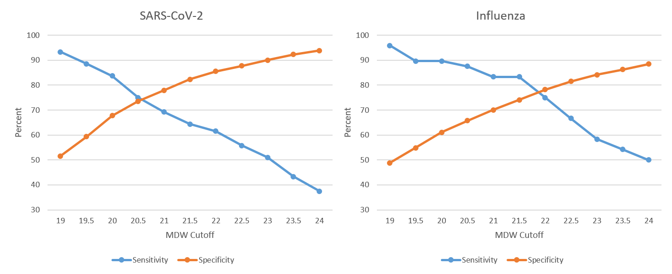
Abbreviations: SARS-CoV-2, severe acute respiratory syndrome coronavirus 2; MDW, monocyte distribution width.

