Supplementary Table 1. Criteria to distinguish narrow funnel-like interaction energy distribution of whole interaction pairs
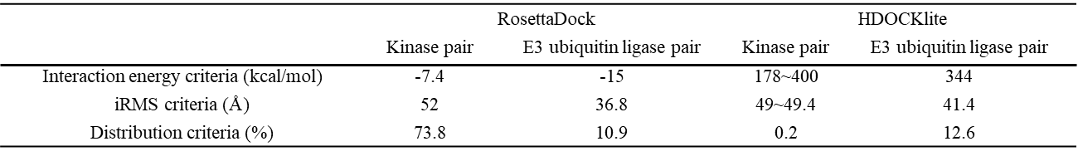

Supplementary Table 2. Criteria to distinguish narrow funnel-like interaction energy distribution of interaction pairs with high-accuracy structure prediction results.
