Supporting Information
Controllable Synthesis of Conjugated Microporous Polymer Films for Ultra-sensitive Detection of Chemical Warfare Agents

Mo et. al.

Supplementary Figures
Supplementary Figure 1. Material design. Synthetic routes of TCz and TCzP. 4-(9H-Carbozol-9-yl) phenylboronic acid purchased by Aladdin. Compound 3,6,11-tribromodibenzo [a,c] phenazine was synthesized according to references¹.

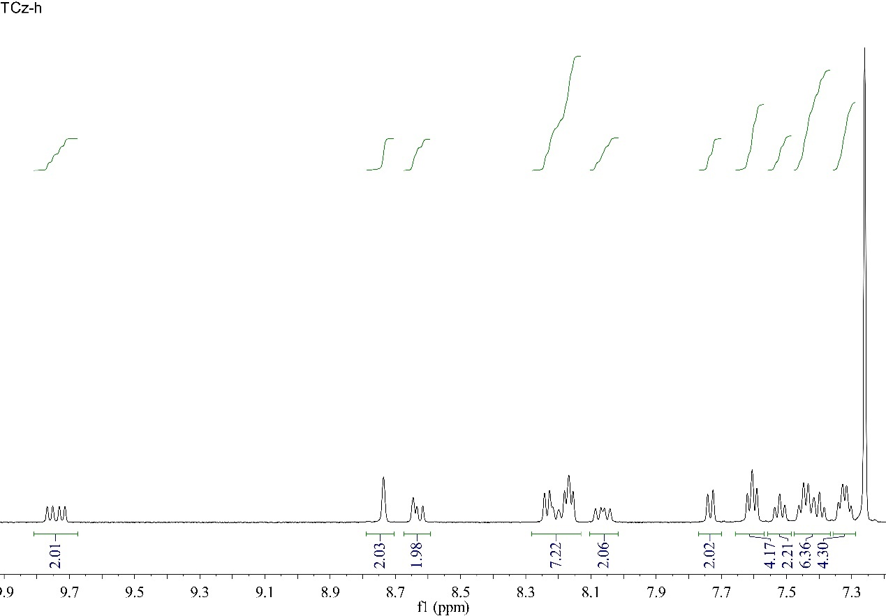
Supplementary Figure 2. ¹H NMR spectra of TCz.

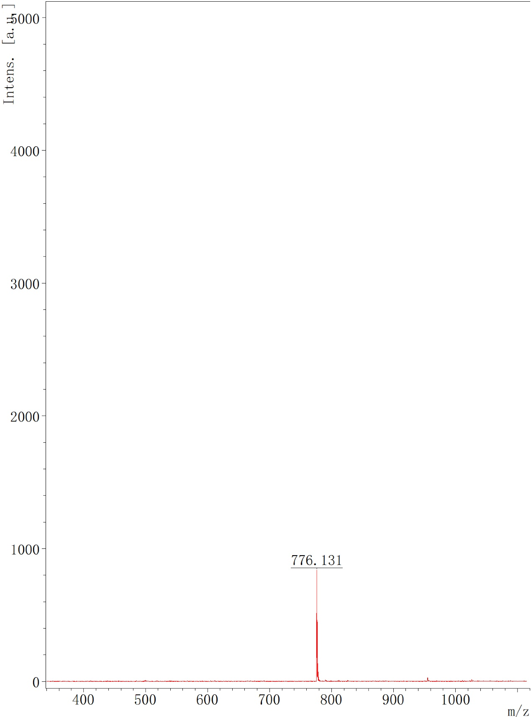
Supplementary Figure 3. MALDI-TOF spectra of TCz.

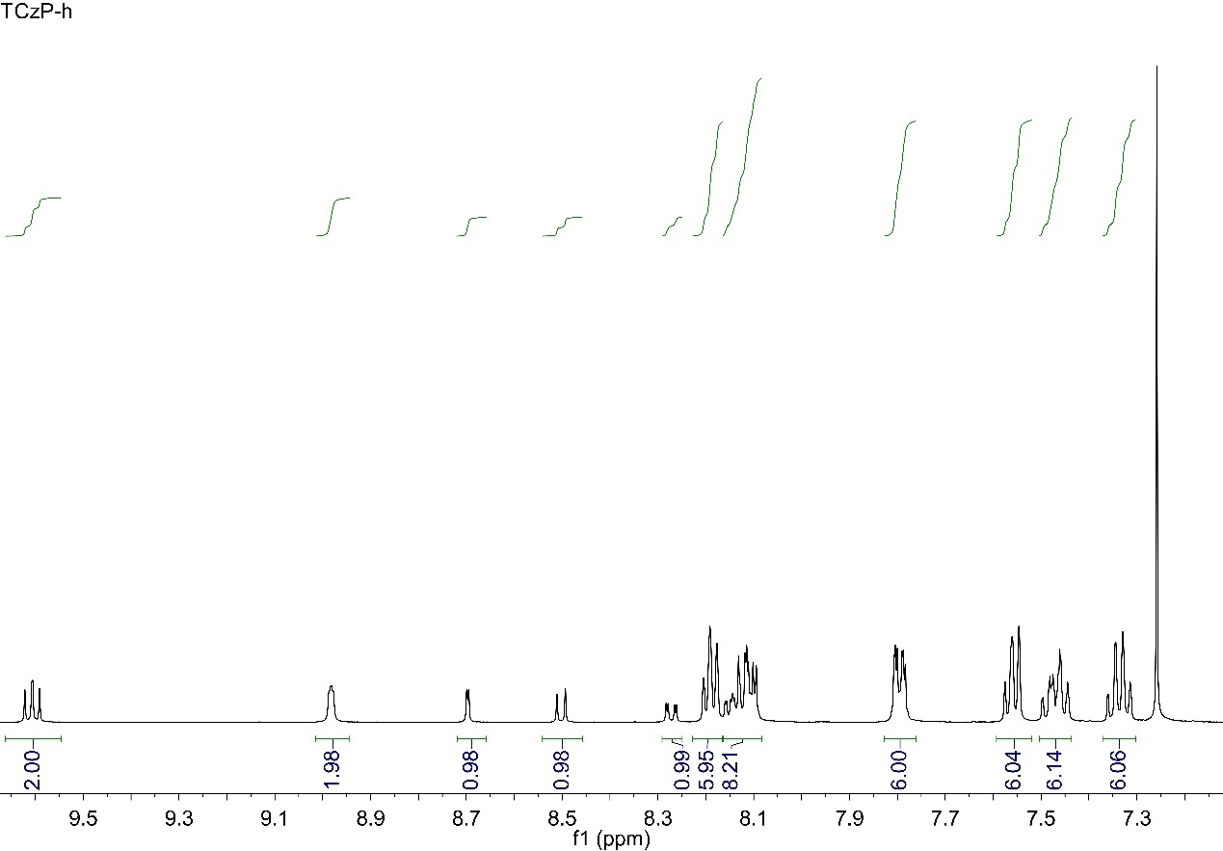
Supplementary Figure 4. ¹H NMR spectra of TCzP.

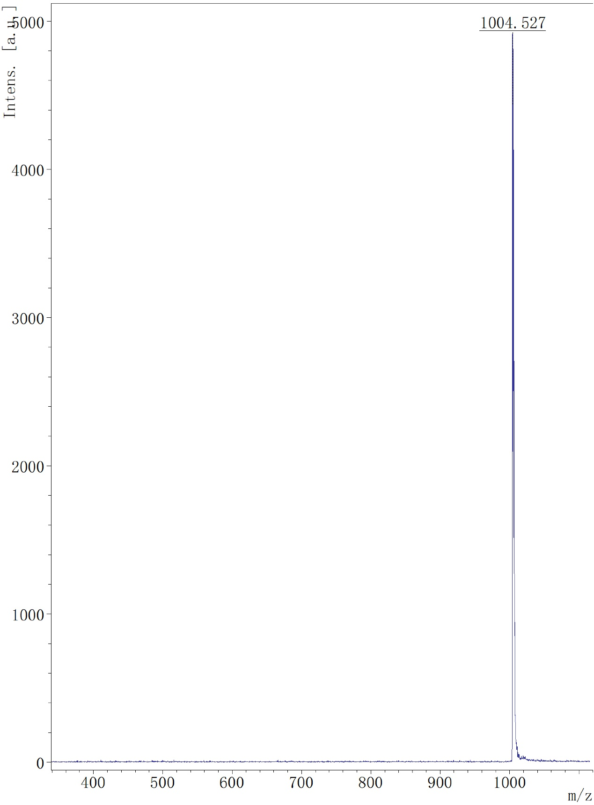
Supplementary Figure 5. MALDI-TOF spectra of TCzP.
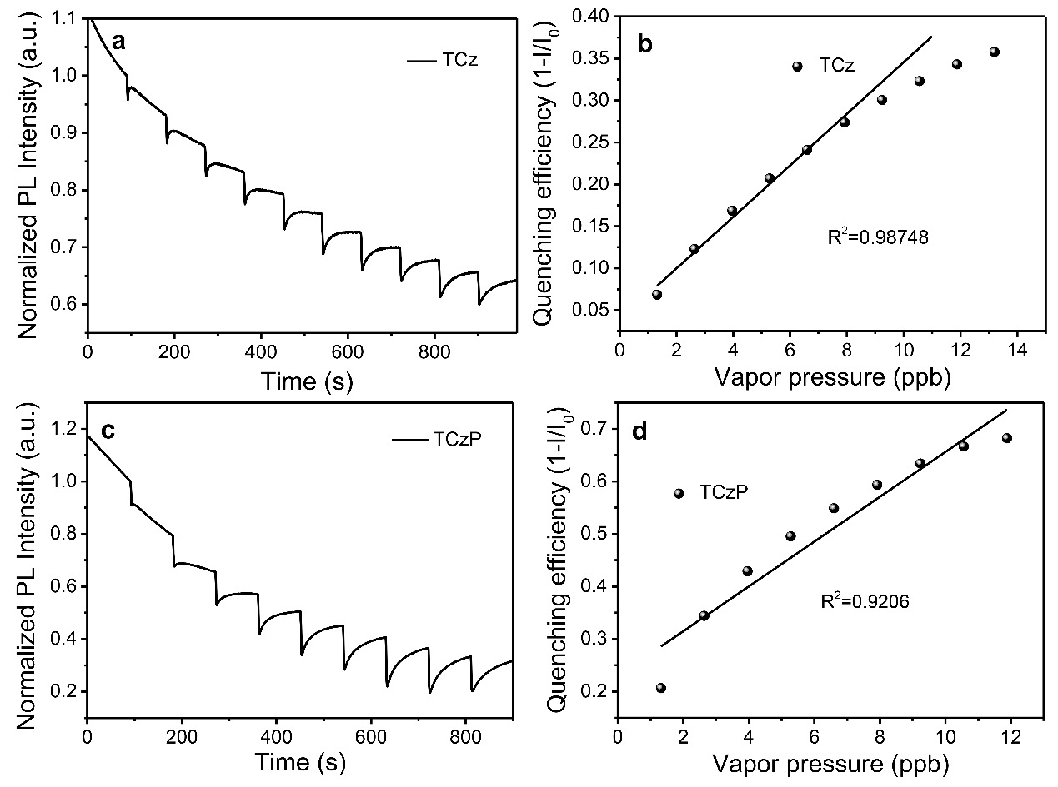
Supplementary Figure 6. Sensing performance of polymer precursors. a Time-dependent fluorescence intensity of TCz spin-coated films to DCP vapors. b The fluorescent intensity of TCz spin-coated films vs the concentration of DCP vapors. c Time-dependent fluorescence intensity of TCzP spin-coated films to DCP vapors. d The fluorescent intensity of TCzP spin-coated films vs the concentration of DCP vapors.

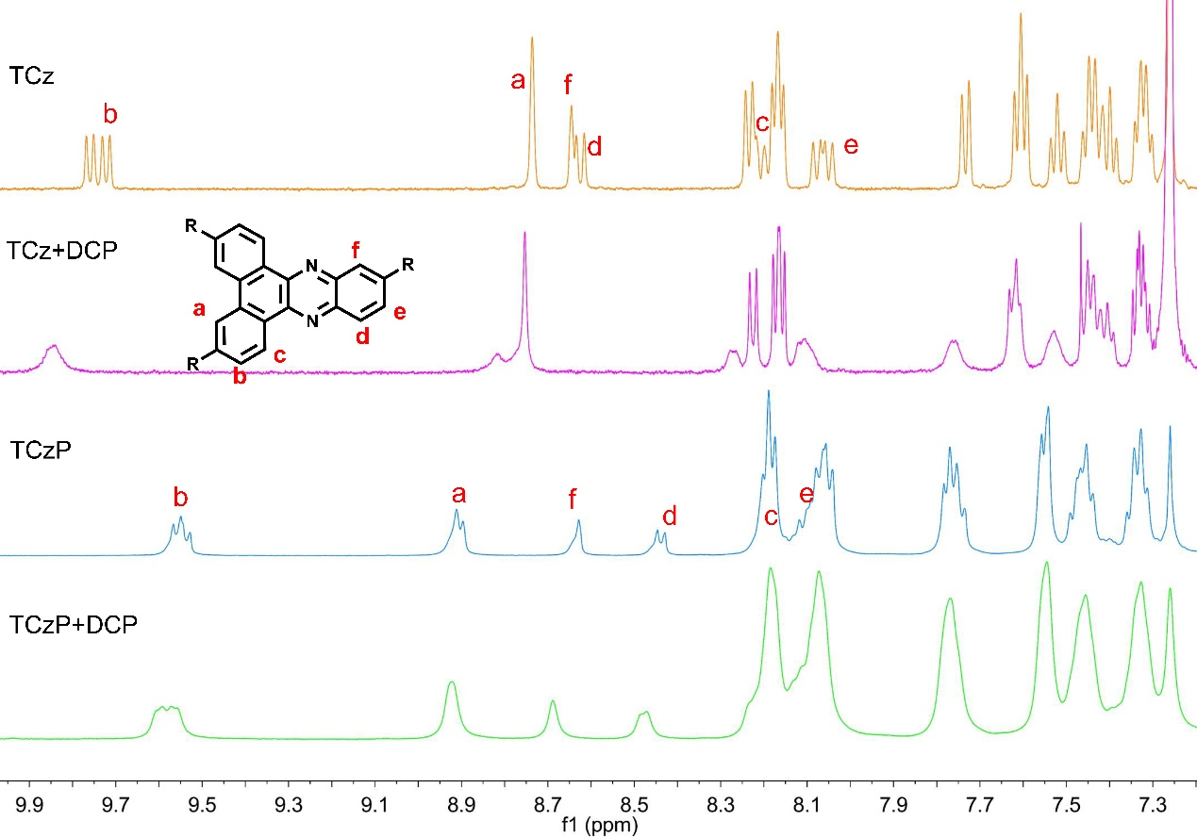
Supplementary Figure 7. ¹H NMR mechanism analysis. a ¹H NMR titration experiments of TCz before and after addition of DCP. b ¹H NMR titration experiments of TCzP before and after addition of DCP.
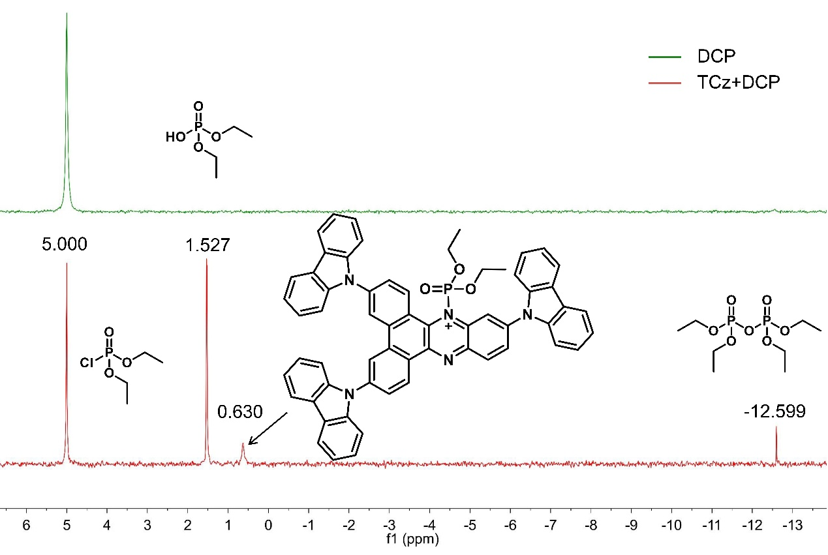
Supplementary Figure 8. ³¹P NMR mechanism analysis. ³¹P NMR titration experiments of DCP before and after addition of TCz.
Supplementary Figure 9. Sensing mechanism.

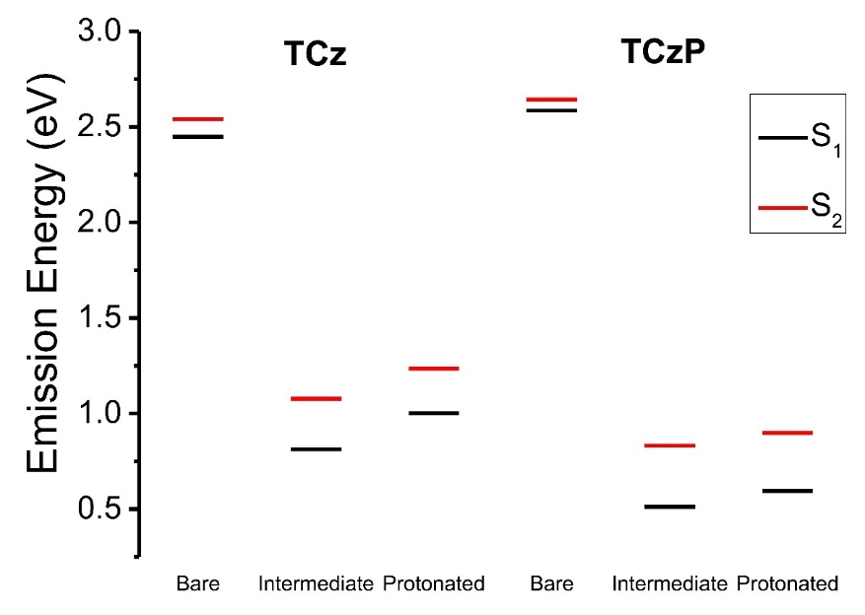
Supplementary Figure 10. Excited state energy. Calculated bared vs protonated emission energy of TCz and TCzP.
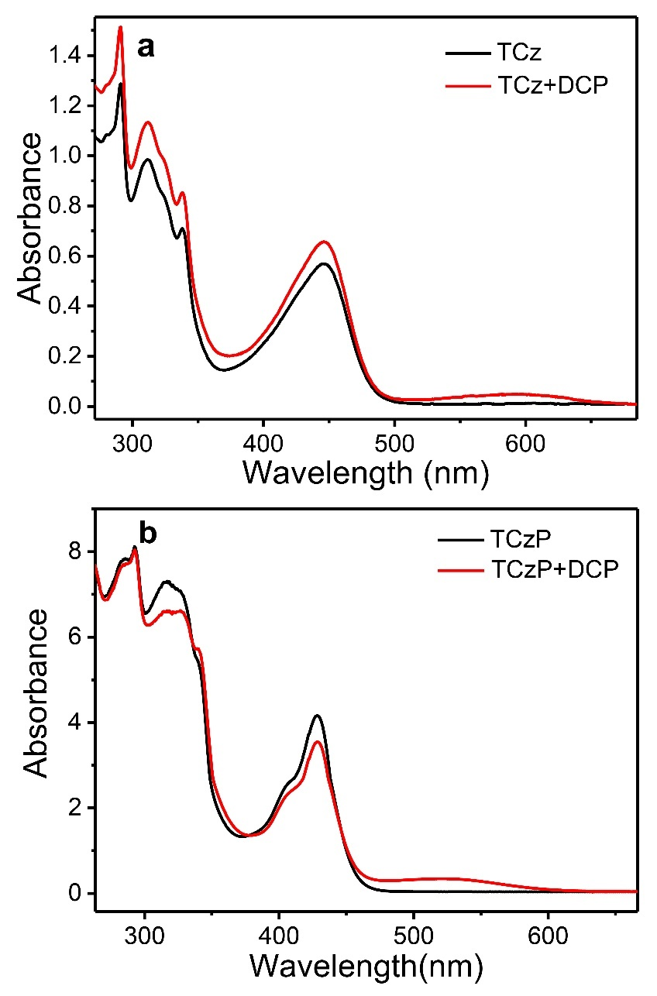
Supplementary Figure 11. Absorption spectrum. UV-Vis absorption spectra of TCz and TCzP before and after adding DCP.

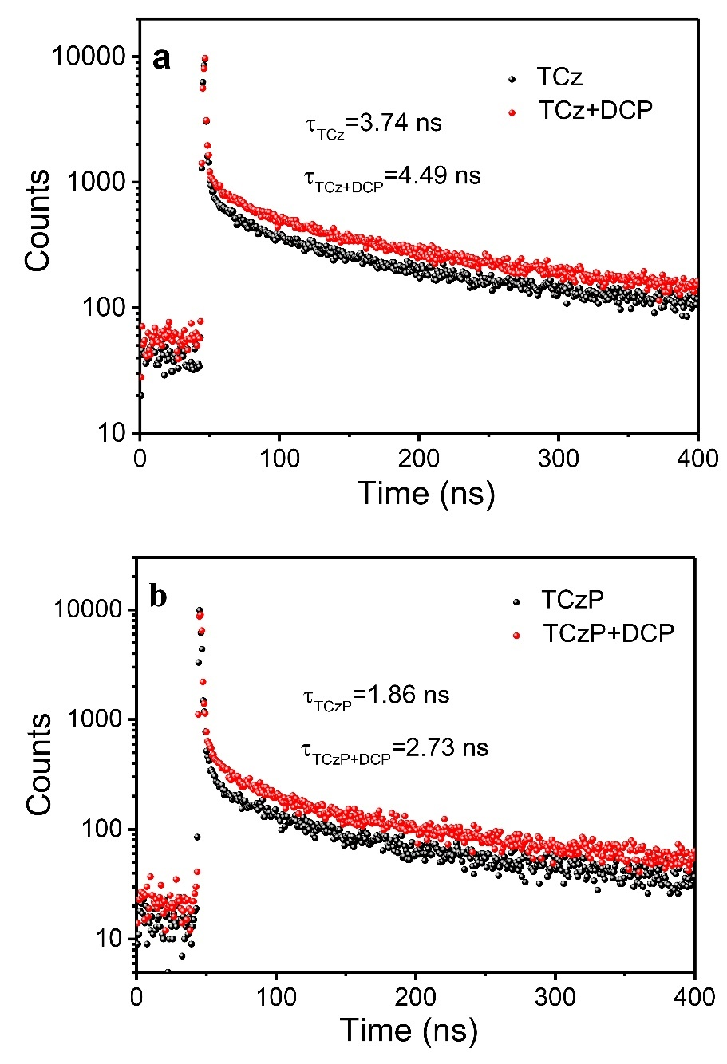
Supplementary Figure 12. Transient PL spectra. Transient PL spectra spin-coated films of TCz and TCzP before and after exposure to DCP vapors.

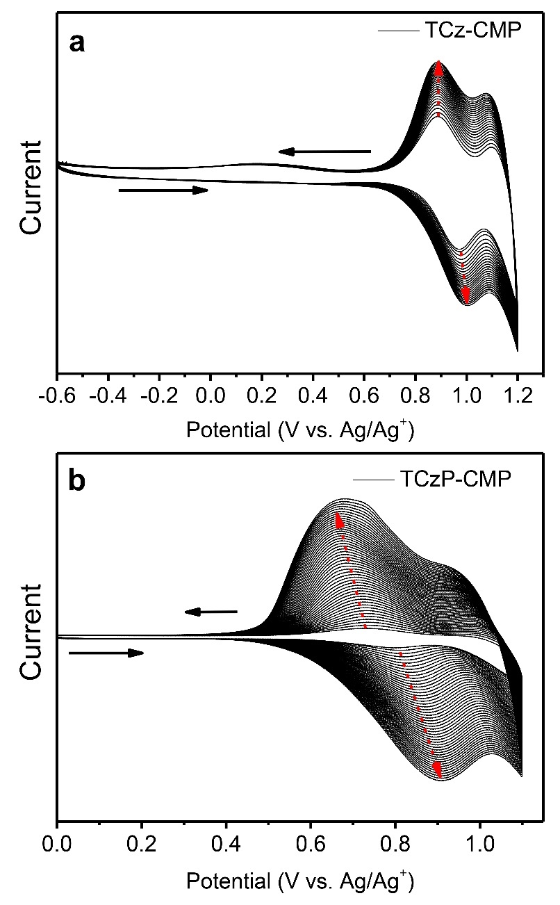
Supplementary Figure 13. Electrochemical polymerization. a Cyclic voltammetry curve for the preparation of TCz-CMPs films. (scanning cycles: 50 cycles; scanning rate: 100 mV/s; scanning potentials: -0.6-1.2 V ) b Cyclic voltammetry curve for the preparation of TCzP-CMPs films. (scanning cycles: 100 cycles; scanning rate: 200 mV/s; scanning potentials: 0-1.1 V )

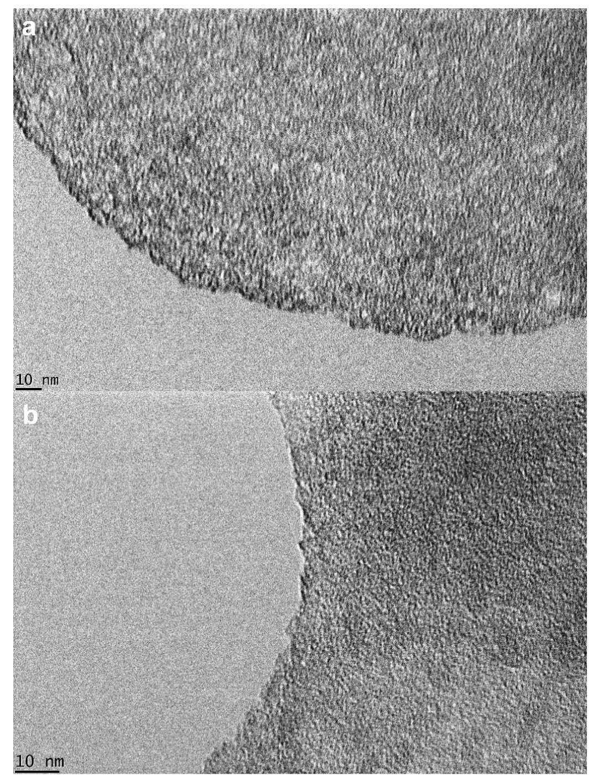
Supplementary Figure 14. TEM images. TEM images of TCz-CMP (a) films and TCzP-CMP (b) films.

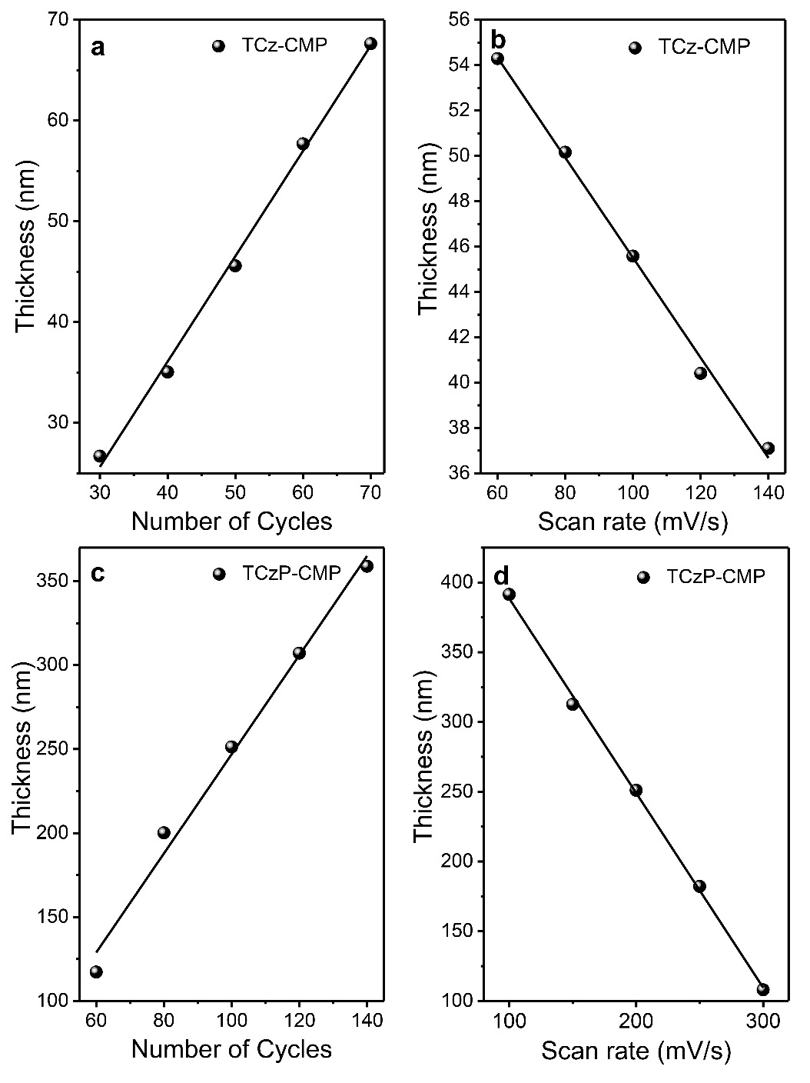
Supplementary Figure 15. The optimization of film thickness. a The linear relationship between the thickness of the TCz-CMP films and the scanning cycles when the scan rate is 100 mV/s. b The thickness of the TCz-CMP films decreases as the scanning rate increases when the scanning cycles is 50 cycles. c The linear relationship between the thickness of the TCzP-CMP films and the scanning cycles when the scan rate is 200 mV/s. d The thickness of the TCzP-CMP film decreases as the scanning rate increases when the scanning cycles is 200 cycles.

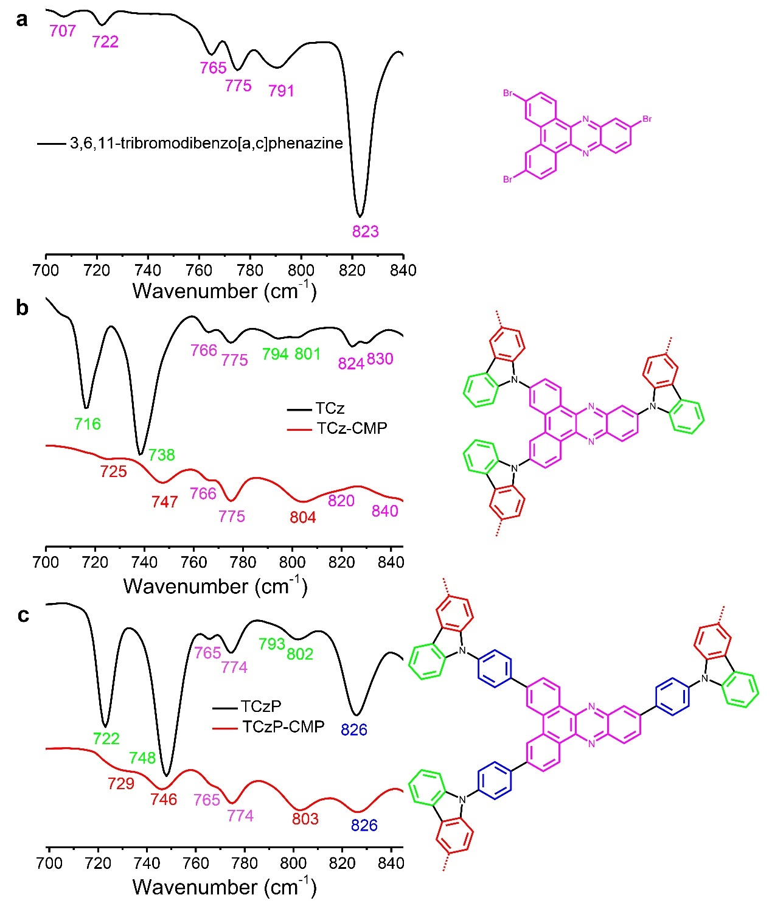
Supplementary Figure 16. FT-IR spectroscopy analysis. a (Left) FT-IR spectrum of 3,6,11-tribromodibenzo [a,c] phenazine and (Right) their peak assignment. b (Left) FT-IR spectrum of TCz-CMP (red curve) and monomer (black curve), and (Right) their peak assignment. c (Left) FT-IR spectrum of TCzP-CMP (red curve) and monomer (black curve), and (Right) their peak assignment.

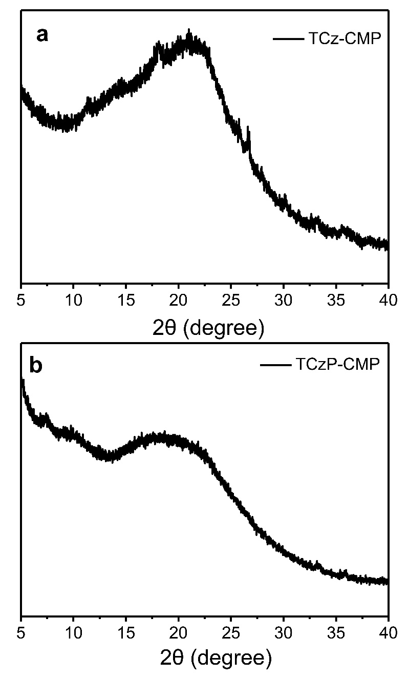
Supplementary Figure 17. XRD pattern of the TCz-CMP and TCzP-CMP. The powder X-ray diffraction (XRD) patterns of TCz-CMP and TCzP-CMP demonstrate a broad and dispersion peak within the 2θ range of 5-40 °.

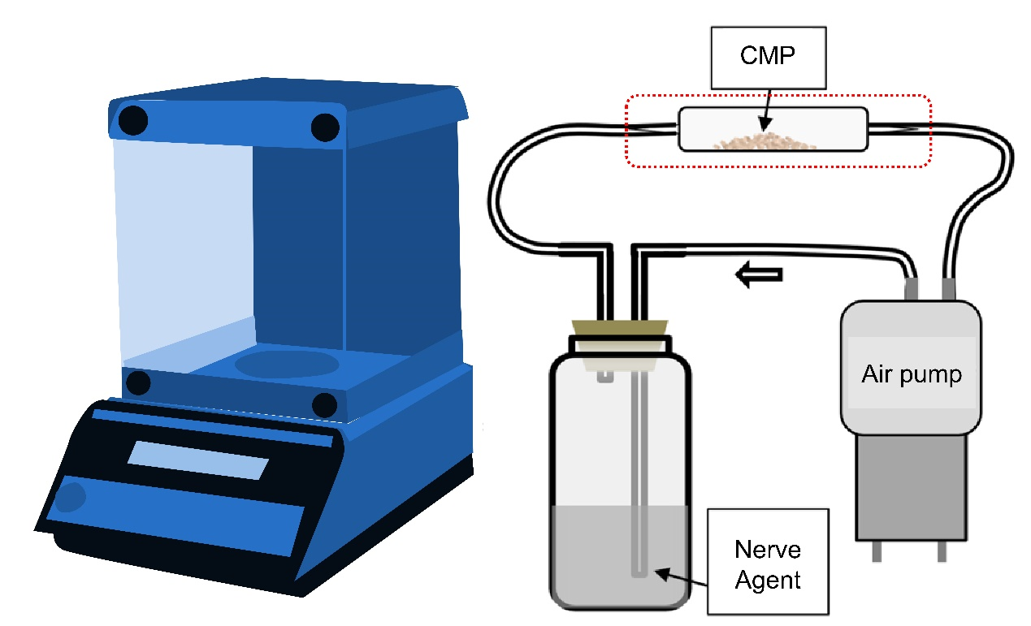
Supplementary Figure 18. Diagram of CMP adsorption test. The part within the red dotted line can be removed for weighing.

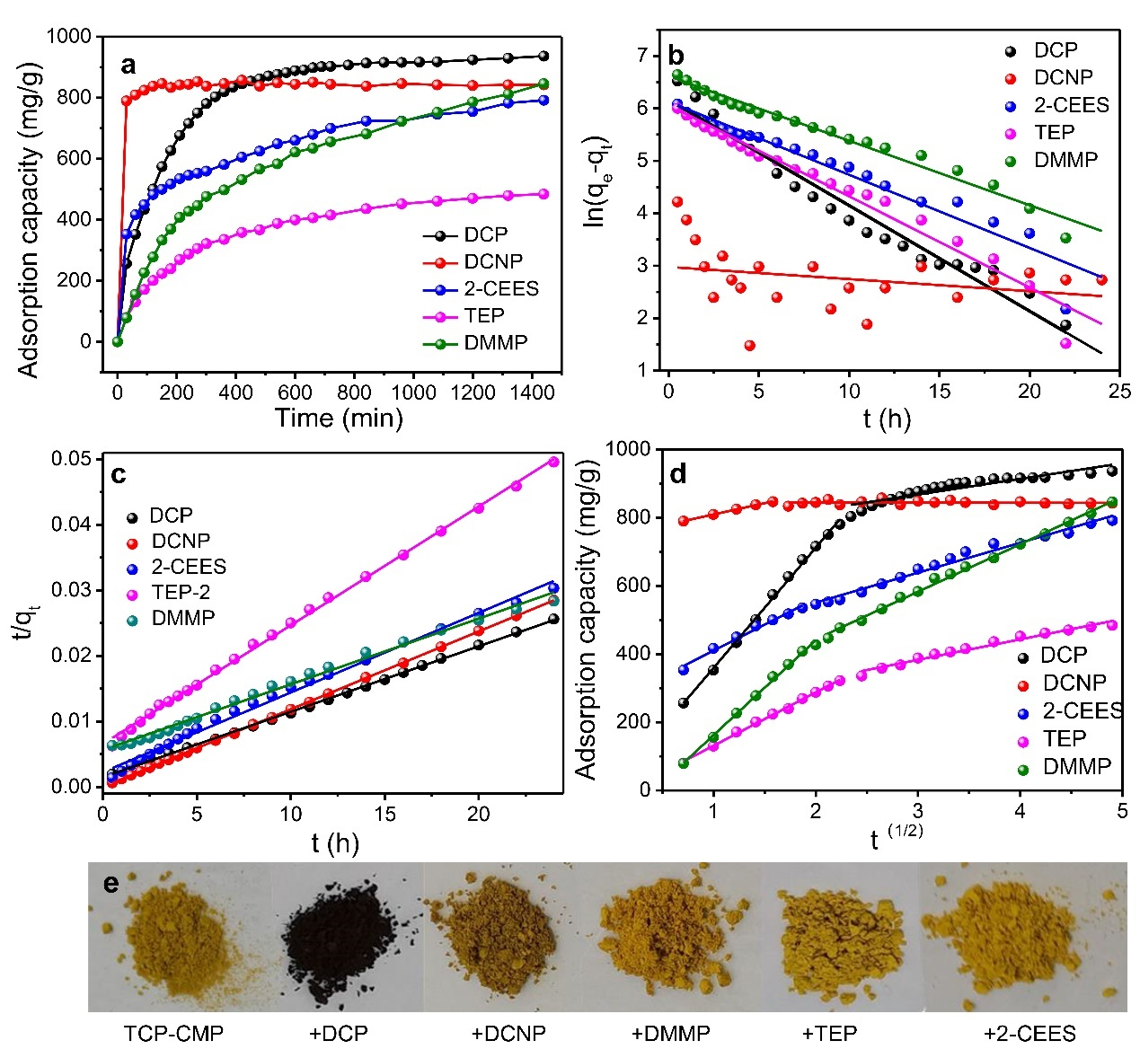
Supplementary Figure 19. CMP adsorption of other toxic agent simulants. a Adsorption kinetics of five chemical warfare agent simulants by TCzP-CMP; b PFO model; c PSO model; d intraparticle diffusion model; e Photos of TCzP-CMP before and after adsorption of five CWA simulants for 24 h.

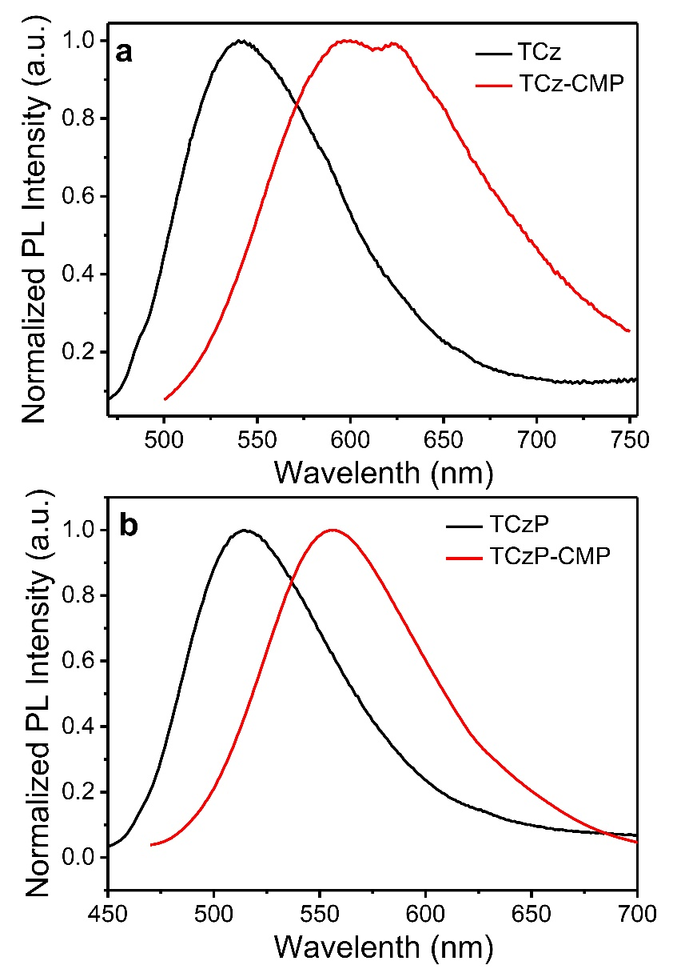
Supplementary Figure 20. The fluorescent properties. Fluorescence spectra of spin-coated films and CMP films based on TCz and TCzP.

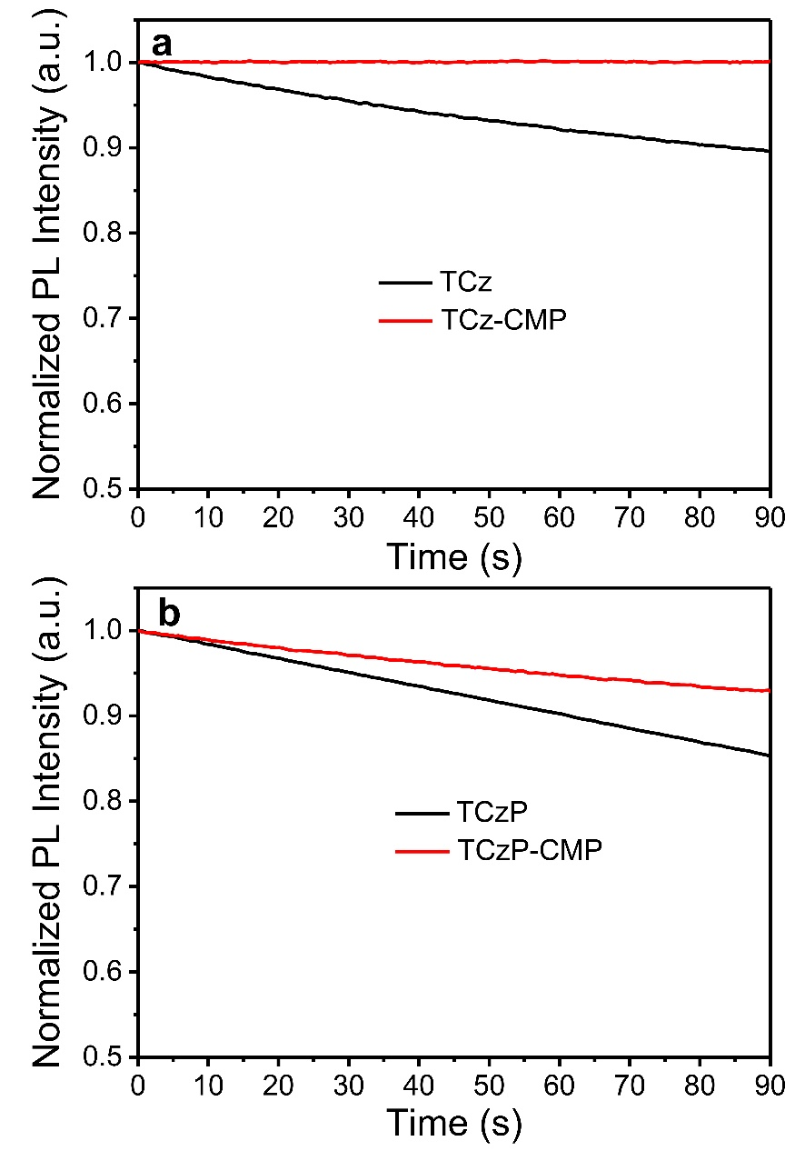
Supplementary Figure 21. Fluorescence intensity of spin-coated films and CMP films based on TCz and TCzP as the function of excitation time.

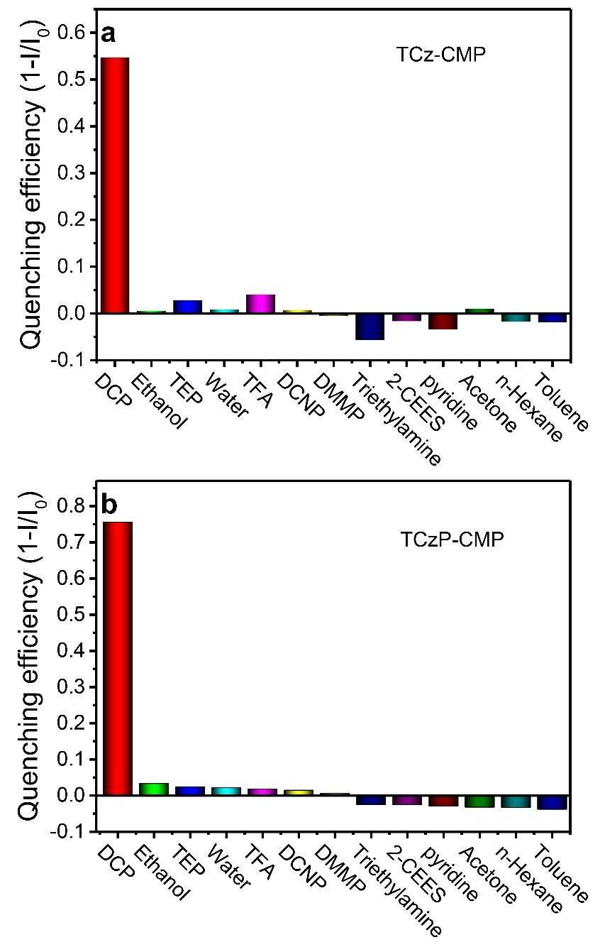
Supplementary Figure 22. Interference test. The quenching efficiency of TCz-CMP and TCzP-CMP films to DCP (1.32 ppm), ethanol (780 ppm), water (32000 ppm), TFA (13 ppm), DCNP (2 ppm), DMMP (200 ppm), triethylamine (1090 ppm), 2-CEES (38 ppm), pyridine (25 ppm), acetone (816 ppm), n-hexane (21 ppm) and toluene (140 ppm) vapors, respectively.

Supplementary Table
Supplementary Table 1. The photoluminescence efficiency, lifetime, radiation and non-radiation transition rate of compounds in four solvents.
Solvents | TCz |  |  |  |  | TCzP
 | η(%)ª | τ^{b} | k_{r}^{c} | k_{nr}^{d} |  | η(%)ª | τ^{b} | k_{r}^{c} | k_{nr}^{d}
n-Hexane | 21.71 | 1.40 | 15.46 | 55.76 |  | 11.42 | 0.56 | 20.46 | 158.69
Isopropyl ether | 27.21 | 1.38 | 19.72 | 52.75 |  | 31.92 | 1.37 | 23.30 | 49.69
Ether | 36.13 | 1.77 | 20.45 | 36.15 |  | 33.99 | 1.55 | 21.99 | 42.70
Dichloromethane | 59.01 | 6.17 | 9.56 | 6.64 |  | 82.50 | 6.03 | 13.67 | 2.90
Acetone | 23.36 | 4.82 | 4.85 | 15.91 |  | 21.98 | 4.67 | 4.68 | 16.60
ª photoluminescence efficiency; ^{b} lifetime (ns); ^{c} radiation transition rate (10⁷ s⁻¹) and ^{d} non-radiative transition rate (10⁷ s⁻¹)

Supplementary Table 2. Solvatochromic UV-PL data for Lippert-Mataga model.
Solvents | $$Δf$$ | TCz |  |  |  | TCzP
 |  | ν_{a} (nm) | ν_{f} (nm) | ν_{a} -ν_{f}  (cm⁻¹) |  | ν_{a} (nm) | ν_{f} (nm) | ν_{a} -ν_{f}  (cm⁻¹)
Hexane | 0.0012 | 453 | 465 | 569.68 |  | 424 | 446 | 1163.38
Triethylamine | 0.048 | 453 | 474 | 978.01 |  | 428 | 451 | 1191.54
Butyl ether | 0.096 | 453 | 484 | 1413.90 |  | 428 | 464 | 1812.76
Isopropyl ether | 0.145 | 451 | 493 | 1888.97 |  | 425 | 459 | 1742.92
Ether | 0.167 | 443 | 502 | 2653.04 |  | 425 | 471 | 2297.99
Ethyl acetate | 0.2 | 443 | 530 | 3705.44 |  | 428 | 506 | 3601.64
Tetrahydrofuran | 0.21 | 446 | 537 | 3799.55 |  | 430 | 522 | 4098.73
Dichloromethane | 0.217 | 445 | 553 | 4388.73 |  | 429 | 548 | 5061.85
Dimethylformamide | 0.276 | 446 | 599 | 5727.03 |  | 434 | 626 | 7067.03376
Acetone | 0.284 | 428 | 579 | 6093.33 |  | 429 | 591 | 6389.55
Acetonitrile | 0.305 | 438 | 595 | 6024.33 |  | 427 | 636 | 7695.93

Supplementary Table 3. Summary of the reported LOD of DCP from previous work.
Sensing Materials | LOD | Solution (S) or Vapor (V) | Reference
TCz | 1.32 ppb | V | This work
TCzP | 1.32 ppb | V | This work
TCz-CMP | 132 ppt | V | This work
TCzP-CMP | 13.2 ppt | V | This work
TPA-9AC | 0.15 ppb | V | ²
B1-SBA | 15 μg/m³ | V | ³
P1 | 2 ppm | V | ⁴
1D PC | 4 ppm | V | ⁵
Sample 1 | 15 ppb | V | ⁶
Sample 1 | 4 ppb | V | ⁷
Sample 1-2 | 8 ppb | V | ⁸
TPOD | 0.14 μM | V | ⁹
DPA-TPE-Py | 1.82 ppb | V | ¹⁰
PTS | 10.4 nM | V/S | ¹¹
TBPY-TPA | 2.6 ppb | V | ¹²
Sample 2 | 0.14 ppb | V | ¹³
TOP-I | 1.2 ppb | V | ¹⁴
PAC-1 | 28 ppb | V | ¹⁵
PY-0PD | -- | V | ¹⁶
FLA | 13 ppm | V | ¹⁷
T1 | 0.8 ppb | V | ¹⁸
BT-OH | 0.186 μM | S/V | ¹⁹
P1 | 2.3 nM/0.7 ppb | S/V | ²⁰
TPIM | 10⁻⁸ M | S/V | ²¹
NA570 | 5 μM | S | ²²
Sample 3 | 8 nM | S/V | ²³
CYD | 18.86 nM | S | ²⁴
PDAC | 88 nM | S | ²⁵
FLA | 1 μM | S | ²⁶
Sample 8 | 2.6 μM | S | ²⁷
RB-AE | 25 ppm | S | ²⁸
S-I-SBA | 90.8 pM | S | ²⁹
RDS | 9.66×10⁻⁹ M | S | ³⁰
PQ | 7 ppm | S | ³¹
AIL-4 | 131.5 ppb | S | ³²
Sample 1 | 0.17 ppm | S | ³³
AQmol-1 | 0.18 μM | S | ³⁴
AQmol-2 | 0.16 μM | S | ³⁴
Sample 1 | 1.87 ppb | S | ³⁵
CoumNMe₂ | 4.4 × 10⁻⁸ M | S | ³⁶
B–SAL–OXIME | 900 μM | S | ³⁷
Sample 2 | 1.72 μM | S | ³⁸
Sample 1 | 0.065 μM | S | ³⁹
Sample 2 | 2.1μM | S | ³⁹
NA-p3 | 21 nM | S | ⁴⁰
m-Py-BOD | 3.36 μM | S | ⁴¹
probe 1 | 0.136 nM | S | ⁴²

Supplementary Table 4. Kinetic parameters of pseudo-first and pseudo-secondary models of TCz-CMP and TCzP-CMP adsorption of CAW simulants.
Material | Compound | q_{e,exp} | PSO |  |  |  | PFO
 |  |  | q_{e,cal} | K₂ | R² |  | q_{e,cal} | K₁ | R²
TCz-CMP | DCP | 78.38 | 81.77 | 0.0118 | 0.99583 |  | 78.87 | 0.1336 | 0.79041
TCzP-CMP | DCP | 936.23 | 976.46 | 0.000993 | 0.99869 |  | 942.75 | 0.2072 | 0.9558
 | DCNP | 842.13 | 875.80 | 0.00119 | 0.99994 |  | 1978.76 | 0.0231 | 0.0321
 | 2-CEES | 791.69 | 824.48 | 0.00122 | 0.99345 |  | 820.53 | 0.1395 | 0.93351
 | TEP-2 | 484.02 | 506.04 | 0.00181 | 0.99332 |  | 491.57 | 0.174 | 0.968
 | DMMP | 846.13 | 885.93 | 0.001 | 0.9986 |  | 892.88 | 0.1229 | 0.975

Supplementary Table 5. Intra-particle diffusion model parameters of TCz-CMP and TCzP-CMP adsorption of CAW simulants.
Material | Compound | Step1 |  |  |  | Step2
 |  | C₁ | K_{P1} | $$R_{P1}^{2}$$ |  | C₂ | K_{P2} | $$R_{P2}^{2}$$
TCz-CMP | DCP | 26.9 | 15.46605 | 0.97522 |  | 73.11561 | 1.25088 | 0.46339
TCzP-CMP | DCP | 6.13123 | 325.8426 | 0.99745 |  | 729.8359 | 45.97253 | 0.84481
 | 2-CEES | 256.9983 | 152.7323 | 0.9809 |  | 375.3993 | 87.73788 | 0.98036
 | DCNP | 743.131 | 66.12067 | 0.99811 |  | 845.8885 | -0.44201 | -0.0566
 | TEP | -25.79 | 156.6325 | 0.9974 |  | 203.1599 | 59.96823 | 0.97245
 | DMMP | -116.544 | 278.3988 | 0.9964 |  | 164.3157 | 139.4644 | 0.99611

Supplementary Table 6. The adsorption capacity of TCzP-CMP and activated carbon on CAW simulants.
Material | Adsorption capacity (mg/g)
 | DCP | DCNP | DMMP | TEP | 2-CEES
Activated carbon | 319.8103 | 253.012 | 475.64 | 283 | 455.2846
TCzP-CMP | 936.2263 | 842.1272 | 846.1325 | 484.0183 | 791.6886

Supplementary Notes
Supplementary Note 1. Chemicals and measurement. All the reagents were obtained from Aldrich, Kanto Chemicals and TCL unless otherwise specified. Unless otherwise specified, all reagents are used directly after purchase. Dry toluene is obtained by adding metallic sodium to toluene and refluxing for 8 h. All chromatographic separations were performed on silica gel (200-300 mesh). The ¹H NMR and ³¹P NMR were recorded on a Bruker AVANCE III HD spectrometer at 500 MHz, using CDCl₃ as the solvent at 298 K. The MALDI-TOF-MS mass spectra are recorded using an AXIMA-CFRTM plus instrument. UV-vis absorption spectra are recorded on an Agilent Cary100 spectrophotometer. Fluorescent spectra are measured with a Shimadzu RF-6000. The absolute quantum efficiency is measured by HORIBA QM8000 spectrometer. Lifetimes are measured with a FLS-980 on an EPL-375 optical laser. The CMP film thickness is recorded on Bruker Countor GT K &, KLA-Tencor D120 step profiler. Fourier transform Infrared (FT-IR) spectra were recorded on a PerkinElmer Spectrum 400 infrared spectrometer. X-ray powder diffraction (XRD) patterns (PANalytical B.V. X, Pert3 Powder diffractometer). The morphology of the CMP film was photographed on a transmission electron microscope (JEOL JEM-2100).
Supplementary Note 2. Radiation form calculation. According to the following formulas, the radiative and non-radiative transition rates of the compound in various states are obtained⁴³:
$$\begin{aligned}k_{r}=\frac{Φ_{f}}{τ}\#（S1）\end{aligned}$$
$$\begin{aligned}Φ_{f}=\frac{k_{r}}{k_{r}+k_{nr}}\#\left(S2\right)\end{aligned}$$
Where Φ_{f} is the luminous efficiency, τ is the lifetime, k_{r} is the radiative transition rate, and k_{nr} is the non-radiative transition rate.
Supplementary Note 3. Solvatochromic UV-PL data for Lippert-Mataga model. The following Lippert-Mataga solvation model was used in the experiment⁴⁴:
$$\begin{aligned}hc\left({\text{ν}}_{\text{a}}-ν_{f}\right)=hc\left({\text{ν}}_{a}^{0}-{\text{ν}}_{f}^{0}\right)+\frac{2{\left(μ_{e}-μ_{g}\right)}^{2}}{a_{0}^{3}}f\left(ε,n\right)\#\left(S3\right)\end{aligned}$$
Where h is the Planck constant; $(ν_{a}-ν_{f})$ is the Stokes shift; $(ν_{a}^{0}-ν_{f}^{0})$ is the Stokes shift when the polarity factor f=0; is the polarity factor of the solvent, which is related to the vacuum dielectric constant ε and the refractive index n,$f=\frac{ε-1}{2ε+1}+\frac{n^{2}-1}{{2n}^{2}+1}$; $a_{0}$ is the Angsag radius of the molecule, $a_{0}=({\frac{3M}{4Nπd})}^{1/3}$,where M is the molar mass of the molecule, N is the Avogadro constant, d is the relative density of the solvent, π is the circumference of the circle, μ_{e} and μ_{g} are the dipoles of the excited state and ground state, respectively Moment. By drawing the slope of the Stokes shift and the solvent polarity factor, the dipole moment of the excited state can be calculated.

Supplementary Note 4. Nitrogen adsorption/desorption measurements. Nitrogen adsorption/desorption measurements were performed on an ASAP 2020 plus at 77 K. The CMP samples were degassed under vacuum at 110 ℃ for 12 h before measurements. The Brunauer-Emmet-Teller (BET) surface area of CMP films can be calculated based on the adsorption-desorption isotherms. The pore-size distribution profile was obtained by the nonlocal density functional theory (NL-DFT) method.
The bulky samples were obtained by chemical oxidation with ferrous (III) chloride⁴⁵. The fluorescent material (TCz or TCzP) monomer was dissolved in the chloroform solution, and then added dropwise to the chloroform suspension containing ferric chloride. After stirring for 48 h, the insoluble solid was filtered and purified by methanol using a Soxhlet extractor for 24 h. The resulting powder yields were 53% (TCz-CMP) and 79% (TCzP-CMP).

Supplementary Note 5. Fluorescence detection of DCP vapors. 2 mL DCP was injected into a 40 mL jar, and sealed the jar for 48 h at 25 ℃. Then, a small amount of saturated DCP vapors was diluted to obtain different concentrations of DCP vapors.

Supplementary Note 6. Theoretical Calculations. The density functional theory (DFT) calculations and the natural transition orbit (NTO) analysis are carried out using a Gaussian 09 D.01 Package. The ground state conformations are optimized using opt/rb3lyp/6-31 g (d, p) method, and the excited state properties are calculated using td-b3lyp/6-31 g (d, p) method.

Supplementary Note 7. Preparation of spin-coated films. The spin-coated films were prepared by a KW-4A spin-coating. TCz (5×10⁻⁵ M) or TCzP (4×10⁻⁴ M) solution was dropped on the quartz glass plate, and setting the rotation speed of the spin coater to 3000 r/min, and the rotation time is 15 s. The obtained spin-coated film was then dried in a vacuum drying oven for 1 h.

Supplementary References:
1. Shaikh AM, Sharma BK, Chacko S, Kamble RM. Novel electroluminescent donor–acceptors based on dibenzo[a,c]phenazine as hole-transporting materials for organic electronics. New J. Chem. 41, 628-638 (2017).

2. Li X, et al. Visualization of Ultrasensitive and Recyclable Dual-Channel Fluorescence Sensors for Chemical Warfare Agents Based on the State Dehybridization of Hybrid Locally Excited and Charge Transfer Materials. Anal. Chem. 91, 10927-10931 (2019).

3. Climent E, et al. A Rapid and Sensitive Strip-Based Quick Test for Nerve Agents Tabun, Sarin, and Soman Using BODIPY-Modified Silica Materials. Chem. - Eur. J. 22, 11138-11142 (2016).

4. Annisa TN, Jung S-H, Gupta M, Bae Jy, Park JM, Lee H-i. A Reusable Polymeric Film for the Alternating Colorimetric Detection of a Nerve Agent Mimic and Ammonia Vapor with Sub-Parts-per-Million Sensitivity. ACS Appl. Mater.Interfaces 12, 11055-11062 (2020).

5. Jung S-H, et al. Chromophore-Free photonic multilayer films for the ultra-sensitive colorimetric detection of nerve agent mimics in the vapor phase. Sens. Actuators, B 323, 128698 (2020).

6. Liu X, et al. Sensitive Detection of a Nerve-Agent Simulant through Retightening Internanofiber Binding for Fluorescence Enhancement. Anal. Chem. 90, 1498-1501 (2018).

7. Sun C, et al. Fast and Ultrasensitive Detection of a Nerve Agent Simulant Using Carbazole-Based Nanofibers with Amplified Ratiometric Fluorescence Responses. Anal. Chem. 90, 7131-7134 (2018).

8. Xiong W, Gong Y, Che Y, Zhao J. Sensitive Discrimination of Nerve Agent and Sulfur Mustard Simulants Using Fluorescent Coassembled Nanofibers with Förster Resonance Energy Transfer-Enhanced Photostability and Emission. Anal. Chem. 91, 1711-1714 (2019).

9. Kammer M, et al. Rapid quantification of two chemical nerve agent metabolites in serum. Biosens. Bioelectron. 131, 119-127 (2019).

10. Huang S, Wu Y, Zeng F, Sun L, Wu S. Handy ratiometric detection of gaseous nerve agents with AIE-fluorophore-based solid test strips. J. Mater. Chem. C 4, 10105-10110 (2016).

11. Huo B, et al. “Covalent-Assembly”-Based Fluorescent Probe for Detection of a Nerve-Agent Mimic (DCP) via Lossen Rearrangement. Anal. Chem. 91, 10979-10983 (2019).

12. Yao J, et al. Concise and Efficient Fluorescent Probe via an Intromolecular Charge Transfer for the Chemical Warfare Agent Mimic Diethylchlorophosphate Vapor Detection. Anal. Chem. 88, 2497-2501 (2016).

13. Fu Y, et al. Simple and Efficient Chromophoric-Fluorogenic Probes for Diethylchlorophosphate Vapor. ACS Sens. 3, 1445-1450 (2018).

14. Xu W, et al. Aggregation State Reactivity Activation of Intramolecular Charge Transfer Type Fluorescent Probe and Application in Trace Vapor Detection of Sarin Mimics. ACS Sens. 1, 1054-1059 (2016).

15. Zhu R, Azzarelli JM, Swager TM. Wireless Hazard Badges to Detect Nerve-Agent. Angew. Chem. Int. Ed. 55, 9662-9666 (2016).

16. Zhou X, Zeng Y, Liyan C, Wu X, Yoon J. A Fluorescent Sensor for Dual-Channel Discrimination between Phosgene and a Nerve-Gas Mimic. Angew.Chem. Int. Ed. 55, 4729-4733 (2016).

17. Bencic-Nagale S, Sternfeld T, Walt DR. Microbead Chemical Switches: An Approach to Detection of Reactive Organophosphate Chemical Warfare Agent Vapors. J. Am. Ceram. Soc. 128, 5041-5048 (2006).

18. Zheng P, et al. A simple organic multi-analyte fluorescent prober: One molecule realizes the detection to DNT, TATP and Sarin substitute gas. J. Hazard. Mater., 124500 (2020).

19. Hu X, Zeng H, Chen T, Yuan H-Q, Zeng L, Bao G-M. Fast and visual detection of a chemical warfare agent mimic using a simple, effective and portable chemodosimeter. Sens. Actuators, B 319, 128282 (2020).

20. Zheng P, Abdurahman A, Liu G, Liu H, Zhang Y, Zhang M. An instantaneously-responded, ultrasensitive, reutilizable fluorescent probe to sarin substitute both in solution and in gas phase. Sens. Actuators, B 322, 128611 (2020).

21. Aich K, Das S, Gharami S, Patra L, Kumar Mondal T. Triphenylamine–benzimidazole based switch offers reliable detection of organophosphorus nerve agent (DCP) both in solution and gaseous state. New J. Chem. 41, 12562-12568 (2017).

22. Lei Z, Yang Y. A Concise Colorimetric and Fluorimetric Probe for Sarin Related Threats Designed via the “Covalent-Assembly” Approach. J. Am. Ceram. Soc. 136, 6594-6597 (2014).

23. Cai Y-C, Li C, Song Q-H. Fluorescent Chemosensors with Varying Degrees of Intramolecular Charge Transfer for Detection of a Nerve Agent Mimic in Solutions and in Vapor. ACS Sens. 2, 834-841 (2017).

24. Ali SS, et al. A chromogenic and ratiometric fluorogenic probe for rapid detection of a nerve agent simulant DCP based on a hybrid hydroxynaphthalene-hemicyanine dye. Org. Biomol. Chem. 15, 5959-5967 (2017).

25. Zeng L, Zeng H, Jiang L, Wang S, Hou J-T, Yoon J. A Single Fluorescent Chemosensor for Simultaneous Discriminative Detection of Gaseous Phosgene and a Nerve Agent Mimic. Anal. Chem. 91, 12070-12076 (2019).

26. Singh VV, et al. Micromotor-based on–off fluorescence detection of sarin and soman simulants. Chem. Commun. 51, 11190-11193 (2015).

27. Wild A, Winter A, Hager MD, Schubert US. Fluorometric, water-based sensors for the detection of nerve gas G mimics DMMP, DCP and DCNP. Chem. Commun. 48, 964-966 (2012).

28. Wu X, Wu Z, Han S. Chromogenic and fluorogenic detection of a nerve agent simulant with a rhodamine-deoxylactam based sensor. Chem. Commun. 47, 11468-11470 (2011).

29. Climent E, et al. Determination of the chemical warfare agents Sarin, Soman and Tabun in natural waters employing fluorescent hybrid silica materials. Sens. Actuators, B 246, 1056-1065 (2017).

30. Heo G, Manivannan R, Kim H, Son Y-A. Liquid and gaseous state visual detection of chemical warfare agent mimic DCP by optical sensor. Dyes Pigm. 171, 107712 (2019).

31. Jo S, Kim D, Son S-H, Kim Y, Lee TS. Conjugated Poly(fluorene-quinoxaline) for Fluorescence Imaging and Chemical Detection of Nerve Agents with Its Paper-Based Strip. ACS Appl. Mater. Interfaces 6, 1330-1336 (2014).

32. Chen C-Y, Li K-H, Chu Y-H. Reaction-Based Detection of Chemical Warfare Agent Mimics with Affinity Ionic Liquids. Anal. Chem. 90, 8320-8325 (2018).

33. Xuan W, Cao Y, Zhou J, Wang W. A FRET-based ratiometric fluorescent and colorimetric probe for the facile detection of organophosphonate nerve agent mimic DCP. Chem. Commun. 49, 10474-10476 (2013).

34. Dagnaw FW, Feng W, Song Q-H. Selective and rapid detection of nerve agent simulants by polymer fibers with a fluorescent chemosensor in gas phase. Sens. Actuators, B 318, 127937 (2020).

35. Lu Z, Fan W, Shi X, Black CA, Fan C, Wang F. A highly specific BODIPY-based fluorescent probe for the detection of nerve-agent simulants. Sens. Actuators, B 255, 176-182 (2018).

36. Jang YJ, Mulay SV, Kim Y, Jorayev P, Churchill DG. Nerve agent simulant diethyl chlorophosphate detection using a cyclization reaction approach with high stokes shift system. New J. Chem. 41, 1653-1658 (2017).

37. Jang YJ, Tsay OG, Murale DP, Jeong JA, Segev A, Churchill DG. Novel and selective detection of Tabun mimics. Chem. Commun. 50, 7531-7534 (2014).

38. Singh N, et al. Exploration of fluorescent organotin compounds of alpha-amino acid Schiff bases for the detection of organophosphorous chemical warfare agents: quantification of diethylchlorophosphate. New J. Chem. 42, 8756-8764 (2018).

39. Khan MSJ, Wang Y-W, Senge MO, Peng Y. Sensitive fluorescence on-off probes for the fast detection of a chemical warfare agent mimic. J. Hazard. Mater. 342, 10-19 (2018).

40. Cai Y-C, Li C, Song Q-H. Selective and visual detection of a nerve agent mimic by phosphorylation and protonation of quinolin oximes. J Mater Chem C 5, 7337-7343 (2017).

41. Kim Y, Jang YJ, Lee D, Kim B-S, Churchill DG. Real nerve agent study assessing pyridyl reactivity: Selective fluorogenic and colorimetric detection of Soman and simulant. Sens. Actuators, B 238, 145-149 (2017).

42. Hu X-X, Su Y-T, Ma Y-W, Zhan X-Q, Zheng H, Jiang Y-B. A near infrared colorimetric and fluorometric probe for organophosphorus nerve agent mimics by intramolecular amidation. Chem. Commun. 51, 15118-15121 (2015).

43. Zhou C, et al. Isomerization effect of triphenylamine-acridine derivatives on excited-state modification, photophysical property and electroluminescence performance. Dyes Pigm. 146, 558-566 (2017).

44. Zhang S, et al. Achieving a Significantly Increased Efficiency in Nondoped Pure Blue Fluorescent OLED: A Quasi-Equivalent Hybridized Excited State. Adv. Funct. Mater. 25, 1755-1762 (2015).

45. Liu H, et al. Dendrimer-Based, High-Luminescence Conjugated Microporous Polymer Films for Highly Sensitive and Selective Volatile Organic Compound Sensor Arrays. Adv. Funct. Mater. 30, 1910275 (2020).

