Extended Data Fig. 1 | high-quality genomes of I. verum and A. gramineus.
a, Chromosome-level assembly of the I. verum genome using Hi-C technology. b, c, Chromosome-level assembly of the A. gramineus genome using Hi-C technology. d, Morphological characteristics of A. gramineus: schematic representations of (a) aerial parts; (b) cross section of spadix; spadices; (d) spadices with pseudo-spathe; (e) leaves.
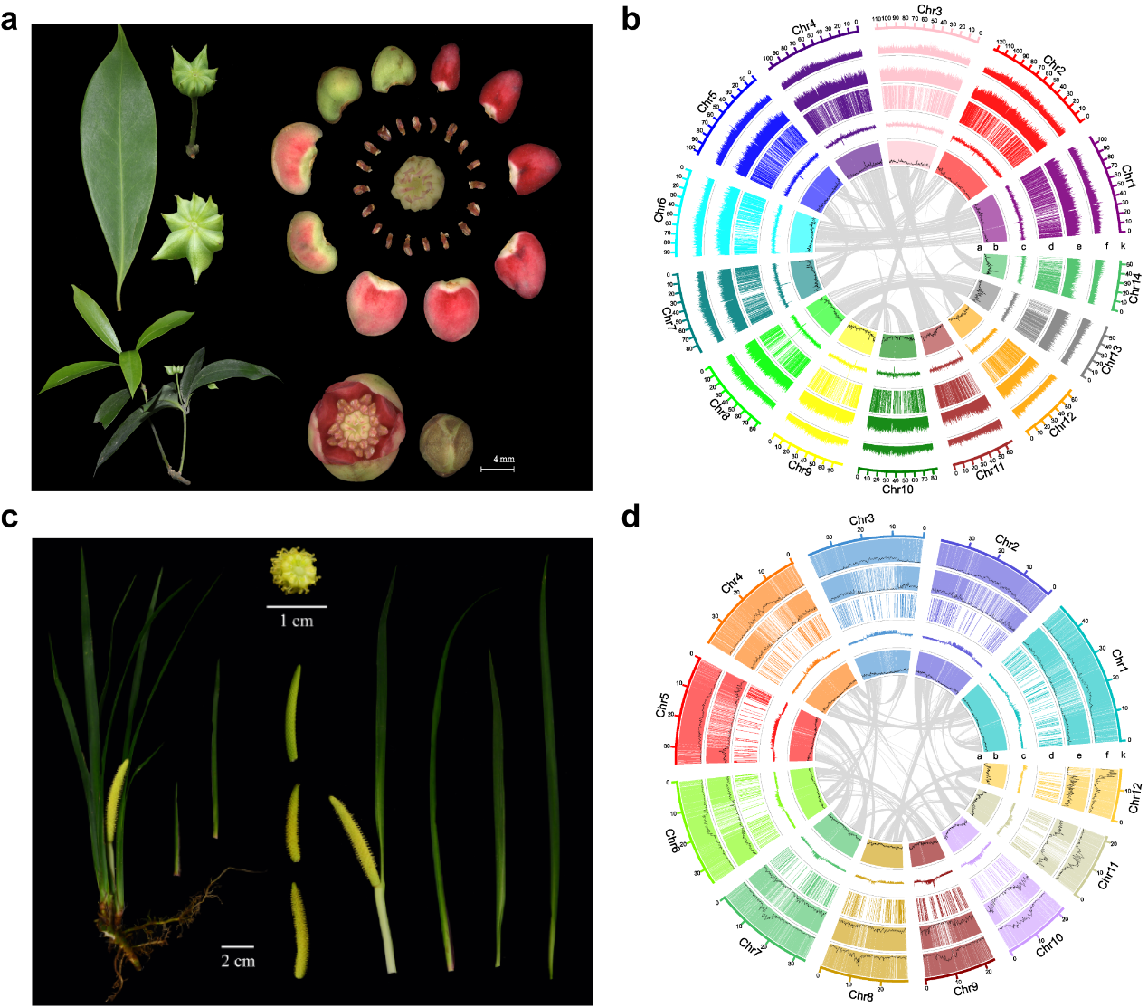

Extended Data Fig. 2 | WGD in I. verum and A. gramineus.
a, Synteny blocks of the I. verum genome. b, Synteny blocks of the A. gramineus genome. c, The Ks distributions of intragenomic synteny blocks. d, Synteny patterns between genomic regions from I. verum, Am. trichopoda, and A. gramineus.
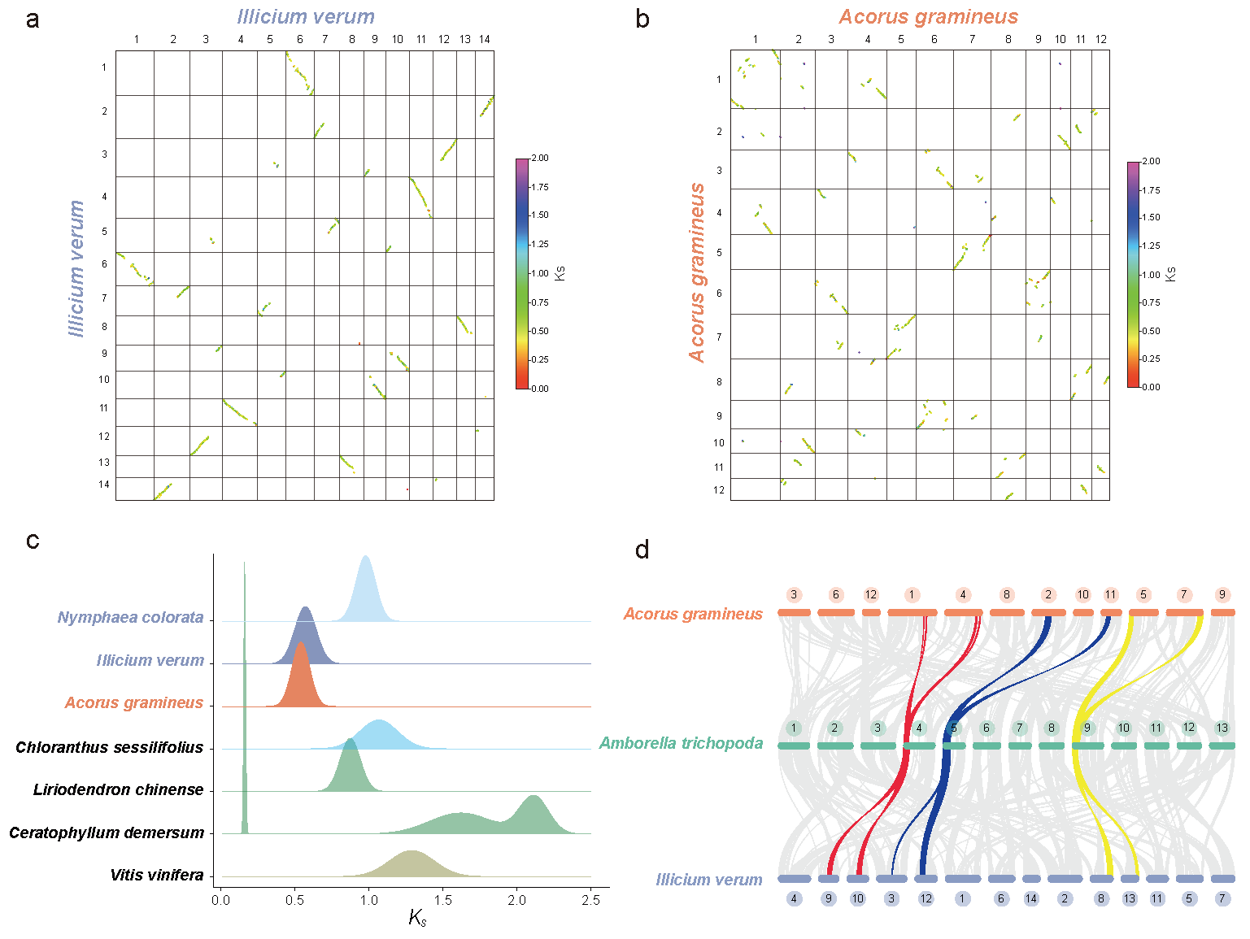

Extended Data Fig. 3 | The identified ancestral angiosperm karyotype (AAK) comprising 16 protochromosomes, each of which was retained as the chromosome-like ‘synteny blocks’ or chromosomes cross multiple species (shaded orange)

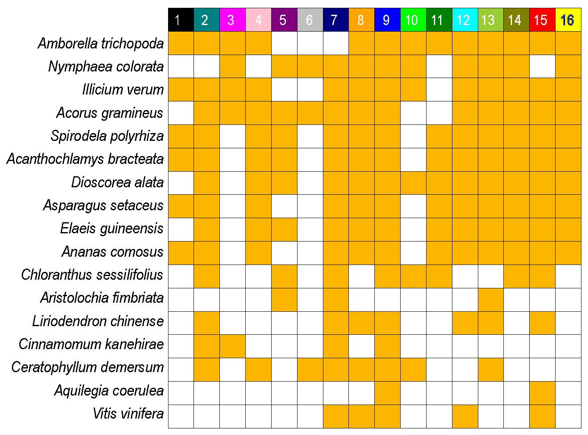

Extended Data Fig. 4 | A single shared fusion between Amborellales and Nymphaeales.
a, The evolutionary trajectory of this shared fusion and a further inversion event in Amborellales. b, The local syntenic blocks related to AAK1 and AAK2 with Am. trichopoda as a reference.
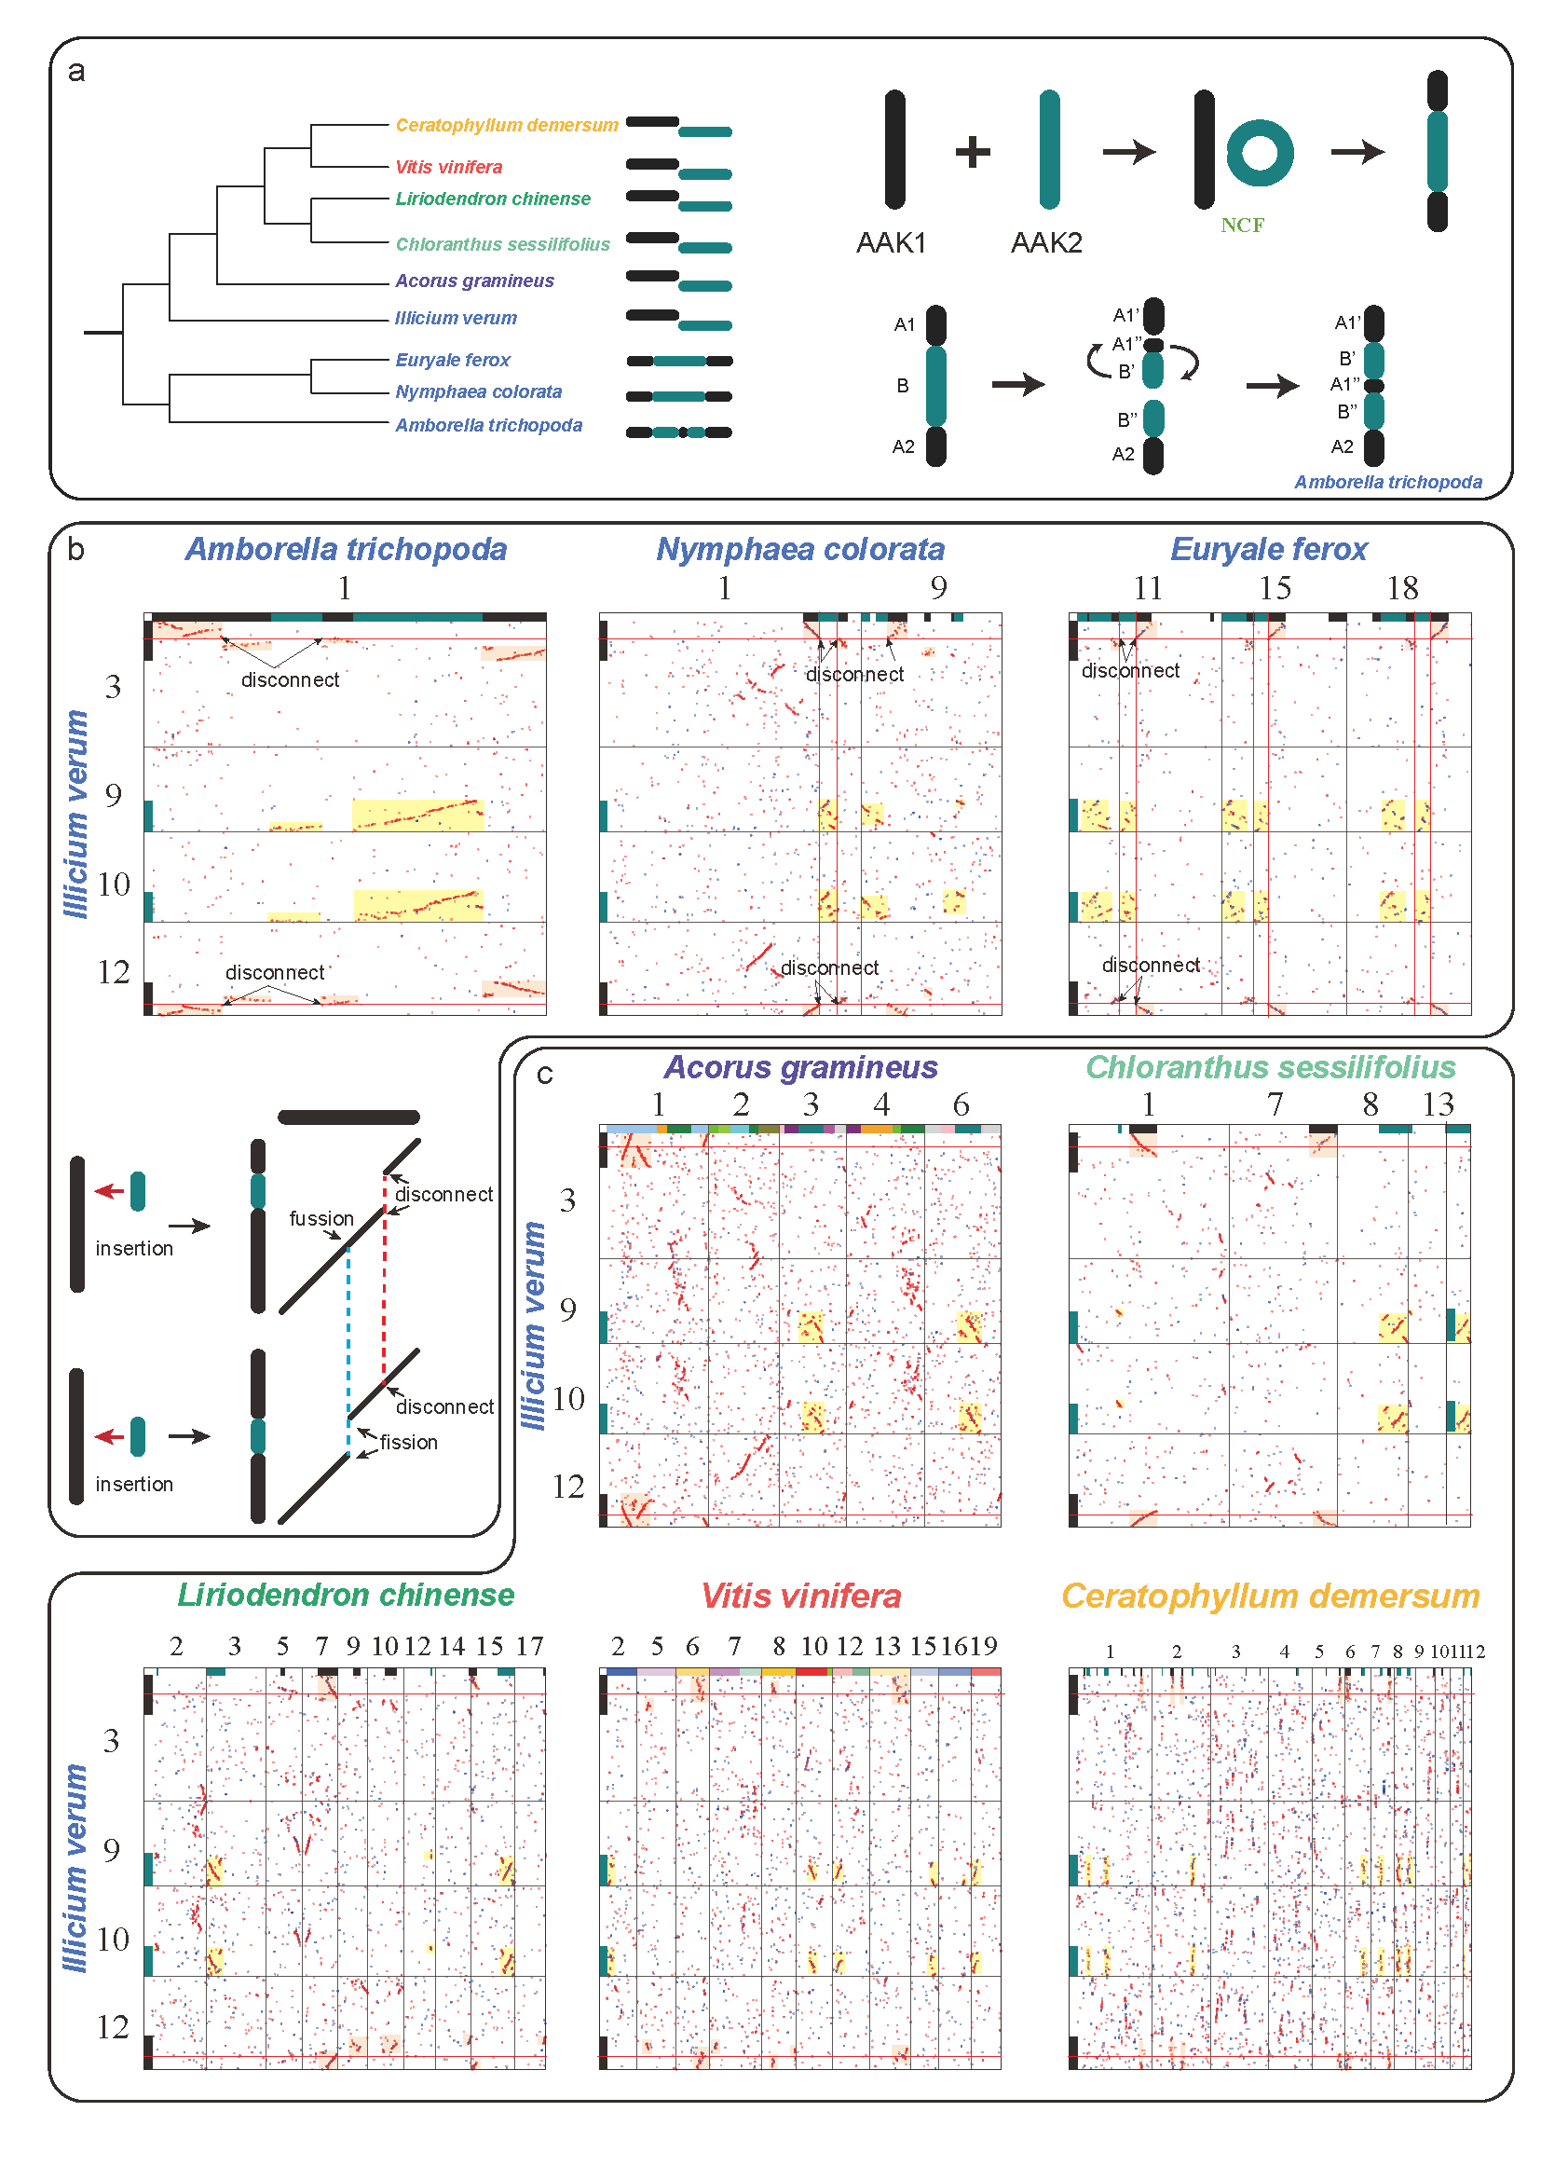

Extended Data Fig. 5 | A single shared fusion between Austrobaileyales and Mesangiospermae.
a, The evolutionary trajectory of the shared fusion. b, An inversion event of the fused chromosome in Mesangiospermae. c, The local syntenic blocks related to AAK16 and AAK7 with I. verum as a reference.
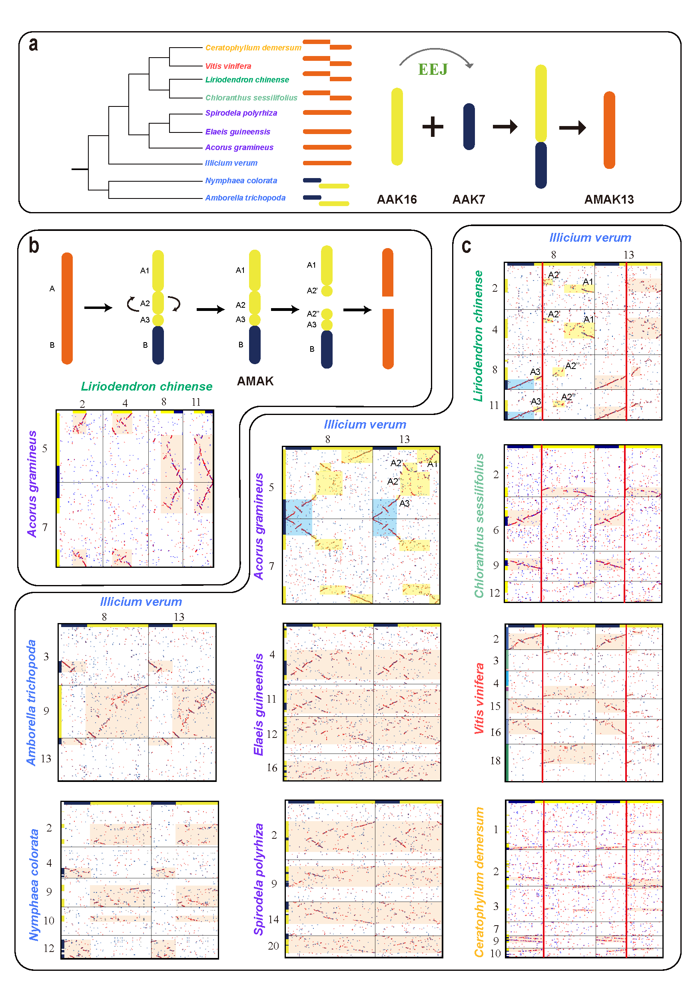

Extended Data Fig. 6 | Evolutionary differences between ancestral monocot karyotype and the other four clades of Mesangiospermae.
a, Representative species of five Mesangiospermae clades (A. gramineus, monocots; L. chinense, magnoliids; C. sessilifolius, Chloranthus; C. demersum, Ceratophyllum; V. vinifera, eudicots) and out group (Am. trichopoda, Amborella). The ancestral chromosomes are distinguished by different colors, and the chromosomes produced by the fusion include different colors. b, The local syntenic blocks related to AAK16 and AAK7. c, The local syntenic blocks related to AAK1 and AAK9.
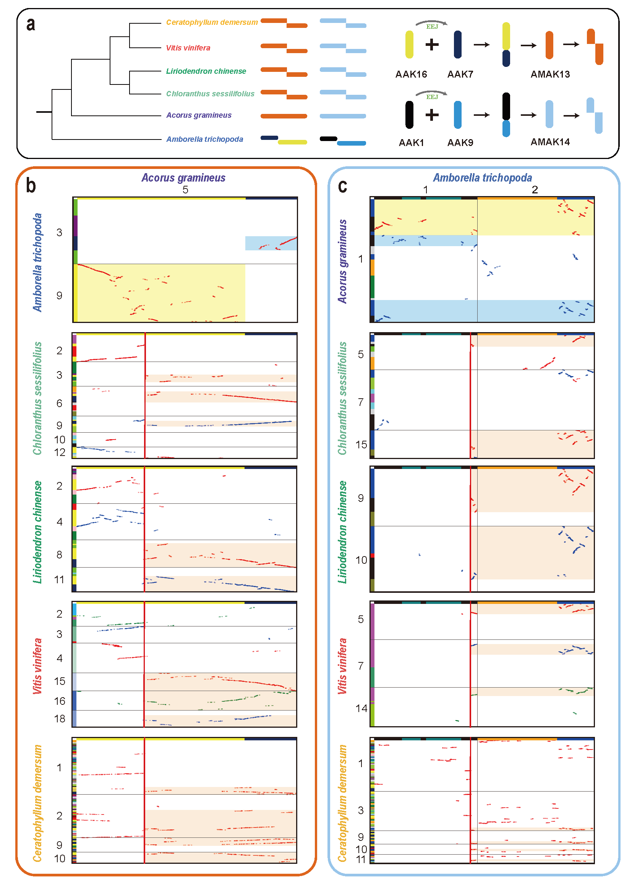
Extended Data Fig. 7 | Inconsistent structural variation for monocots and magnolias with Aristolochia as a reference.
a, The evolutionary trajectory of evolutionary events related to AAK7, AAK16 and AAK14. The primitive AMAK13 was still retained in A. gramineus, but in the common ancestor of the other monocots, it further fused with AAK14 to produce the protochromosome 5. AMAK 13 was obviously fragmented into two parts in magnolias and a part of AAK 16 in this primitive chromosome was connected again with a part of AAK 14 in one chromosome of Ar. fimbriata. Moreover, the structural variation of Piperales is not consistent in Magnoliales and Laurales and is not representative of magnoliids. b, The local syntenic blocks related to AAK3 with Am. trichopoda as a reference.
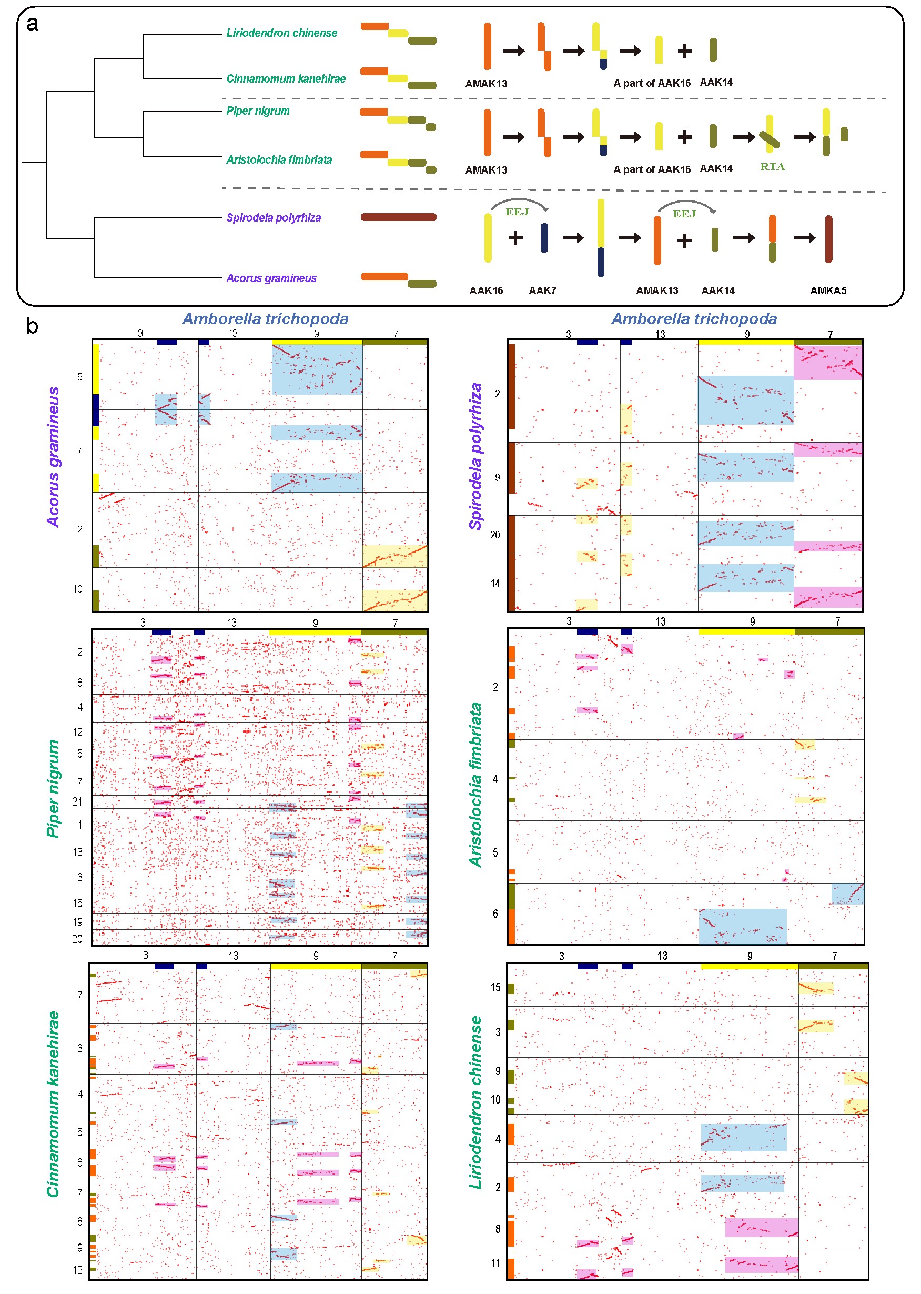

Extended Data Fig. 8 | Inconsistent structural variation for monocots and magnolias with Aristolochia as a reference.
a, The evolutionary trajectory of evolutionary events related to AAK3 (Chromosome 10 of Am. trichopoda). The primitive AMK3 was still retained in A. gramineus, but these fission positions in other monocots and magnoliids are inconsistent, indicating that these structural variations in monocots and magnolias are independent. b, The local syntenic blocks related to AAK3 with Am. trichopoda as a reference.
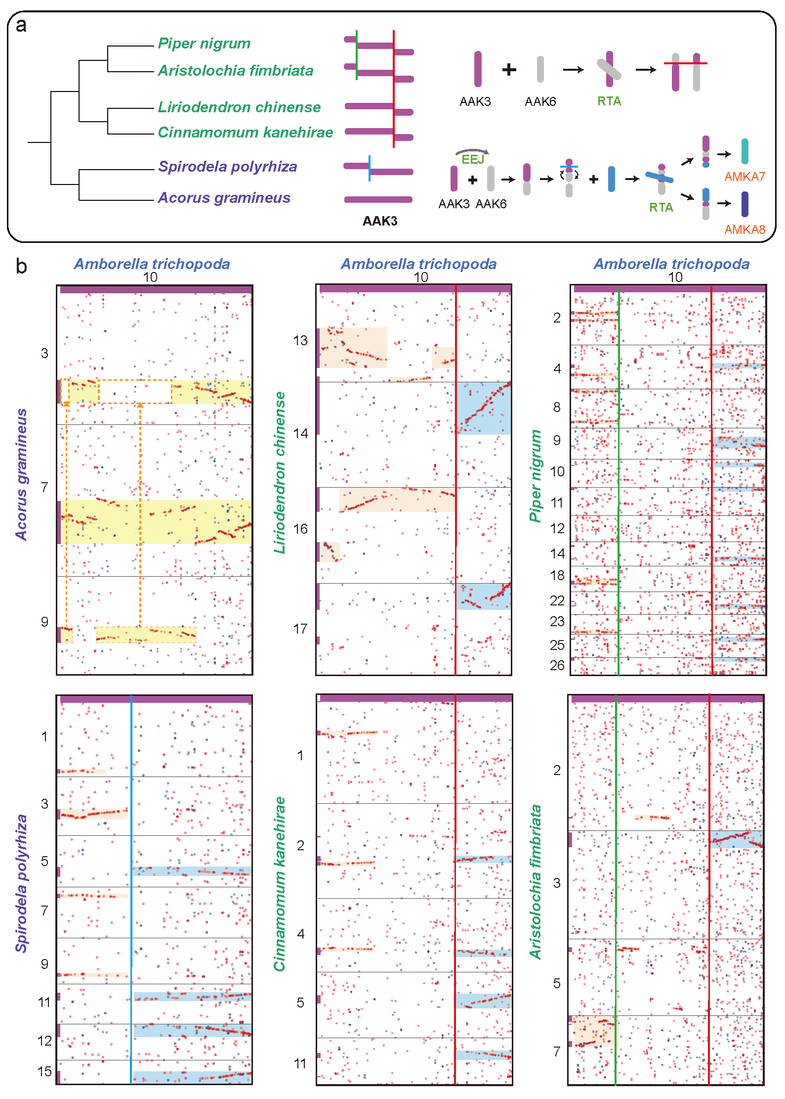
Extended Data Fig. 9 | the τ event and the following two shared fusion events.
a, The evolutionary relationship between major clades of monocots with A. gramineus as a reference. b, the two shared fusions after the σ event. c, The local syntenic blocks related to AMKA1, AMKA6 and AMKA8.
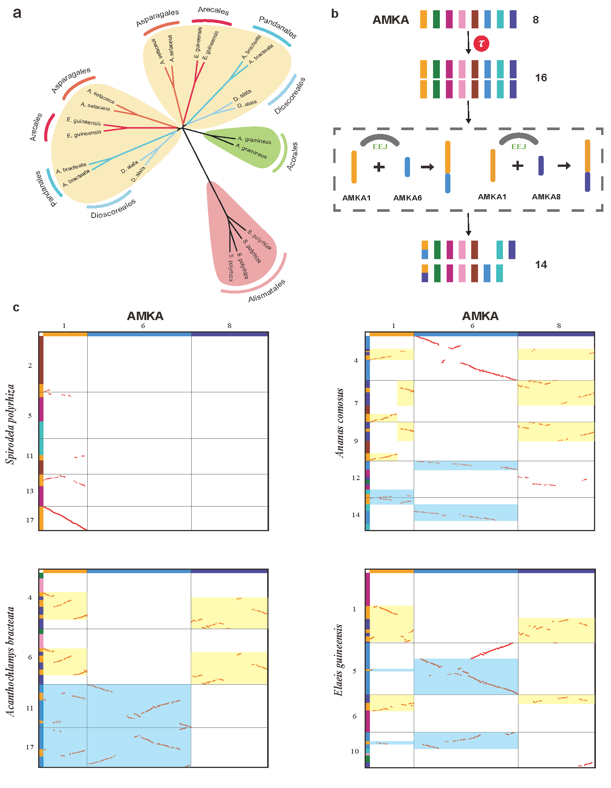

Extended Data Fig. 10 | The ancestral chromosome karyotype accurately identified the polyploidy levels and corrected the assembly.
a, The marked questions indicate that the current branch's polyploidy levels are in disputes. b, The syntenic depth ratio of AMKA2 and AMKA6 identified to be 8 in Dendrobium chrysotoxum, which indicates three WGDs. c, Using chromosomes 4, 11, 12, and 16 of Elaeis guineensis as a reference, which were produced by AMKA5 after two WGDs, the syntenic depth ratio identified to be 31 in Musa acuminata, which indicates five WGDs. d, the two shared fusions in Oryza sativa and A. comosus indicate that the σ event in Poales was a hexaploidization event. e, Chromosome 8 of S. polyrhiza has a fragment of AMKA6, while this structural variation did not occur in Spirodela intermedia. Similarly, chromosomes 24 and 25 of A. comosus may be broken from the AMKA5, and they are the complete AMKA5 in Ananas bracteatus.
