Bacterial community in saline farmland soil on the Tibetan Plateau: Responding to salinization while resisting extreme environments
YiQiang Li¹, YingHui Chai^{1,2}, XuSheng Wang¹, LiYing Huang³, XiMing Luo^{1,4}, Cheng Qiu³, QingHai Liu³, XiangYu Guan^{1,4,*}

¹ School of Ocean Sciences, China University of Geosciences (Beijing), Beijing, 100083, China
² Laboratory division, Eighth Medical Center of Chinese People's Liberation Army General Hospital, Beijing100000, PR China
³ Institute of Agricultural Quality Standards and Testing, Tibet Academy of Agriculture and Animal Husbandry Sciences,850000, China
⁴ Beijing Key Laboratory of Water Resources and Environmental Engineering, China University of Geosciences (Beijing), Beijing, 100083, China

* Corresponding author: School of Ocean Sciences, China University of Geosciences (Beijing), Beijing, 100083, China. E-mail address: guanxy@cugb.edu.cn (X. Guan).

Supplementary Materials
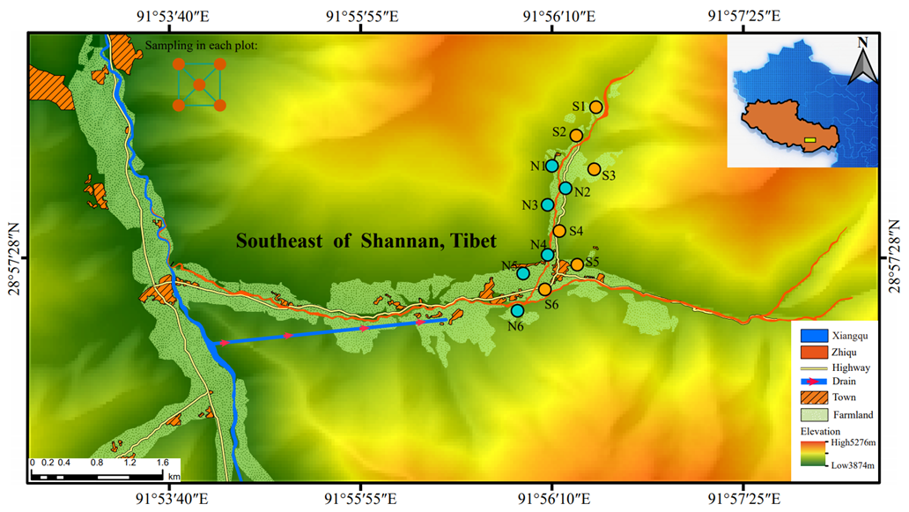
Figure S1. Sampling sites on the Tibetan Plateau.
The orange dots represent sampling sites of saline soil, and cyan dots represent sampling sites of nonsaline soil.

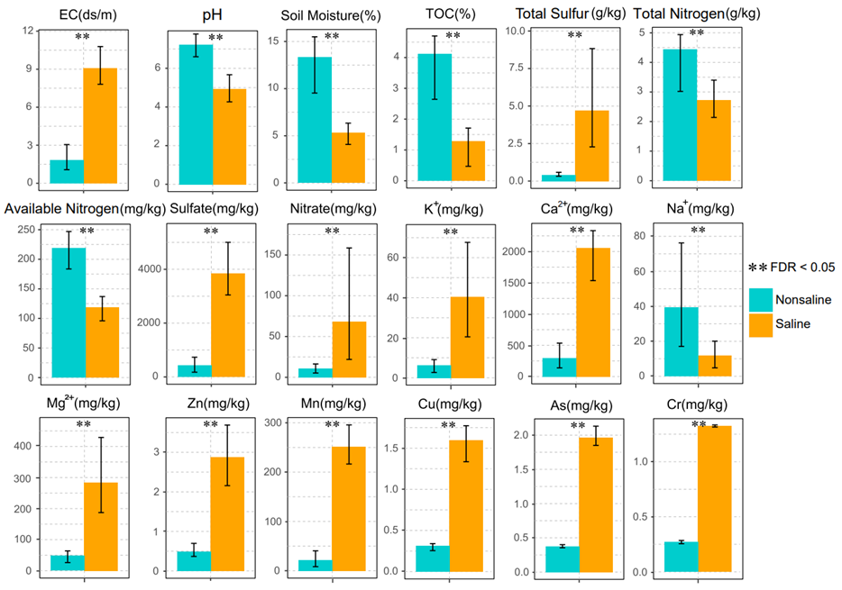
Figure S2. physicochemical parameters in saline and nonsaline soil on the Tibetan Plateau.

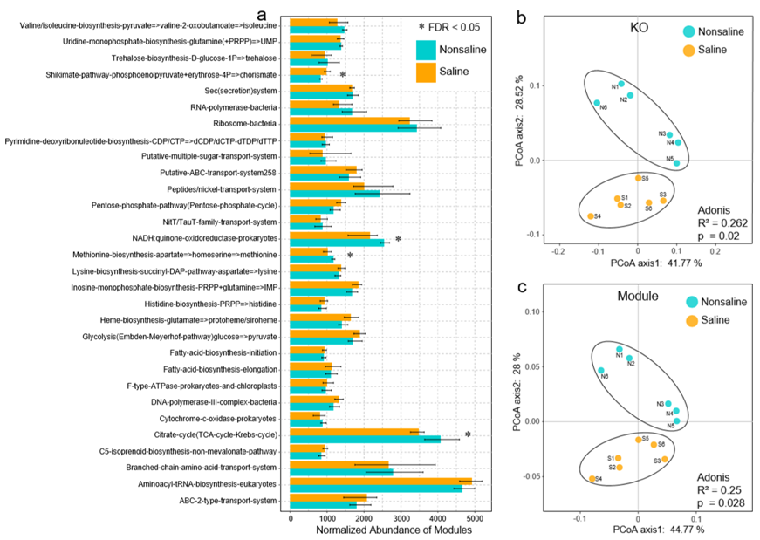
Figure S3. The difference and principal coordinate analysis (PCoA) of bacterial community functions in saline and nonsaline soil on the Tibetan Plateau. a. The normalized abundance of top30 functional modules in two types of soil samples from the Tibetan Plateau at module level. Significant difference (FDR < 0.05) genes are marked with “*”. The total number of reads is normalized to 100000. b. PCoA of microbial community functions at KO level. c. PCoA of microbial community functions at KEGG module level. The Significant differences (ADONIS, P < 0.05) of functions in the two types of soil samples from the Tibetan Plateau were tested.

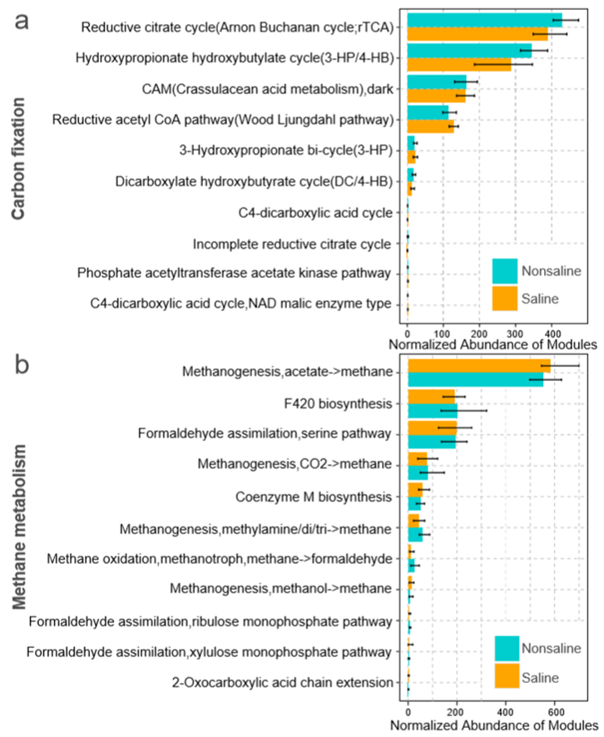
Figure S4. Normalized abundance of functional pathways of carbon fixation (a) and methane metabolism (b) of bacterial community in saline and nonsaline soil on the Tibetan Plateau. Bar plots show the normalized abundances of carbon cycling modules. The total number of reads is normalized to 100000.

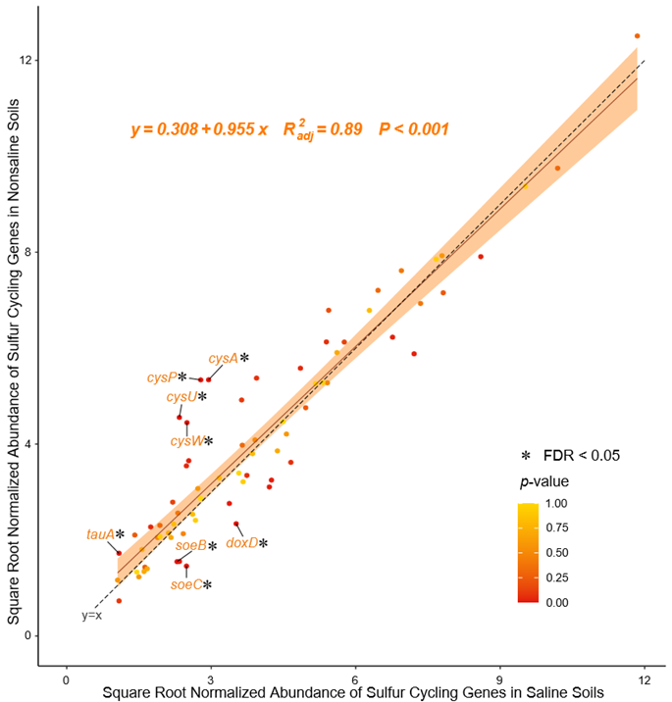
Figure S5. The ratio of sulfur cycling genes in saline and nonsaline soil on the Tibetan Plateau. The black dotted line equation: “y = x”, indicates that the horizontal and vertical axes are equal. Genes of Significant difference (FDR < 0.05) are marked with text in orange and connected with short lines. The total number of reads is normalized to 100000.

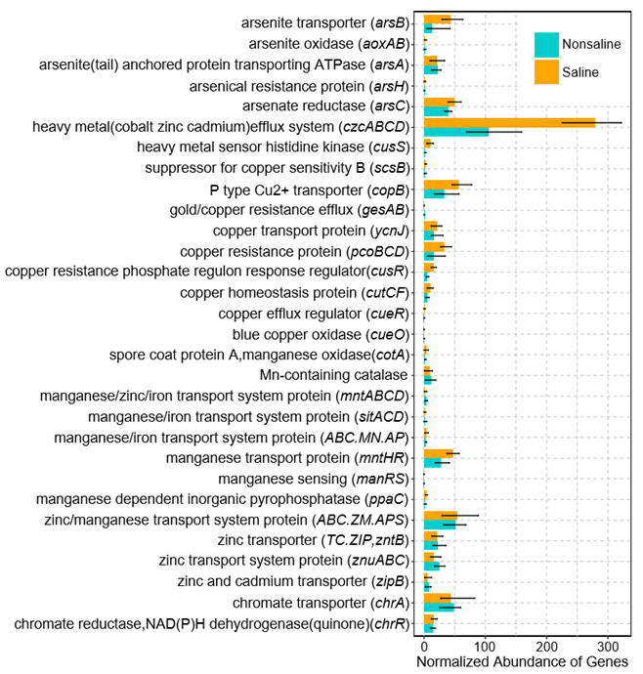
Figure S6. The normalized abundance of heavy metal(loid)s resistance genes in saline and nonsaline soil on the Tibetan Plateau. Bar plots show the normalized abundances of mental resistance genes. The total number of reads is normalized to 100000.

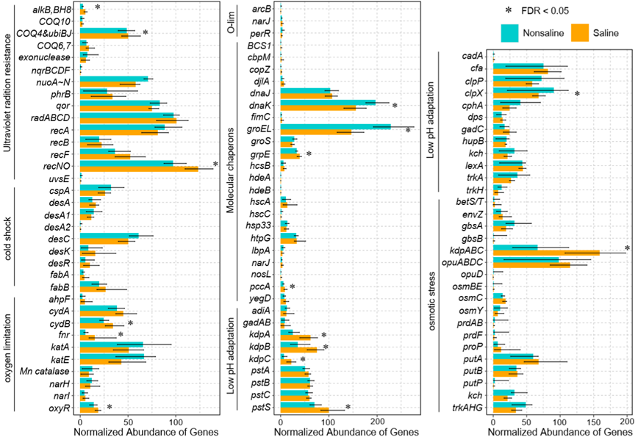
Figure S7. The normalized abundance of environmental stress response genes in saline and nonsaline soil on the Tibetan Plateau. Bar plots show the normalized abundances of environmental stress resistance genes. Significant difference (FDR < 0.05) genes are marked with “*”. The total number of reads is normalized to 100000.

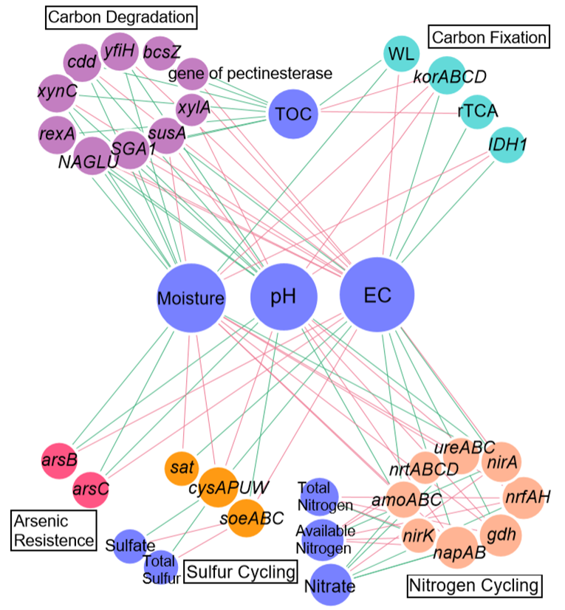
Figure S8. The network of carbon, nitrogen and sulfur cycling genes and arsenic resistance genes with environmental factors in saline and nonsaline soil on the Tibetan Plateau.
The significantly strong correlation (|r|>0.6, p-value < 0.05) between functional genes and physicochemical parameters were used to construct a network. The red and green lines mean positive and negative correlation between two nodes. The size of each node is proportion of the number of connections (i.e., degree). The thickness of each connection between two nodes (i.e., edge) is proportion of the Spearman’s correlation coeﬃcient (i.e., weight), ranging from |0.6| to |1|. WL: Wood–Ljungdahl pathway. rTCA: reductive citrate cycle.

Table S1. The quality of whole-genome shotgun data of bacterial community in saline and nonsaline soils of Tibetan Plateau.
Samples | Clean reads | Clean base(bp) | Percent in raw reads(%) | Percent in raw bases(%)
S1 | 47225924 | 7.08E+09 | 99.44756 | 99.39406
S2 | 43152670 | 6.47E+09 | 99.11633 | 99.05117
S3 | 50480934 | 7.57E+09 | 99.59716 | 99.54808
S4 | 39621138 | 5.94E+09 | 99.45815 | 99.3844
S5 | 59838390 | 8.97E+09 | 99.57736 | 99.52632
S6 | 43471276 | 6.52E+09 | 99.26592 | 99.19434
N1 | 55238666 | 8.28E+09 | 99.5666 | 99.51223
N2 | 62112944 | 9.31E+09 | 99.47834 | 99.42098
N3 | 66759060 | 1E+10 | 99.6198 | 99.5683
N4 | 44842584 | 6.72E+09 | 99.37352 | 99.31624
N5 | 43635626 | 6.54E+09 | 99.41396 | 99.35688
N6 | 42532714 | 6.38E+09 | 99.44296 | 99.38223

Table S2. The assembly of whole-genome shotgun data of bacterial community in saline and nonsaline soils of Tibetan Plateau.
Samples | Contigs | Contigs bases(bp) | N50  (bp) | N90  (bp) | Max  (bp) | Min  (bp)
S1 | 247170 | 1.65E+08 | 681 | 346 | 62138 | 300
S2 | 664171 | 3.98E+08 | 588 | 341 | 106047 | 300
S3 | 560395 | 3.88E+08 | 720 | 349 | 115026 | 300
S4 | 567654 | 3.7E+08 | 668 | 346 | 68168 | 300
S5 | 656432 | 4.26E+08 | 673 | 346 | 171693 | 300
S6 | 311586 | 1.94E+08 | 632 | 344 | 86932 | 300
N1 | 242951 | 1.09E+08 | 445 | 325 | 4689 | 300
N2 | 298994 | 1.31E+08 | 431 | 322 | 18250 | 300
N3 | 503193 | 2.58E+08 | 507 | 333 | 39120 | 300
N4 | 378385 | 1.95E+08 | 518 | 335 | 9810 | 300
N5 | 472496 | 2.73E+08 | 581 | 340 | 41898 | 300
N6 | 377628 | 1.71E+08 | 446 | 324 | 10643 | 300

Table S3. The alpha diversity of bacterial community in saline and nonsaline soils of Tibetan Plateau.
Samples | Shannon index
S1 | 5.60745
S2 | 5.660981
S3 | 5.421845
S4 | 4.999145
S5 | 5.393344
S6 | 5.495674
N1 | 5.297761
N2 | 5.40852
N3 | 5.392616
N4 | 5.367385
N5 | 5.369099
N6 | 5.280454

Table S4. The topology structure characteristics of network of bacteria and environmental factors.
Module | All node | All link | Positive link | Negative link | Color
0 | 22 | 440 | 440 | 0 | Red
1  2  Environmental Factors | 42  36  9 | 598  738  219 | 594  736  108 | 4  2  111 | Lavender  Green  Blue
Average Degree：27.266
Average Weighted Degree：20.397
Average Clustering Coefficient：0.632
Diameter：4
Radius：3
Average Path Length：1.961
Density：0.252

Table S5. Genera in different modules in network of genus and environmental factors.
Module |  | Genus
0 | Gemmatirosa  Bradyrhizobium  unclassified_f__Acidobacteriaceae  Rhodanobacter  Candidatus_Koribacter  Pseudolabrys  Burkholderia  Ktedonobacter  Rudaea  unclassified_o__Rhodospirillales  Acidobacterium |  | Opitutus  Thermogemmatispora  Edaphobacter  Candidatus_Nitrosotalea  Chthoniobacter  Mizugakiibacter  Dyella  Silvibacterium  Sphaerobacter  Granulicella  Dokdonella
1 | Gemmatimonas  unclassified_c__Betaproteobacteria  unclassified_p__Acidobacteria  unclassified_d__Bacteria  Pyrinomonas  Candidatus_Solibacter  unclassified_p__Chloroflexi  unclassified_p__Candidatus_Rokubacteria  Nitrospira  Pedosphaera  unclassified_c__Gammaproteobacteria  Rhodoplanes  Haliangium  Pseudomonas  Sorangium  Candidatus_Entotheonella  Mesorhizobium  Steroidobacter  Variovorax  Rhizobacter  Polaromonas |  | Myxococcus  Nitrososphaera  Anaeromyxobacter  Reyranella  unclassified_c__Deltaproteobacteria  Bryobacter  Microvirga  Massilia  Dongia  Geobacter  Methylobacterium  Labilithrix  Methylibium  Cystobacter  Chloracidobacterium  Paenibacillus  Cupriavidus  Rhizobium  Azospirillum  Herbaspirillum  Janthinobacterium
2 | Sphingomonas  Streptomyces  Nocardioides  Arthrobacter  Mycobacterium  unclassified_f__Geodermatophilaceae  Leifsonia  Solirubrobacter  unclassified_c__Actinobacteria  Frankia  Conexibacter  Blastococcus  Pseudonocardia  Amycolatopsis  unclassified_o__Solirubrobacterales  Actinoplanes  Gaiella  Marmoricola |  | Phenylobacterium  Lysobacter  Modestobacter  Phycicoccus  Devosia  Singulisphaera  Rhodococcus  Microbacterium  Gemmata  Mucilaginibacter  Altererythrobacter  Nocardia  Geodermatophilus  Rubrobacter  Caulobacter  Flavobacterium  Kribbella  Aeromicrobium

