**0 30 60 90 120**

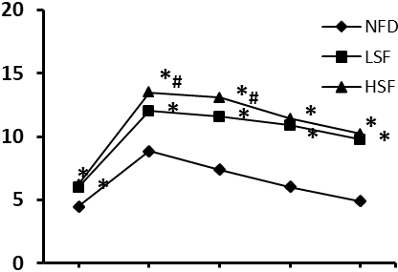

**Time (min)**

**Glucose (mmol/L)**