Supplementary methods-GC-MS conditions as well as method performance
1. Standard solutions preparation and method validation
Stock solutions of the 11 fatty acids and an internal standards (heptadecanoic acid) were prepared at 1000.00 μg/mL in methanol. Working solutions were prepared with methanol at concentrations of 1.10–1000.00 μg/mL. All standard solutions were stored at −20℃ until required. Calibration samples were prepared by spiking with 11 different concentrations of fatty acids standards. Limit of detection (LOD) were defined as lowest concentrations with signal-to-noise (S/N) ratios of 10. Repeatability of calibration samples was expressed as coefficients of variation (CV%) and percentage biases (bias%), respectively. The CV was 2.97%-7.73% and the bias was 83.40%-103.80%.
2. Sample preparation
Briefly, aliquots (200 μL) of serum were spiked with internal standard (I.S.) working solution (200 μL heptadecanoic acid C17:0 200 μg/mL), and 1 mL 0.05% H₂SO₄ was then added to deposit protein. The FFA was extracted using 3 mL ethyl acetate and shaking with a vortex mixer for 60 s, then centrifuged at 4,000 × g for 10 min at room temperature. The ethyl acetate phase was evaporated to dryness under N₂. Following the addition of 2 mL 10% H₂SO₄–CH₃OH and incubation in a 62℃ water bath for 2 h, 2 mL saturated sodium chloride and 2 mL hexane were sequentially added andmixedfor 60 s to obtain the fatty acidmethyl esters. Samples were evaporated to dryness under N₂ gas, and 100 μL hexane was added to each tube prior to analysis
3. Gas chromatography–mass spectrometry
GC–MS analysis was performed using a TRACE gas chromatograph with a Polaris Q mass spectrometer (Thermo Finnigan, Austin, TX, USA). Helium was used as the carrier gas. A split injector (the split ratio being 1:10) at 230℃ was used to add the sample (1.0 μL) onto a J&W DB-WAX (30 m × 0.25 mm I.D., 0.25 mm film thickness) capillary column. Fatty acid methyl esters were separated at constant flow with the following oven program: (a) initially 50℃ for 2 min; (b) temperature was increased at a rate of 10℃/min up to 200℃; (c) maintained at 200℃ for 10 min; (d) increased at a rate of 10℃/min up to 220◦C; (e) maintained at 220℃ for 15 min. The transfer line was maintained at 230℃. The ion trap mass spectrometer was operated under electron bomb ionization (EI) mode. Mass spectra of m/z 30–450 were collected by full scan mode with 0.58 s/scan velocity. Solvent delay time was 5 min. The source temperature was 230℃ with the electron energy at 70 eV.

Table S1 Composition of diets (g/1000g diets)
Ingredient | ND | HSF | LSF
Casein | 200 | 200 | 200
L-Cystine | 3 | 3 | 3
Corn Starch | 397.485 | 287.485 | 287.485
Maltodextrin | 132 | 132 | 132
Sucrose | 100 | 100 | 100
Cellulose | 50 | 50 | 50
Soybean Oil | 70 | 30 | 30
Palm oil | 0 | 0 | 150
Lard | 0 | 150 | 0
Mineral Mix | 35 | 35 | 35
Vitamin Mix | 10 | 10 | 10
Choline Bitartrate | 2.5 | 2.5 | 2.5
Antioxidant | 0.015 | 0.015 | 0.015
Total amount | 1000 | 1000 | 1000
Total energy (kJ) | 16558.86 | 18841.34 | 18841.34
Energy from fat (%) | 15 | 36 | 36

Table S2. The changes in the body weight of mice among groups
Weeks | NFD | LSF | HSF
0 | 23.03±0.58 | 23.47±0.97 | 23.02±0.73
1 | 23.02±0.73 | 23.83±0.66 | 23.83±0.87
2 | 23.57±1.29 | 25.20±0.89 | 25.00±0.66
3 | 24.35±1.34 | 27.48±1.58* | 26.73±1.57*
4 | 25.85±1.23 | 29.83±1.38* | 29.43±2.43*
5 | 27.22±1.38 | 31.72±2.06* | 32.68±2.29*
6 | 28.33±1.54 | 33.75±1.56* | 35.43±2.44*#
7 | 29.62±1.49 | 35.13±1.46* | 37.15±2.57*#
8 | 30.73±1.43 | 37.21±1.16* | 38.95±1.96*#
9 | 32.10±1.73 | 38.65±0.90* | 41.33±1.78*#
10 | 32.90±1.27 | 39.80±1.03* | 42.09±1.41*#
All values are presented as mean ± SEM (n=10). NFD, normal fat diet group; HSF, high stearic acid diet group (C18:0/ C16:0=1:2); LSF, low stearic acid diet group (C18:0/ C16:0=1:8). * Compared with the NFD group, P < 0.05. # Compared with LSF group, P < 0.05.

Table S3 Comparisons of mice body composition among groups
Body composition (g) | NFD | LSF | HSF
Body weight | 33.34±0.82 | 40.45±1.07* | 43.6±1.62*#
Muscle mass | 11.38±0.52 | 13.11±0.48 | 13.55±0.45
Fat mass | 1.19±0.45 | 9.13±0.46* | 11.98±0.52*#
Viceral fat mass | 0.53±0.06 | 4.23±0.08* | 5.62±0.12*#
Subcutaneous fat mass | 0.66±0.04 | 4.9±0.12* | 6.35±0.48*#
All values are presented as mean ± SEM (n=10). NFD, normal fat diet group; HSF, high stearic acid diet group (C18:0/ C16:0=1:2); LSF, low stearic acid diet group (C18:0/ C16:0=1:8). * Compared with the NFD group, P < 0.05. # Compared with LSF group, P < 0.05.

Table S4 The total body fat ratio and liver fat ratio among groups
Fat ratio (%) | NFD | LSF | HSF
Total fat ratio | 9.45±0.41 | 41.05±0.52* | 46.92±0.7*#
Liver fat ratio | 9.38±0.35 | 15.87±0.56* | 18.34±0.63*#
All values are presented as mean ± SEM (n=10). NFD, normal fat diet group; HSF, high stearic acid diet group (C18:0/ C16:0=1:2); LSF, low stearic acid diet group (C18:0/ C16:0=1:8). * Compared with the NFD group, P < 0.05. # Compared with LSF group, P < 0.05.

Table S5 The levels of fasting serum indices in mice among groups
Indices | NFD | LSF | HSF
Glucose (mmol/L) | 4.5±0.46 | 7.24±1.19* | 9.35±1.32*#
Insulin (mmol/L) | 11.58±0.39 | 23.96±5.4* | 33.54±1.8*#
HOMA-IR | 2.27±0.22 | 6.2±0.1* | 13.53±1.56*#
TC (mmol/L) | 3.21±0.28 | 4.87±0.38* | 4.91±0.28*
TG (mmol/L) | 0.58±0.1 | 0.71±0.12* | 0.8±0.14*#
HDL-c (mmol/L) | 2.61±0.2 | 3.65±0.21* | 3.43±0.25*
LDL-c (mmol/L) | 0.26±0.08 | 0.64±0.11* | 0.69±0.07*
HDL/LDL | 10.59±0.76 | 5.83±0.75* | 5.02±0.34*#
TNF-α (pg/mL) | 1.75±0.23 | 2.75±0.11* | 2.85±0.18*
IL-6 (pg/mL) | 2.91±0.24 | 4.13±0.11* | 4.48±0.17*#
All values are presented as mean ± SEM (n=10). All of the parameters were mesured and calculated in the fasting state. HOMA-IR, Homeostasis model assessment-insulin resistence; TC, total cholesterol; TG, triglyceride; HDL-c: High density lipoprotein cholesterol; LDL-c: Low density lipoprotein cholesterol; IL-6: Interleukin-6; TNF-α: Tumor necrosis factor-α; NFD, normal fat diet group; HSF, high stearic acid diet group (C18:0/ C16:0=1:2); LSF, low stearic acid diet group (C18:0/ C16:0=1:8). * P < 0.05, compared with NFD group; # P < 0.05, compared with LSF group.

Table S6 Liver fatty acids profile in mice among groups
Fatty acids (μg/ml) | NFD | LSF | HSF
C14:0 | 22.36±7.39 | 31.59±2.01 | 44.63±5.49
C16:0 | 1260.45±141.31 | 2057.52±37.34* | 2375.92±44.24*#
C16:1 | 291.08±132.97 | 534.38±54.29* | 615.8±113.6*
C18:0 | 263.65±176.61 | 246.95±12.8* | 422.27±56.22*#
C18:1 | 924.93±272.74 | 2430.89±59.88* | 3053.13±327.72*#
C18:2 | 1705.99±246.38 | 1468.52±43.62* | 1649.87±116.15
γ- C18:3 | 117.19±18.11 | 130±32.39 | 138.43±31.64
C18:3 | 1779.34±379.37 | 528.51±42.73* | 1046.36±62.25*#
C20:2 | 10.59±1.81 | 7.17±4.59 | 15.84±4.31
C20:4 | 317.03±50.04 | 441.88±4.37* | 394.99±54.89*
C20:5 | 51.21±15.89 | 23.23±1.02 | 51.62±1.74
saturated fatty acid | 1546.46±496.44 | 2336.06±50.13* | 2842.82±6.48*#
unsaturated fatty acid | 5197.36±1087.71 | 5564.58±103.18* | 6966.05±179.44*#
total free fatty acids | 6452.74±1431.13 | 7366.27±1.24* | 9083.07±59.36*#
All values are presented as mean ± SEM (n=10). NFD, normal fat diet group; HSF, high stearic acid diet group (C18:0/ C16:0=1:2); LSF, low stearic acid diet group (C18:0/ C16:0=1:8). * Compared with the NFD group, P < 0.05. # Compared with LSF group, P < 0.05.
Fig.S1
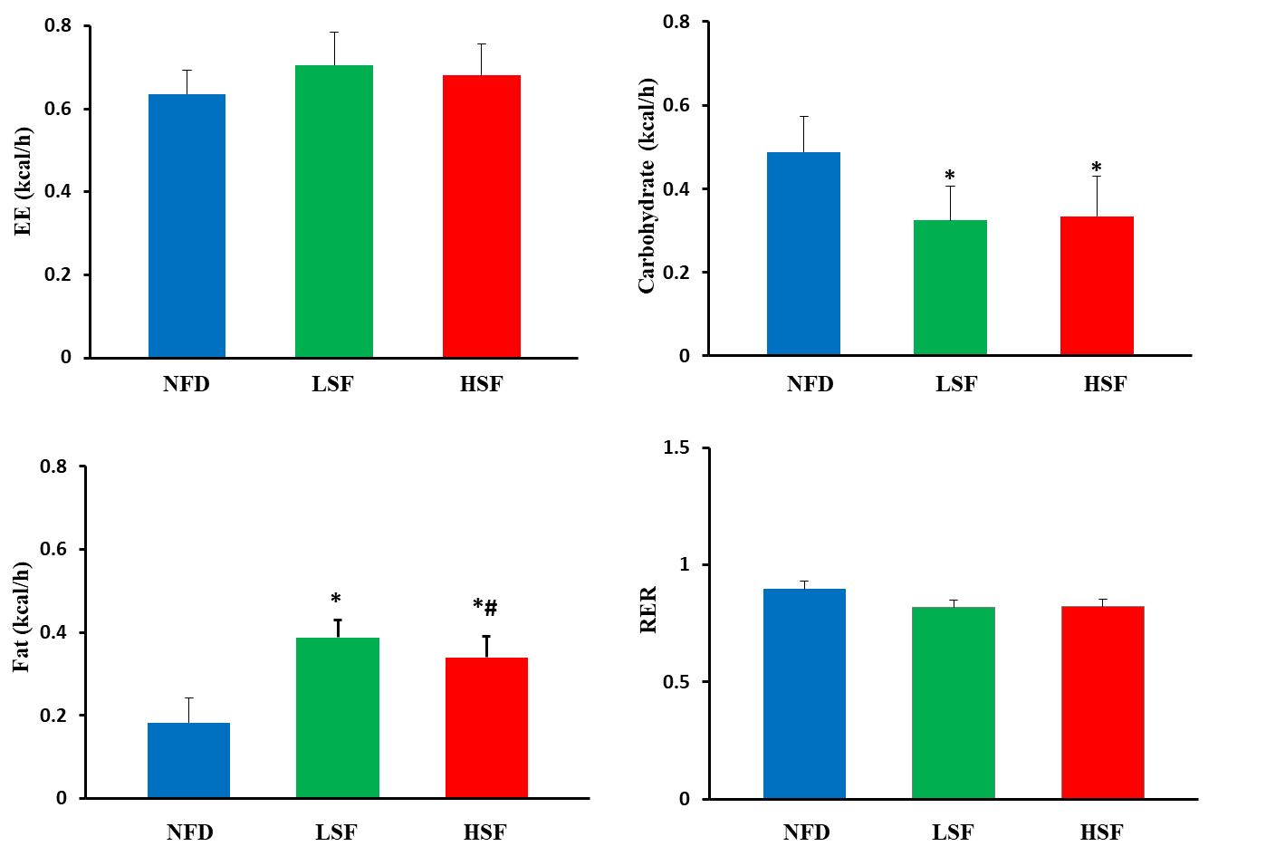
Fig. S2
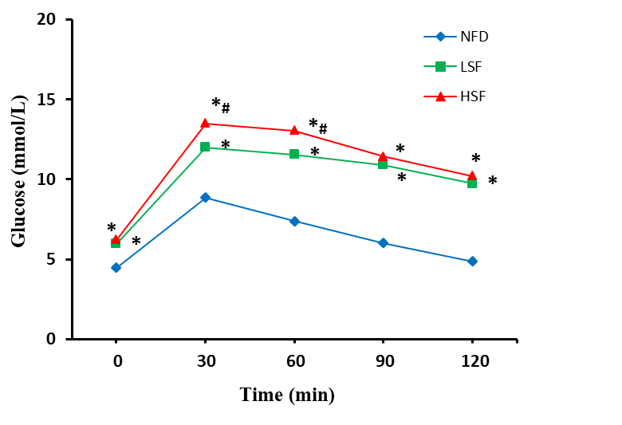

Fig. S3
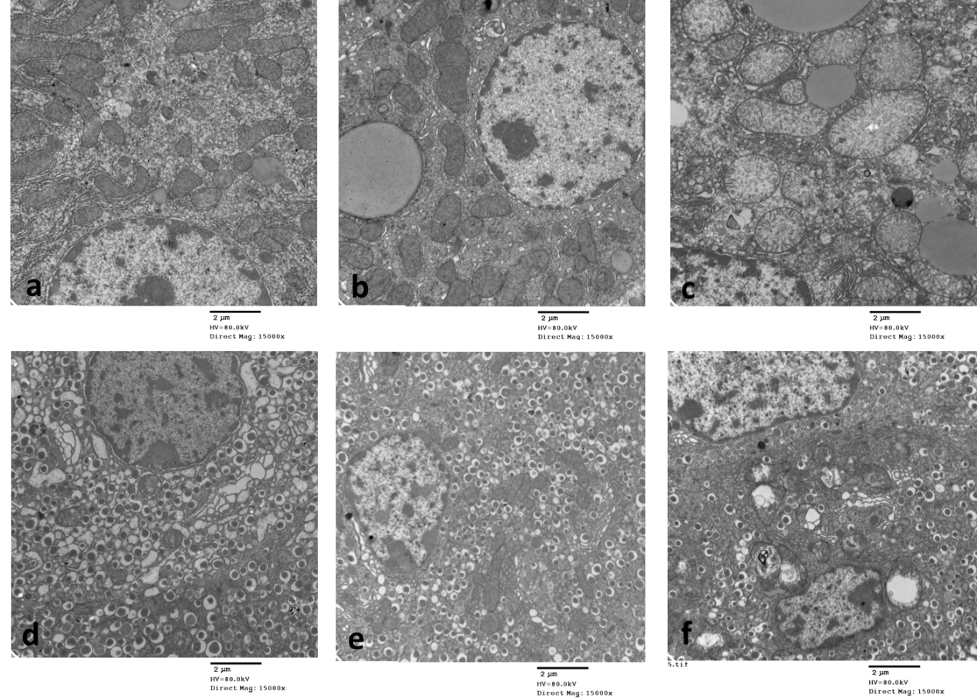

Fig.4S
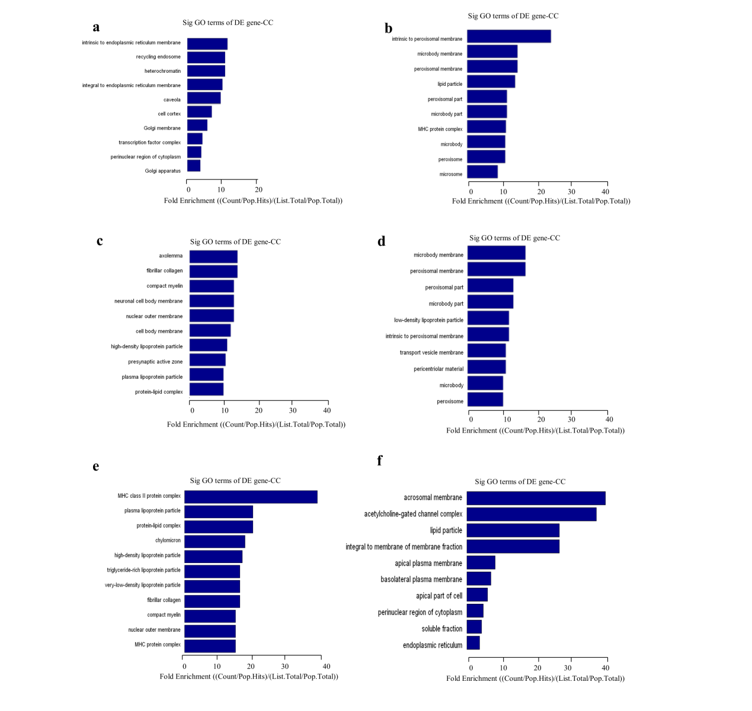

Fig.5S
