ADDITIONAL FILE 1 - Short descriptions and pictures of the seven sampling units (SU) from the Bois de Lauzelle in 2016.
Heterogeneity of tick abundance and infection with zoonotic pathogenic bacteria in a Belgian peri-urban forest.
Raphaël Rousseau^{1*}, Marcella Mori², Benoît Kabamba³, Sophie O. Vanwambeke¹
¹ Georges Lemaitre Centre for Earth and Climate Research, Earth and Life Institute, UCLouvain, Place Pasteur, Louvain-la-Neuve, Belgium.
² Sciensano, Veterinary bacteriology, Groeselenberg 99, Ukkel/Uccle, Belgium.
³ Pôle de Microbiologie Médicale, Institute of Clinical and Experimental Research (IREC), UCLouvain, Brussels, Belgium.

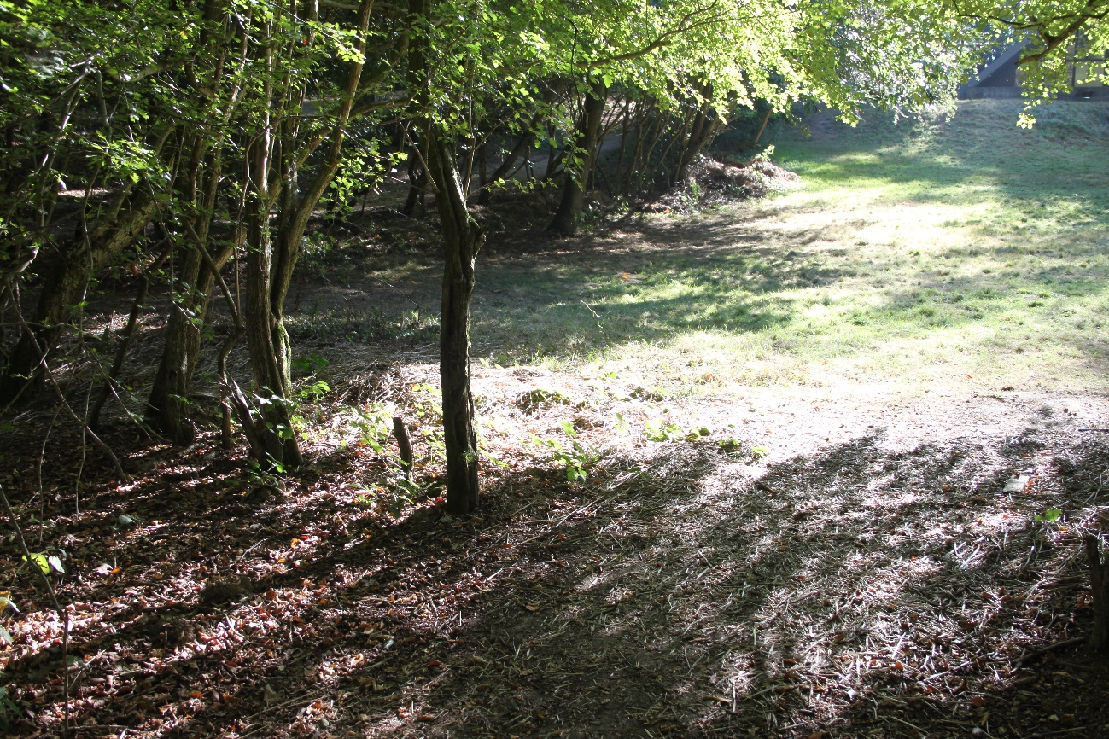
Figure S1: Picture of SU1. It was at an entrance of the forest, close to a cub scout’s meeting place. The transect was located on a loamy soil covered by grass and dead leaves. Credits: Elliott Wolter (2016).

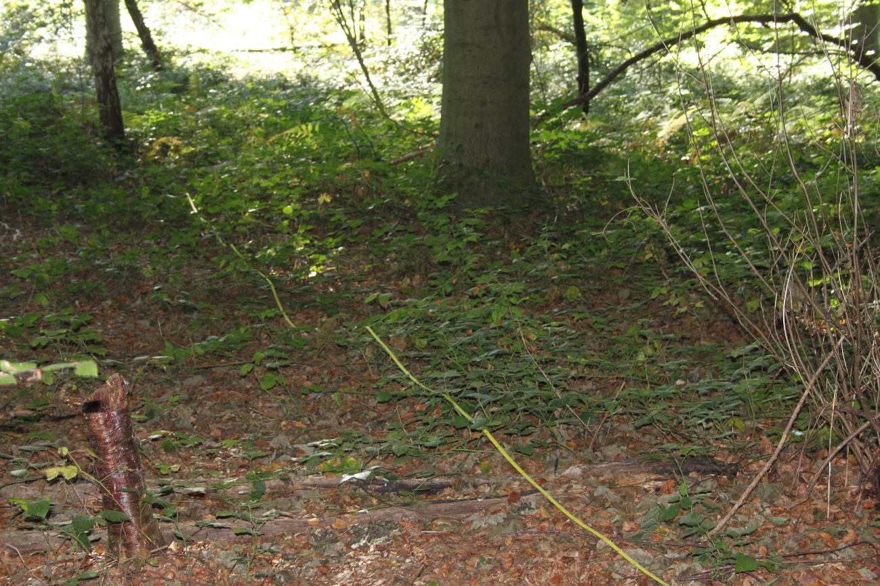
Figure S2 : Picture of SU2. It was deeper in the forest, away from the trails on dense undergrowth of brambles, ferns, and dead leaves. Credits: Elliott Wolter (2016).

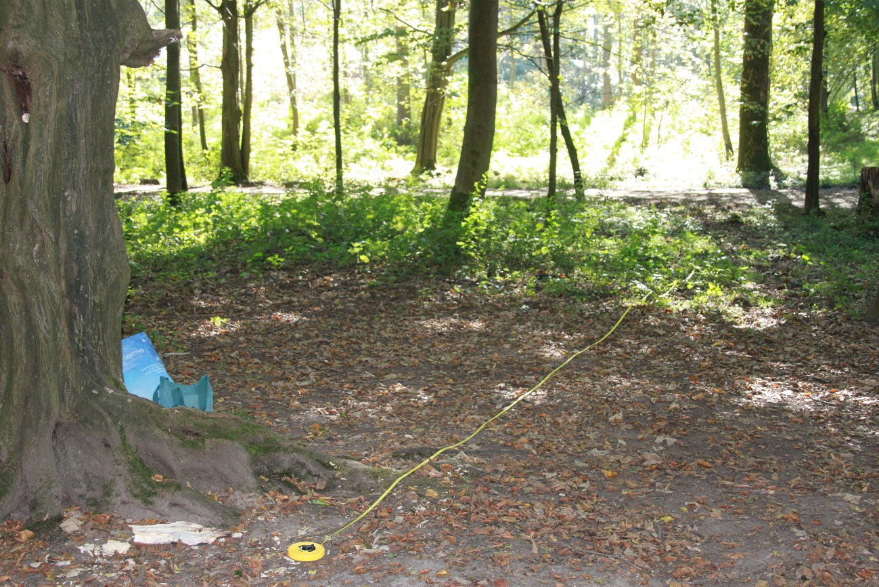
Figure S3 : Picture of SU3. It was at the junction of two trails, close to a bench and an information panel. The undergrowth was not high or abundant. Credits: Elliott Wolter (2016).
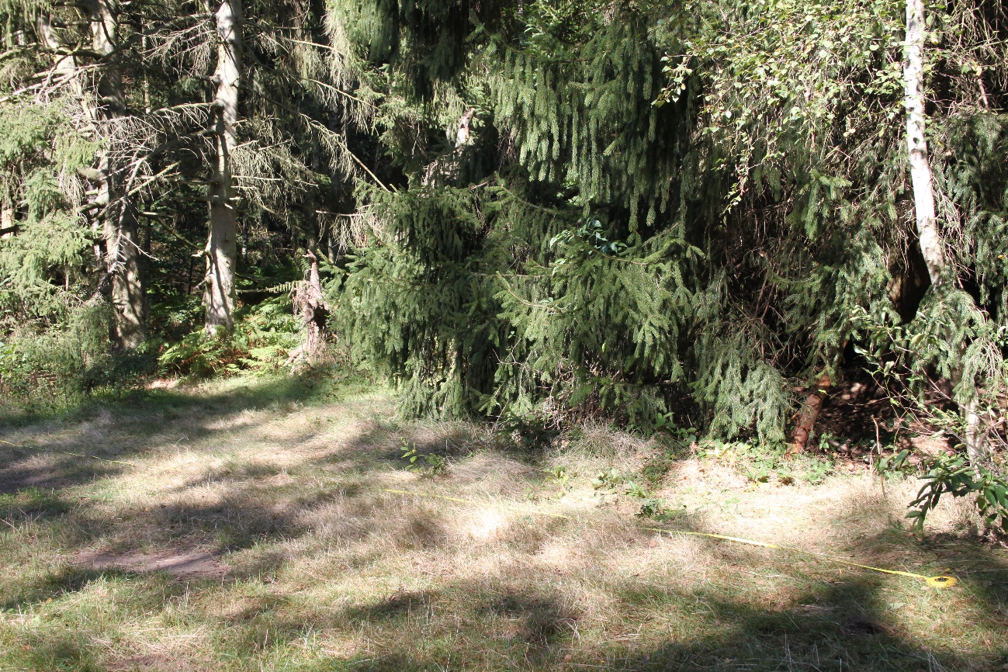
Figure S4 : Picture of SU4. It was at the edge of a small clearing, composed by middle-height grass. Credits: Elliott Wolter (2016).

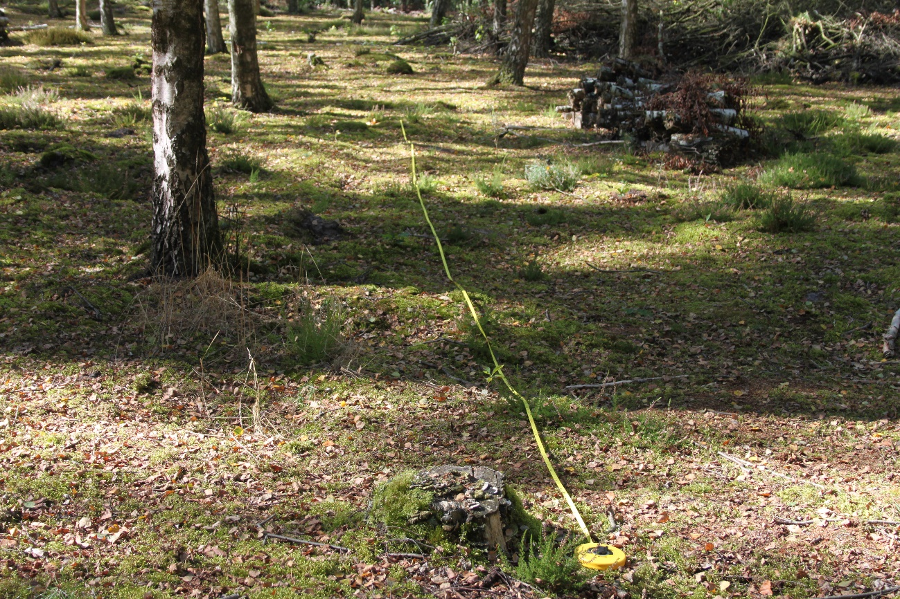
Figure S5 : Picture of SU5. It was in an area where trees had recently been cut. The undergrowth was poor, mainly composed by a small layer of moss. Credits: Elliott Wolter (2016).
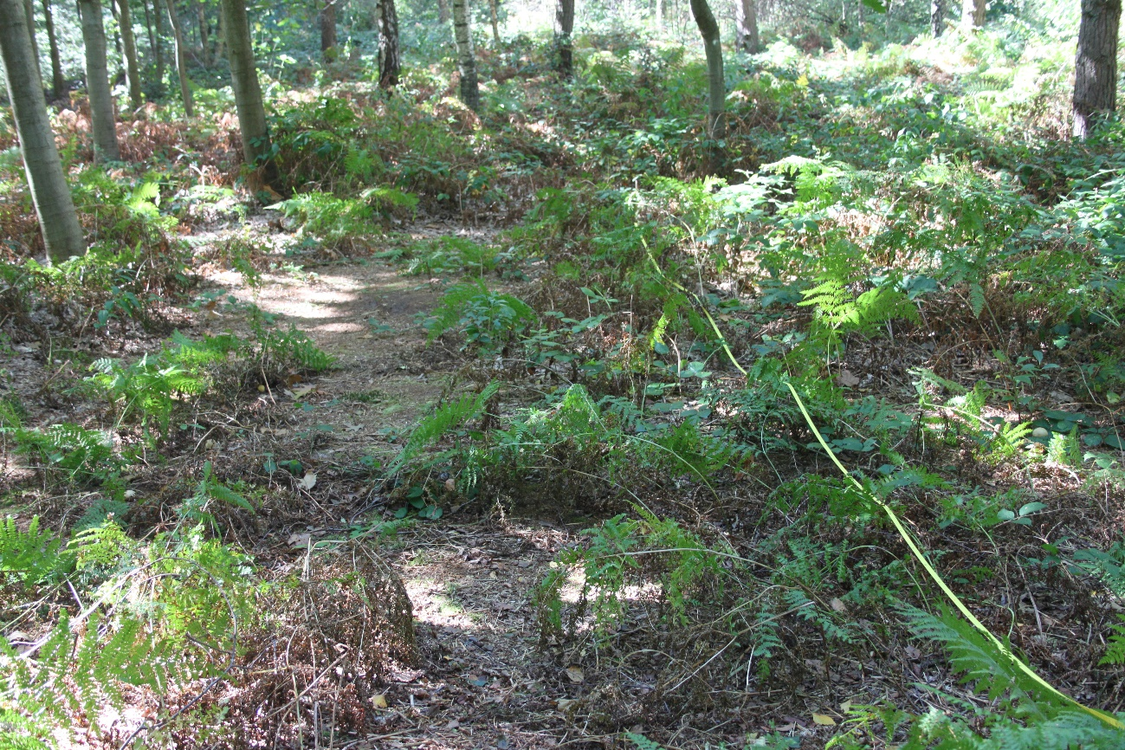
Figure S6 : Picture of SU6. It was close to a barbecue facility, but away from the trails, with a dense undergrowth composed of brambles and ferns, and dead leaves. Credits: Elliott Wolter (2016).

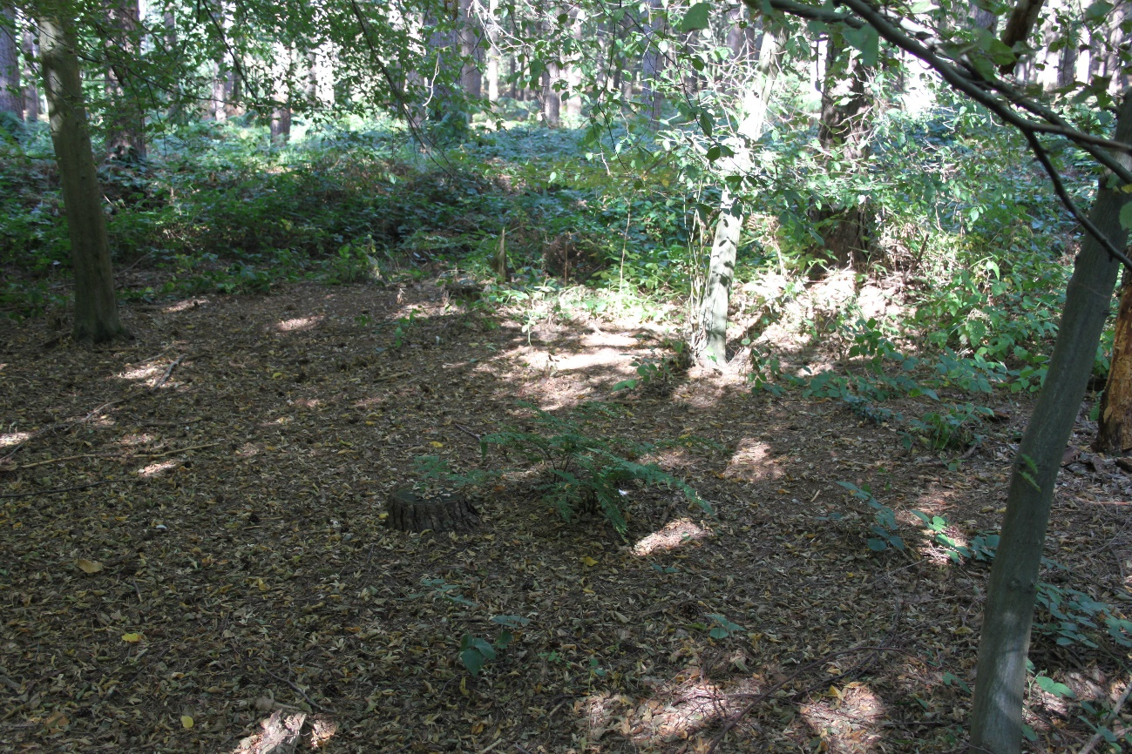
Figure S7 : Picture of SU7. It was at the edge between coniferous and deciduous tree stands, away from the trails and with a dense undergrowth. Credits: Elliott Wolter (2016).

