ADDITIONAL FILE 4 - Supplementary statistics.
Heterogeneity of tick abundance and infection with zoonotic pathogenic bacteria in a Belgian peri-urban forest.
Raphaël Rousseau^{1*}, Marcella Mori², Benoît Kabamba³, Sophie O. Vanwambeke¹
¹ Georges Lemaitre Centre for Earth and Climate Research, Earth and Life Institute, UCLouvain, Place Pasteur, Louvain-la-Neuve, Belgium.
² Sciensano, Veterinary bacteriology, Groeselenberg 99, Ukkel/Uccle, Belgium.
³ Pôle de Microbiologie Médicale, Institute of Clinical and Experimental Research (IREC), UCLouvain, Brussels, Belgium.

Table S1: Moran I index for the dependent and continuous explantoary site variables. The expected I is -0.17; P < 0.05 ‘*’.
Variable | Observed | SD | P
DON | -0.42 | 0.14 | 0.07
DOA | 0.14 | 0.15 | 0.0400 (*)
DIA | -0.19 | 0.07 | 0.70
DIN | -0.28 | 0.14 | 0.39
Vegetation height | -0.03 | 0.14 | 0.33
Slope percentage | -0.02 | 0.15 | 0.35
Distance to forest edge | 0.05 | 0.14 | 0.13

Table S2: Kruskal-Wallis H and p-values (P) of the density of nymphs for the categorical variables. P < 0.001 ‘***’; P < 0.01 ‘**’; P < 0.05 ‘*’.
Variable | DON |  | DOA |  | DIN |  | DIA
 | H | P | H | P | H | P | H | P
SU | 24.49 | 0.0004 (***) | 15.85 | 0.0146 (*) | 26.67 | < 0.0001 (***) | 19.92 | 0.0029 (**)
Season | 41.97 | < 0.0001 (***) | 13.45 | 0.0012 (**) | 10.67 | 0.0048 (**) | 6.77 | 0.0339 (*)
Undergrowth | 7.96 | 0.019 (*) | 3.39 | 0.183 | 7.88 | 0.0204 (*) | 3.08 | 0.214
Forest type | 1.28 | 0.257 | 1.08 | 0.300 | 12.25 | 0.0005 (***) | 8.03 | 0.0046 (**)
Forest management | 2.49 | 0.287 | 4.59 | 0.101 | 1.19 | 0.552 | 7.79 | 0.0203 (*)
Type of soils | 9.64 | 0.019 (*) | 2.88 | 0.089 | 0.23 | 0.633 | 0.05 | 0.816
Drainage | 3.96 | 0.047 (*) | 4.77 | 0.0289 (*) | 24.22 | < 0.0001 (***) | 12.34 | 0.0004 (***)

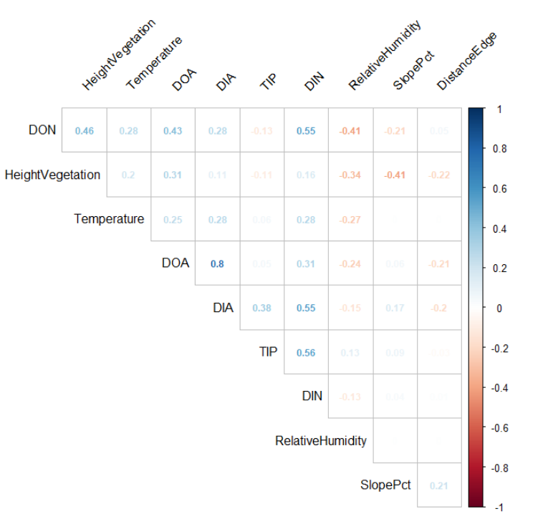
Figure S1: Corrplot of the Spearman coefficient correlations for the explanatory and continuous response variables. Only the significant correlations at P < 0.05 are indicated.

Table S3: Vuong test (Z) for the comparison between the negative binomial models, and, respectively the Poisson models, the zero-inflated (ZI) Poisson models and the ZI negative binomial models. When there was no significant z-test score, we choose the simplest distribution. P < 0.001 ‘***’; P < 0.01 ‘**’; P < 0.05 ‘*’.
Negative binomial model preferred over: | DON |  | DOA
 | Z | P | Z | P
Poisson Model | 5.717 | < 0.0001 (***) | 1.789 | 0.0368 (*)
ZI Poisson Model | 4.565 | < 0.0001 (***) | 1.783 | 0.0373 (*)
ZI negative binomial model | -0.316 | 0.3761 | 0.996 | 0.1597

