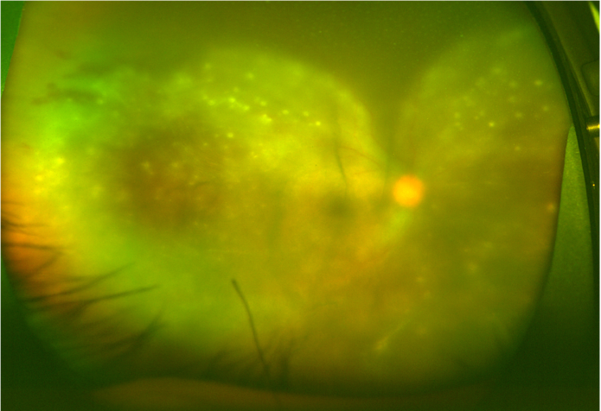

Figure S1. Wide-field fundus photograph demonstrating the feature of opacified retinitis with multiple superficial retinal precipitates

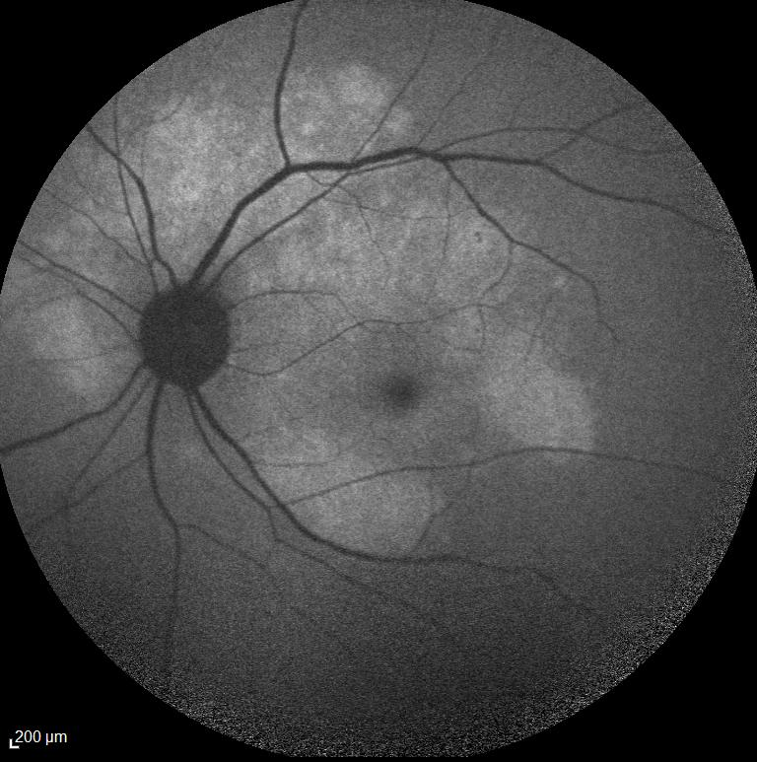

Figure S2. Fundus autofluorescence photo demonstrating the placoid appearing area of abnormality

