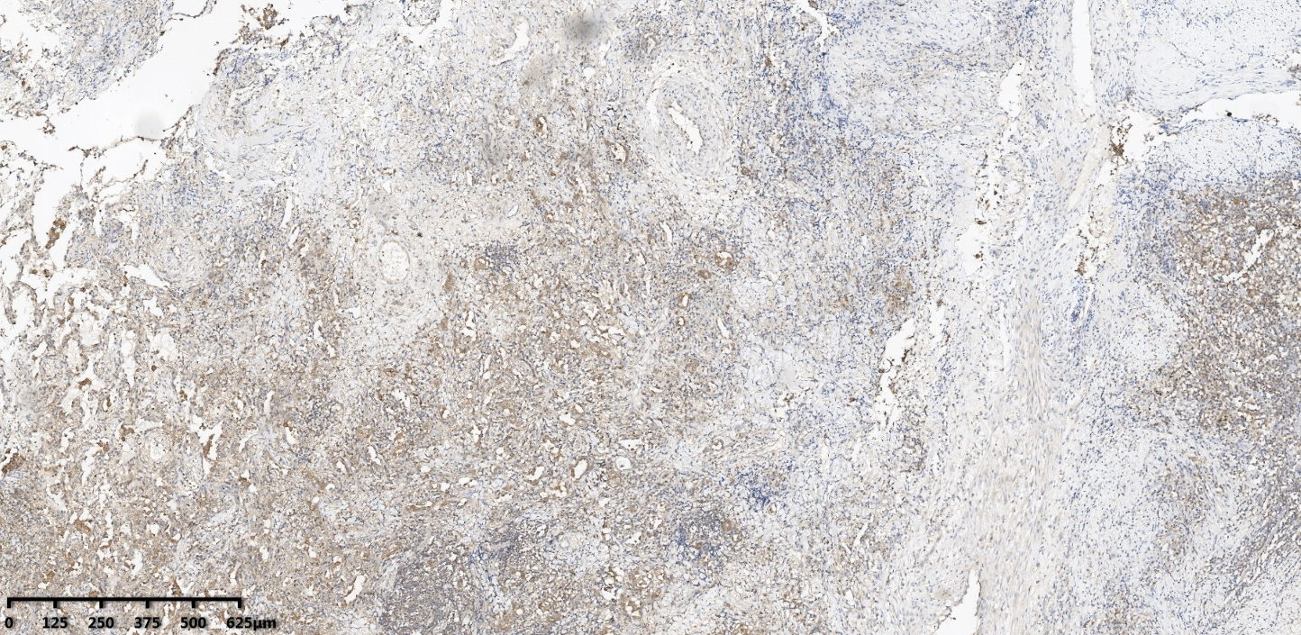
TOLLIP expression of lung specimens of the subjects at 1:800 dilution x40
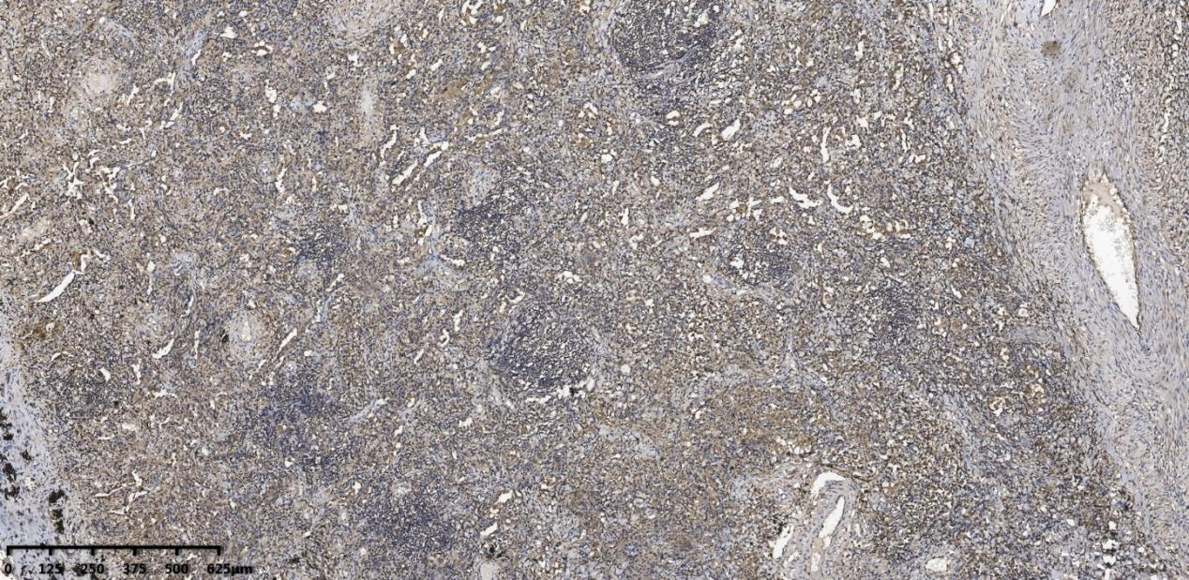
TOLLIP expression of lung specimens of the subjects at 1:400 dilution x40

