Supplemental Information
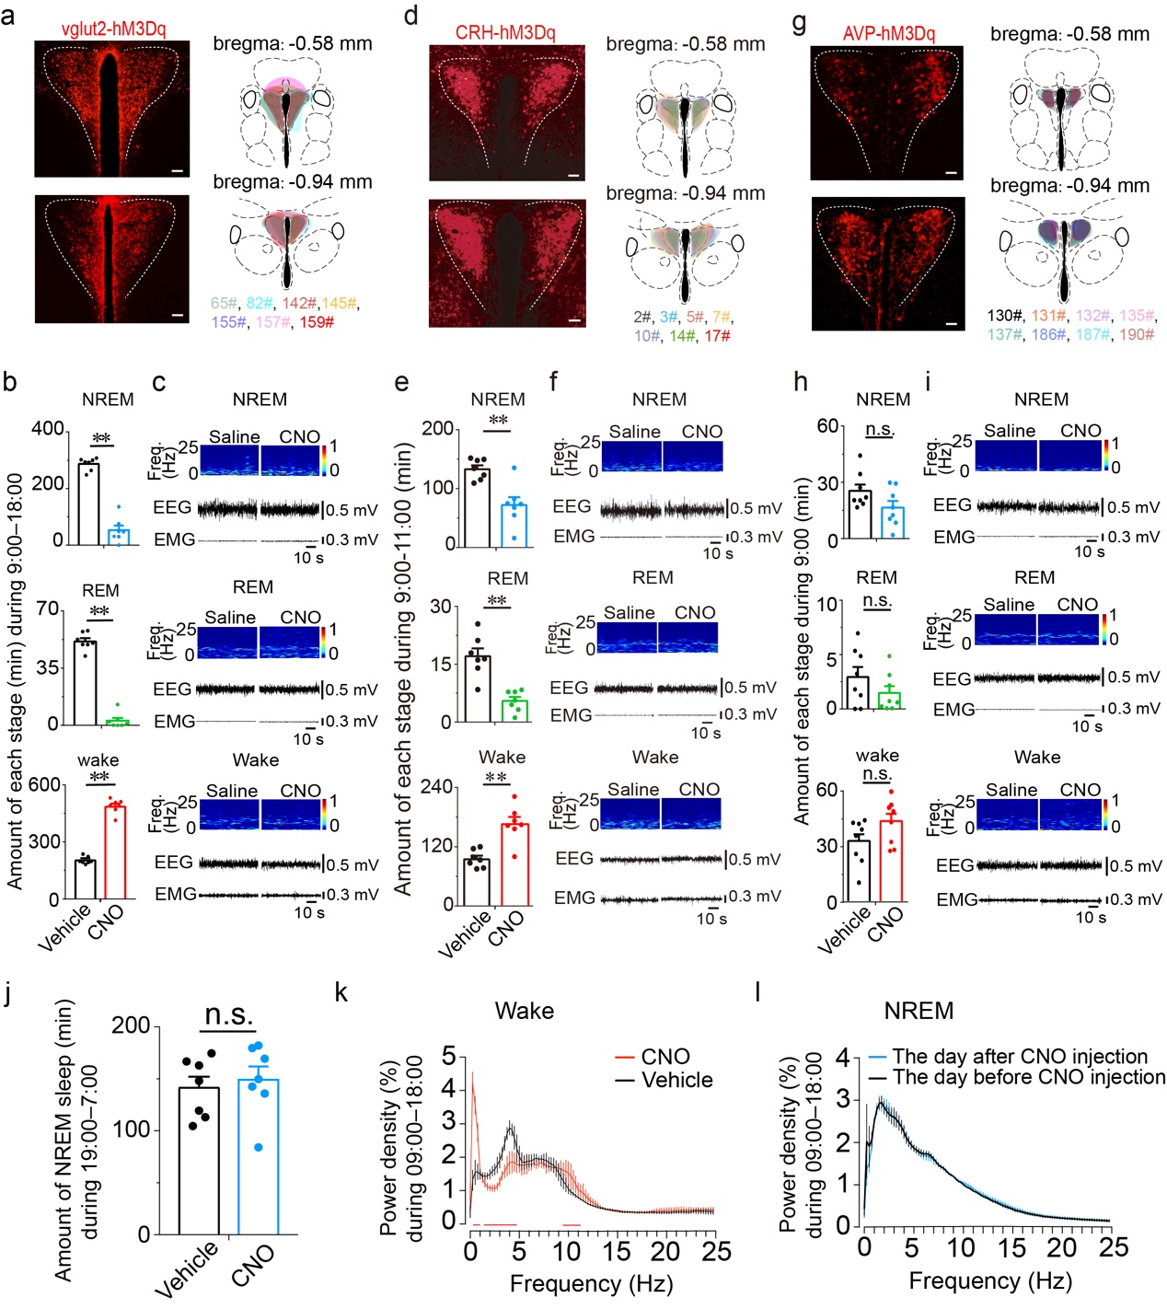 Supplementary Fig 1. Chemogenetic activation of PVH^{vglut2}, PVH^{CRH} neurons rather than PVH^{AVP} neurons during the light phase increases wakefulness (related to Fig 3). a, d and g Location of hM3Dq expression in the PVH^{vglut2}, PVH^{CRH} and PVH^{AVP} neurons. b Total time spent in each stage after vehicle or CNO injection to Vglut2-IRES-cre mice (b, n = 7, paired t test; P < 0.001 [wake], P < 0.001 [NREM], P < 0.001 [REM]), CRH-IRES-cre mice (n = 7, paired t test, P < 0.01 [wake], P < 0.01 [NREM], P < 0.01 [REM]), to AVP-IRES-cre mice (n = 8, paired t test; P = 0.09 [wake], 0.09 [NREM], 0.21 [REM]). Data represent the mean ± SEM (*P < 0.05, **P < 0.01, n.s. means no significant difference). c, f and i Representative EEG power spectra and EEG-EMG traces of wakefulness, NREM and REM sleep after injection in Vglut2-Cre mouse (c), CRH-Cre mouse (f) and AVP-Cre mouse (i). j Total time spent in NREM sleep during the dark period after vehicle or CNO injection (n = 7, P > 0.05, paired t test). k EEG power density of wakefulness during 9 h after vehicle or CNO injection (n = 5; P < 0.05, paired t test). l EEG power density of NREM sleep during the day (7:00–18:00) before/after the day of CNO injection (n = 5, P > 0.05, paired t test). Data represent the mean ± SEM (*P < 0.05, **P < 0.01, n.s. means no significant difference).

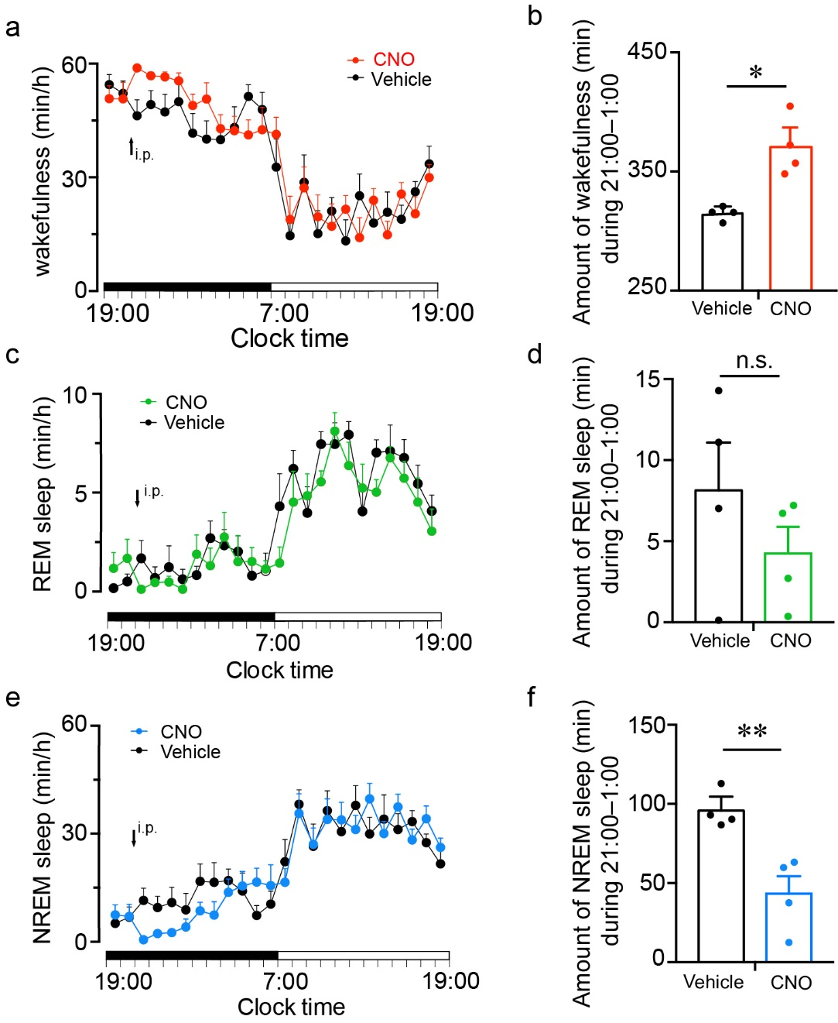
Supplementary Fig 2. Chemogenetic activation of PVH^{vglut2} neurons during the dark phase increases wakefulness. a-c Time course of wakefulness, NREM sleep, and REM sleep following injection of vehicle or CNO in mice expressing hM3Dq receptor in PVH^{vglut2} neurons (n = 4, repeated-measures ANOVA; F_{1, 6}= 0.83 [wake], 0.51 [NREM], 0.91 [REM]; P = 0. 40 [wake], 0.50 [NREM], 0.38 [REM]). d-f Total time spent in each stage for 12 h after vehicle or CNO injection (n = 4, paired t test; P = 0.02 [wake], 0.01 [NREM], 0.26 [REM]). Data represent the mean ± SEM (*P < 0.05, **P < 0.01, n.s. means no significant difference).
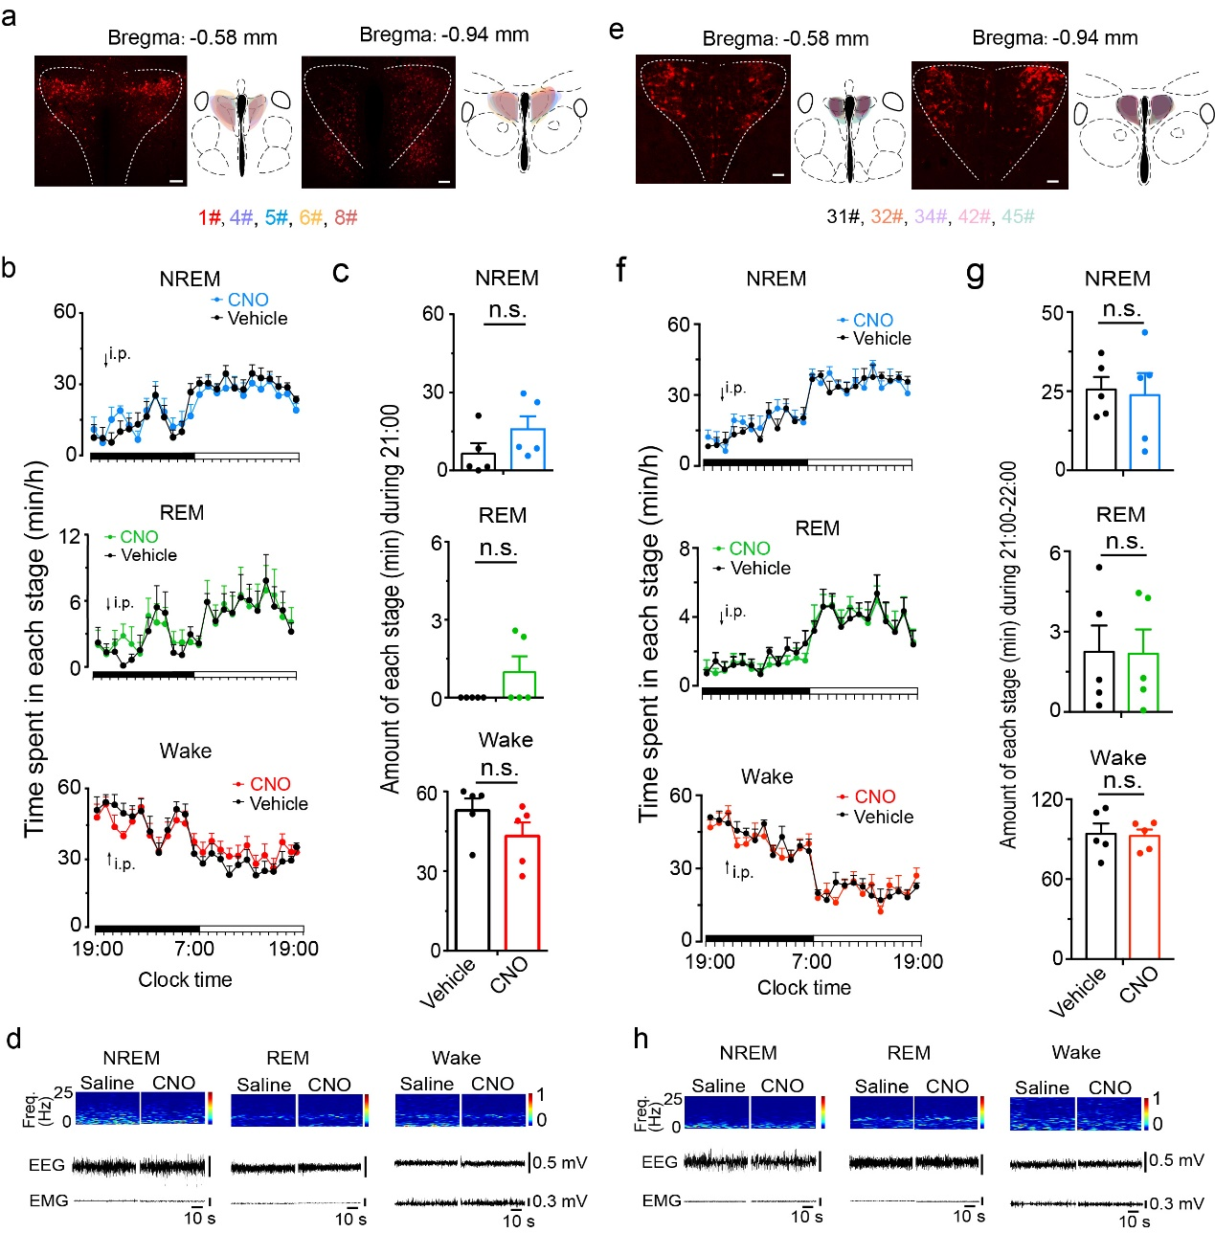
Supplementary Fig 3. Chemogenetic inhibition of PVH^{CRH} or PVH^{AVP} neurons during the dark phase has no effect on sleep and wakefulness. a, e Location of hM4Di expression in the PVH^{CRH} and PVH^{AVP} neurons. b, f Time course of wakefulness, NREM sleep, and REM sleep following injection of vehicle or CNO in mice expressing hM3Dq receptor in PVH^{CRH} neurons (b, n= 5, repeated-measures ANOVA, F_{1,8}= 0.279 [wake], 0.861 [NREM], 0.36 [REM]; P = 0.52 [wake], 0.39 [NREM], 0.87 [REM]) and PVH^{AVP} neurons (f, n = 5, repeated-measures ANOVA; F_{1,8}= 0.279 [wake], 0.190 [NREM], 0.57 [REM]; P = 0.61 [wake], 0.68 [NREM], 0.87 [REM]). c, g Total time spent in each stage after vehicle or CNO injection to CRH-IRES-cre mice (n = 5, paired t test, P = 0.19 [wake], P = 0.36 [NREM], P = 0.14 [REM]), AVP-IRES-cre mice (n = 5, paired t test, P = 0.19 [wake], P = 0.36 [NREM], P = 0.14 [REM]). d, h Representative EEG power spectra and EEG-EMG traces of wakefulness, NREM and REM sleep after injection in CRH-Cre mouse (d) and AVP-Cre mouse (h). Data represent the mean ± SEM (*P < 0.05, **P < 0.01, n.s. means no significant difference).
Supplementary Fig 4. Model of the PVH control of wakefulness. Left: Increased levels of PVH^{vglut2} neurons projecting to the PB and the LSv, thereby activating PB and LSv neurons to control wakefulness. Top right: Decreased activity of PVH^{vglut2} neurons leads to sleep. Bottom right: The impairment of PVH neurons in neurological diseases may be associated with hypersomnolence.

