Supplementary Information for

**Universal Light-Driven Micro/Nanoscale** **Rotors**

Hongru Ding, Pavana Siddhartha Kollipara, Abhay Kotnala, Zhihan Chen, Yuebing Zheng*

*Correspondence to: [zheng@austin.utexas.edu](mailto:zheng@austin.utexas.edu)

Materials and Methods

Materials

PEG 20000, PBS solution and 11-Mercaptohexanoic acid were purchased from Sigma-Aldrich. PS microparticles (2.8 and 1 µm) with Streptavidin ligands, 40-nm fluorescent nanobeads with biotin ligands, and 2-µm silica particles were purchased from Thermo Fisher Scientific. 500 and 300 nm PS particles were purchased from Bangs Laboratories.

Substrate preparation

The plasmonic substrates were fabricated by a three-step process. 4.5 nm Au films were thermally deposited on glass slides at a base pressure of 8×10-6 torr. Then, the Au films were annealed at 550 °C for 2 h. Finally, the substrates were immersed in 1 mM 11-Mercaptohexanoic acid (solvent: ethanol) at room temperature for 24 h, followed by rinsing with DI water and drying under nitrogen stream.

Janus particle preparation

PS nanoparticles diluted in DI water were spin-coated on a glass slide to form a monolayer of nanoparticles. A layer of Au film with a thickness of 15 nm was thermally deposited (8×10-6 torr) on the monolayer of particles to create the Janus particles. The Janus nanoparticles were detached from the glass and redispersed in PEG/PBS solutions.

Fluorescent labeling

2.8 µm and 1 µm PS particles were diluted with 5% PBS solution by 1000 times. 1 µL fluorescent nanobeads solution was added into 1 mL of the PS particle solution. The mixed solution was stored at 4 °C for 12 h, followed by centrifugation at 8,000 rpm for 5 min at room temperature. The particles were redispersed into PEG/PBS solutions. For 1 µm PS particles with zeta potentials of -38 and -23 mV, the concentrations of PBS solutions for incubation are 10% and 50%, respectively.

FEA simulations

We used a FEA software (COMSOL Multiphysics ver. 5.4a) to simulate the temperature distribution and electrical potential. Laser heating was modelled as heat influx with a Gaussian laser beam profile with laser power, beam width and absorptivity as the inputs to define a Gaussian heating source at the bottom edge of the simulation domain. A particle on a substrate was introduced, with varying positions from the laser beam axis. The temperature on the substrate and on the particle surface was obtained as discreet dataset from COMSOL. The differential element of thermo-electrokinetic force was evaluated in MATLAB (ver 2020). Modelling details are shown in Supplementary Note 3 regarding the modelling framework, governing equations, and boundary conditions.

MD simulations

We performed MD simulations for Soret coefficients using the LAMMPS package with a time step of 1 fs at 300 K and ambient pressure. Periodic boundary conditions were applied in all directions. The rigid SPC/E model (*1*) was used for water molecules. Widely used TIP4P model (*2*) was also tested. All-atom optimized potentials for liquid simulations (OPLS-AA) force field (*3, 4*) were used in all simulations. The long-range electrostatic forces were computed with the P3M method. Lorentz-Berthelot mixing rule was applied for all pairwise LJ terms. The cut-off distance in the LJ potential was set to 2.5 $σ$. 200 ns non-equilibrium molecular dynamics (NEMD) simulations in the canonical ensemble were used to record simulation data after the structure relaxation in the isothermal–isobaric ensemble, followed by 1 ns microcanonical ensemble. Langevin thermostats were coupled with water molecules in the middle and boundaries of the system to generate temperature gradients. To obtain meaningful statistics, for each set of parameters, 8 independent simulations were performed.

FDTD simulation

We used finite-difference time-domain method (Lumerical Inc.) to calculate optical forces and torques. The refractive index of the PS particles was set as 1.58, and the permittivity of the Au films was taken from Johnson and Christy (*5*). The optical forces and torques were calculated through the Maxwell stress tensor (MST) at an excitation wavelength of 660 nm. The mesh size in the simulation was set as 5 nm.

Optical setup

A 660 nm laser beam (Laser Quantum, Ventus) and a 532 nm laser beam (Coherent, Genesis MX STM-1W) were expanded with a 5× beam expander (Thorlabs, GBE05-A) and directed to a Nikon inverted microscope (Nikon Ti-E) with a ×100 oil objective (Nikon, NA 0.5–1.3) for the rotor experiments inside a microfluidic chamber of ~120 µm thickness. For the dark-field optical imaging, an air condenser was used to focus the incident white light onto the sample from the top. A color charge-coupled device (CCD) camera (Nikon) was used to record the optical images.

Fluorescent intensity and RGB signal analysis

The fluorescence and dark-field scattering images of the particles were extracted from the recorded videos of the rotating particles. A region-of-interest (ROI) encircling the whole particle was defined to record the periodic variation in the average fluorescence intensity and RGB intensity arising from the change in fluorescence and scattering signals from the particle due to its rotation. The periodic signal change was used to estimate the rotation rate of the particle. Each frame is decomposed into red, green, and blue channels and the average values in each channel are plotted as a function of frame number (or time). A dip in the green channel correlates well with a peak in the red channel, which indicates the rotation of the particle.

**Supplementary Movies**

**Supplementary Movie 1.** Rotation of a 2.8 μm PS particle under a bright-field optical microscope. The wavelength of the laser beam is 532 nm.

**Supplementary Movie 2****.** Rotation of a 2.8 μm PS particle labelled by fluorescent nanobeads.

**Supplementary Movie 3.**Trapping and immobilization of a 2.8 μm PS particle on a bare Au film substrate.

**Supplementary Movie 4.**Rolling and trapping of a 1 μm PS particle with a zeta potential of – 38 mV.

**Supplementary Movie 5.**Rolling, trapping, and printing of a 1 μm PS particle with a zeta potential of – 23 mV.

**Supplementary Movie 6.** Rotation of a 1 μm PS particle with a zeta potential of – 47 mV.

**Supplementary Movie 7.** Rotation of a 500 nm PS/Au Janus particle.

**Supplementary Movie 8.** Rotation of a 300 nm PS/Au Janus particle (one-third original speed).

**Supplementary Movie 9.** Rotation of a yeast cell.

**Supplementary Movie 10.** Rotation of a B. subtilis.

**Supplementary Movie 11.** Rotation of a dimer consisting of two 2 μm silica particles.

**Supplementary Movie 12.** Rotation of a trimer consisting of three 1 μm PS particles.

**Supplementary Movie 13.** Rotation of a hexamer consisting of six 2 μm silica particles.

**Supplementary Movie 14.** Rotation of a yeast cell with controlled angles and rotation axes (two-time original speed).

Supplementary Figures

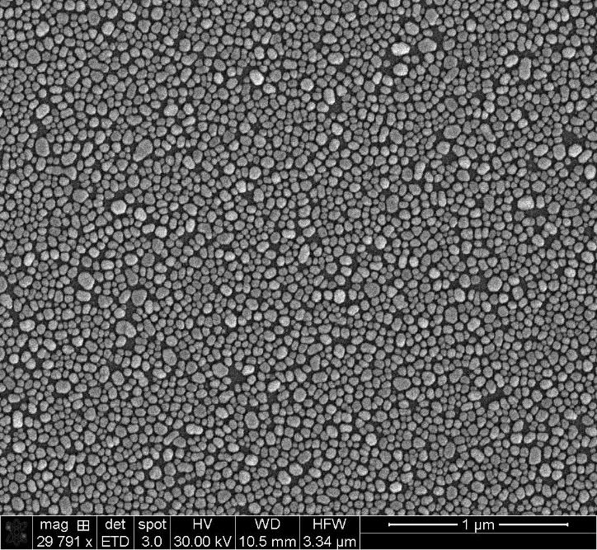

**Supplementary Figure 1**

Scanning electron micrograph of a porous Au film substrate.

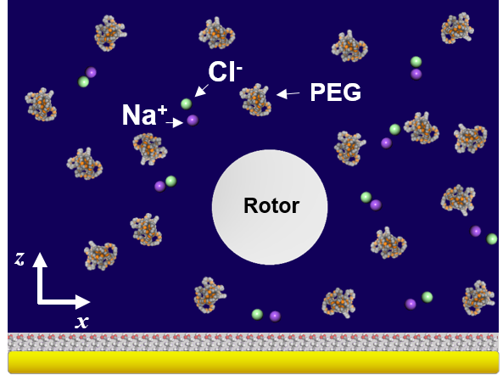

**Supplementary Figure 2**

Schematic illustration of a random distribution of Na+ and Cl- ions, and PEG molecules, along with uniformly distributed surface charges on the substrate and particle, in a uniform temperature field.

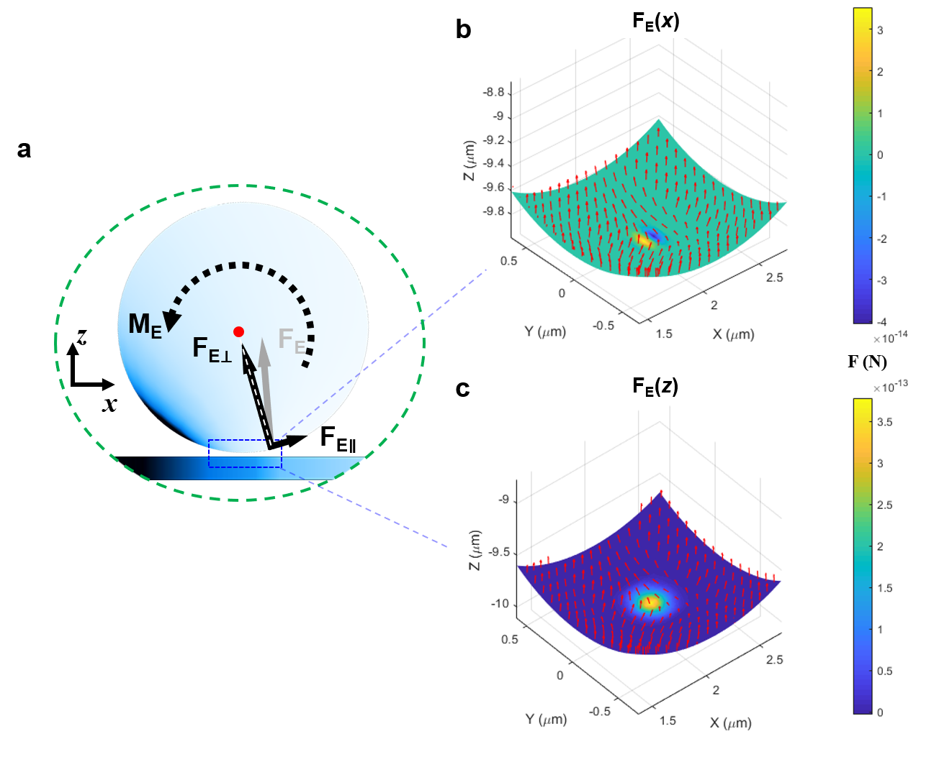

**Supplementary Figure 3**

**a**, Schematic of the decomposition of the thermo-electrokinetic force, **FE**, into a force, **FE⊥**, which passes through the centroid (red circle) of the particle and a force, **FE∥**, which drives the torque, **ME =** a $⋅$**FE∥**. Simulated distributions of *x* (**b**) and *z* (**c**) components of the thermo-electrokinetic force acting on the bottom of a 2.8-µm PS particle. The color bars show the magnitude of these forces (the negative values in the color bar of **b** correspond to the forces pointing toward -*x* axis). The red arrows mark the total **FE** at each point. The laser beam heating the substrate has an optical intensity of 78.4 µW.

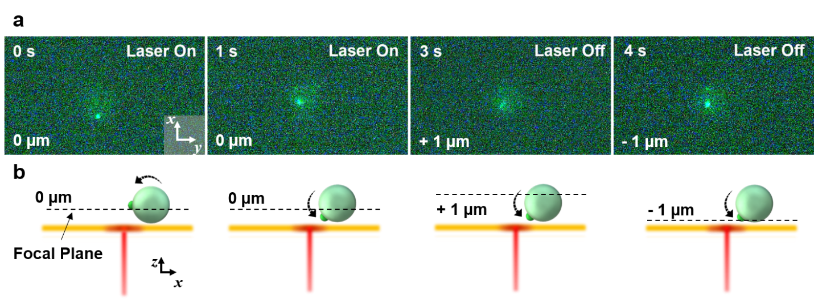

**Supplementary Figure 4**

Experimental measurement of the rotation direction. **a**, Successive fluorescence images of a rotating 2.8-µm PS particle taken at various focal planes. Initially, the fluorescent nanobead on the particle was at the focal plane (imaging plane). After rotation of particle for 1 s, the nanobead moved slightly out of the focal plane. To determine the rotation direction, laser was turned off and the focal plane was moved 1 µm above and below the current focal plane. The nanobead image went further out of focus for +1 µm, and came into focus for -1 µm, confirming the rotation direction illustrated in **b**.

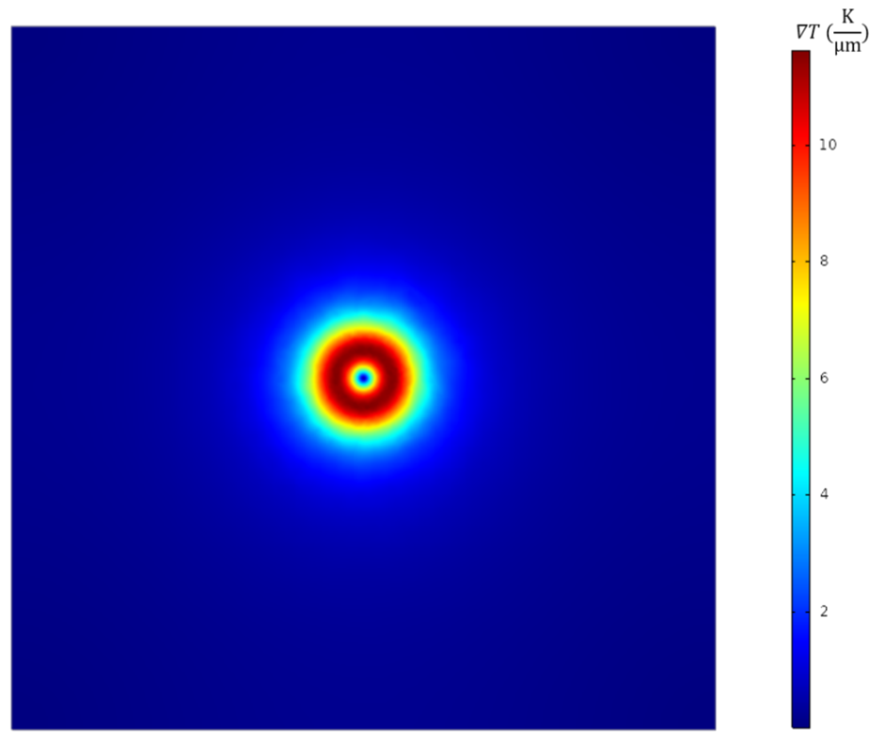

**Supplementary Figure 5**

Simulated temperature gradient distribution in *xy* plane.The side length is 20 µm.

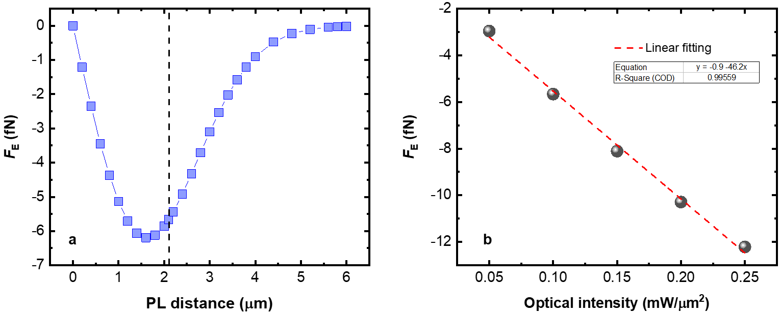

**Supplementary Figure 6**

The dependence of thermo-electrokinetic force, *F*E, on the PL distance and optical intensity. **a**, Simulated thermo-electrokinetic force on a 2.8-µm PS particle as a function of PL distance in 5% PEG/5% PBS solution. *F*E at the critical PL distance, 2.1 µm, is -5.66 fN. The optical intensity was set to 0.1mW/ $μm^{2}$. **b**, Simulated *F*E at the critical PL distance increases linearly with the optical intensity of the laser beam.

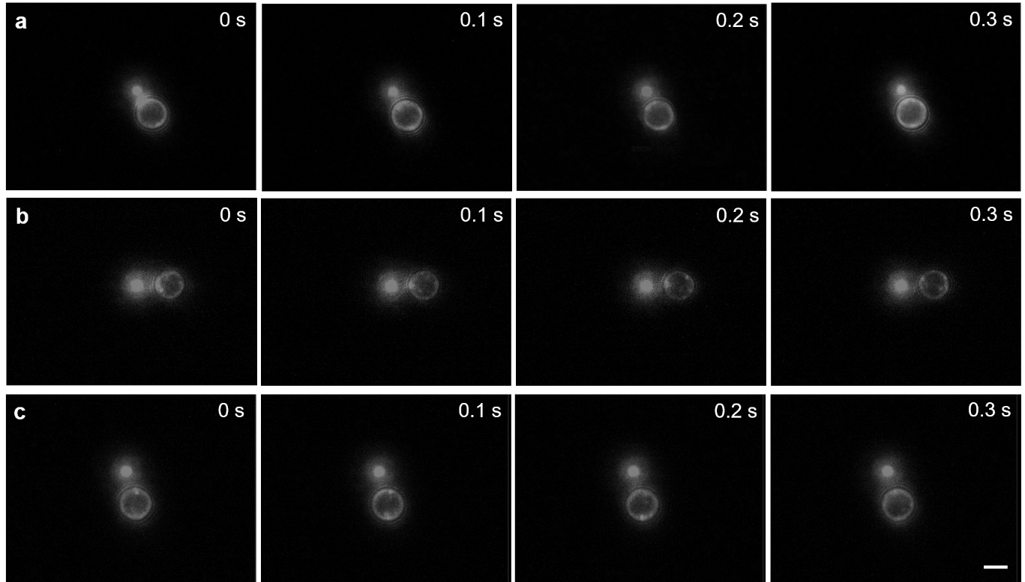

**Supplementary Figure 7**

Dependence of critical PL distance on PEG concentration. Successive fluorescence images of a rotating 2.8-µm PS particle in 5%PBS solution with 5% (**a**), 10% (**b**), and 15% (**c**) PEG and the critical PL distances: of 2.2 µm, 2.6 µm, and 2.9 µm, respectively. Scale bar: 2 µm. A 532 nm laser beam was used for the rotation experiments.

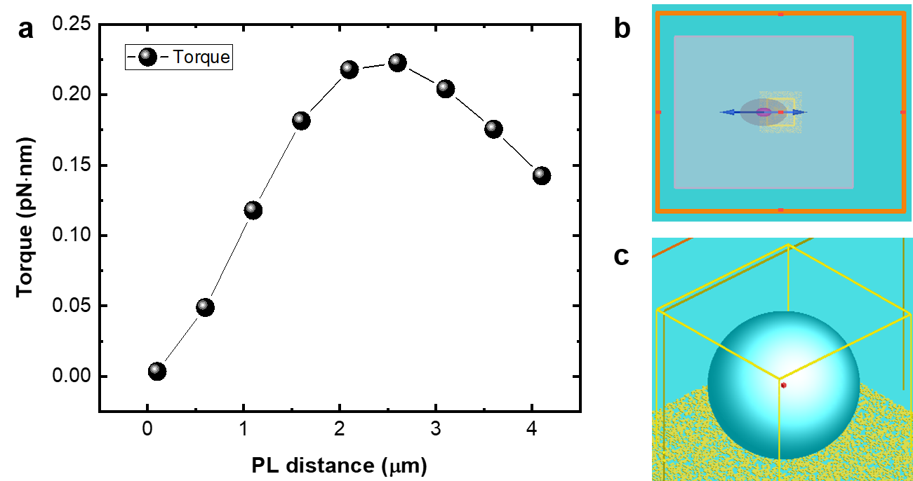

**Supplementary Figure 8**

Calculated optical torque as a function of PL distance. **a**, a FDTD simulation was performed to calculate the optical torque of a 2.8-µm PS particle on porous Au film under the illumination of a 660 nm laser beam at 78.4 µW. **b-c**, 2D and 3D models of the FDTD simulation.

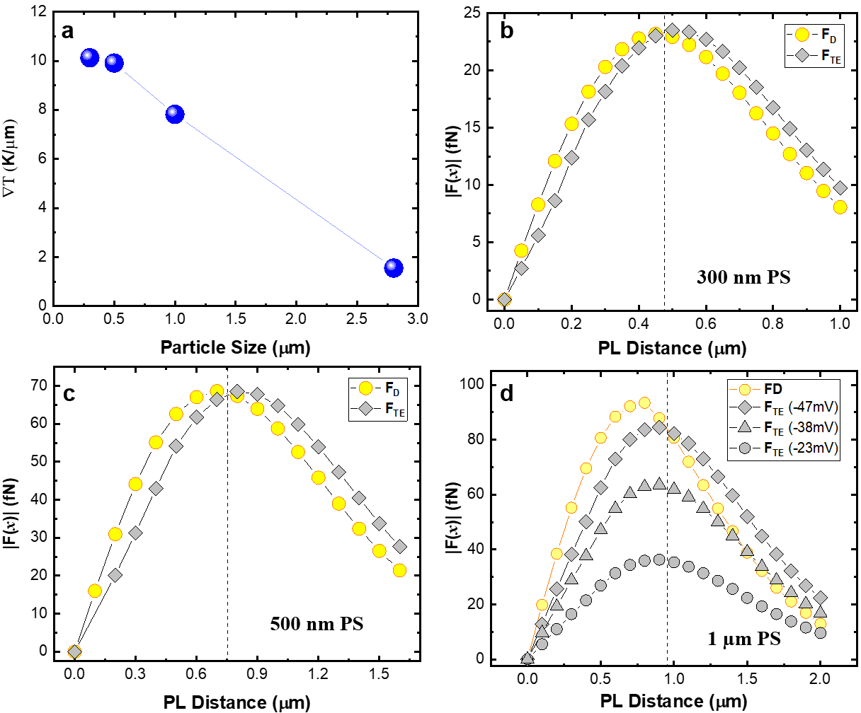

**Supplementary Figure 9**

**a**, Simulated temperature gradient on the substrate versus the position of the center of PS particles with different sizes (data extracted from Supplementary Fig. 5). Simulated depletion (FD) and TE (FTE)forces on PS particles along *x* axis for (**b**) 0.5 µm PS particle and (**c**) 0.3 µm PS particle, respectively. The critical PL distance shifts from 0.95 to 0.48 µm with a decreased particle size. The zeta potentials of the PS particles were set as -47 mV. (**d**) Simulated depletion (FD) and TE (FTE)forces (along x axis) on 1-µm PS particles with zeta potentials of -47, -38, and -23 mV as a function of PL distance in 5% PEG/5% PBS solution. Dashed lines mark the critical PL-distances.

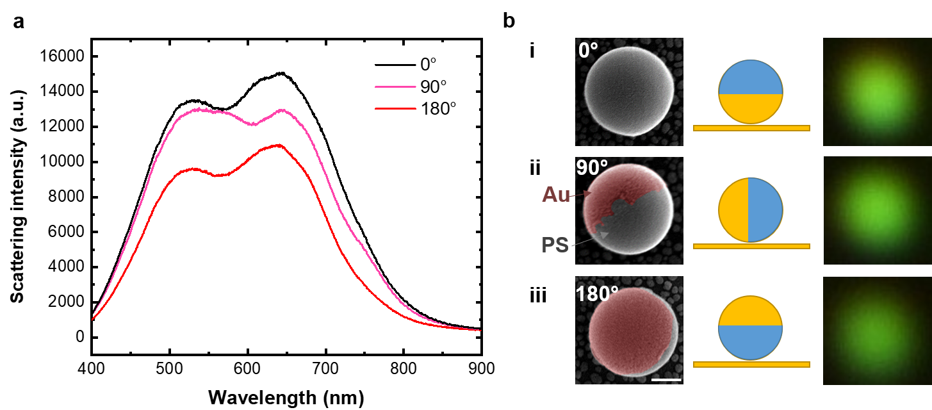

**Supplementary Figure 10**

**a**, The scattering spectra of 300-nm PS/Au Janus particles with gold cap oriented at different angles with respect to the substrate. **b**, The scanning electron micrographs, schematics, and dark-field optical images of the Janus particle with the three different orientations, i.e., 0° (i), 90° (ii), and 180° (iii). Scale bar: 100 nm.

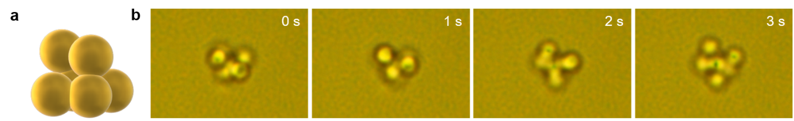

**Supplementary Figure 11**

Rotation of a hexamer made of six 2-µm silica particles. **a**, schematic of the silica hexamer. **b**, successive optical images of the rotation process. Scale bar: 2 µm.

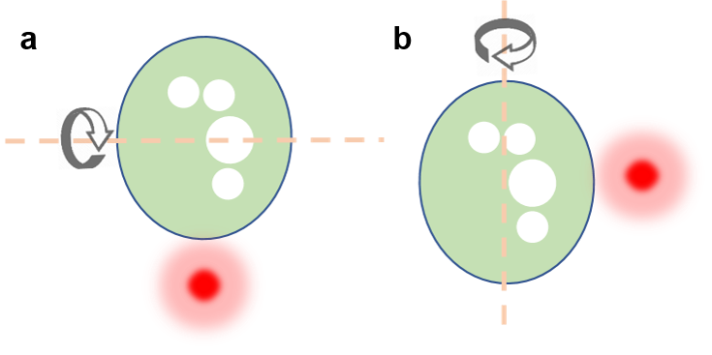

**Supplementary Figure 12**

Schematic illustrating the control of the rotation axis of a yeast cell by the position of laser beam around the cell (see Supplementary Movie14). A yeast cell can rotate by its short axis (**a**) and long axis (**b**), respectively, when we control the position of laser beam (red circle). The white circles represent the organelles inside the cell.

**Supplementary Notes**

Note 1: Zeta potential and surface zeta potential measurements

Dynamic light scattering (DLS) measurements were performed on Malvern Zetasizer Nano ZS equipped with a 633 nm laser in a backscattering configuration. For the zeta potential of colloids, samples were loaded into a pre-rinsed folded capillary cell and measured at 25-65 °C at an applied voltage of 150 V. The surface zeta potential of the plasmonic substrates was measured in two steps. We cut a large substrate into rectangular pieces of 6 mm × 4 mm using dicing saw (Disco 321 Wafer Dicing Saw) and loaded the surface zeta potential cell with one piece of the substrate. We inserted the cell (MS ZEN3600, Malvern Panalytical) into the target PEG/PBS solutions containing tracer particles (i.e., 300 nm PS particles) and measured the potentials at six positions

with distance of (125, 250, 375, 500, 625, and 1000 µm) away from the substrate (Supplementary Fig. 13a). For distances between 125-625 µm, the mobility of tracker particles is the balance between the electro-osmosis and electrophoretic force. At the distance of 1000 µm where an electrophoresis-dominated motion happens, we can measure the zeta potential of the tracker particles. The surface zeta potential is given by

$$ζ_{surface}=-Intercept+ζ_{tracker} (S1)$$

where $Intercept$ is calculated from the the first four measurements, $ζ_{tracker}$ is the zeta potential of the tracker particle. The dependence of the surface zeta potential of Au film with carboxylic acid coating on temperature was investigated. As shown in Supplementary Fig. 11b, the magnitude of $ζ_{surface}$ linearly decreases with temperature. BareAu film shows a much weaker surface charge around -10 mV at 25 °C.

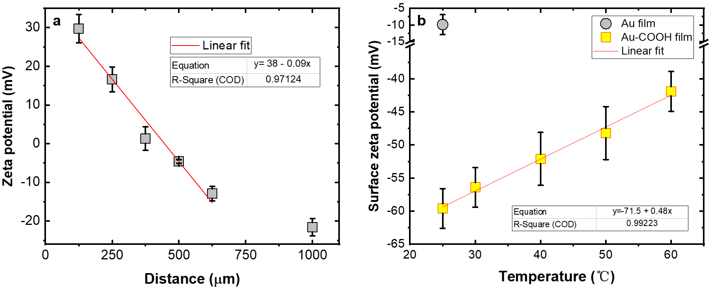

**Supplementary Figure 13**

Measured surface zeta potentials of Au film with and without carboxylic acid coating. **a**, measured zeta potential at different distances from the surface of Au film with carboxylic acid coating immersed in 15%PEG/5%PBS solution. **b**, Measured surface zeta potential of Au film with carboxylic acid coating as a function of temperature and the surface zeta potential of bare Au film at 25 °C. The red lines are linear fittings with the fitting equations shown in the figures (R-Square (COD) is the coefficient of determination).

Note 2: Temperature measurements

Temperature profiles were obtained through thermal imaging with quadriwave shearing interferometry (TIQSI) (*6*). A thermal imaging camera (SID4-HR, Phasics) was coupled to an inverted microscope (Nikon Ti-E) with an ×100 oil objective. Thermal images were recorded using a SIDFTHERMO software (Phasics).Note that we utilized DI water as a medium for temperature measurements due to the availability of refractive index of PEG/PBS solution in the software. This measurement is still valid because there is a small difference between the thermal conductivity of PEG/PBS solution and that of water. The thermal conductivity of a PEG solution can be calculated by $λ_{PEG solution}=\left(\frac{λ_{PEG}}{λ_{EG}}\right)*x+λ_{water}*(1-x)$ (*7*), *x* is the weight percentage of PEG 20000 in PEG solution, $λ_{PEG}$, $λ_{EG}$, and $λ_{water}$ are the thermal conductivity of PEG, ethylene glycol, and water, respectively. Substituting the thermal conductivity data (*8, 9*) and weight percentages of PEG (5%-15%), we obtained $λ_{PEG solution}$, 0.56 ~ 0.59 W/m·k, which is very close to the value of water, 0.6 W/m·k.

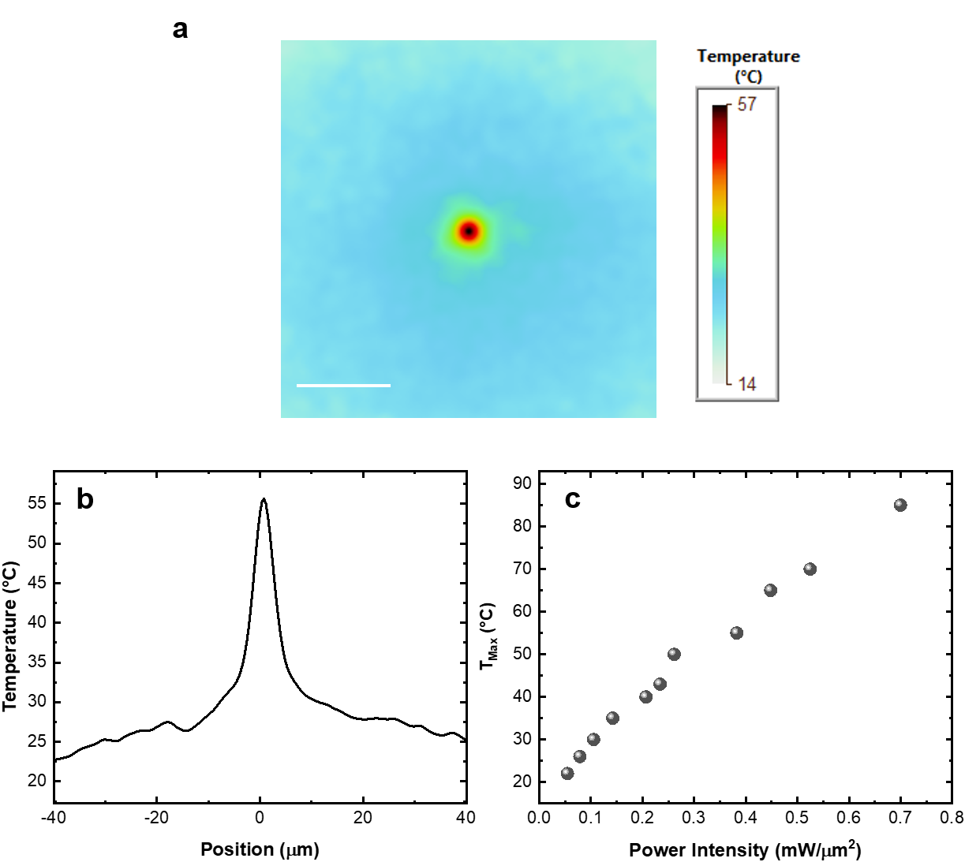

**Supplementary Figure 14**

Measured two-dimensional (**a**) and one-dimensional (**b**) temperature distributions on the substrate at an optical power intensity of 253.2 $μW$. Scale bar: 20 $μm$. **c**, Maximum temperature as a function of the power intensity of laser beam.



**Supplementary Figure 15**

Measured zeta potentials of 2.8-µm PS particles a function of temperature.The PS particles were dispersed in 5%PEG solutions with PBS concentration ranging from 5% to 15%. The temperature ranges from 25 to 65 °C.

Note 3: Temperature and solute concentration modeling

The simulation domain and mesh are shown in Figure S16. Pre-defined modules in COMSOL (Ver. 5.4a) were used to solve for the heat transfer equations in the fluid domain. The input heat flux is a gaussian beam source defined with respect to position as

|  |  |  |
| --- | --- | --- |
|  | $$HF(x,y)=\frac{2αP_{laser}}{πw_{0}^{2}}e^{-\left(\frac{d^{2}}{2w_{0}^{2}}\right)}$$ | (S2) |

where $α$ is the absorptivity of the gold nanoislands (0.2), $P_{laser}$ is the laser power, $w_{0}$ is the beam spot size at the substrate, and d is the radial distance from the laser beam axis (0,0) to (*x*,*y*) on the substrate. The temperatures at all other interfaces were set at 20 °C. Heat generated due to viscous dissipation of the natural convection is neglected and there is no volumetric heat generation term due to absence of heat sources present. The simplified governing equation is given as

|  |  |  |
| --- | --- | --- |
|  | $$∇\left(-k∇T\right)=0$$ | (S3) |

where $k$ is the thermal conductivity of the particle. The boundary conditions are given as

|  |  |  |
| --- | --- | --- |
|  | $q=-HF\hat{n}$ (substrate)  T = 291.15 K (all other boundaries) | (S4) |

Then, the simulated temperature was utilized to evaluate the three types of optothermal forces acting on the particle.

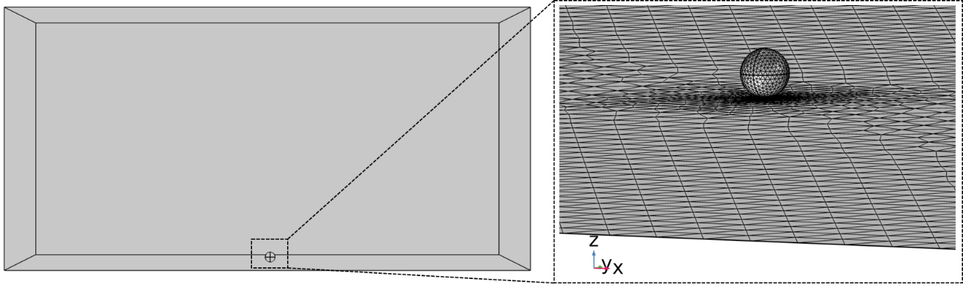

**Supplementary Figure 16**

COMSOL simulation domain and mesh.

Note 4: Optothermal force analysis

Electrokinetic force and torque: The zeta potential obtained as a function of temperature was utilized to define the surface charge on the substrate and the sphere using the relation

|  |  |  |
| --- | --- | --- |
|  | $$σ_{s}=\frac{2ϵζ_{s}}{λ}$$ $$σ_{p}=\frac{ϵζ_{p} }{a}$$ | (S5) |

where $σ$, $ζ$ denote the surface charge density and zeta potential, respectively. The subscripts s and p indicate the substrate and particle, respectively. $λ$ and $a$ indicate the Debye length and radius of the particle, respectively, and $ϵ$ is the dielectric constant of water. The electric field ($E$) exerted by a differential charge on the substrate ( $σ_{s}dA=σ_{s}dxdy)$ located at $\left(x_{s},y_{s},z_{s}\right)$ on the particle at a location $(x_{p},y_{p},z_{p})$ is defined as

|  |  |  |
| --- | --- | --- |
|  | $$dE=\left(\frac{σ_{s}dA}{4ϵr}\right)\left(\frac{1}{r}+\frac{1}{λ}\right)e^{-r/λ}\hat{r}$$ | (S6) |
|  | $$r=\left(x_{p}-x_{s}\right)\hat{i}+\left(y_{p}-y_{s}\right)\hat{j}+\left(z_{p}-z_{s}\right)\hat{k}$$ | (S7) |
|  |  | (S8) |
|  | $$\hat{r}=\frac{r}{r}$$ | (S9) |

where $r$ defines the vector between the differential element and point on the particle. The differential force on the particle is given as

|  |  |  |
| --- | --- | --- |
|  | $$dF_{E}=σ_{p}dA_{p}\int_{x→ -∞}^{x→∞}{\int_{y→ -∞}^{y→∞}{{dE}_{∥}}}$$ | (S10) |

where $dA_{p}$ is the differential area element on the particle surface given as $asin\left(θ\right)dθdϕ$, $θ$ and $ϕ$ being the polar and azimuthal angles, respectively, and $E_{∥}$ is the parallel component of the electric field given as

|  |  |  |
| --- | --- | --- |
|  | $$E_{∥}=E-\left(E.\hat{n}\right)\hat{n}$$ | (S11) |

with $\hat{n}$ defined as the normal vector on the particle surface expressed in terms of the particle coordinates and particle center $\left(x_{0},y_{o},z_{0}\right)$ as

|  |  |  |
| --- | --- | --- |
|  | $$\hat{n}=\frac{x_{p}-x_{0}}{a} \hat{i}+\frac{y_{p}-y_{0}}{a} \hat{j}+\frac{z_{p}-z_{0}}{a} \hat{k}$$ | (S12) |

The electrokinetic force ( $F_{E})$ is obtained by integrating equation (S10) over the particle surface

|  |  |  |
| --- | --- | --- |
|  | $$F_{E}=\oint{dF_{E}}$$ | (S13) |

Depletion force: PEG 20000 molecules have a large size, which results in a low Stokes diffusion coefficient, and thus a large Soret coefficient, $S_{T,PEG}$. The large $S_{T,PEG}$ gives rise to a high concentration gradient across the particle due to the temperature gradient. The COMSOL model is extended using a General Form PDE module (Mathematics/PDE Interfaces) to couple the temperature distribution and concentration of PEG using flux equations as

|  |  |  |
| --- | --- | --- |
|  | $$Γ=-∇c_{PEG}-c_{PEG}S_{T,PEG}∇T$$ | (S14) |
|  | $$∇.Γ=0$$ | (S15) | |

where the PEG flux ( $Γ)$ and concentration ($c_{PEG}$) were obtained throughout the simulation domain. The osmotic pressure exerted on the particle is given as $c_{PEG}k_{B}T$ along $-\hat{n}$ on the particle surface ($k_{B}$, Boltzmann constant). The net depletion force on the particle was obtained via the integration of the osmotic pressure on the surface as

|  |  |  |
| --- | --- | --- |
|  | $$F_{D}=-\oint{c_{PEG}k_{B}T}dA_{p}\hat{n}$$ | (S16) |

Thermoelectric (TE) force: TE force was evaluated in a similar fashion as the thermo-electrokinetic force by integrating the parallel component of the TE field due to the differential motion of the sodium and chlorine ions under a temperature gradient. The TE field is represented as a function of local temperature gradient, local concentration of the salt, and the Soret coefficients of individual ions of the binary electrolyte, which is expressed as

|  |  |  |
| --- | --- | --- |
|  | $$E_{TE}=\frac{k_{B}T∇T}{e}\left(\frac{c_{Na}S_{T,Na}-c_{Cl}S_{T,Cl}}{c_{Na}+c_{Cl}}\right)$$ | (S17) |

where *T* and $∇T$ represent the temperature and temperature gradient, respectively; $c$ and $S_{T}$ represent the concentration and Soret coefficients of ions, respectively, where the subscript *T* indicates sodium ($Na$) and chlorine ($Cl$) ions, respectively.

Note 5: Torque and rotation rate analysis

The thermo-electrokinetic torque on a spherical particle is given as,

|  |  |  |
| --- | --- | --- |
|  | $$M_{E}= \oint{a\hat{n}×dF_{E}}$$ | (S18) |

We should note that *x* and *z* components of the torque will be negligible (numerical error) compared to the *y* component due to symmetric temperature distribution about *y* axis. The thermo-electrokinetic torque along *y* direction is balanced by the Stokes drag to obtain the simulated rotation rate of the particle according to

|  |  |  |
| --- | --- | --- |
|  | $$ω=a^{3}υρϕ\left(d\right)/M_{d}$$ $$ϕ\left(d\right)=C (0.4\log\left(\frac{a}{a-d}\right)+0.37)$$ | (S19) |

where $M_{d}$ is hydrodynamic torque, $a$ is the radius of the particle, and $υ$ and $ρ$ are the kinematic viscosity and density of the solution, respectively. $ϕ\left(d\right)$ is the correction factor of wall effect (*10*); $d$ is the distance between rotor and the plane, which was estimated as 30 nm considering the balance among the electrostatic repulsion force, depletion force, and the van der Waals force (*11*); $C$ is a constant, 0.21, adopted from Ref 11 (*12*). The solution dynamic viscosity, $η=υρ$, is given as below (*13*):

$$\frac{η}{η_{0}}=1+\frac{bx}{1-hx} (S20)$$

where $η_{0}$ is the solvent dynamic viscosity, $x$ is the solute mole fraction, $b$ is the solute-solvent interaction coefficient, and $h$ is the hydration number. According to the Ref. 14, $b$ and $h$ of PEG 20000 are 48, and 3.6, respectively. Substituting Eq. S20 into Eq. S19, we obtained the theoretical rotation rate as shown in Fig. 4**a**.

Note 6: Role of different forces in the rotor

To examine the contribution of TE force to the rotation behavior, we removed the Na+ and Cl- ions (i.e., no PBS was added to the solution), which resulted in the decrease in the force magnitude and the reversal of the force direction (Supplementary Fig. 17a). Specifically, in the absence of ions, TE field arises only from the thermal polarization of water molecules in an aqueous solution. Such a TE field points toward the cold region and is weaker than the TE field in a electrolyte solution (*14*). Due to the reversal of TE force on the PS particle from a repulsive force into an attractive one, the net force acting on the particle along the *x* axis points toward the laser beam. Therefore, the laser beam trapped and translated the particle rather than rotating it as shown in Supplementary Fig. 17a(ii). To test the role of depletion force, we did not add any PEG molecules to the solution. As a result, the attractive depletion force vanished (Supplementary Fig. 17b(i)). Driven by the repulsive TE force, the PS particle migrated toward the cold region quickly upon the illumination of a laser beam (Supplementary Fig. 17b(ii)).

We further investigated the role of thermo-electrokinetic force in rotation by directing a laser beam on a bare porous Au thin film and observing the behavior of the PS particle. The substrate without surface modification shows much lower surface charge, ~ -10 mV, compared to the substrate coated with carboxylic acid (Supplementary Fig. 12b). The resulting electrokinetic force is very small and can be ignored. As expected, no rotation of the particle was observed at the critical PL distance. Once the PL distance was shortened, the particle was trapped at the center of laser and subsequently immobilized on the substrate due to the much weaker electrokinetic interaction between the particle and the substrate (see Supplementary Movie3). Finally, the effect of optical force on the rotation was explored. We used the optical power ranging from 10 to 236 µW in experiments. The optical forces and corresponding torques due to asymmetric illumination on the particle were calculated through FDTD simulations. As shown in Supplementary Fig. 8, owing to the low optical power, the optical torque acting on the particle is too small to drive the rotation. For instance, the optical torque on a 2.8-µm PS particle generated by a laser beam (78.4 µW) at a PL distance of 2.1 µm is 0.218 pN·nm, which is one order of magnitude smaller than the thermo-electrokinetic torque. In addition, we found that the rotation direction did not change when we flipped the incidence of the laser beam, which further verifies that optical forces do not contribute to OTER.

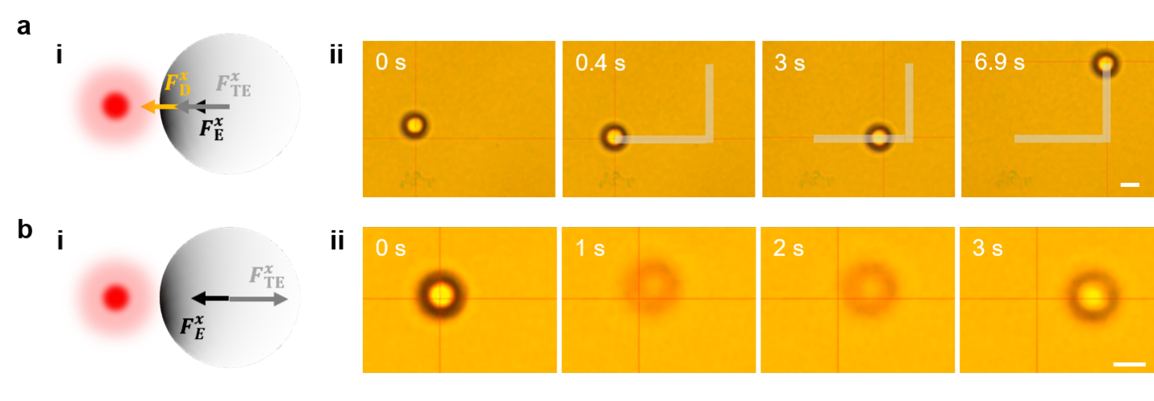

**Supplementary Figure 17**

**a**, (i) Schematic illustration of the depletion, TE and thermo-electrokinetic forces on the PS particle in a 5% PEG solution. In this case, all the forces drag the particle toward the laser beam. (ii) Successive optical images showing that the particle was trapped and transported steadily by the laser beam. **b**, (i) Schematic illustration of TE and thermo-electrokinetic forces on the PS particle in a 5% PBS solution. In this case, the thermoelectric force is dominant. (ii) Successive optical images showing that the particle was repelled from the laser beam and towards the cold region. Scale bars: 2 μm.

Supplementary References

1. H. J. C. Berendsen, J. R. Grigera, T. P. Straatsma, The Missing Term in Effective Pair Potentials. *J. Phys. Chem.* **91**, 6269-6271 (1987).

2. H. Ding *et al.*, Ultra-fast vapor generation by a graphene nano-ratchet: a theoretical and simulation study. *Nanoscale* **9**, 19066-19072 (2017).

3. W. D. Cornell *et al.*, A Second Generation Force Field for the Simulation of Proteins, Nucleic Acids, and Organic Molecules. *J. Am. Chem. Soc.* **117**, 5179-5197 (1995).

4. X. Sui *et al.*, The roles of metal-organic frameworks in modulating water permeability of graphene oxide-based carbon membranes. *Carbon* **148**, 277-289 (2019).

5. P. B. Johnson, R. W. Christy, Optical Constants of the Noble Metals. *Physical Review B* **6**, 4370-4379 (1972).

6. G. Baffou *et al.*, Thermal imaging of nanostructures by quantitative optical phase analysis. *ACS Nano* **6**, 2452-2458 (2012).

7. T. Sun, A. S. Teja, Density, Viscosity, and Thermal Conductivity of Aqueous Ethylene, Diethylene, and Triethylene Glycol Mixtures between 290 K and 450 K. *J. Chem. Eng. Data* **48**, 198-202 (2003).

8. R. DiGuilio, A. S. Teja, Thermal conductivity of poly(ethylene glycols) and their binary mixtures. *J. Chem. Eng. Data* **35**, 117-121 (1990).

9. Y. Kou *et al.*, Thermal analysis and heat capacity study of polyethylene glycol (PEG) phase change materials for thermal energy storage applications. *The Journal of Chemical Thermodynamics* **128**, 259-274 (2019).

10. Q. Liu, A. Prosperetti, Wall effects on a rotating sphere. *J. Fluid Mech.* **657**, 1-21 (2010).

11. L. Lin *et al.*, Opto-thermophoretic assembly of colloidal matter. *Sci Adv* **3**, e1700458 (2017).

12. N. Sule, Y. Yifat, S. K. Gray, N. F. Scherer, Rotation and Negative Torque in Electrodynamically Bound Nanoparticle Dimers. *Nano Lett.* **17**, 6548-6556 (2017).

13. L. Ninni, H. Burd, W. H. Fung, A. J. A. Meirelles, Kinematic Viscosities of Poly(ethylene glycol) Aqueous Solutions. *J. Chem. Eng. Data* **48**, 324-329 (2003).

14. H. Ding, P. S. Kollipara, L. Lin, Y. Zheng, Atomistic modeling and rational design of optothermal tweezers for targeted applications. *Nano Research* **14**, 295-303 (2020).