**Supplementary Information**

**Process Optimization with Acid Functionalised Activated Carbon derived from Corncob for production of *4-hydroxymethyl-2,2-dimethyl-1,3-dioxolane* and *5-hydroxy-2,2-dimethyl-1,3-dioxane***

Jaspreet Kaur1, Anil Kumar Sarma2*, Poonam Gera1, Mithilesh Kumar Jha1

1Department of Chemical Engineering, Dr. B. R. Ambedkar National Institute of Technology, Jalandhar, Punjab, India

2Chemical Conversion Division, Sardar Swaran Singh National Institute of Bio-Energy

(An Autonomous Institute of MNRE, Government of India), Kapurthala, Punjab, India

*Corresponding author: Phone: +919988425251, Email: [anil.sarma16@gov.in](mailto:anil.sarma16@gov.in)

**Results and Discussions**

**Supplementary Section I (SS-I)**

The experimental data obtained from RSM was analyzed to obtain secondorder quadratic model equations of the dependent variable i.e. RSY in terms of coded and actual factors including their interactions using multiple regression analysis for fitness of the model (Equation 1).

**Eq 1: $Y=16.64 ×A -0.90611 ×B -1.80278 ×C+0.317778 ×D+0.614375 ×A ×B -0.56813 ×A ×C -0.169438 ×A ×D -1.07813 ×B ×C -0.33438 ×B ×D -0.91438 ×C ×D -0.37956 ×A^{2}+ 0.435439 ×B^{2}- 2.31456 ×C^{2}- 5.76956 ×D^{2}$**

Where, Y = RSY, A, B, C, D are Molar ratio, time, temperature, catalyst amount, respectively.

Significance of the models was investigated by applying “F-test” (Fisher’s test) using analysis of variance (ANOVA) to estimate significance of the model, and on the basis of obtained F-values, the highest order polynomial model with significant terms was selected (Table 1).

Table 1: ANNOVA for FCCD results

|  |  |  |  |  |  |  |
| --- | --- | --- | --- | --- | --- | --- |
| **Source** | **Sum of squares** | **df** | **Mean square** | **F-value** | **p-value > F** |  |
| Model | 5563.123 | 14 | 397.3659 | 49.56877 | < 0.0001 | Significant |
| A-Molar Ratio | 4984.013 | 1 | 4984.013 | 621.7226 | < 0.0001 |  |
| B - Time | 14.77867 | 1 | 14.77867 | 1.843542 | 0.1946 |  |
| C-Temperature | 58.50014 | 1 | 58.50014 | 7.297505 | 0.0164 |  |
| D-Amount | 1.817689 | 1 | 1.817689 | 0.226745 | 0.6408 |  |
| AB | 6.039306 | 1 | 6.039306 | 0.753363 | 0.3991 |  |
| AC | 5.164256 | 1 | 5.164256 | 0.644207 | 0.4347 |  |
| AD | 45.93451 | 1 | 45.93451 | 5.730026 | 0.0302 |  |
| BC | 18.59766 | 1 | 18.59766 | 2.319935 | 0.1485 |  |
| BD | 1.788906 | 1 | 1.788906 | 0.223154 | 0.6434 |  |
| CD | 13.37731 | 1 | 13.37731 | 1.66873 | 0.2160 |  |
| A^2 | 0.373264 | 1 | 0.373264 | 0.046562 | 0.8321 |  |
| B^2 | 0.491254 | 1 | 0.491254 | 0.061281 | 0.8078 |  |
| C^2 | 13.88 | 1 | 13.88 | 1.731439 | 0.2080 |  |
| D^2 | 86.24576 | 1 | 86.24576 | 10.75859 | 0.0051 |  |
| Residual | 120.2469 | 15 | 8.016457 |  |  |  |
| Lack of Fit | 120.2469 | 10 | 12.02469 |  |  | Not significant |
| Pure Error | 0 | 5 | 0 |  |  |  |
| Cor Total | 5683.37 | 29 |  |  |  |  |

Std. Dev. - 2.831335; Mean - 52.73033; C.V. (%) - 5.369461;R2 - 0.978842; Adj. R2 - 0.959095; Pred. R2 - 0.889956; df- Degrees of freedom; F-Fisher’s variance ratio; P-probability value; P<0.05- significant at 5 % level.

High F-value (49.56877) and lower P-value (probability, <0.0001) implies the model as significant for all the variables [1]. The “lack-of-fit” was found to be non-significant which accurately specified the model validity. Coefficient of determination (R2), which denotes the proportion of variance in the response values predictable from variation in interaction between process parameters was observed as 0.978842, further indicated the fitness and high statistical significance of the model with 97.88% variation in values of dependent variables (response) as shown in Fig. 1, wherein predicted and observed values of the response have been plotted for estimating the closeness of data, which found to be in vicinity of the slope line.



Figure 1: Diagnostic plot for the experimental and predicted values of RSY for the parameters

The results obtained after conducting the complete set of 30 experiments in the form of observed values of response against coded values for acid activated carbon is shown in Table 2. High values of adjusted R2 (0.959095) and predicted R2 (0.889956) for the quadratic model were further validated significance of the model by showing a better correlation between the observed and predicted values.

Table 2: FCCD data from RSM for ketalisation reaction for acid activated carbon

|  |  |  |  |  |  |  |
| --- | --- | --- | --- | --- | --- | --- |
| **Run No.** | **X1: Molar ratio** | **X2: Time (hour)** | **X3: Temperature (oC)** | **X4: Catalyst loading (wt. % w.r.t. glycerol)** | **Y:Response (% Conversion)** | |
| **Experimental value** | **Predicted value** |
| 1. | 5 | 2 | 100 | 3 | 56.79 | 57.54728 |
| 2. | 8 | 3 | 150 | 1 | 65.05 | 65.04362 |
| 3. | 2 | 3 | 150 | 5 | 32.24 | 29.80917 |
| 4. | 2 | 1 | 50 | 5 | 37.27 | 37.81695 |
| 5. | 2 | 1 | 50 | 1 | 33.85 | 31.29515 |
| 6. | 8 | 3 | 50 | 1 | 70.04 | 70.11292 |
| 7. | 2 | 3 | 50 | 5 | 37.2 | 36.26348 |
| 8. | 5 | 2 | 100 | 3 | 56.79 | 57.54728 |
| 9. | 5 | 2 | 100 | 3 | 56.79 | 57.54728 |
| 10. | 2 | 1 | 150 | 1 | 33.48 | 32.81084 |
| 11. | 8 | 3 | 150 | 5 | 57.4 | 59.79292 |
| 12. | 5 | 2 | 150 | 3 | 55.76 | 53.42994 |
| 13. | 8 | 1 | 50 | 1 | 64.9 | 67.8714 |
| 14. | 5 | 3 | 100 | 3 | 58.68 | 57.07661 |
| 15. | 5 | 2 | 100 | 3 | 56.79 | 57.54728 |
| 16. | 5 | 2 | 100 | 1 | 53.35 | 51.45994 |
| 17. | 8 | 3 | 50 | 5 | 67.31 | 68.51973 |
| 18. | 8 | 1 | 150 | 1 | 66.34 | 67.11459 |
| 19. | 2 | 1 | 150 | 5 | 35.91 | 35.67515 |
| 20. | 5 | 2 | 100 | 5 | 51.72 | 52.0955 |
| 21. | 5 | 2 | 50 | 3 | 56.22 | 57.0355 |
| 22. | 2 | 3 | 50 | 1 | 31.41 | 31.07917 |
| 23. | 2 | 2 | 100 | 3 | 35.55 | 40.52772 |
| 24. | 5 | 2 | 100 | 3 | 56.79 | 57.54728 |
| 25. | 8 | 1 | 150 | 5 | 62.33 | 63.2014 |
| 26. | 5 | 1 | 100 | 3 | 58.8 | 58.88883 |
| 27. | 5 | 2 | 100 | 3 | 56.79 | 57.54728 |
| **28.** | **8** | **2** | **100** | **3** | **80.3** | **73.80772** |
| 29. | 2 | 3 | 150 | 1 | 26.65 | 28.28237 |
| 30. | 8 | 1 | 50 | 5 | 69.41 | 67.6157 |

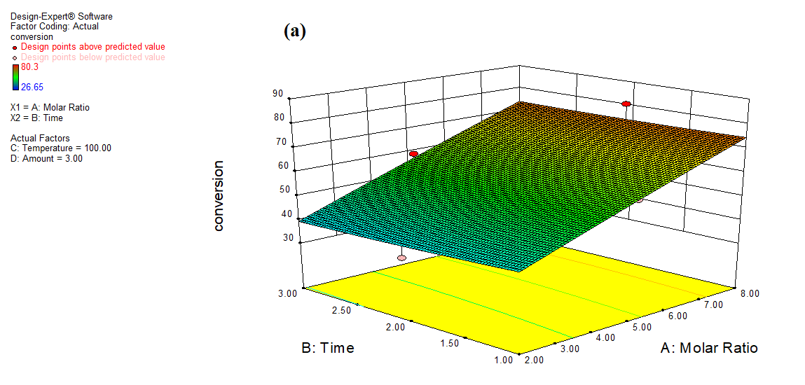

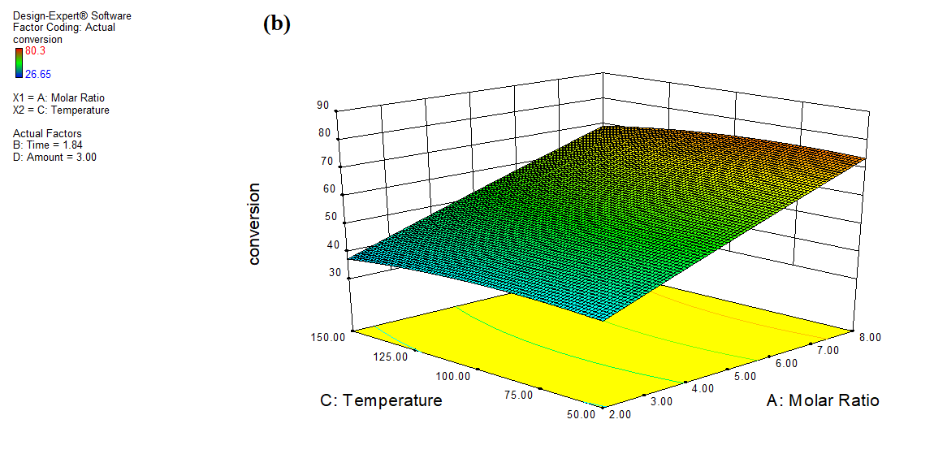

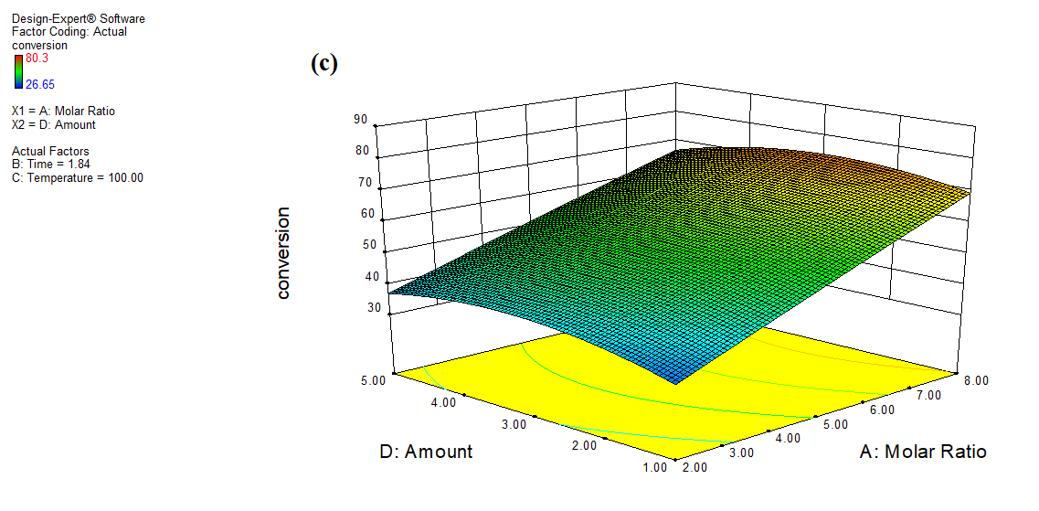

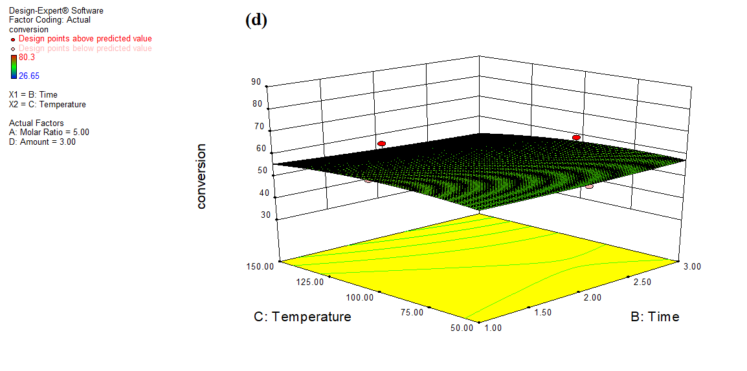

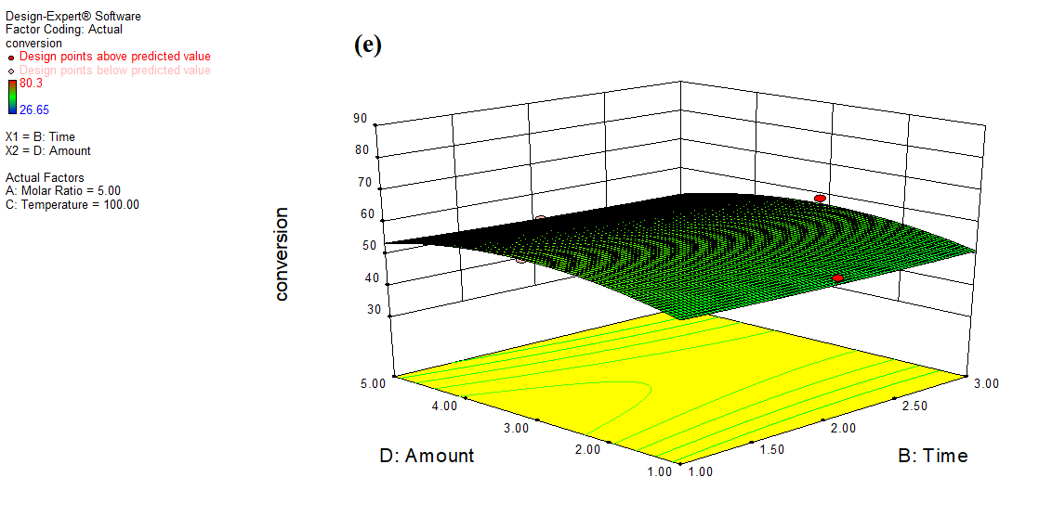

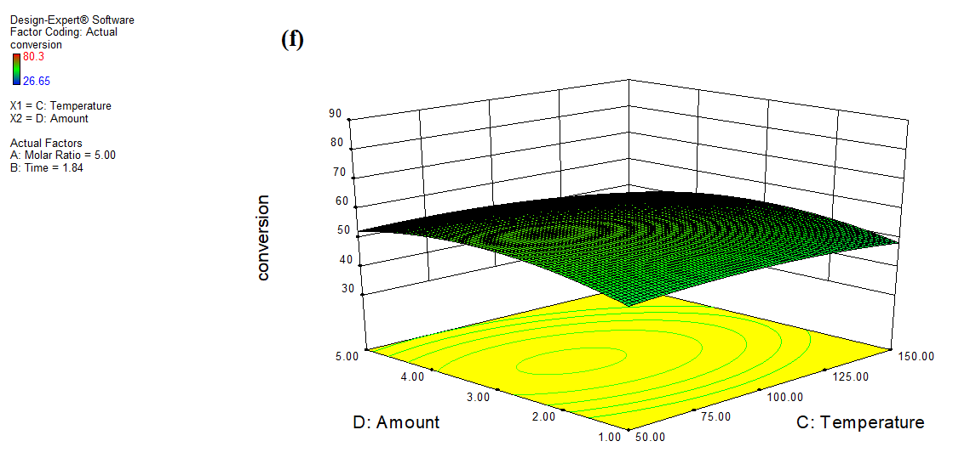

Figure 2: 3-D Plots for interaction between the process parameters for acid acivated carbon for glycerol conversion to produce solketal

**References**

[1] Arora R, Behera S, Sharma NK, Kumar S. A new search for thermotolerant yeasts, its characterization and optimization using response surface methodology for ethanol production. Front Microbiol. 2015 Sep 1;6:889. doi: 10.3389/fmicb.2015.00889.

[2] Y.H. Tan, M.O. Abdullah, C. Nolasco-hipolito, N.A. Zauzi, Application of RSM and Taguchi methods for optimizing the transesterification of waste cooking oil catalyzed by solid ostrich and chicken-eggshell derived CaO, Renew. Energy. (2017). https://doi.org/10.1016/j.renene.2017.07.024.