Table S1. Antimicrobial therapy and 90-day mortality in 71 patients with bloodstream infection caused by carbapenem-resistant Klebsiella pneumoniae
Definitive antimicrobial therapy | No. of deaths  /Total (%) | Hazard Ratio  (95% CI) | P value
Type of therapy
High-dose extended/continuous infusion  of carbapenem monotherapy | 11/31 (35.5) | Ref | -
Amikacin + carbapenem | 4/9 (44.4) | 1.20 (0.38, 3.80) | 0.76
Fosfomycin + carbapenem | 4/22 (18.2) | 0.51 (0.16, 1.60) | 0.25
Polymyxin B + carbapenem | 2/9 (22.2) | 0.74 (0.16, 3.40) | 0.70
Polymyxin B/fosfomycin based therapy vs. other therapies
Polymyxin B/fosfomycin + carbapenem | 6/31 (19.4) | Ref | -
Amikacin + carbapenem | 4/9 (44.4) | 2.11 (0.59, 7.58) | 0.25
Carbapenem monotherapy | 11/31 (35.5) | 1.76 (0.65, 4.79) | 0.26
Combination therapy vs. carbapenem monotherapy
Combination therapy | 10/40 (25.0) | Ref | -
Carbapenem monotherapy | 11/31 (35.5) | 1.39 (0.59, 3.29) | 0.45

Table S2. Predictive performance of the single predictors and the combined models for predicting 90-day mortality
Predictive model | AUC (95% CI) | Sensitivity | Specificity | Accuracy | PPV | NPV
Single predictors
Prior hospitalization within 6 months ① | 0.64 (0.55, 0.73) | 0.67 | 0.61 | 0.62 | 0.33 | 0.86
Intra-abdominal source ② | 0.68 (0.59, 0.77) | 0.67 | 0.88 | 0.79 | 0.53 | 0.85
Premature ③ | 0.58 (0.49, 0.68) | 0.71 | 0.45 | 0.65 | 0.31 | 0.82
Carbapenem-resistant isolate ④ | 0.60 (0.50, 0.69) | 0.64 | 0.56 | 0.58 | 0.30 | 0.84
C-reactive protein (stratified) ⑤ | 0.72 (0.62, 0.82) | 0.58 | 0.82 | 0.77 | 0.49 | 0.87
Albumin (stratified) ⑥ | 0.66 (0.55, 0.76) | 0.58 | 0.74 | 0.71 | 0.40 | 0.86
Lactate (stratified) ⑦ | 0.61 (0.52, 0.71) | 0.48 | 0.74 | 0.68 | 0.36 | 0.83
SOFA score ⑧ | 0.80 (0.71, 0.89) | 0.84 | 0.68 | 0.72 | 0.43 | 0.94
Adding predictors to the SOFA score
SOFA + Prior hospitalization ① | 0.86 (0.79, 0.93) | 0.78 | 0.80 | 0.79 | 0.52 | 0.92
SOFA + Intra-abdominal source ② | 0.84 (0.76, 0.93) | 0.59 | 0.96 | 0.88 | 0.79 | 0.89
SOFA + Premature ③ | 0.80 (0.71, 0.89) | 0.84 | 0.68 | 0.72 | 0.43 | 0.94
SOFA + Carbapenem-resistant isolate ④ | 0.81 (0.73, 0.90) | 0.81 | 0.76 | 0.77 | 0.49 | 0.93
SOFA + C-reactive protein ⑤ | 0.84 (0.76, 0.92) | 0.75 | 0.82 | 0.81 | 0.55 | 0.92
SOFA + Albumin ⑥ | 0.83 (0.75, 0.91) | 0.78 | 0.82 | 0.81 | 0.56 | 0.93
SOFA + Lactate ⑦ | 0.81 (0.72, 0.90) | 0.84 | 0.64 | 0.68 | 0.40 | 0.94
SOFA + ①② | 0.89 (0.82, 0.96) | 0.86 | 0.84 | 0.87 | 0.64 | 0.95
SOFA + ①⑤ | 0.88 (0.81, 0.95) | 0.84 | 0.80 | 0.81 | 0.54 | 0.95
SOFA + ①⑥ | 0.89 (0.83, 0.95) | 0.75 | 0.85 | 0.77 | 0.60 | 0.92
SOFA + ②⑤ | 0.86 (0.78, 0.93) | 0.78 | 0.81 | 0.80 | 0.53 | 0.93
SOFA + ②⑥ | 0.86 (0.78, 0.93) | 0.88 | 0.73 | 0.77 | 0.48 | 0.95
SOFA + ⑤⑥ | 0.86 (0.79, 0.93) | 0.94 | 0.65 | 0.71 | 0.43 | 0.97
SOFA + ①②⑤ | 0.89 (0.83, 0.96) | 0.88 | 0.85 | 0.86 | 0.62 | 0.96
SOFA + ①②⑥ | 0.90 (0.85, 0.96) | 0.81 | 0.89 | 0.88 | 0.68 | 0.94
SOFA + ①⑤⑥ | 0.90 (0.84, 0.96) | 0.81 | 0.89 | 0.87 | 0.67 | 0.94
SOFA + ②⑤⑥ | 0.87 (0.80, 0.95) | 0.91 | 0.70 | 0.74 | 0.46 | 0.96
SOFA + ①②⑤⑥ | 0.91 (0.85, 0.96) | 0.88 | 0.88 | 0.88 | 0.67 | 0.96
AUC area under the curve, PPV positive predictive value, NPV negative predictive value, SOFA sequential organ failure assessment.
Table S3. The added prognostic value of the predictive models as determined by the integrated discrimination improvement index
Predictive model | IDI (%)ª | 95% CI | P value
SOFA + Prior hospitalization ① + C-reactive protein ② | -3.89 | (10.68, 2.89) | 0.26
SOFA + Prior hospitalization ① + Albumin ③ | -2.91 | (-10.17, 4.36) | 0.43
SOFA + Intra-abdominal source ④ + C-reactive protein ② | -5.72 | (-11.57, 0.13) | 0.55
SOFA + Intra-abdominal source ④ + Albumin ③ | -4.77 | (-11.25, 1.71) | 0.15
SOFA + C-reactive protein ② + Albumin ③ | -7.51 | (-16.38, 1.35) | 0.10
SOFA + ①②④ | 1.83 | (-1.27, 4.93) | 0.24
SOFA + ①③④ | 2.10 | (-1.34, 5.54) | 0.23
SOFA + ①②③④ | 3.84 | (-0.39, 8.08) | 0.23
IDI integrated discrimination improvement
ªCompared with the combined risk model of prior hospitalization within six months, intra-abdominal source of infection, and the SOFA score.

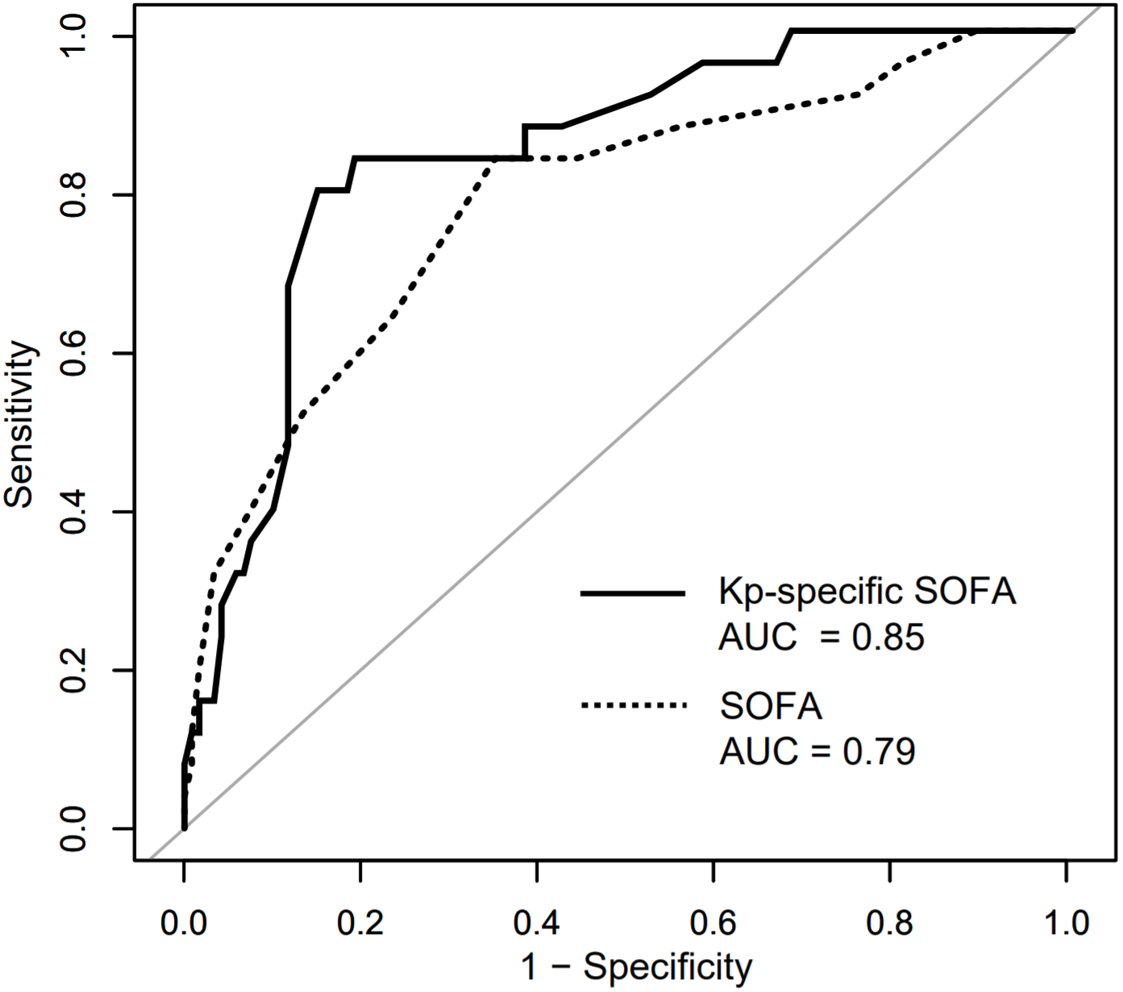
Fig. S1. Receiver operating characteristic curves of the original SOFA score and the Kp-specific SOFA score for predicting 30-day mortality.

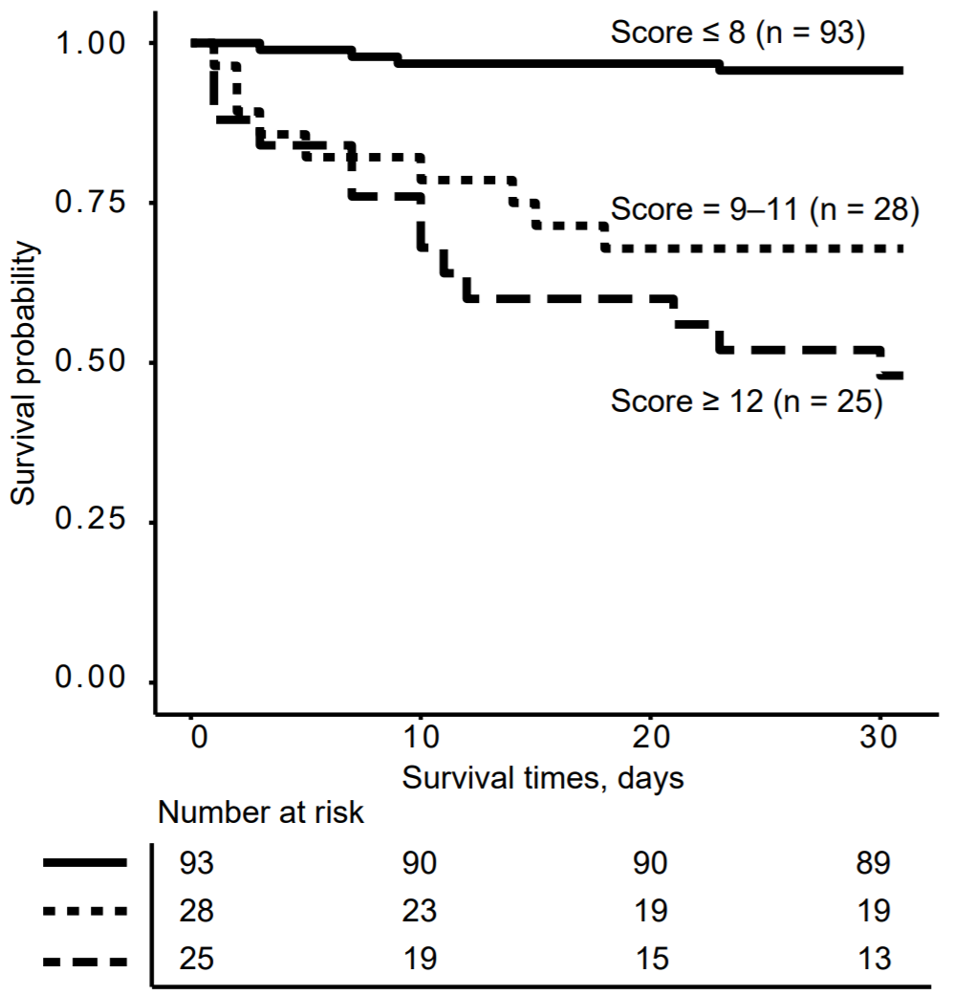
Fig. S2. Thirty-day survival probabilities at three risk categories (score ≤ 8, 9–11 and ≥ 12) after the onset of Klebsiella pneumoniae bloodstream infection in children estimated by the Kaplan-Meier analysis (log-rank test, P < 0.01).

