Novel experimental approach enabling harvesting of vertically configured SiNWs from a Si-donor substrate and their subsequent transfer onto the acceptor transparent glass substrate with minimal artifacts and their subsequent compatibility with live-cell phase-contrast imaging.

Roey Elnathan†, Andrew W. Holle†, Jennifer Young†, Marina A. George, Omri Heifler, Andriy Goychuk, Erwin Frey, Ralf Kemkemer, Joachim P. Spatz, Alon Kosloff*, Fernando Patolsky*, and Nicolas H. Voelcker*
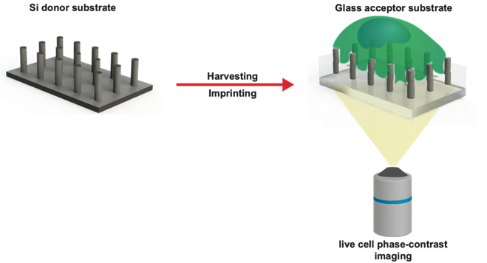
Optically Transparent Vertical Silicon Nanowire Arrays for Live-Cell Imaging

