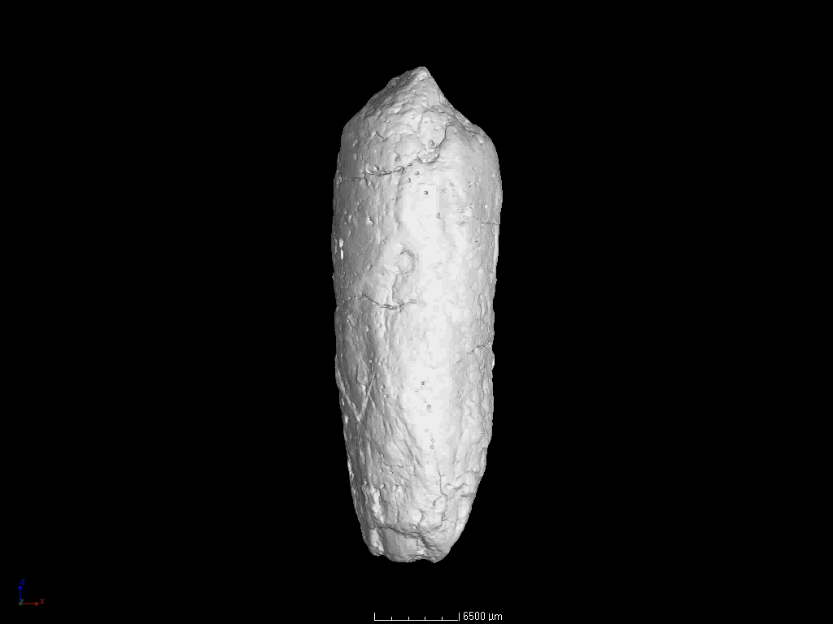
The first record of exceptionally-preserved spiral coprolites from the Tsagan-Tsab Formation (Lower Cretaceous), Tatal, western Mongolia
Paul Rummy, Kazim Halaclar & He Chen
Supplemental Video. 3D reconstruction of the inclusions in specimen IVPP V 27545

