Supplementary Information

Substituent-induced electronic localization of nickel phthalocyanine with enhanced electrocatalytic CO₂ reduction

Chen et.al

Supplementary Figures

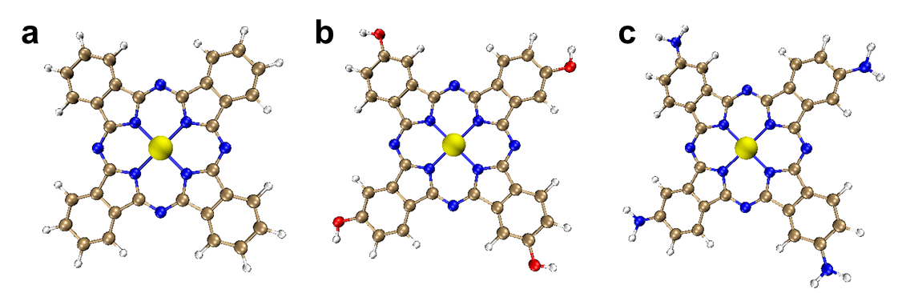
Supplementary Fig. 1 Calculation models. a NiPc. b NiTHPc. c NiTAPc.

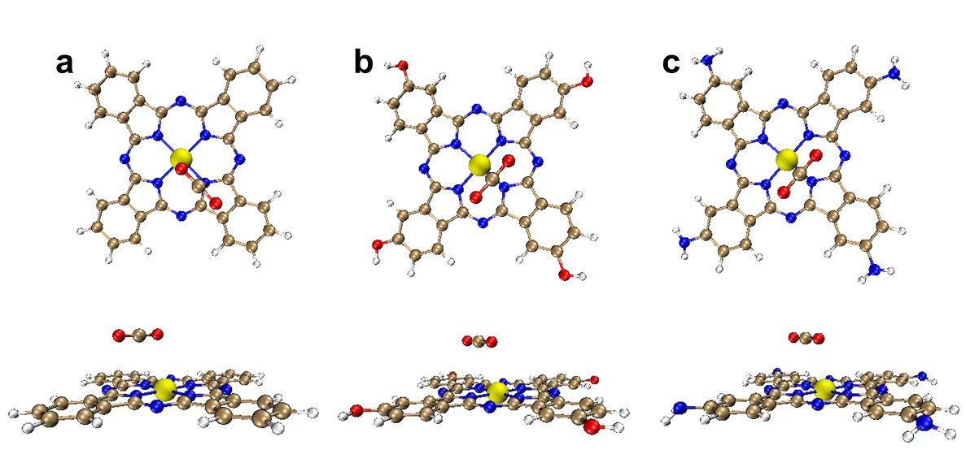
Supplementary Fig. 2 CO₂ adsorption configurations. a NiPc. b NiTHPc. c NiTAPc.

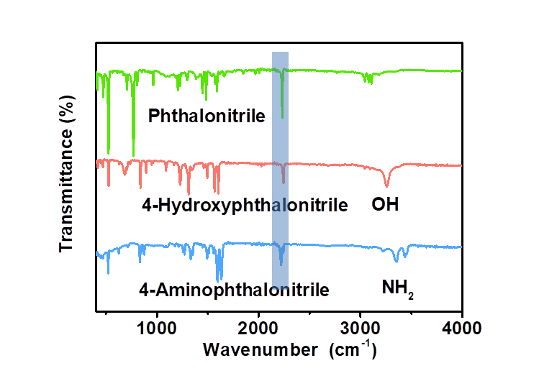
Supplementary Fig. 3 FTIR spectra. FTIR spectra of phthalonitrile, 4-Hydroxyphthalonitrile and 4-Aminophthalonitrile.

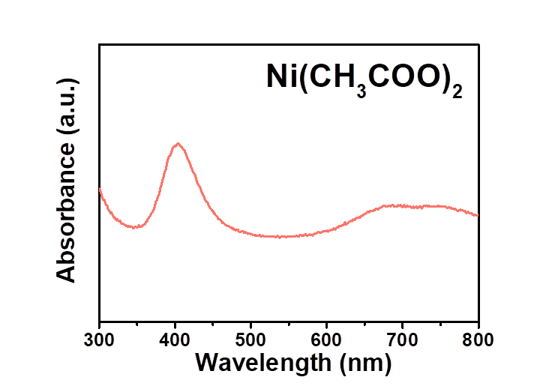
Supplementary Fig. 4 UV-Vis spectrum. UV-Vis spectrum of nickel acetate tetrahydrate in dimethyl formamide.

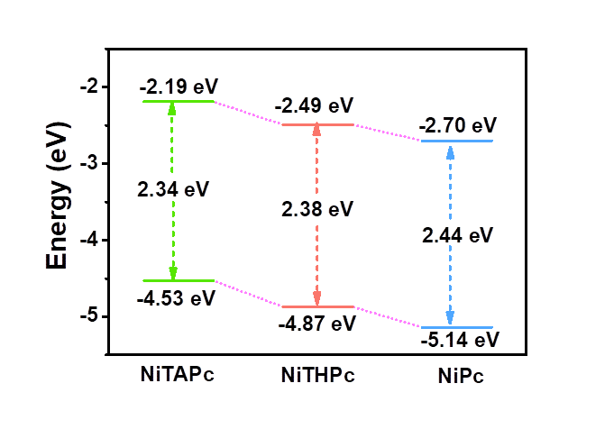
Supplementary Fig. 5 Molecule orbitals. The HOMO and LUMO orbital energies of NiPc, NiTHPc and NiTAPc.

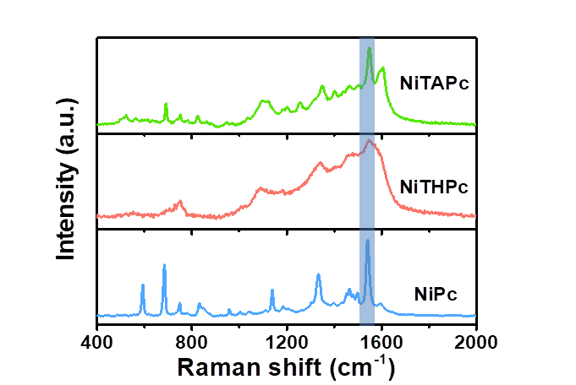
Supplementary Fig. 6 Raman spectra. Raman spectra of NiPc, NiTHPc and NiTAPc.

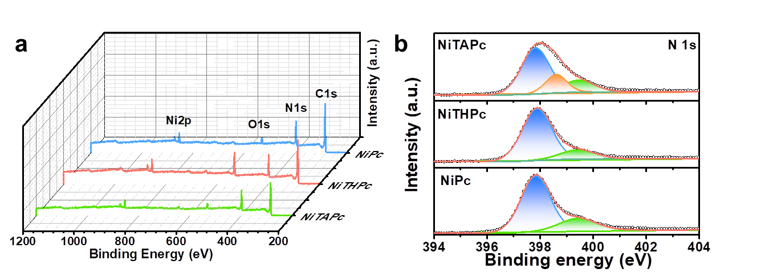
Supplementary Fig. 7 XPS characterizations. a XPS survey and b high-resolution XPS N 1s spectra of NiPc, NiTHPc and NiTAPc.

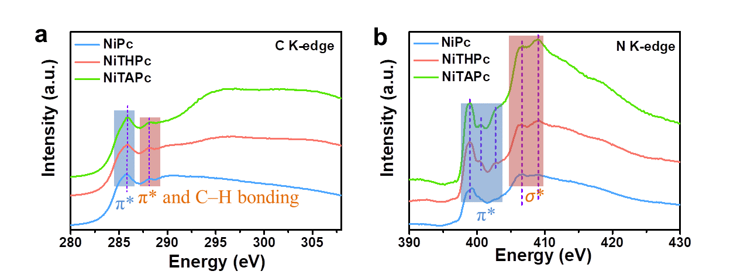
Supplementary Fig. 8 XAS characterizations. XAS spectra of a C and b N K-edge in NiPc, NiTHPc and NiTAPc.

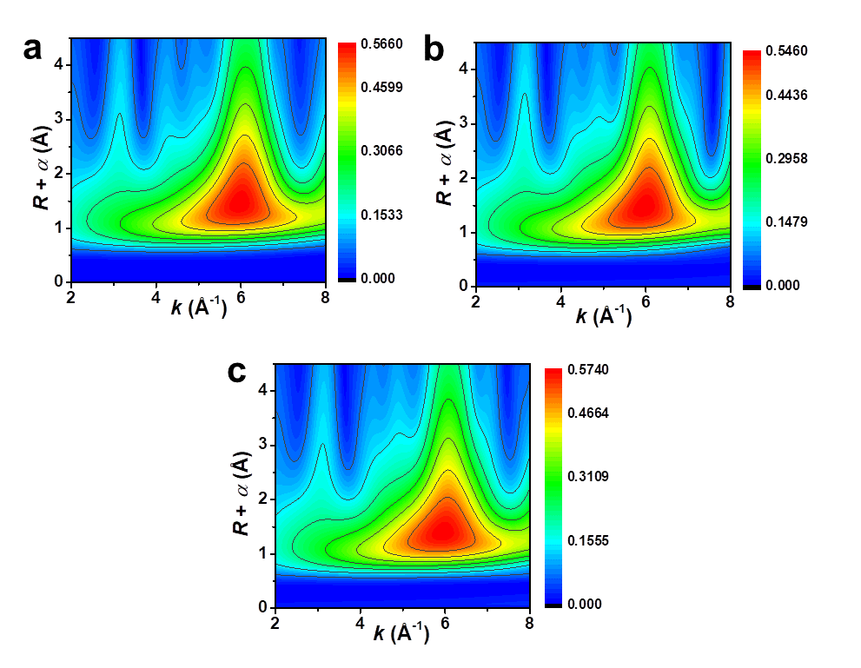
Supplementary Fig. 9 The wavelet transform plot. a NiPc, b NiTHPc and c NiTAPc.

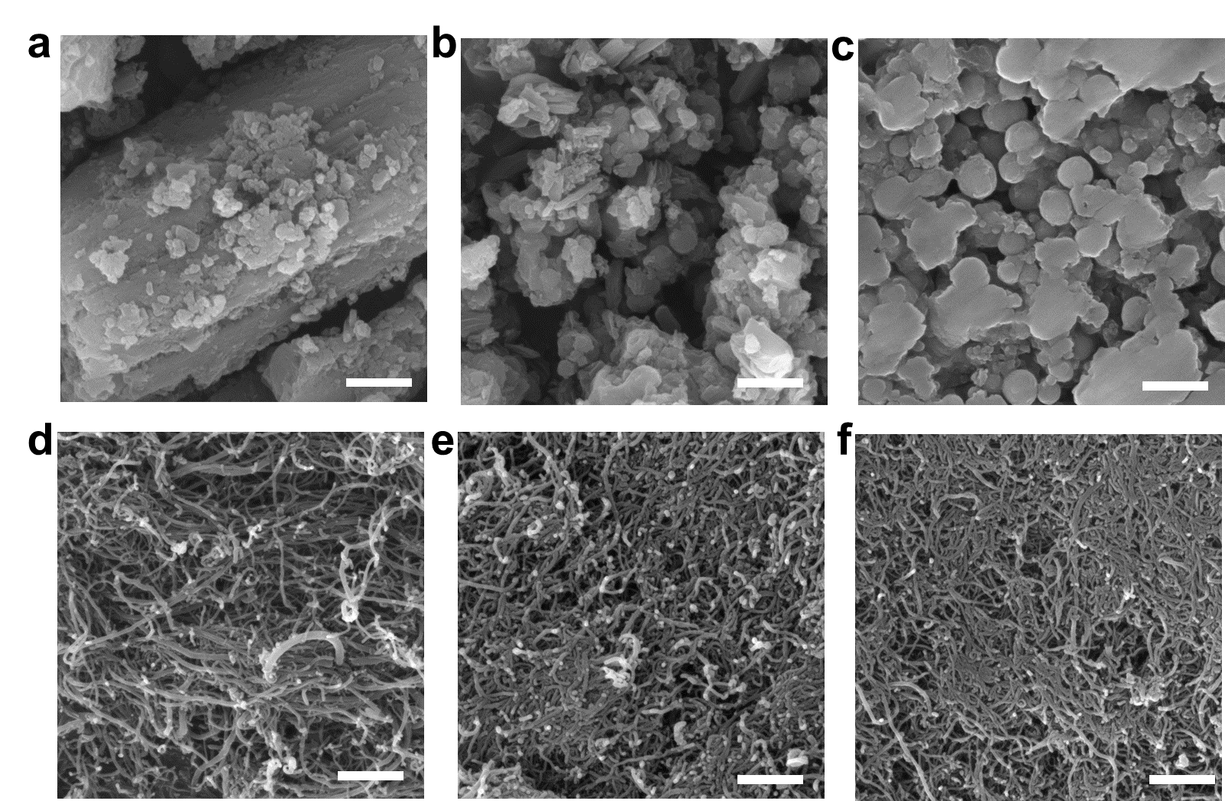
Supplementary Fig. 10 SEM characterization. SEM images of a NiPc, b NiTHPc, c NiTAPc, d NiPc/CNT, e NiTBPc/CNT, f NiTHPc/CNT and g NiTAPc/CNT. Scale bar, 1 µm.

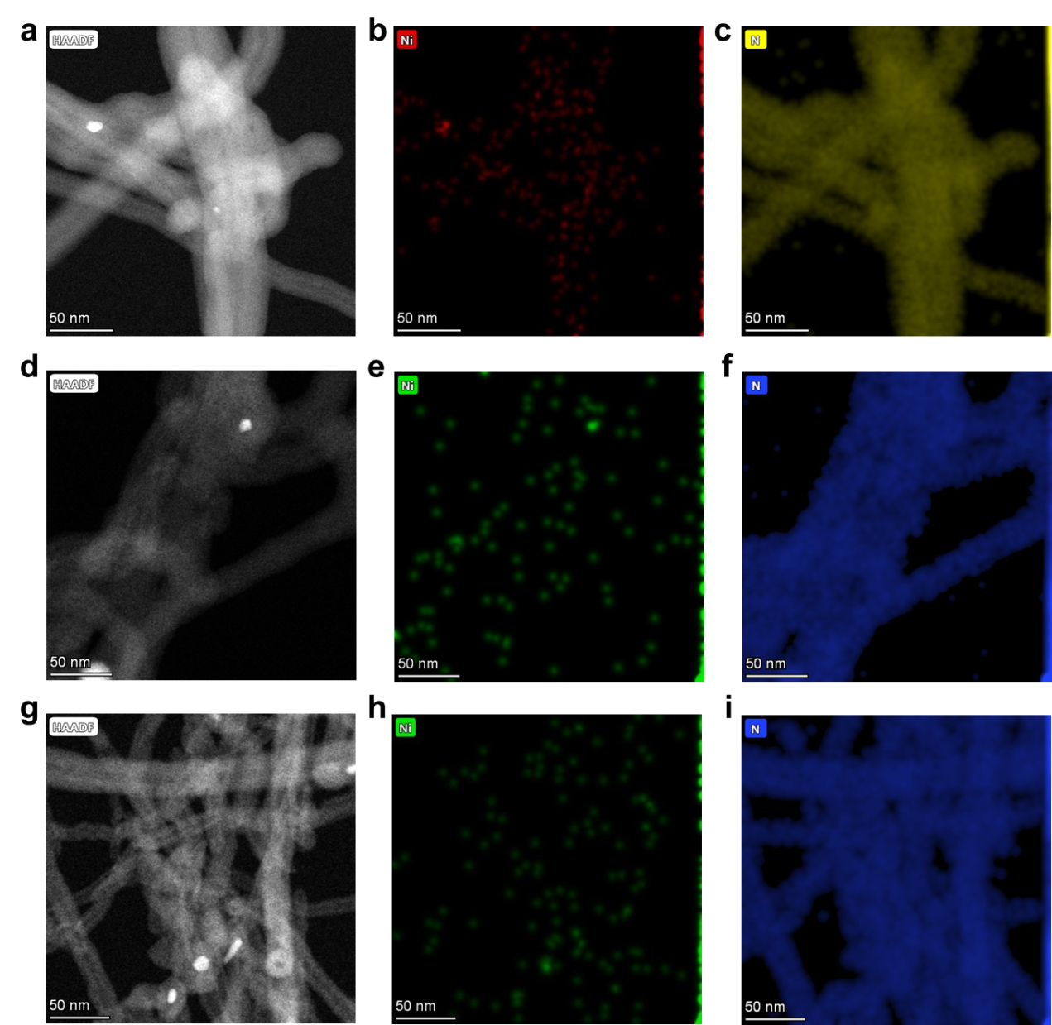
Supplementary Fig. 11 HAADF-STEM characterization. HAADF-STEM images and corresponding EDX elemental mapping of Ni and N in a-c NiPc/CNT, d-f NiTHPc/CNT and g-i NiTAPc/CNT.

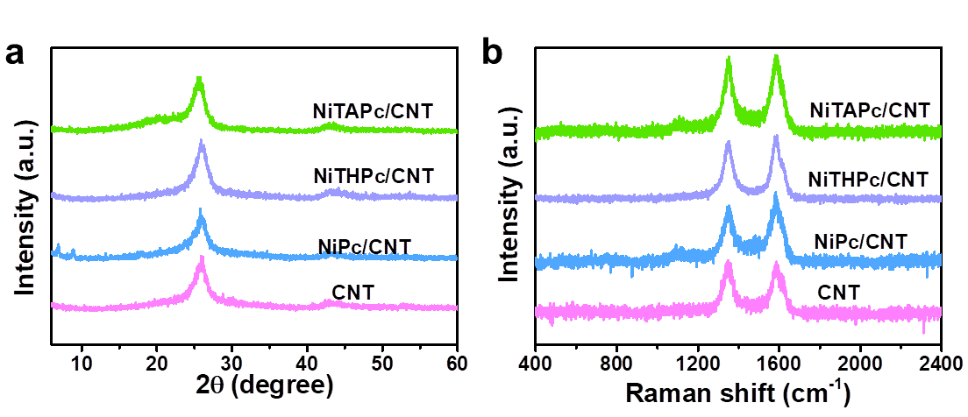
Supplementary Fig. 12 Structure characterizations. a XRD patterns and b Raman spectra of the pristine CNT, NiPc/CNT, NiTHPc/CNT and NiTAPc/CNT.

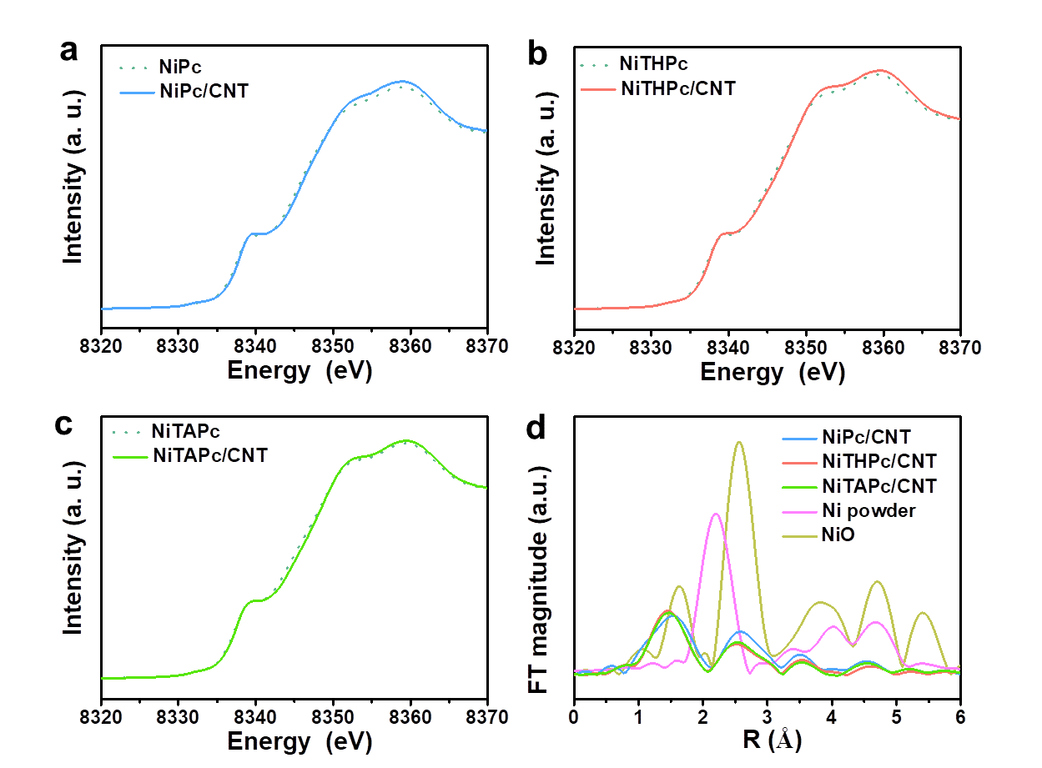
Supplementary Fig. 13 X-ray absorption spectra. a XANES spectra of Ni K-edge in NiPc and NiPc/CNT. b XANES spectra of Ni K-edge in NiTHPc and NiTHPc/CNT. c XANES spectra of Ni K-edge in NiTAPc and NiTAPc/CNT. d EXAFS spectra of Ni K-edge in NiO, Ni powder, NiPc/CNT, NiTHPc/CNT and NiTAPc/CNT.

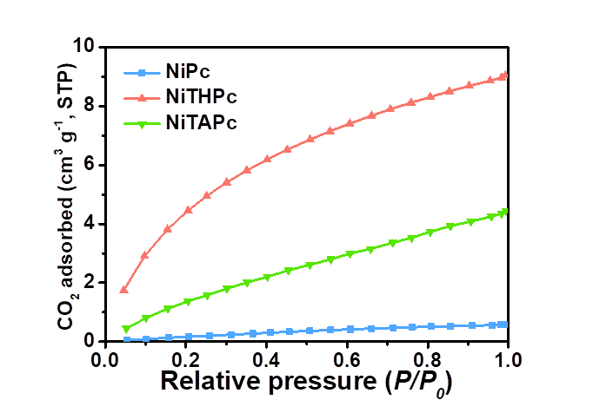
Supplementary Fig. 14 CO₂ adsorption. The CO₂ adsorption isotherms of NiPc, NiTHPc and NiTAPc.

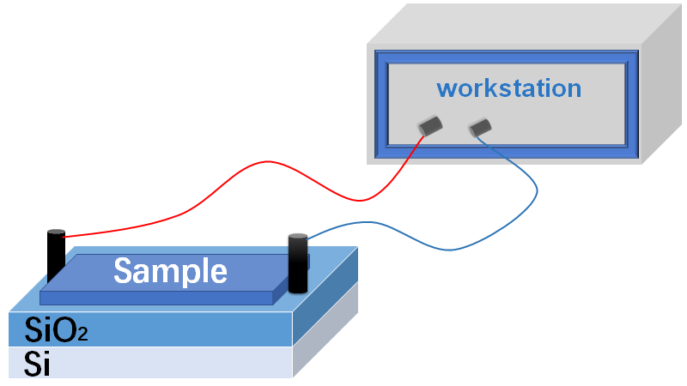
Supplementary Fig. 15 Schematic illustration of the CO₂ adsorption responses measurements.

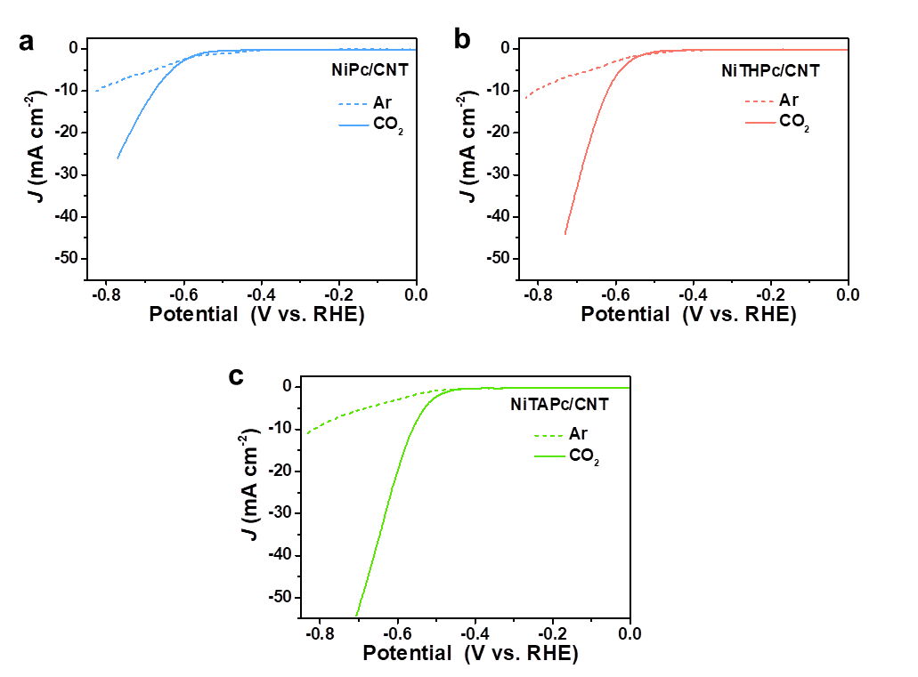
Supplementary Fig. 16 LSV curves. LSV curves of catalysts in the CO₂ and Ar-saturated 0.5 M KHCO₃ electrolyte.

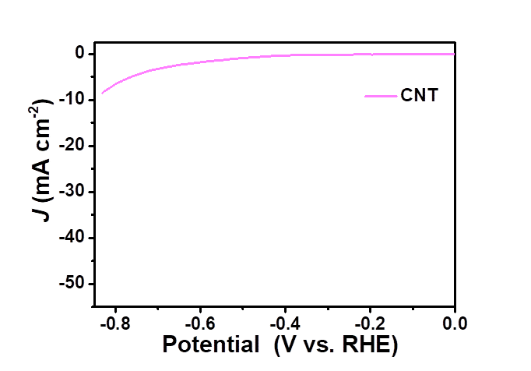
Supplementary Fig. 17 LSV curve. LSV curve of blank carbon nanotube in the CO₂-saturated 0.5 M KHCO₃ electrolyte.

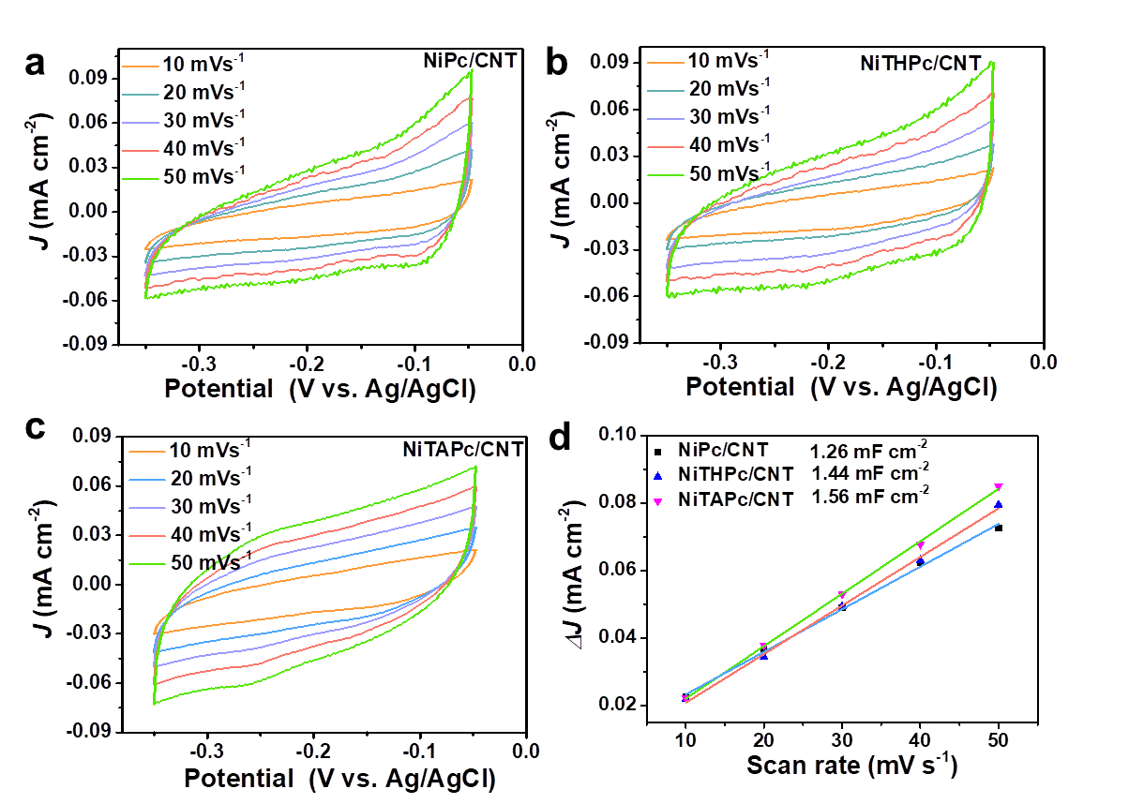
Supplementary Fig. 18 ECSA measurements. a CV profiles of NiPc/CNT, b NiTHPc/CNT and c NiTAPc/CNT in Ar-saturated 0.5 M KHCO₃ electrolyte. d Electrochemical double layer capacitance of NiPc/CNT, NiTHPc/CNT and NiTAPc/CNT.

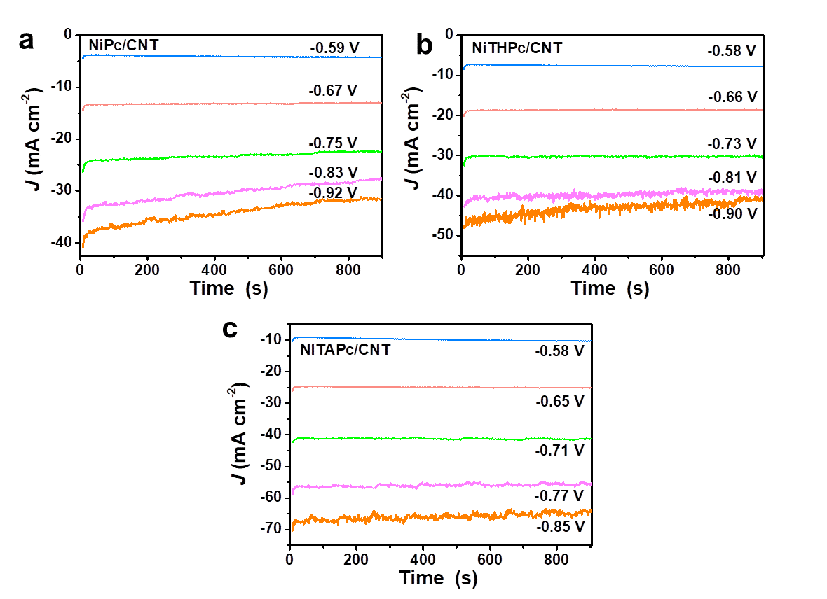
Supplementary Fig. 19 I-T curves. Chronoamperometry of a NiPc/CNT, b NiTHPc/CNT and c NiTAPc/CNT at different potentials in CO₂-saturated 0.5 M KHCO₃ electrolyte.

Supplementary Fig. 20 The GC traces of gaseous products of NiTAPc/CNT from flame ionization detector (FID) channel.

Supplementary Fig. 21 ¹HNMR spectrum. ¹HNMR spectrum of the electrolyte of NiTAPc/CNT after 2 h electrochemical CO₂RR in H-cell.

Supplementary Fig. 22 FE(H₂). FE(H₂) of catalysts at different applied potential.

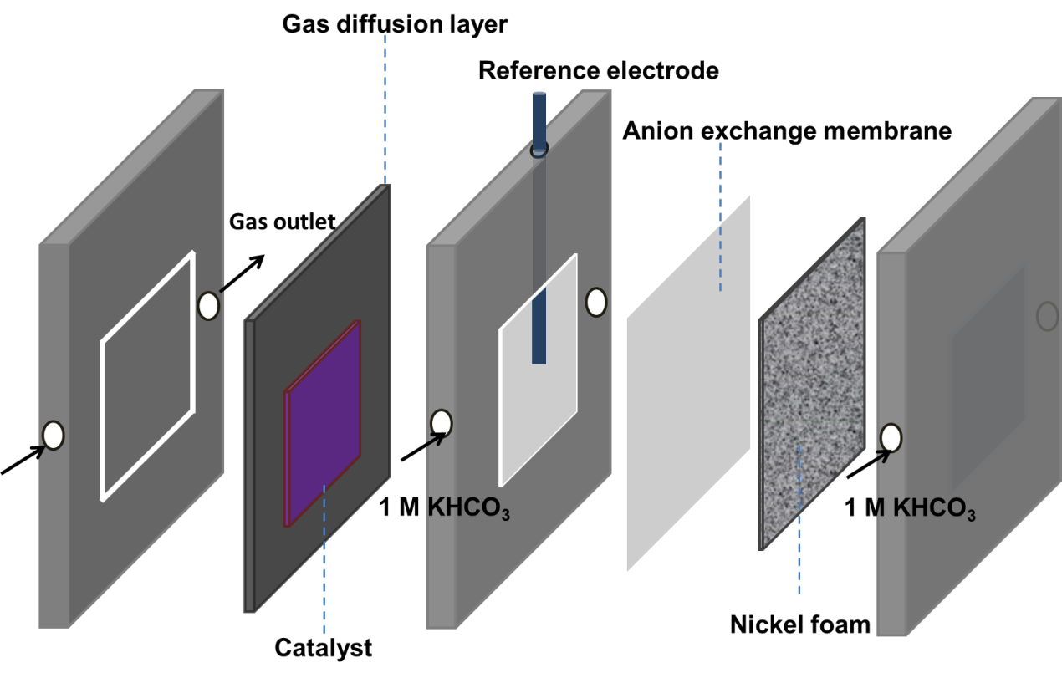
Supplementary Fig. 23 Schematic illustration of flow cell for CO₂RR.

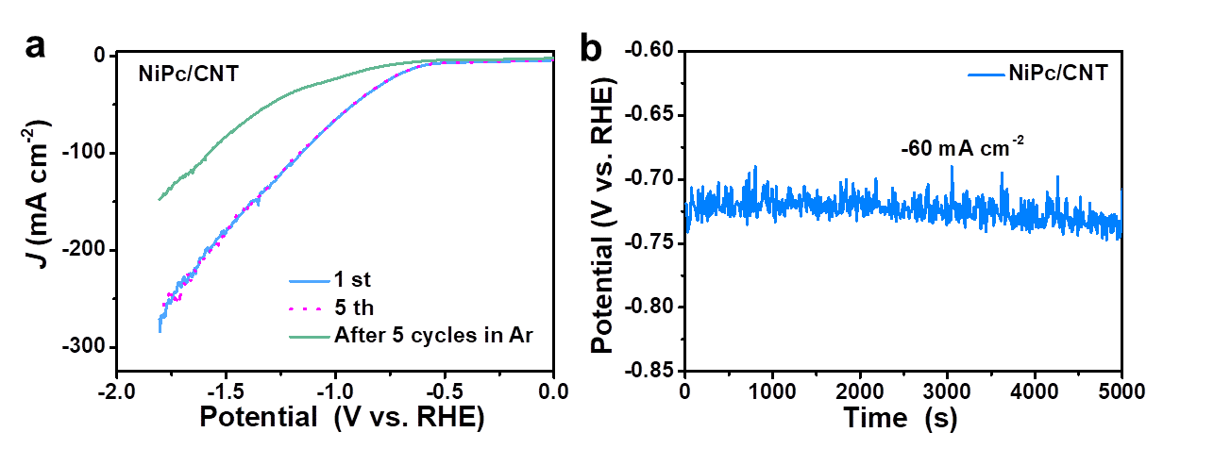
Supplementary Fig. 24 Electrochemistry tests of NiPc/CNT. a The LSV of catalyst without iR corrections in CO₂ including the pristine of NiPc/CNT and the NiPc/CNT after the LSV measurement for 5 times in the Ar atmosphere. b The NiPc/CNT for CO₂RR electrolysis at the current density of −60 mA cm⁻².

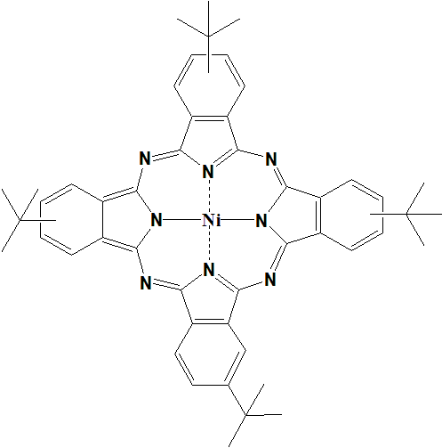
Supplementary Fig. 25 Molecular structure. Molecular formula of NiTBPc.

Supplementary Fig. 26 Structure characterization of NiTBPc. a MALDI-TOF MS spectrum. b FTIR spectra. c UV-Vis spectrum in dimethyl formamide. d Raman spectrum.

Supplementary Fig. 27 SEM and HAADF-STEM characterizations. SEM images of a NiTBPc and b NiTBPc/CNT, Scale bar, 1 µm. c-e HAADF-STEM images and corresponding EDX elemental mapping of Ni and N in NiTBPc/CNT.

Supplementary Fig. 28 Electronic density characterizations. a High-resolution XPS Ni 2p spectra of NiPc and NiTBPc. b XAS spectra of Ni L-edge NiPc and NiTBPc. c XANES spectra of Ni K-edge from NiPc and NiTBPc. d XANES spectra of Ni K-edge from NiPc/CNT and NiTBPc/CNT.

Supplementary Fig. 29 X-ray absorption spectra. a EXAFS spectrum of Ni K-edge from NiTBPc. b The wavelet transform plot of NiTBPc,

Supplementary Fig. 30 CO₂RR performance of NiTBPc in H-cell. a LSV profile in 0.5 M CO₂-saturated KHCO₃ electrolyte. b Chronoamperometry of NiTBPc/CNT at −0.68 V. c Chronoamperometry of NiTBPc/CNT at different potentials in CO₂-saturated 0.5 M KHCO₃ electrolyte. d FE(CO)s of NiTBPc/CNT at the according potentials.

Supplementary Fig. 31 CO₂RR performance of NiTBPc in flow cell. Current densities of NiTBPc/CNT at different potentials in 1 M KHCO₃ electrolyte. b FE(CO) of NiTBPc/CNT.

Supplementary Tables
Supplementary Table 1. The surface area of as-prepared molecule catalysts from the N₂ adsorption/desorption analysis

Samples | Surface area (m² g⁻¹)
NiPc | 74.681
NiTHPc | 9.235
NiTAPc | 3.138

·`
Supplementary Table 2. Comparison of CO₂RR performance between the prepared catalysts and the reported noble-metal-free catalysts for conversion CO₂ into CO in H-cell with 0.5 M KHCO₃ electrolyte.

Catalysts | E vs. RHE (V) | J (mA cm⁻²) | FE(CO) | Reference
NiTAPc/CNT | -0.58 | 12.2 | Almost 100% | This work
NiTHPc/CNT | -0.61 | 11.0 | Almost 100%
NiPc/CNT | -0.68 | 8.2 | 99.6%
NiPc-OMe-MDE | -0.64 | 14.5 | Almost 100% | 1
Co−N₅/HNPCSs | -0.73 | 6.2 | 99.2% | 2
A-Ni-NSG | -0.72 | 22 | 98% | 3
Ni-CNT-CC | -0.71 | 32.3 | 99% | 4
Ni^{I}-NCNT@Ni9Cu | -0.73 | 32.87 | 97% | 5
Ni-NCB | -0.66 | 23 | 95% | 6
Co(II)CPY/CNT | -0.70 | 10.73 | 96% | 7
CoPc2@MWCNTS | -0.676 | 18.1 | 93% | 8

Supplementary Table 3 Comparison of CO₂RR performance between the prepared catalysts and the reported catalysts with gas-diffusion electrodes.

Catalysts | Electrolyte | J (mA cm⁻²) | FE(CO) | Reference
NiTAPc/CNT | 1 M KHCO₃ | 150 | 99.9% | This work
 | 1 M KHCO₃ | 500 | 94.6%
NiPc-OMe-MDE | 1 M KHCO₃ | 150 | 99.6% | 1
CoPc2@MWCNTS | 1 M KOH | 116 | ~96% | 8
Fe³⁺-N-C | 0.5 M KHCO₃ | ~50 | ~90% | 9
CoPc+phenol | 1 M KOH | 200 | ~88% | 10
CoPc©Fe-N-C | 0.5 M KOH | 275.6 | ~90% | 11
Ni-N-C | 1 M KHCO₃ | ~200 | ~89% | 12

Supplementary Table 4. The ICP-OES results of prepared molecular catalysts and carbon nanotubes.

Samples | Nickel content
NiPc/CNT | 0.4553 wt%
NiTHPc/CNT | 0.4234 wt%
NiTAPc/CNT | 0.3474 wt%
CNT | 0.0030 wt%

Supplementary Notes
Supplementary Note 1. The XPS survey (Supplementary Fig. 4a) indicates the molecule catalysts comprised by the C, N and Ni. The NiTHPc has a pronounced O signal from the periphery substituent of hydroxyl. The high-resolution XPS of N 1s (Supplementary Fig. 4b) can be well deconvoluted with a Lorentzian-Gaussian fit into three peaks. The peaks at around 397.9 eV can be assigned to the pyridinic-N, and the peaks locates at 399.5 eV belongs to the pyrrolic-N of Ni–N. In addition, the binding energy of N from the NH₂ falls in between that of pyridinic-N and pyrrolic-N at 398.5 eV.¹³ On the basis of these results, the amino and hydroxyl are successfully substituted in NiTAPc and NiTHPc, respectively.

Supplementary Note 2. Supplementary Fig. 8a presents the C K-edge XANES spectra of the three investigated NiPc in this work. The prominent peaks of NiPc-base molecules at about 285.8 eV can be assigned to π* excitation of C–C bonds in the phthalocyanines ring,¹⁴ and the modern intensity peaks located at 288.1 eV can be attributed to C–H bonding and π* states.¹⁵ Supplementary Fig. 8b display the N K-edge XANES spectra of samples. The absorption edge among 397 and 403 eV is indexed to the π* resonance, and the absorption peaks at about 406.6 and 409 eV are belonged to σ* features.¹⁵ The electron-donating substituents of amino and hydroxyl have great influence on the electronic structure of N to further tune the electron density catalytic site of Ni.

Supplementary References
1. Zhang, X., et al. Molecular engineering of dispersed nickel phthalocyanines on carbon nanotubes for selective CO₂ reduction. Nat. Energy 5, 684-692 (2020).
2. Pan, Y., et al. Design of single-atom Co–N₅ catalytic site: a robust electrocatalyst for CO₂ reduction with nearly 100% CO selectivity and remarkable stability. J. Am. Chem. Soc. 140, 4218-4221 (2018).
3. Yang, H.B., et al. Atomically dispersed Ni (I) as the active site for electrochemical CO₂ reduction. Nat. Energy 3, 140-147 (2018).
4. Liu, S., et al. Elucidating the Electrocatalytic CO₂ Reduction Reaction over a Model Single‐Atom Nickel Catalyst. Angew. Chem. Int. Ed. 59, 798-803 (2020).
5. Zhang, T., et al. Atomically Dispersed Nickel(I) on an Alloy-Encapsulated Nitrogen-Doped Carbon Nanotube Array for High-Performance Electrochemical CO₂ Reduction Reaction. Angew. Chem. Int. Ed. 59, 12055-12061 (2020).
6. Zheng, T., et al. Large-scale and highly selective CO₂ electrocatalytic reduction on nickel single-atom catalyst. Joule 3, 265-278 (2019).
7. Sun, L., et al. A Planar, Conjugated N₄‐Macrocyclic Cobalt Complex for Heterogeneous Electrocatalytic CO₂ Reduction with High Activity. Angew. Chem. 132, 17252-17257 (2020).
8. Wang, M., et al. CO₂ electrochemical catalytic reduction with a highly active cobalt phthalocyanine. Nat. Commun. 10, 1-8 (2019).
9. Gu, J., Hsu, C.-S., Bai, L., Chen, H.M. & Hu, X. Atomically dispersed Fe³⁺ sites catalyze efficient CO₂ electroreduction to CO. Science 364, 1091-1094 (2019).
10. Ren, S., et al. Molecular electrocatalysts can mediate fast, selective CO₂ reduction in a flow cell. Science 365, 367-369 (2019).
11. Lin, L., et al. Synergistic Catalysis over Iron-Nitrogen Sites Anchored with Cobalt Phthalocyanine for Efficient CO₂ Electroreduction. Adv. Mater. 31, 1903470 (2019).
12. Möller, T., et al. Efficient CO₂ to CO electrolysis on solid Ni–N–C catalysts at industrial current densities. Energy Environ. Sci. 12, 640-647 (2019).
13. Fu, J., et al. Graphitic carbon nitride with dopant induced charge localization for enhanced photoreduction of CO₂ to CH₄. Adv. Sci. 6, 1900796 (2019).
14. Zhong, J., et al. Probing solid state N-doping in graphene by X-ray absorption near-edge structure spectroscopy. Carbon 50, 335-338 (2012).
15. Willey, T.M., et al. Electronic structure differences between H₂-, Fe-, Co-, and Cu-phthalocyanine highly oriented thin films observed using NEXAFS spectroscopy. J. Chem. Phys. 139, 034701 (2013).

