The ARRIVE Guidelines Checklist
Animal Research: Reporting In Vivo Experiments
Carol Kilkenny¹, William J Browne², Innes C Cuthill³, Michael Emerson⁴ and Douglas G Altman⁵
¹The National Centre for the Replacement, Refinement and Reduction of Animals in Research, London, UK, ²School of Veterinary Science, University of Bristol, Bristol, UK, ³School of Biological Sciences, University of Bristol, Bristol, UK, ⁴National Heart and Lung Institute, Imperial College London, UK, ⁵Centre for Statistics in Medicine, University of Oxford, Oxford, UK.

 |  | ITEM | RECOMMENDATION | Section/  Paragraph
 |  |  |  | Title
 |  |  |  | Abstract
 | INTRODUCTION
 | 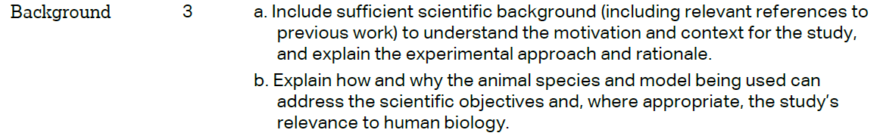 |  |  | Paragraph  1-3  Paragraph 2-3
 |  |  |  | Paragraph 4
 | METHODS
 |  |  |  | Paragraph 1
 | 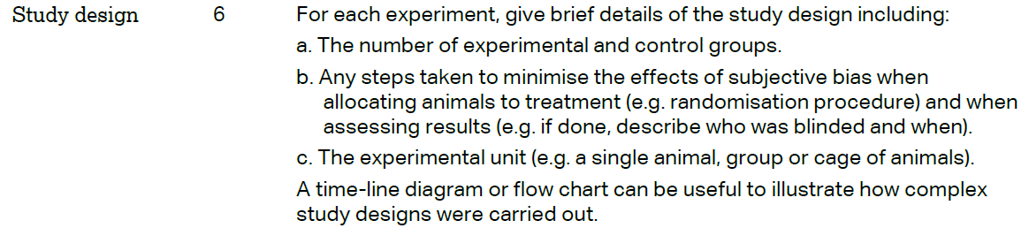 |  |  | Paragraph 1  Paragraph 1  No applicable
 | 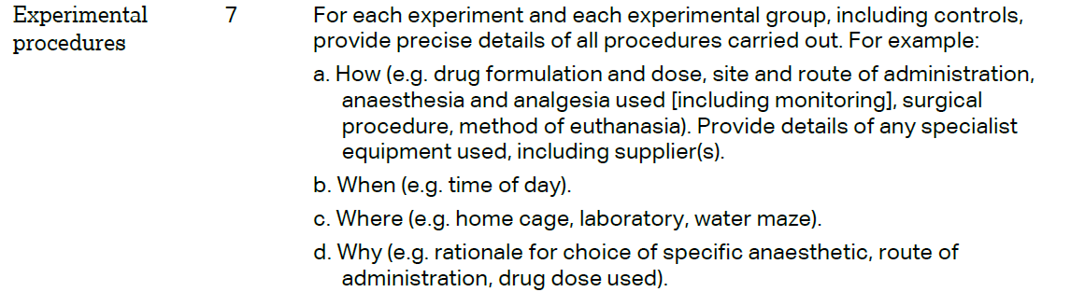 |  |  | Paragraph 1-3  Paragraph 1  Paragraph 1  Paragraph 2
 | 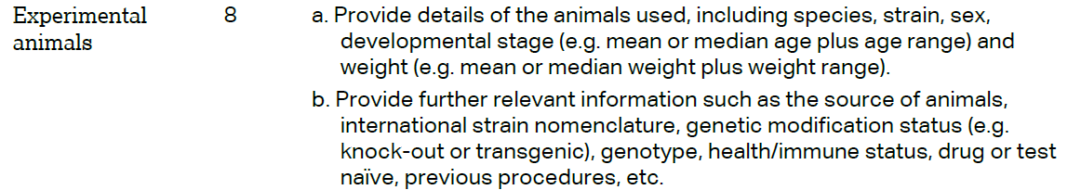 |  |  | Paragraph1
The ARRIVE guidelines. Originally published in PLoS Biology, June 2010¹
 | 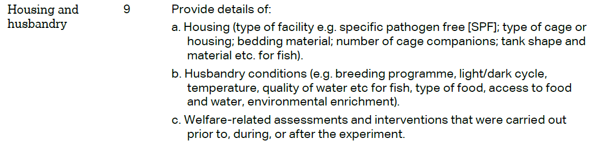 | Paragraph1  Paragraph1  Paragraph  1-2
 | 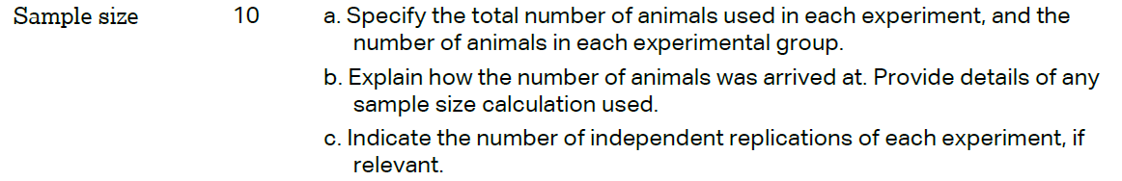 | Paragrap1
 | 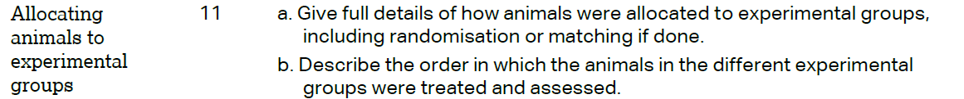 | Paragrap1
Paragraph
4-7
 | 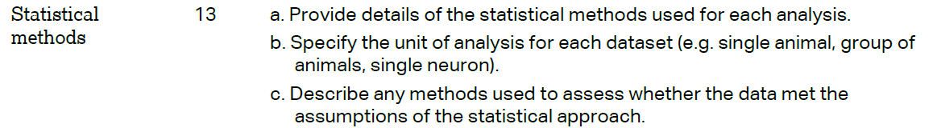 | Paragraph8
 | RESULTS
 |  | Method, paragraph 1
 |  | Method Paragraph 1
Paragraph
1-4

 |  | Method Paragraph 3
 | DISCUSSION
 | 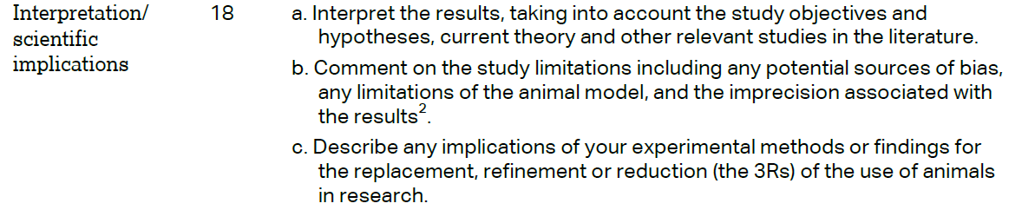 | Paragraph  1-6  Paragraph  7  Paragraph  7
Paragraph
1-6
 |  | Funding
