Supplementary Figure 1: Plasmid profiles for lentivirus-transformed plasmid, pLV-SARS-CoV-2-F1abFabNE-GFP, and envelope plasmid, pCMV3-2019-nCoV-Spike
(S1+S2).
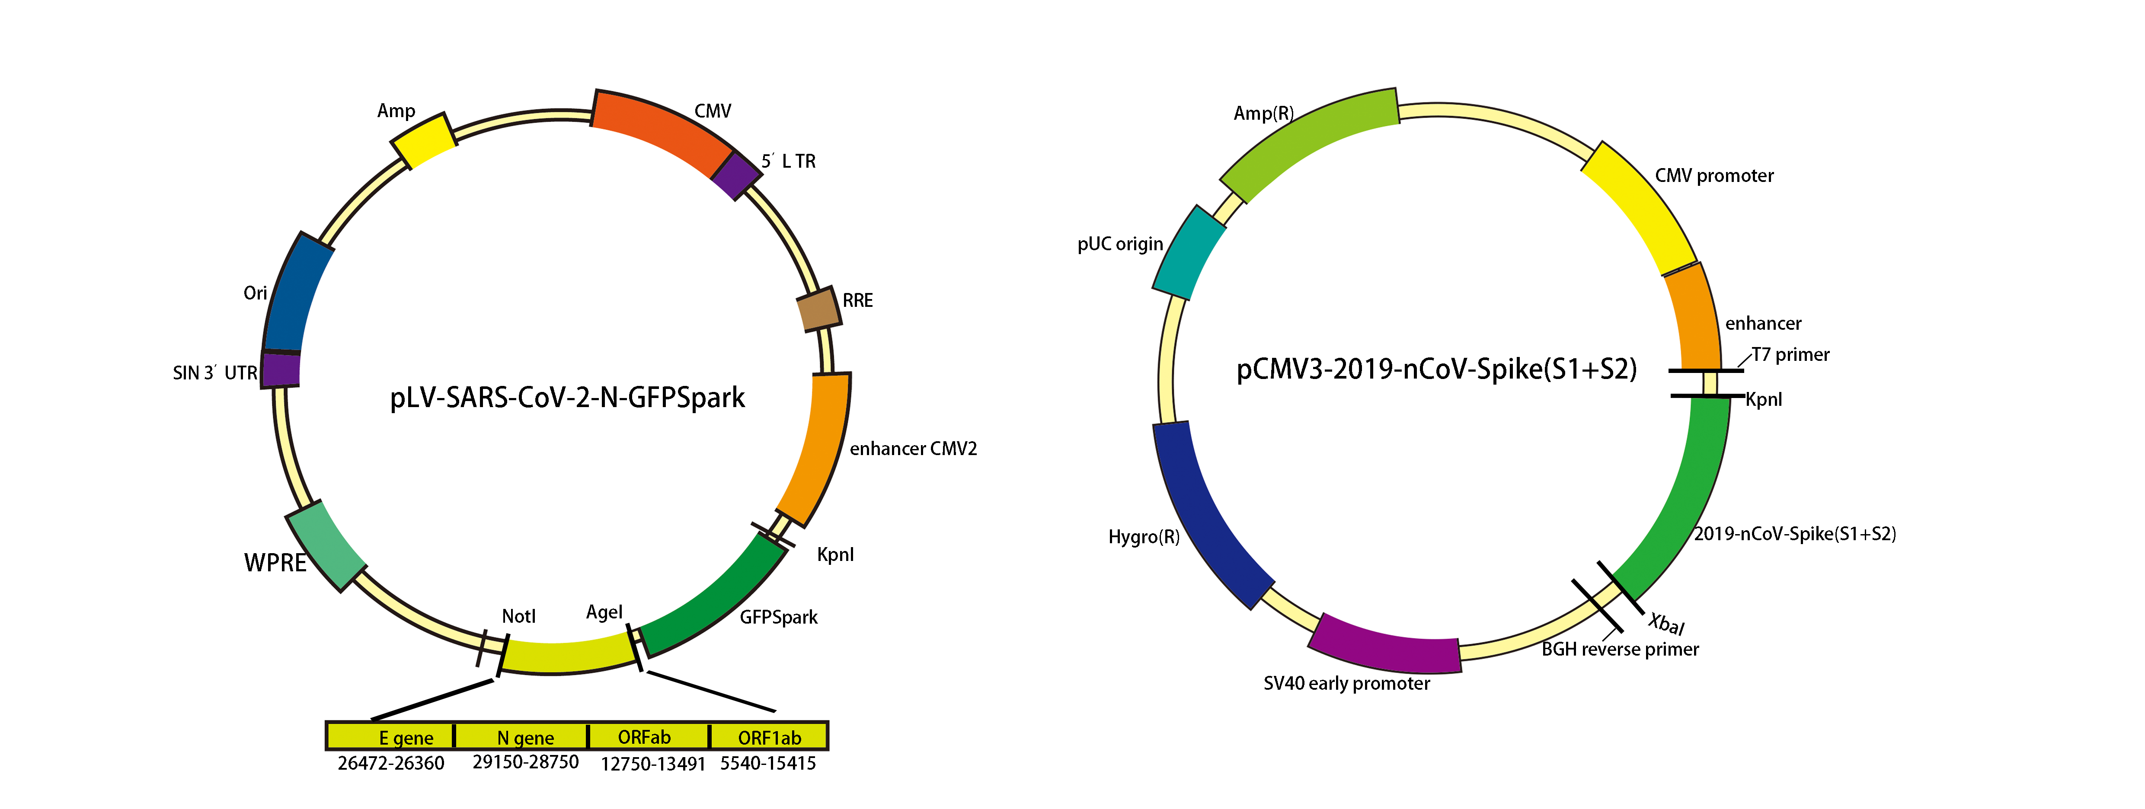
Supplementary Figure 2: Principle of Lentivirus packaging.
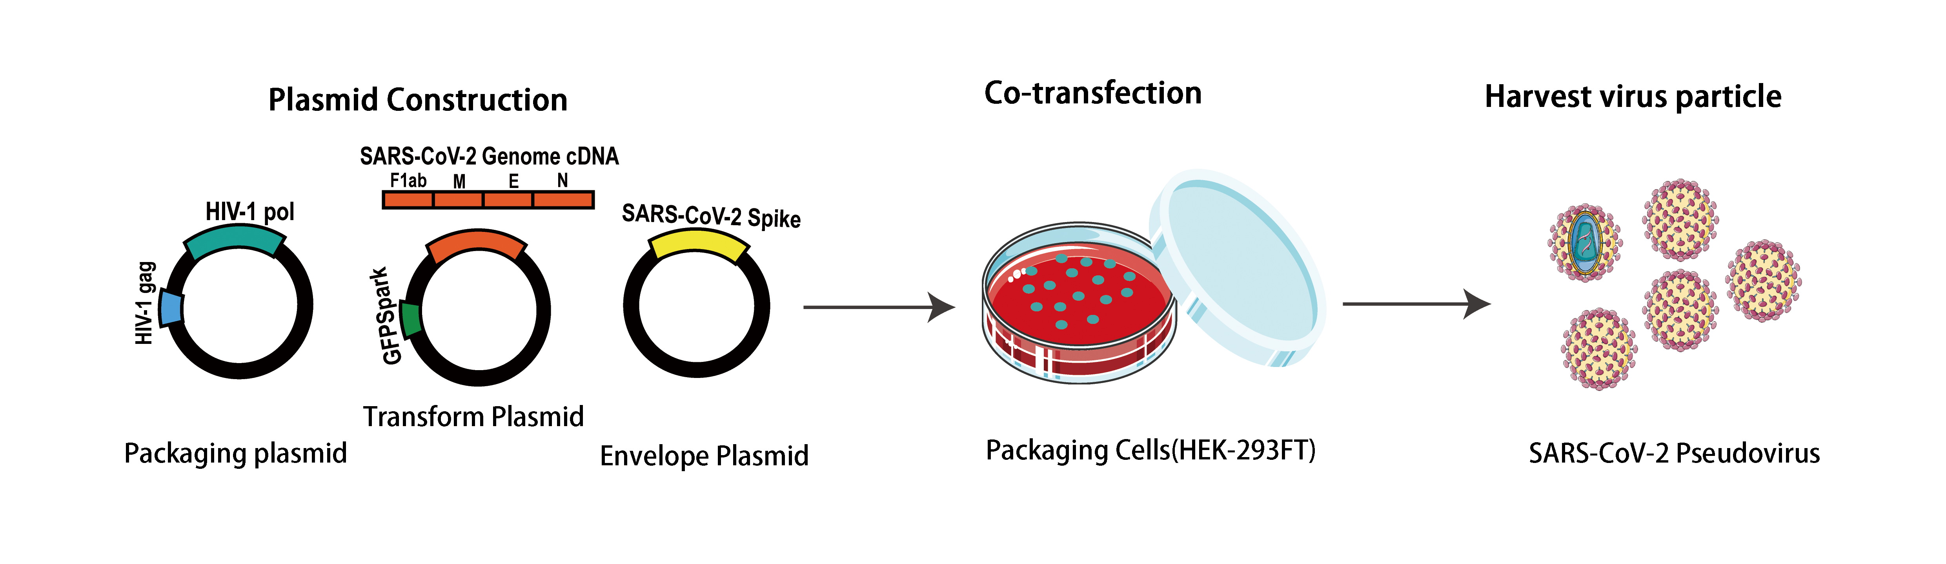
Supplementary Figure 3: Optimized detection conditions
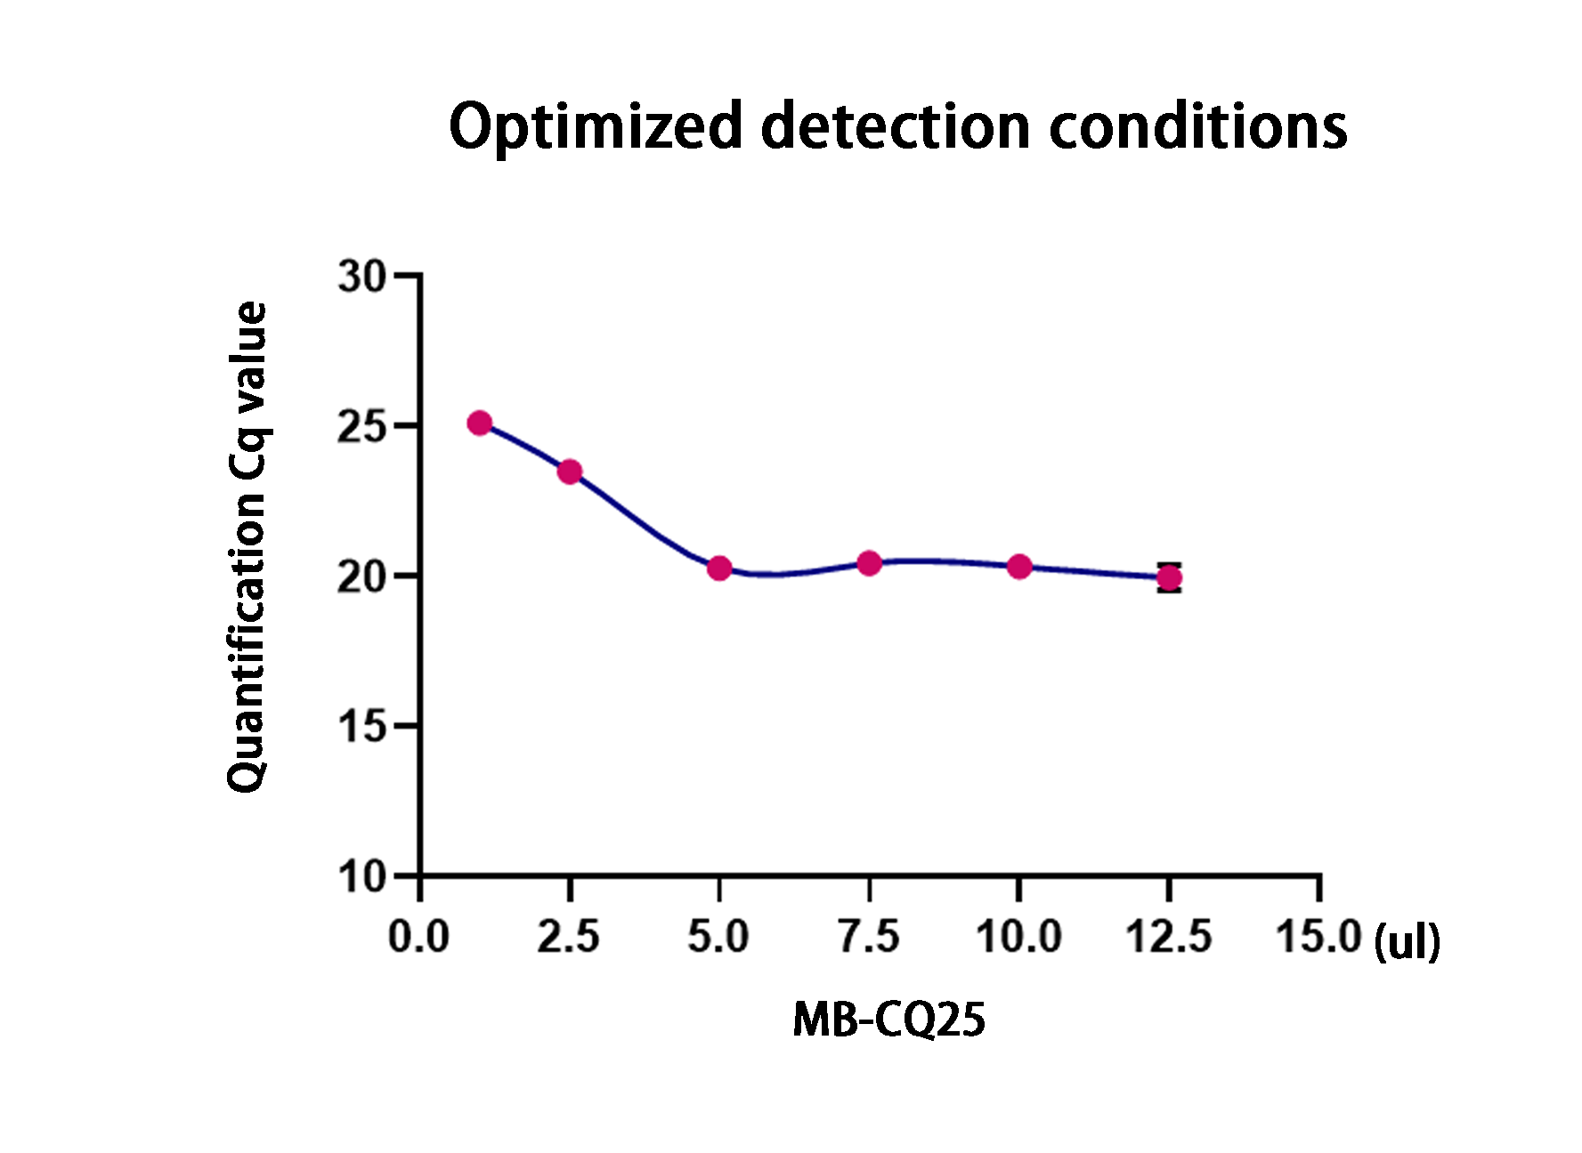
Supplementary Figure 4: The SARS-CoV-2 pseudovirus stability with respect to time and temperature.
