Supplemental Material

Supplementary Section 1: Quality-Control analysis and data harmonisation

SNPs were removed with Minor Allele frequency (MAF) <0.01; Hardy-Weinberg equilibrium (p $≤$ 10⁻⁶); with missing data proportion >5% in UKBB, 1000 Genomes, HipSci and >2% in ADNI, ROSMAP, MSBB, MAYO; SNPs with poor accuracy of imputation (INFO ≤ 0.4) in UKBB and (INFO ≤ 0.7) in HipSci; or with non-autosomal location. Samples were removed on the basis of call rate <98%; heterozygosity (HET > ±0.1); relatedness based on identity by descent with PI_HAT >0.2 in 1000 Genomes, UKBB, HipSci, ADNI and PI_HAT >0.22 for ROSMAP, MSBB, MAYO; list of recommended sample exclusions from AMP-AD portal for ROSMAP, MSBB, MAYO. Studies were merged with 1000 Genomes data to compute principal components (PC) and individuals were removed that did not cluster near 1000 Genomes European. More informatics can be found in Supplementary Table 1.
To gain more power we combined and harmonised ADNI, ROSMAP, MSBB and MAYO studies, removed overlapping samples that were used in Kunkle GWAS study [2], leaving 271 AD cases and 278 controls with 6,077,045 SNPs for the further analysis (see details in Supplementary Table 2). This sample was also combined with the European 1000 Genomes sample to enable PRS standardisation against a population cohort. To adjust for population stratification principal components were computed in the full merged datasets (i.e. ADNI+ROSMAP+MSBB+MAYO+1000G); pairwise PCs were plotted and those which displayed heterogeneity were used to adjust the PRS. Eight PCs were used to account for population structure in the case-control sample (ADNI+ROSMAP+MSBB+MAYO+1000G) and twenty PCs were used in the (HipSci+1000G+UKBB) data.

Supplementary Table 1: Description of studies (genetics).
Study | Genotypes available  N samples | Study design | N variants  Genotyping/  Imputation | After QC:  N samples | After QC:  N variants
1000G (EUR) | 503 | Population | 80,000,000  WGS | 503 | 9,047,395
UK Biobank | 500,000 | Population | 35,884,914  HRC imputed SNPs | 443,018 | 7,654,308
HipSci | 1254 | Population | 6,216,949  HRC imputed SNPs | 1228 | 5,454,509
ADNI | 770 | Case-control | 42,732,452  WGS | 293 | 7,808,548
ROSMAP | 1196 | Case-control | 43,440,340  WGS | 52 | 8,717,089
MAYO | 349 | Case-control | 27,537,089  WGS | 121 | 8,717,089
MSBB | 349 | Case-control | 35,445,106  WGS | 83 | 8,717,089
Legend: Genetic information available by study: includes number of individuals with genetic profile, number of variants (whole genome sequenced (WGS) or imputed using the Haplotype Reference Consortium (HRC)), study design followed by number of samples and variants retained after the Quality-Control (QC) analysis described in Supplementary Section 1.

Supplementary Table 2: Definition of AD case-control status in ADNI, ROSMAP, MAYO, MSBB that overlaps with genetic data and their APOE distribution.
Study | Diagnostic criteria | Thresholds for Case-control definition | Number of cases and controls | AGE  Mean (min and max) | APOE distribution in  (ε2ε2/ε2ε3/ε2ε/ε3ε3/ε3ε4/ε4ε4)
ADNI | Clinical diagnosis at last assessment: 1-stable control; 2-stable MCI; 3-stable AD; 4-conversion control to MCI; 5-conversion MCI to AD; 7-conversion MCI to control;8- AD to MCI. | 1-Control  3-AD | 126/167 | Age at the last interview  77.3(55.6, 94.5) | 0/27/2/131/105/28
ROSMAP | Final consensus diagnosis: 1-control; 2-MCI no other cause of CI; 3-MCI with another cause of CI; 4- AD-no other cause of CI; 5-AD with another CI; 6-Other dementia. | 1 –control  4,5 –AD case | 31/21 | Age at death  85.4(70.4,90+) | 0/4/2/30/13/3
MAYO | Clinical diagnosis: AD, Progressive Supranuclear Palsy, Pathological Aging, Control | Control-control  AD-AD case; | 68/53 | Age at death  82.2(58, 90+) | 0/14/1/64/35/7
MSBB | Clinical Dementia Rating: 0-no dementia; 0.5-questinable dementia, 1-mild dementia; 2-moderate dementia; 3-severe dementia, 4-profound dementia, 5-terminal dementia | 0, 0.5-Control  3,4,5 –AD case* | 46/37 | Age at death  82.5(61,90+) | 0/10/1/42/30/0
Legend: Phenotypic information available by study: clinical diagnosis criteria; threshold that was used for definition of AD cases and cognitively normal controls; number of cases and controls retained in the analysis; mean (minimum and maximum) of age and APOE distribution. Only CDR was available to us in MSBB study, which does not distinguish between different types of dementia, therefore there is the potential for AD to be misdiagnosed. Abbreviations: AD-Alzheimer’s’ Disease; MCI-Mild Cognitive Impairment; CI-Cognitive Impairment.
Supplementary Table 3: Prediction Accuracy and Number of Extremes Across Different PRS Methods.
Method | Model | AUC (%) | R2 | OR  (95% CI) | No of Positive Extremes at 2SD  (N Cases) | No of Negative Extremes at 2SD  (N  Controls)
PRS (P+T) | ORS.full | 69.4 | 0.162 | 10 (1, 75) | 38 (33) | 5 (3)
 | ORS.no.APOE | 56.7 | 0.016 | 2 (0.3, 9) | 12 (6) | 11 (7)
PRSice | ORS.full | 69.0 | 0.146 | 11 (1, 70) | 32 (26) | 7 (5)
 | ORS.no.APOE | 56.5 | 0.015 | 2 (0.4, 12) | 11 (6) | 11 (7)
LDpred-inf | ORS.full | 67.3 | 0.123 | 4 (0.9, 23) | 33 (24) | 8 (5)
 | ORS.no.APOE | 57.0 | 0.019 | 10 (0.5, 205) | 19 (9) | 5 (5)
PRS-CS | ORS.full | 68.2 | 0.134 | 17 (4, 68) | 39 (32) | 19 (15)
 | ORS.no.APOE | 55.3 | 0.011 | 3 (0.4, 16) | 18 (9) | 7 (5)
LDAK | ORS.full | 65.1 | 0.095 | 23 (2, 236) | 24 (19) | 7 (6)
 | ORS.no.APOE | 55.5 | 0.013 | 9 (0.9, 91) | 16 (9) | 8 (7)
SBayesR | ORS.full | 54.5 | 0.009 | 4 (0.6, 26) | 15 (8) | 9 (7)
 | ORS.no.APOE | 55.4 | 0.012 | 3 (0.6, 18) | 17 (10) | 10 (7)
PRS (P+T) | PRS .full | 64.9 | 0.093 | 32 (6, 180) | 22 (19) | 18 (15)
 | PRS.no.APOE | 61.3 | 0.058 | 32 (6, 182) | 20 (17) | 20 (17)
 | PRS.AD | 74.1 | 0.236 | 124 (6, 2707) | 36 (33) | 6 (6)
PRSice | PRS.full | 64.0 | 0.083 | 18 (4, 88) | 21 (18) | 20 (15)
 | PRS.no.APOE | 60.9 | 0.053 | 36 (6, 202) | 20 (17) | 22 (19)
 | PRS.AD | 73.9 | 0.231 | 124 (6, 2707) | 36 (33) | 6 (6)
LDpred-inf | PRS.full | 62.5 | 0.074 | 12 (3, 45) | 30 (25) | 24 (17)
 | PRS.no.APOE | 59.7 | 0.049 | 10 (3, 36) | 30 (24) | 25 (18)
 | PRS.AD | 73.6 | 0.226 | 113 (6, 2243) | 41 (36) | 8 (8)
PRS-CS | PRS.full | 66.7 | 0.116 | 23 (4, 125) | 30 (22) | 19 (17)
 | PRS.no.APOE | 59.9 | 0.042 | 7 (2, 25) | 33 (20) | 22 (18)
 | PRS.AD | 73.3 | 0.220 | 82 (4, 1661) | 39 (34) | 6 (6)
LDAK | PRS.full | 62.5 | 0.062 | 5 (1, 16) | 32 (23) | 20 (13)
 | PRS.no.APOE | 60.4 | 0.046 | 5 (1, 18) | 30 (22) | 17 (11)
 | PRS.AD | 73.4 | 0.217 | 21 (3, 148) | 38 (34) | 7 (5)
SBayesR | PRS.full | 60.7 | 0.047 | 4 (1, 14) | 19 (13) | 19 (12)
 | PRS.no.APOE | 60.8 | 0.047 | 3 (1, 12) | 19 (12) | 17 (11)
 | PRS.AD | 73.9 | 0.227 | 69 (3, 1431) | 39 (34) | 5 (5)

Legend: Prediction accuracy and number of PRS extremes are presented for 6 PRS approaches: PRS(P+T), PRSice, LDpred-Inf, PRS-CS, LDAK, SBayesR for two p-value thresholds pT≤1e-5 (ORS) and pT<0.1 (PRS). PRS was computed in the case-control sample (271 cases and 278 controls) and weighted with effect sizes from Kunkle et al. 2019. Three models were assessed within each method a) ORS.full/PRS.full calculated on the full summary statistics b) ORS.no.APOE/PRS.no.APOE where the APOE region was excluded (chr19:44.4-46.5Mb) c) PRS.AD calculated as a weighted sum of PRS.no.APOE and APOE(ε2+ε4). PRS extremes were defined as individuals with a score exceeding ±2 SD from the population mean (1000 Genomes). Prediction accuracy was assessed with AUC(%), R², OR with 95% Confidence Intervals (calculated on extremes only), total number of positive extremes (number of cases (Ncases) in the positive tail), total number of negative extremes (number of controls (Ncontrols) in negative tail).

Supplementary Table 4. PRS distribution parameters in cases and controls for in-sample and population-based standardisation in the case-control data
Distribution Parameters |  | In-sample standardisation |  | Population-based standardisation
 |  | Cases | Controls | Cases | Controls
ORS.full | Mean | 0.352 | -0.343 | 0.478 | -0.335
 | SD | 1.063 | 0.798 | 1.242 | 0.931
PRS.full | Mean | 0.265 | -0.258 | 0.385 | -0.193
 | SD | 0.989 | 0.943 | 1.092 | 1.041
PRS.AD | Mean | 0.426 | -0.415 | 0.630 | -0.370
 | SD | 1.009 | 0.796 | 1.200 | 0.946

Legend: PRS(P+T) distribution parameters (mean and standard deviation) for three models: ORS (pT≤1e-5), PRS (pT≤0.1) and PRS.AD (pT≤0.1) standardised a) within sample (271 cases and 278 controls) and b) on 1000 Genomes (503 individuals).
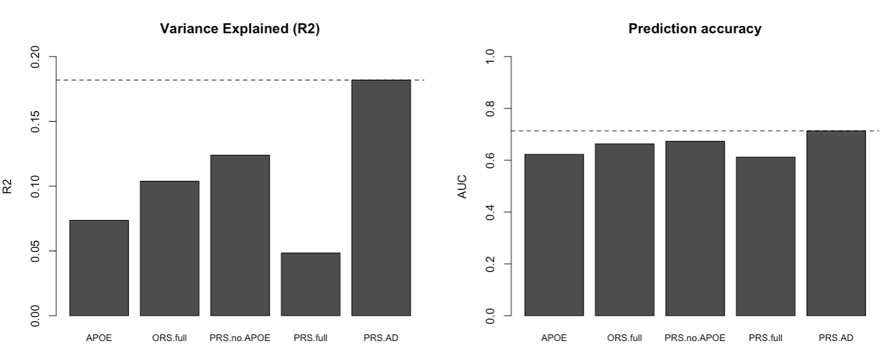

Supplementary Figure 1.Title: Prediction accuracy and variance explained by APOE, ORS and PRS models in younger and older study participants; simulation study.
Legend: Prediction accuracy and variance explained by APOE, ORS (pT≤ 1e-5) and PRS (pT≤ 0.1) accounting for differential distribution of ε4 alleles in younger and older study participants in the simulation study when controls are sampled from the general population.
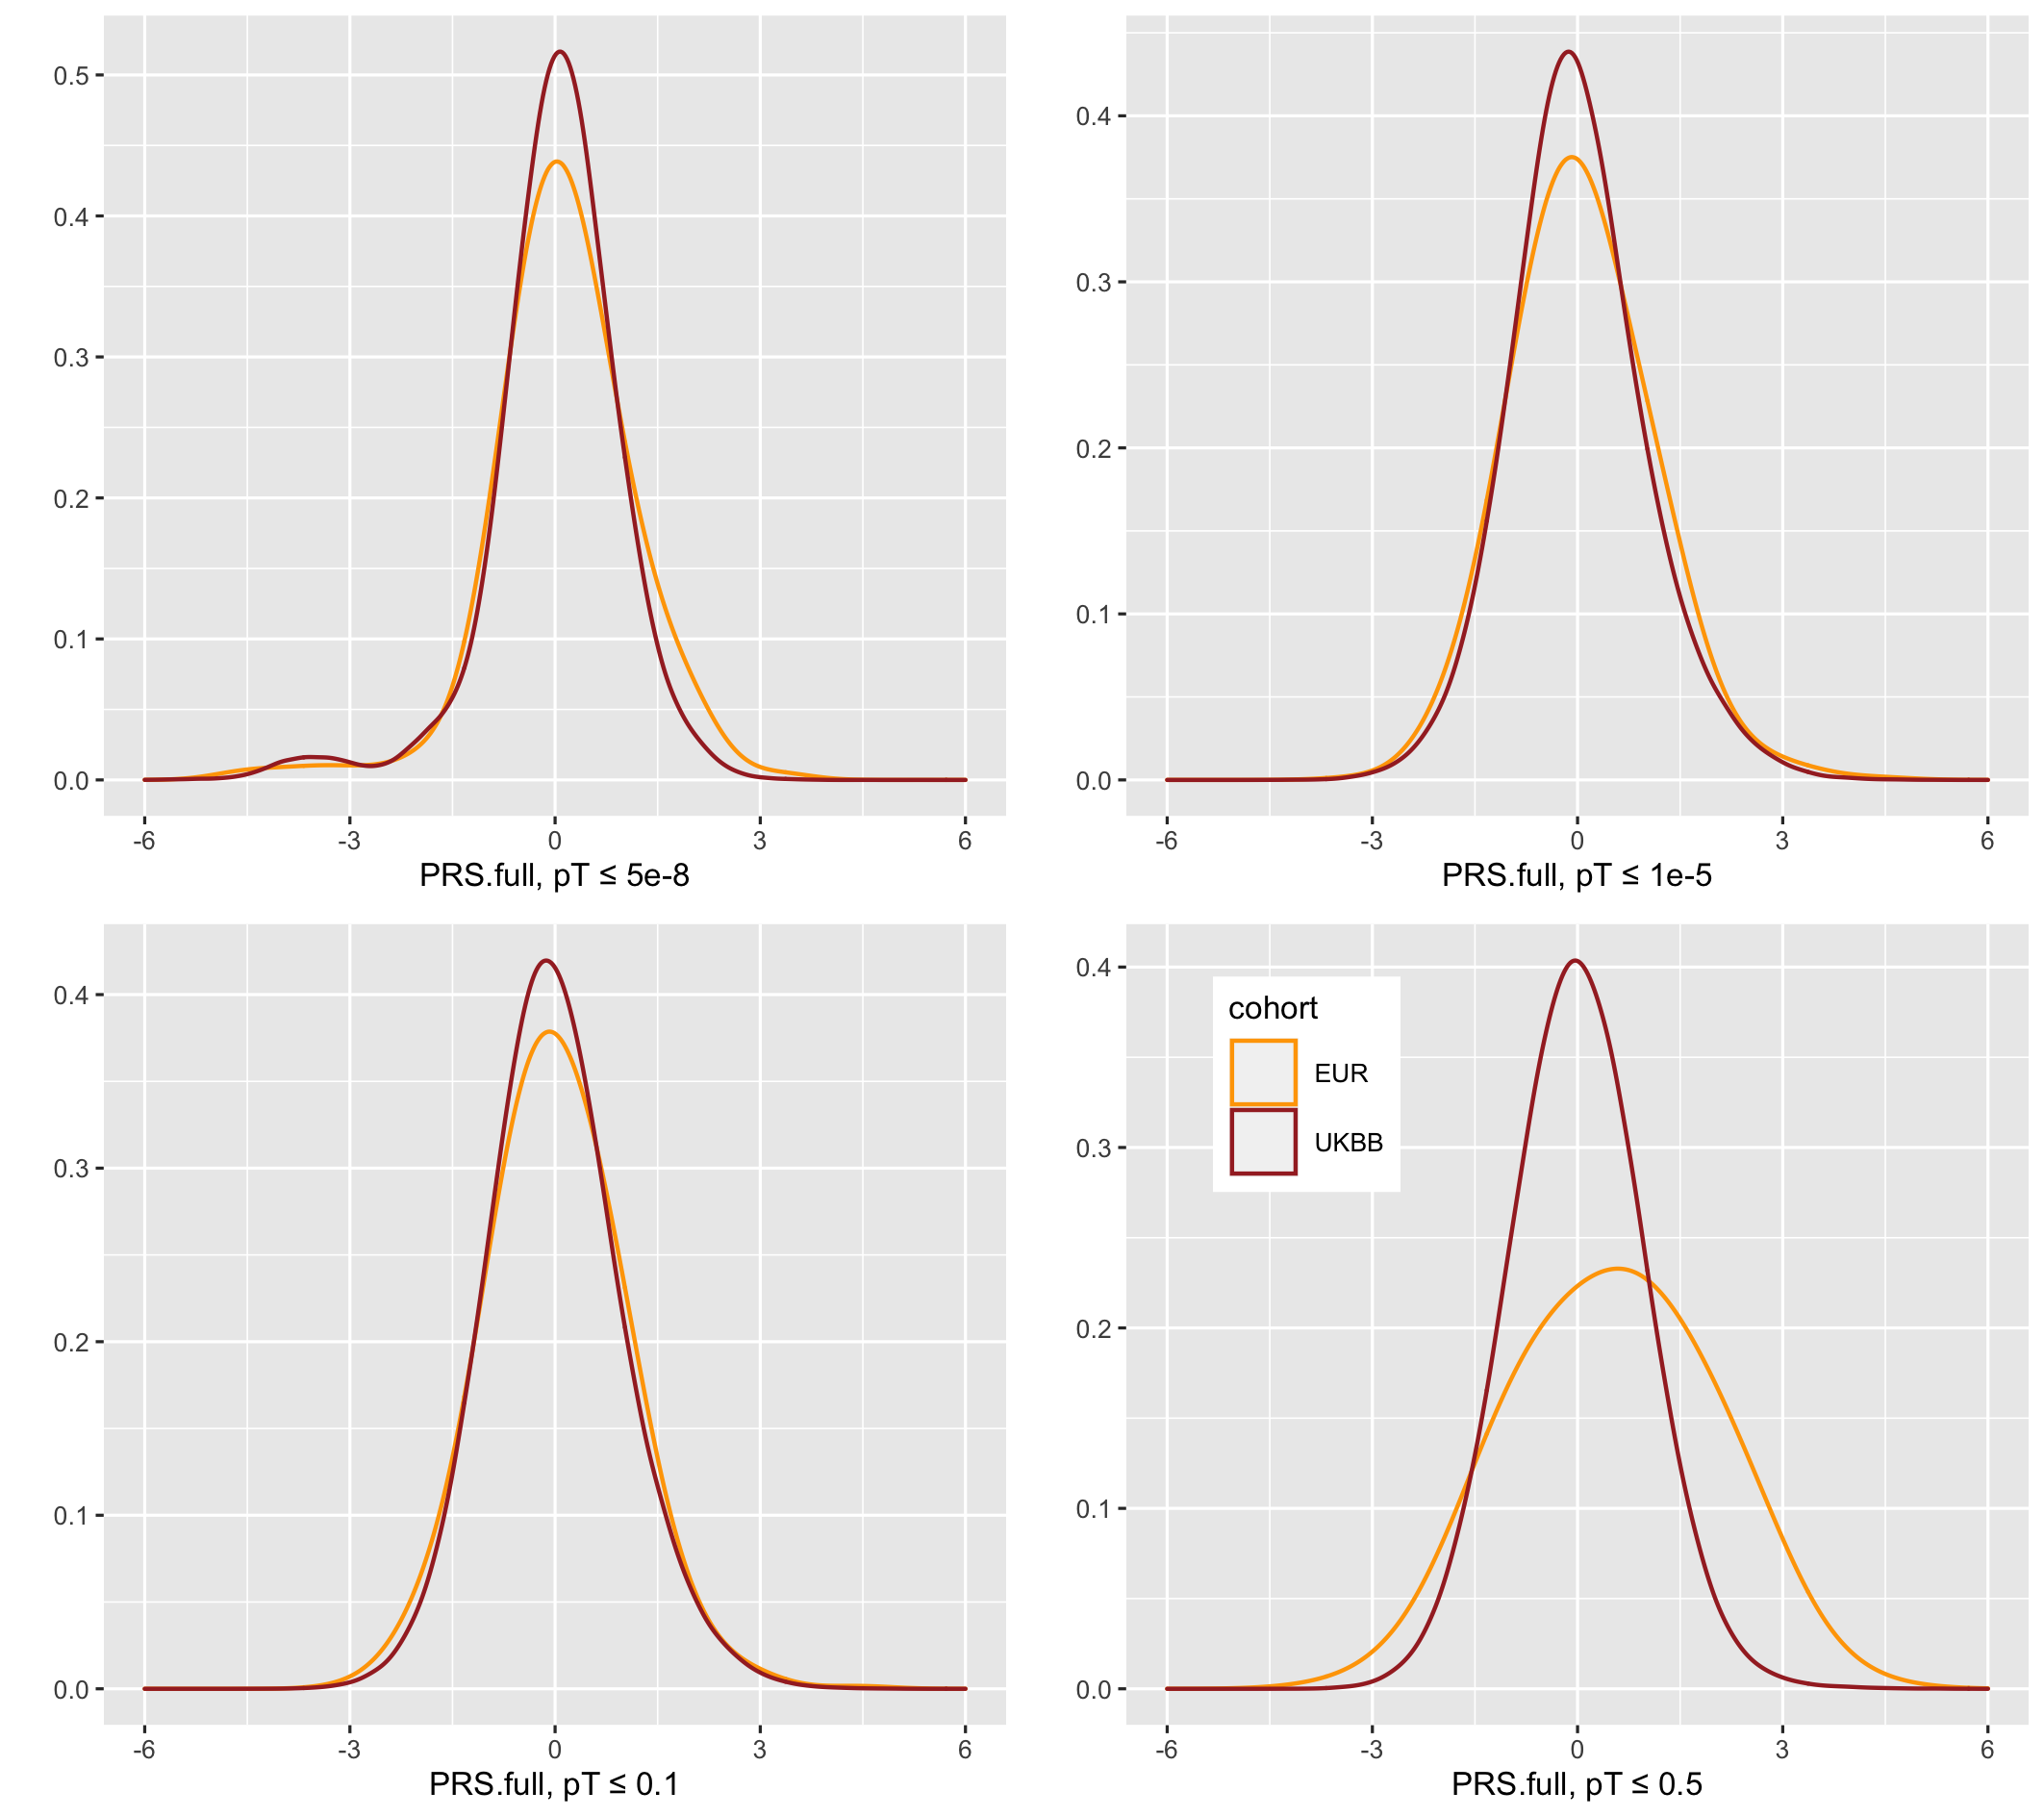

Supplementary Figure 2. Title: AD PRSs distributions for UK Biobank (UKBB) and 1000 Genomes (EUR).
Legend: PRS(P+T) distributions for UKBB (brown) and 1000 Genomes (orange) calculated on Kunkle et al. (2019) summary statistics for pT≤5e-8, 1e-5, 0.1, 0.5 LD pruned SNPs. PRS distributions have not been adjusted for PCs.

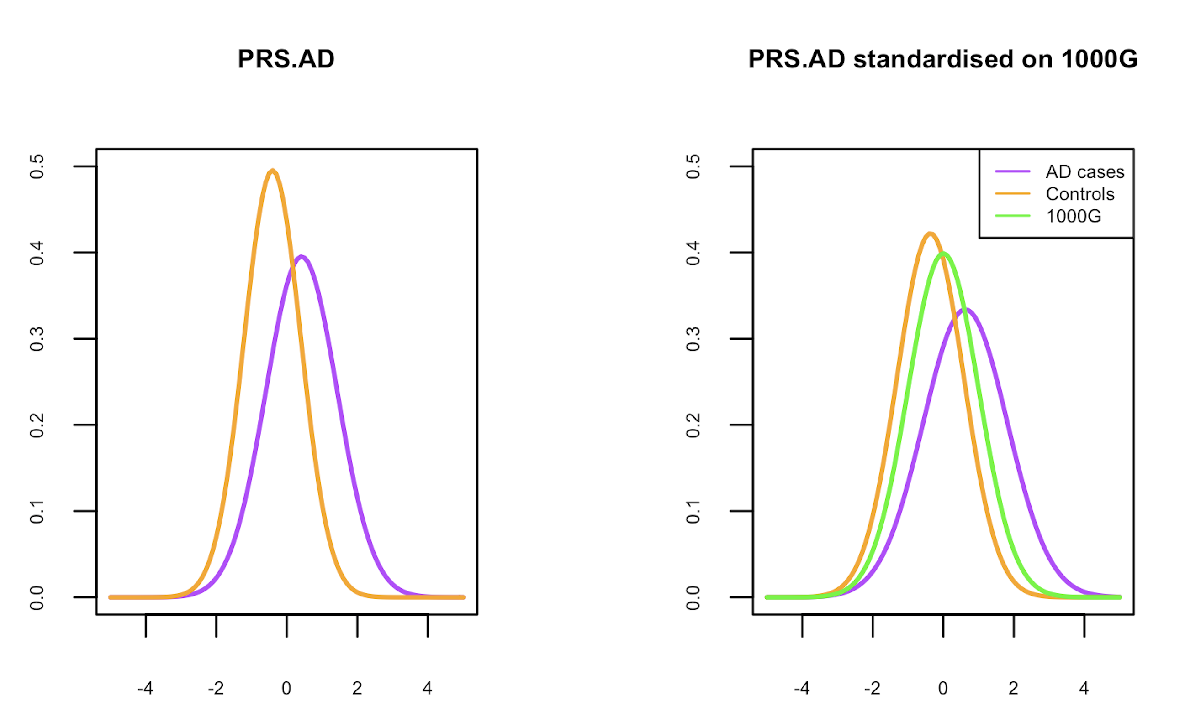

Supplemental Figure 3. Title: PRS.AD distributions for case-control dataset using in-sample and population standardisations.
Legend: PRS.AD distributions for case-control dataset (271 cases and 278 controls) that are standardised in-sample (left) and on 1000 Genomes (right). PRS.AD is calculated as a weighted sum of PRS.no.APOE (excluding SNPs in APOE region) and APOE(ε2+ε4). The distribution parameters are estimates from Supplementary Table 4.

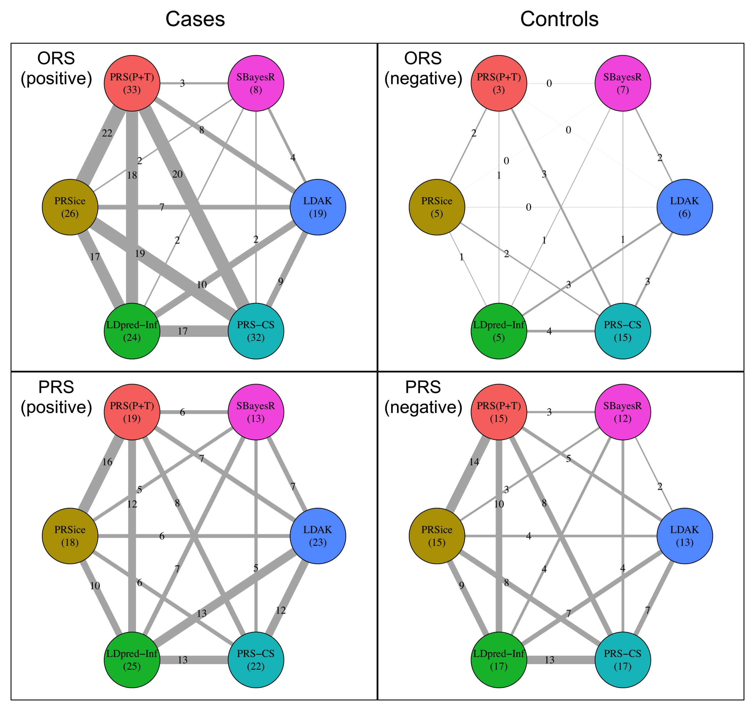
Supplementary Figure 4. Title: Spider-plot for number of shared PRS extremes across six PRS approaches for ORS and PRS.
Legend: Pairwise network visualisation plot showing the number of common individuals identified by each pairwise combination of the 6 PRS approaches (PRS(P+T), PRSice, LDpred-Inf, PRS-CS, LDAK, SBayesR). The total number of correctly identified extremes (cases in positive tail, controls in negative tail) are shown in brackets under the corresponding PRS approach. Line widths show the number of shared identifications, also depicted numerically. Rows are ORS.full (pT≤ 1e-5) (top) and PRS.full (pT≤ 0.1) (bottom). Columns are number of cases in the positive tail (left) and controls in the negative tail (right)

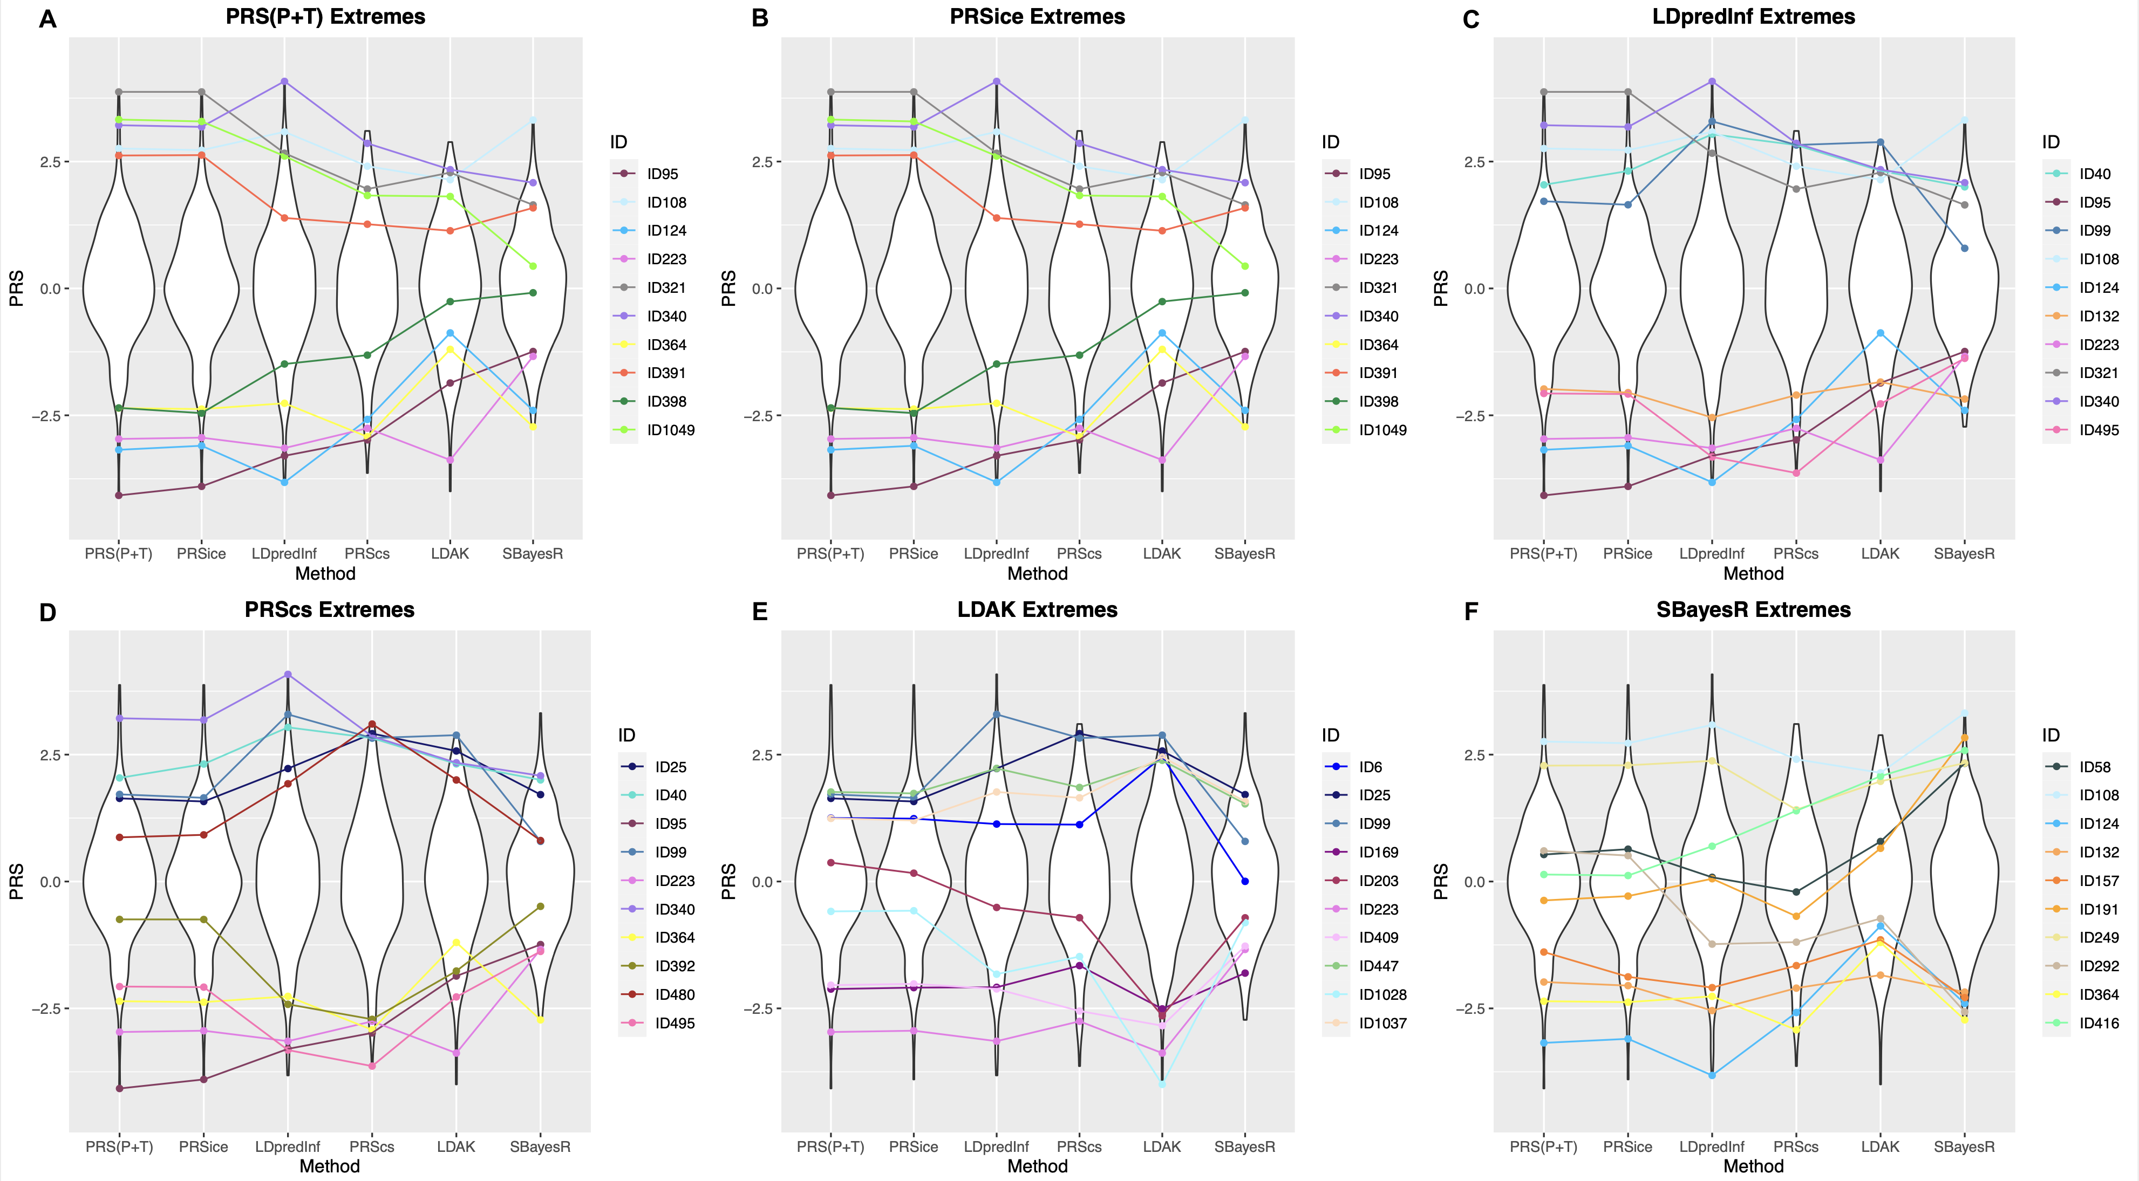

Supplementary Figure 5.Title: Map of top and bottom PRS.no.APOE (p≤0.1) extremes in e33 individuals from A) PRS(P+T) B) PRSice, C) LDpred-Inf, D) PRS-CS, E) LDAK and F) SBayesR across different PRS methods. The y-axis displays the PRS standardised against the 1000 Genome cohort.
Legend: A map of the top 5 and bottom 5 extremes selected by each different PRS method, and how these extremes compare across the different methods. Violins show the PRS.no.APOE distributions standardised against the 1000 Genome cohort. PRS.no.APOE excludes SNPs in the APOE region. IDs are anonymised and the colour scheme is consistent across the 6 plots to highlight extremes selected by multiple PRS approaches.

