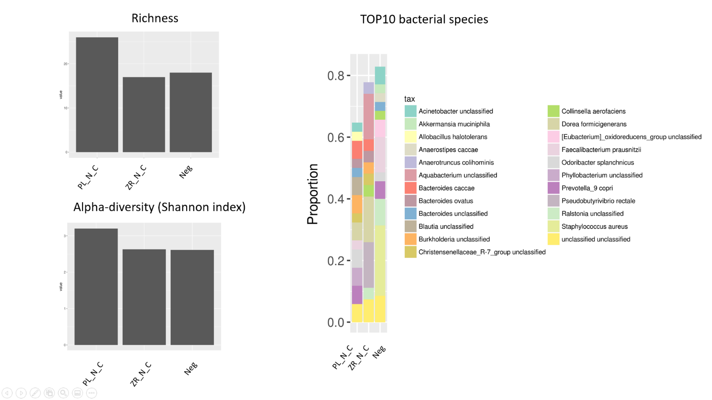
Figure 1. Comparative analysis of all negative controls (kit-ome and no-template sequence control) used in the current study. Data demonstrated as Richness and Alpha-diversity histograms, TOP10 of the most representative bacterial species are shown. No template library negative control (Neg) has got 43 reads (0,0013% from all reads), PureLink negative kit-ome sample (PL_N_C) has got 39 reads (0,0011% of all reads), and ZymoResearch negative kit-ome sample (ZR_N_C) has got 34 reads (0,0014% of all reads), while the average number of reads per sample in the sequencing run was 193200.

Figure 2. Image of the agarose gel for gDNA integrity visualisation. PL - PureLink™ Microbiome DNA Purification kit, ZR – ZymoBIOMICS™ DNA Miniprep kit; 1-5 – different samples. 50 ng of gDNA was put into a well. Thermo Scientific GeneRuler 1 kb DNA Ladder was used as a length marker. Agarose gel electrophoresis conditions were as follows: 0,75 % agarose gel, electrophoresis voltage 70 V and duration 45 min.
1 2 3 4 5 1 2 3 4 5
PL ZR
bp
10000
6000

3000

1000

