Table S1 Survival condition of parabiotic mice after UUO surgery
groups | Number of paraboisis(pairs) | Deaths(pairs) |  | Total deaths(pairs) | Mortality within 2 weeks (%)
 |  | One week after UUO | Two weeks after UUO
Y-IP | 10 | 0 | 1 | 1 | 10%
HP | 10 | 1 | 1 | 2 | 20%
O-IP | 10 | 1 | 1 | 2 | 20%
Y-IP: Young-young isochronic parabiotic; HP: heterochronic parabiotic; O-IP: old-old isochronic parabiotic. Three weeks after parabiosis, UUO surgery was performed in one of the parabiotic pairs in the IP group and in the old mice in the HP group.

Figure S1. Youthful blood environment promotes renal function recovery in old mice after UUO surgery.
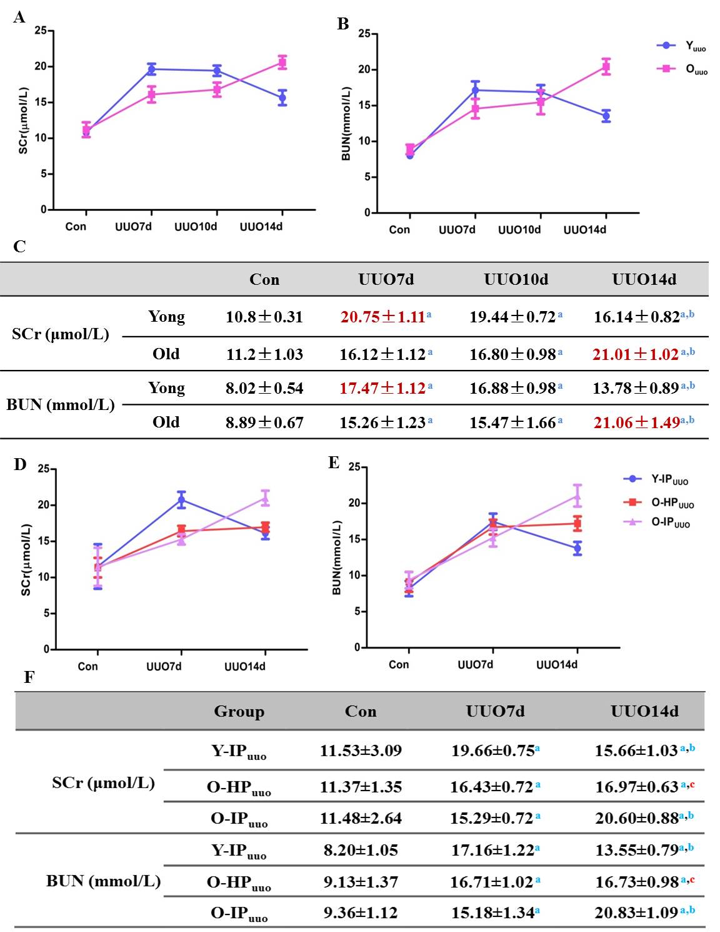
(A) SCr levels at different time after surgery in the two groups. (B) BUN levels in at different time after surgery in the two groups. (D) SCr levels at different time after surgery in the three groups. (E) BUN levels in at different time after surgery in the three groups. (C)(F) Detailed data of SCr and BUN levels in each group. Data shown as mean ± sd. Y: young; O: old; SCr: serum creatinine; BUN: blood urine nitrogen; UUO: unilateral ureteral obstructive; UUO7d: 7 days after UUO surgery; UUO10d: 10 days after UUO surgery; UUO14d: 14 days after UUO surgery; Con: control; IP: isochronic parabiosis; HP: heterochronic parabiosis; Y-IPuuo: UUO surgery performed in one of the young parabiotic pairs in the IP group; O-IPuuo: UUO surgery performed in one of the old parabiotic pairs in the IP group; O-HPuuo: UUO surgery performed in the old parabiotic pairs in the HP group. a, P < 0.01 vs. con; b, P < 0.01 vs. UUO7d; c, P < 0.01 vs. O-IP.

Figure S2. Youthful blood environment alleviates renal interstitial fibrosis of elderly UUO mice.
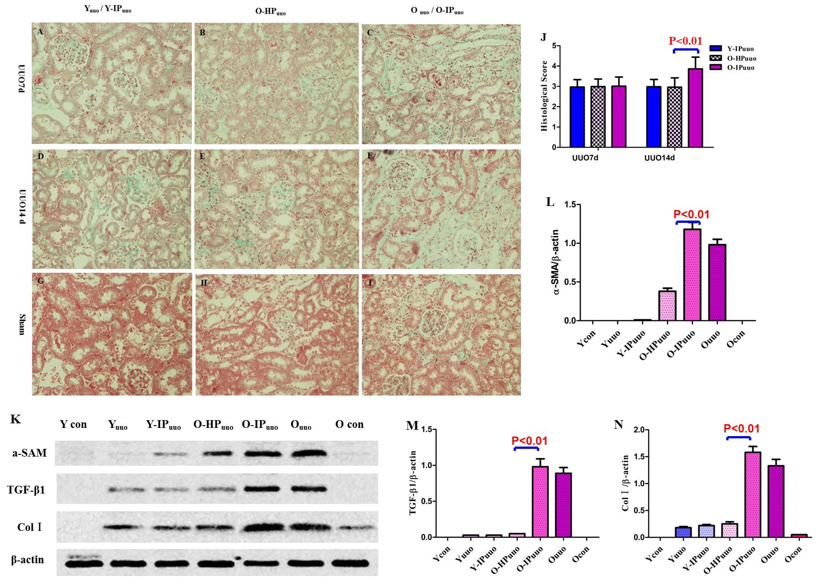
(A-I) Masson staining results of renal tissue in each group. There was no significant difference of pathological manifestations between Y-IPuuo and Yuuo groups or between O-IPuuo and Ouuo groups, so we showed the picture as Yuuo/ Y-IPuuo and Ouuo/ O-IPuuo. Tissue damages 14 days after UUO surgery in old mice exposed to a youthful blood environment (O-HPuuo14) are milder compared to Ouuo or O-IPuuo groups (original magnification, 400×). (J) Graph representing tubulointerstitial lesions measured by NIH semi quantitative scoring method after Masson staining. Ten fields were randomly selected from each slide to calculate the pathological scores, data shown as mean±sd. (K) Expression of fibrosis-associated proteins ColI, α-SMA, and TGF-β1 in the renal tissues 14 days after UUO surgery. Western Blot analysis showed the expressions of these three proteins in the O-HPuuo14 group were significantly lower than those in the O-IPuuo14 and Ouuo14 groups. (L-N) Graph representing quantitative analysis results of ColI, α-SMA, and TGF-β1. Y: young; O: old; UUO: unilateral ureteral obstructive; UUO7d: 7 days after UUO surgery; UUO14d: 14 days after UUO surgery; Con: control; IP: isochronic parabiosis; HP: heterochronic parabiosis; Y-IPuuo: UUO surgery performed in one of the young parabiotic pairs in the IP group; O-IPuuo: UUO surgery performed in one of the old parabiotic pairs in the IP group; O-HPuuo: UUO surgery performed in the old parabiotic pairs in the HP group.

Figure S3. Youthful blood environment may alleviate elderly mice kidney fibrosis by reducing NF-κB activation.
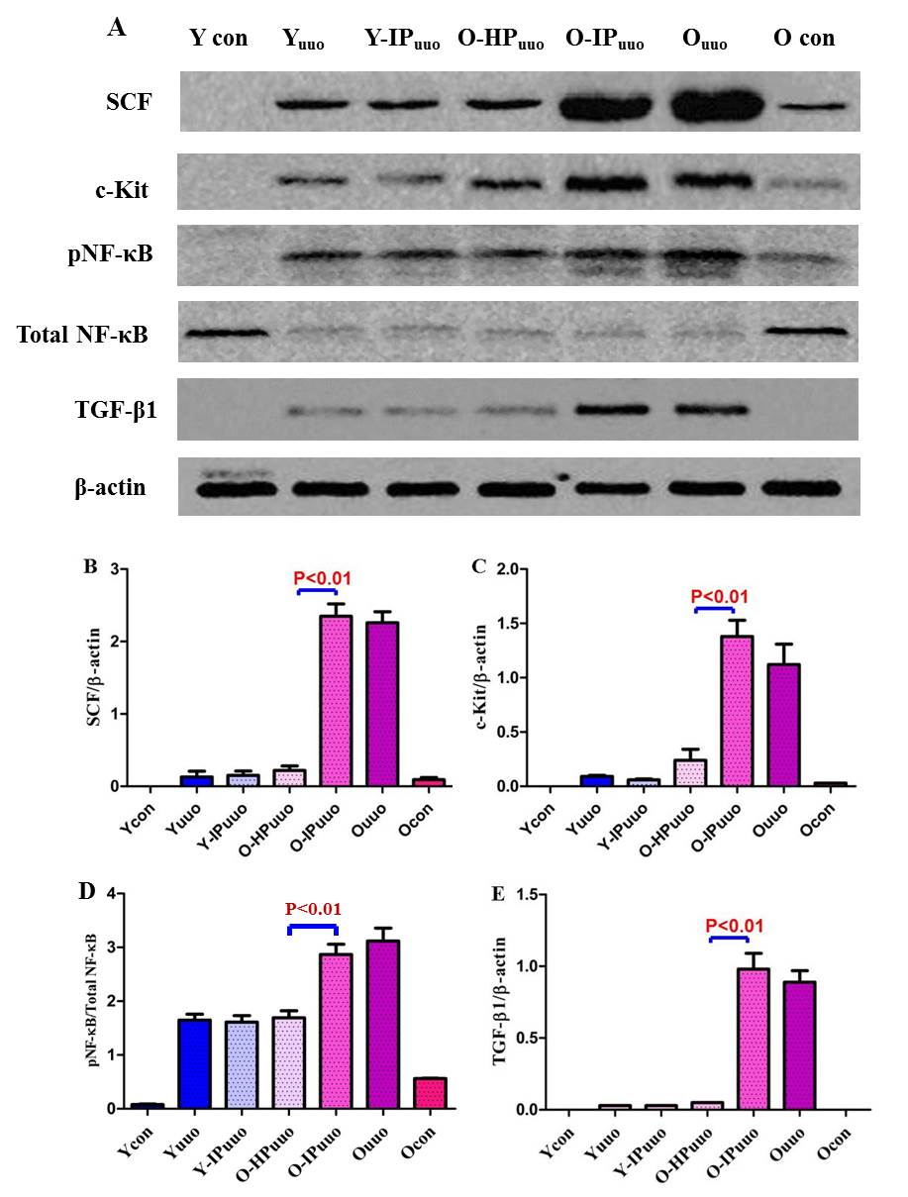
(A) The levels of SCF, c-Kit, TGF-β1, and the phosphor-NF-κB/total NF-κB ratio in kidney tissue from different groups were measured by western blotting. (B-E) Graph representing quantitative analysis results of these four protein expression. Data are presented as means ± sd. Compared to the Ouuo14 and O-IPuuo14 groups, the expressions of SCF and its receptor c-Kit in the O-HPuuo14 group decreased significantly, and the expressions of TGF-β1 in the O-HPuuo14 group were similar decreased. The phosphor-NF-κB/total NF-κB ratio in the O-HPuuo14 group was remarkably lower than that in the Ouuo14 and O-IPuuo14 groups. Y: young; O: old; UUO: unilateral ureteral obstructive; UUO14: 14 days after UUO surgery; Con: control; IP: isochronic parabiosis; HP: heterochronic parabiosis; Y-IPuuo: UUO surgery performed in one of the young parabiotic pairs in the IP group; O-IPuuo: UUO surgery performed in one of the old parabiotic pairs in the IP group; O-HPuuo: UUO surgery performed in the old parabiotic pairs in the HP group.

