Supplementary materials
A genetic variant rs10251977 in long non-coding RNA EGFR-AS1 creates a new binding site for miR-891b and modulates the expression of EGFR A/D isoforms
Shankar Dhamodharan^{1,+}, Mathew Maria Rose^{1,+}, Reddy Chakkarappan Sundaram^{1,4}, Karuppiah Vijayamuthuramalingam Uma Dharshini¹, Ramalingam Arulmurugan², Shanmugam Subbiah², Ituro Inoue³, Arasambattu Kannan Munirajan^{1,*}.
¹Department of Genetics, Dr. ALM PG Institute of Basic Medical Sciences, University of Madras, Taramani Campus, Chennai-600 113, India.
²Center for Oncology, Royapettah Government Hospital & Kilpauk Medical College, Royapettah, Chennai-600 014, India.
³Division of Human genetics, National Institute of Genetics, Mishima- 411-8540, Japan
⁴Department of Health Research – Multi Disciplinary Research Unit (DHR-MRU), Dr. ALM PG Institute of Basic Medical Sciences, University of Madras, Taramani Campus, Chennai-600 113, India.
⁺ These authors contributed equally to this work
*Correspondence to:
Arasambattu Kannan Munirajan, PhD
Department of Genetics
Dr. ALM PG Institute of Basic Medical Sciences
University of Madras, Taramani Campus
Chennai – 600113, India.
Phone: +91-44-24547064, Fax: +91-44-24540709
E-mail: akmunirajan@gmail.com; akmunirajan@unom.ac.in.

Figure S1
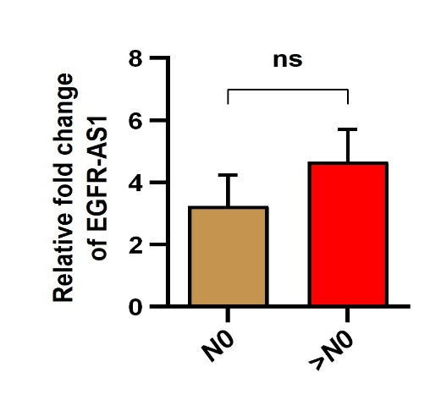
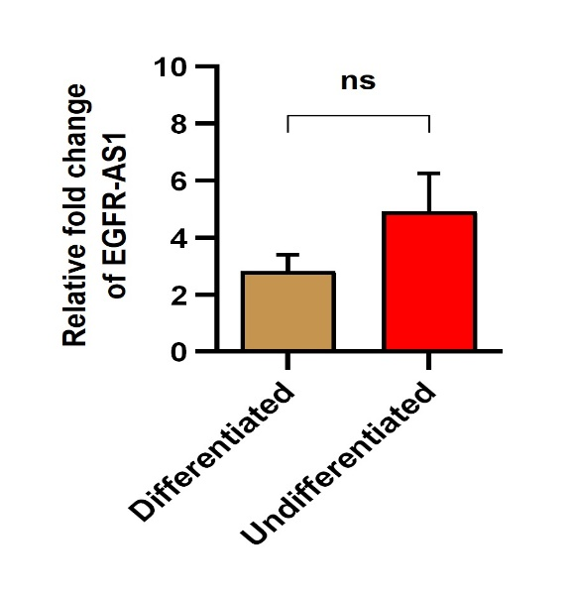
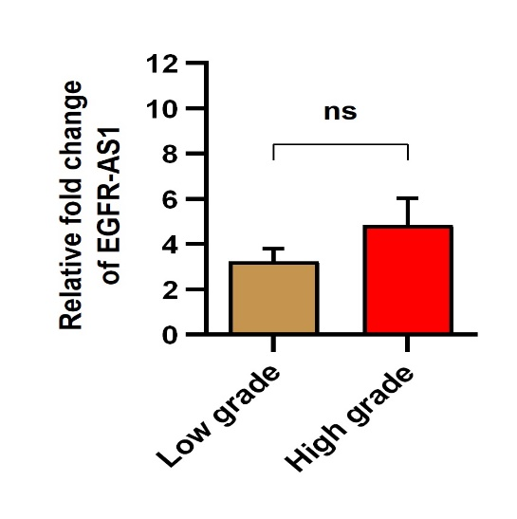
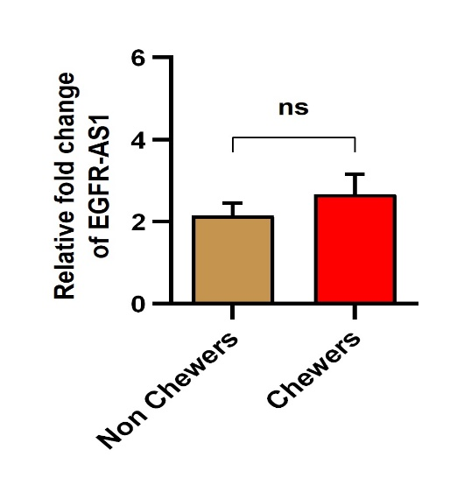
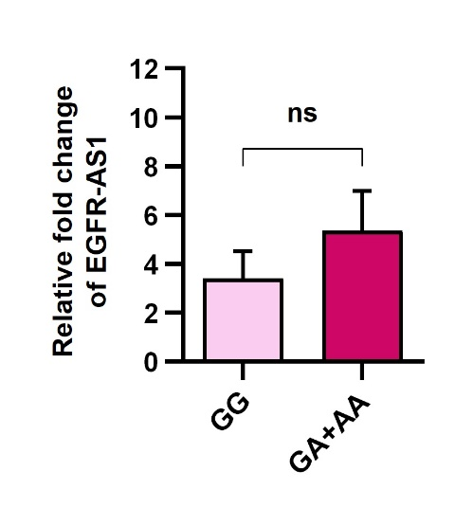
a
b

Figure S2
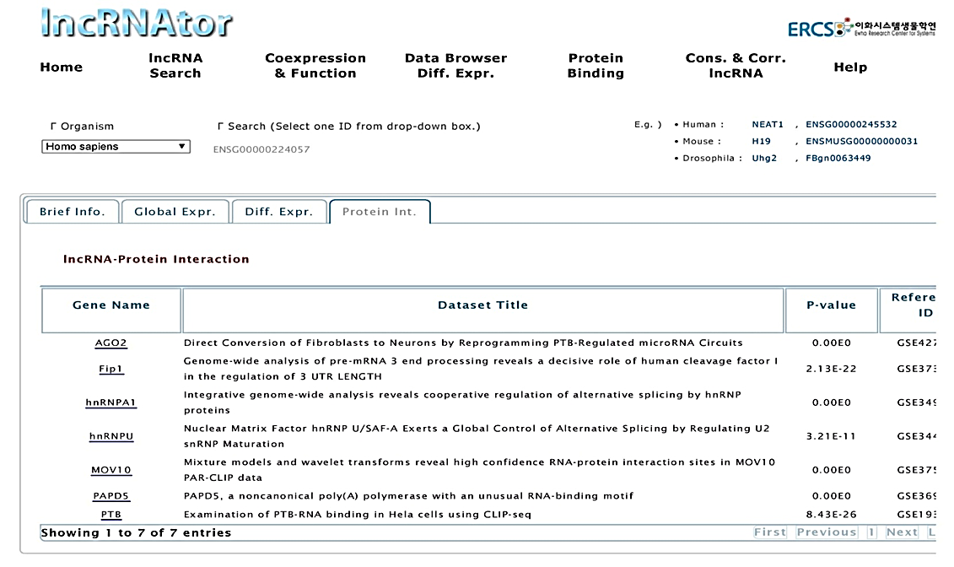
a

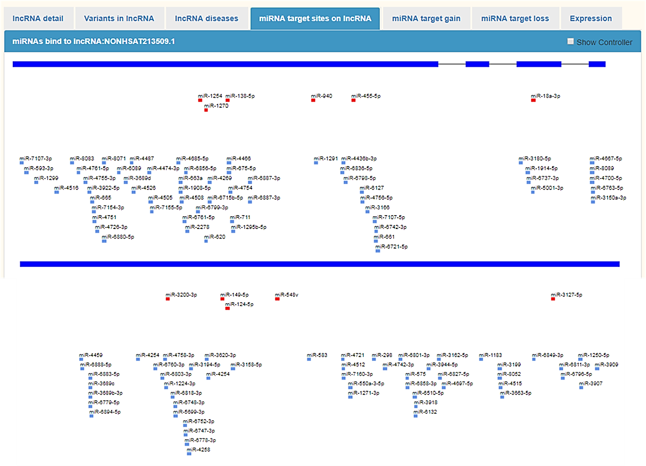
b

Figure S3
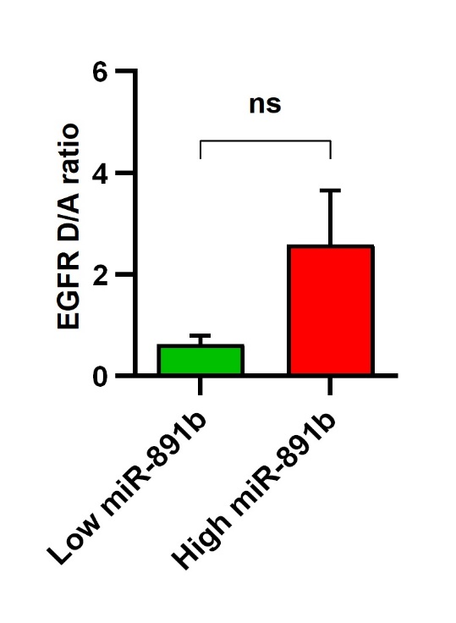
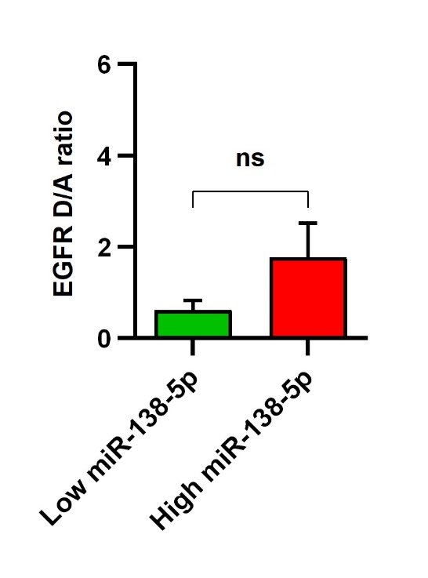
b
a

Table S1. Table showing the prevalence of binding motif of PTBP1 in EGFR-AS1 using RBPmap online tool:

Protein: PTBP1(Hs/Mm)
Sequence Position | Motif | K-mer | Z-score | P-value
38 | ucuu | ucuu | 2.58 | 4.94E-03
213 | cucucu | gugucu | 2.196 | 1.40E-02
220 | cucucu | cucccu | 2.946 | 1.61E-03
222 | cucucu | cccucc | 2.25 | 1.22E-02
224 | cucucu | cucccu | 2.955 | 1.56E-03
226 | cucucu | cccucu | 2.955 | 1.56E-03
228 | cucucu | cucugg | 2.259 | 1.19E-02
233 | cucucu | gucccu | 2.259 | 1.19E-02
244 | cucucu | aucucu | 2.955 | 1.56E-03
246 | cucucu | cucugg | 2.205 | 1.37E-02
253 | cucucu | cccccu | 1.911 | 2.80E-02
265 | cucucu | cugucg | 1.839 | 3.30E-02
450 | ucuu | ucuu | 2.161 | 1.53E-02
451 | cucucu | cuuucu | 1.92 | 2.74E-02
481 | cucucu | cuggcu | 1.839 | 3.30E-02
492 | cucucu | uucugu | 1.839 | 3.30E-02
500 | cucucu | cugucu | 2.259 | 1.19E-02
502 | cucucu | gucucc | 1.884 | 2.98E-02
523 | cucucu | cuaccu | 2.625 | 4.33E-03
532 | cucucu | cacucu | 3.232 | 6.15E-04
534 | cucucu | cucugc | 2.58 | 4.94E-03
537 | cucucu | ugcucu | 2.58 | 4.94E-03
539 | cucucu | cucucu | 3.607 | 1.55E-04
541 | cucucu | cucuca | 3.232 | 6.15E-04
551 | cucucu | cgcccu | 2.58 | 4.94E-03
555 | cucucu | cuggcu | 2.58 | 4.94E-03
557 | cucucu | ggcucu | 2.58 | 4.94E-03
559 | cucucu | cucugg | 2.482 | 6.53E-03
626 | cucucu | cgcccu | 2.071 | 1.92E-02
628 | cucucu | cccucu | 2.839 | 2.26E-03
630 | cucucu | cucugu | 2.839 | 2.26E-03
632 | cucucu | cuguca | 2.188 | 1.43E-02
639 | cucucu | cuccuu | 2.188 | 1.43E-02
652 | cucucu | cucacu | 2.813 | 2.45E-03
1053 | cucucu | cuccuu | 1.929 | 2.69E-02
1057 | cucucu | uuaucu | 1.929 | 2.69E-02
1059 | cucucu | aucucc | 1.929 | 2.69E-02
1061 | cucucu | cucccc | 1.929 | 2.69E-02
1064 | cucucu | cccucc | 1.929 | 2.69E-02
1066 | cucucu | cucccc | 1.929 | 2.69E-02
1072 | cucucu | guaucu | 1.929 | 2.69E-02
1074 | cucucu | aucucc | 1.929 | 2.69E-02
1076 | cucucu | cucccu | 2.304 | 1.06E-02
1081 | cucucu | uucccu | 1.929 | 2.69E-02
1098 | cucucu | cgaucu | 1.839 | 3.30E-02
1137 | ucuu | uauu | 1.884 | 2.98E-02
1142 | ucuu | ucuu | 2.446 | 7.22E-03
1148 | ucuu | uguu | 1.884 | 2.98E-02
1373 | ucuu | ucuu | 2.161 | 1.53E-02
1580 | cucucu | aucucu | 2.179 | 1.47E-02
1581 | ucuu | ucuc | 1.884 | 2.98E-02
1582 | cucucu | cucuga | 1.866 | 3.10E-02
1583 | ucuu | ucug | 1.884 | 2.98E-02
1603 | cucucu | guaucu | 1.884 | 2.98E-02
1605 | cucucu | aucuuu | 1.884 | 2.98E-02
1606 | ucuu | ucuu | 2.58 | 4.94E-03
1892 | cucucu | cucugc | 1.83 | 3.36E-02
1914 | cucucu | agcucu | 1.884 | 2.98E-02
1916 | cucucu | cucuuu | 2.205 | 1.37E-02
1917 | ucuu | ucuu | 2.446 | 7.22E-03
1918 | cucucu | cuuuca | 1.732 | 4.16E-02
1940 | ucuu | uuuu | 1.884 | 2.98E-02
2002 | cucucu | auuucu | 2.563 | 5.19E-03
2019 | cucucu | gucucu | 3.277 | 5.25E-04
2021 | cucucu | cucucu | 3.679 | 1.17E-04
2023 | cucucu | cucugu | 3.304 | 4.77E-04
2043 | cucucu | cucccu | 3.277 | 5.25E-04
2045 | cucucu | cccuau | 2.491 | 6.37E-03
2149 | ucuu | acuu | 2.161 | 1.53E-02

Table S2. Table showing the prevalence of binding motif of PTBP1 in EGFR 15 and 16 exons using RBPmap online tool:
Protein: PTBP1(Hs/Mm)

Sequence Position | Genomic Coordinate | Motif | K-mer | Z-score | P-value
32 | chr7:55165469 | cucucu | uccucu | 2.045 | 2.04E-02
34 | chr7:55165471 | cucucu | cucucu | 2.795 | 2.60E-03
35 | chr7:55165472 | ucuu | ucuc | 1.884 | 2.98E-02
36 | chr7:55165473 | cucucu | cucuug | 2.179 | 1.47E-02
37 | chr7:55165474 | ucuu | ucuu | 2.446 | 7.22E-03
293 | chr7:55165730 | cucucu | cagucu | 2.071 | 1.92E-02
295 | chr7:55165732 | cucucu | gucucc | 2.071 | 1.92E-02
313 | chr7:55165750 | cucucu | guuucu | 2.089 | 1.84E-02
315 | chr7:55165752 | cucucu | uucucu | 2.652 | 4.00E-03
317 | chr7:55165754 | cucucu | cucucc | 2.652 | 4.00E-03
325 | chr7:55165762 | cucucu | auuucu | 2.018 | 2.18E-02
704 | chr7:55166141 | cucucu | aacucu | 1.679 | 4.66E-02
706 | chr7:55166143 | cucucu | cucugu | 1.982 | 2.37E-02
764 | chr7:55166201 | cucucu | cacucu | 2.116 | 1.72E-02
766 | chr7:55166203 | cucucu | cucuga | 1.741 | 4.08E-02
767 | chr7:55166204 | ucuu | ucug | 1.884 | 2.98E-02
778 | chr7:55166215 | cucucu | guaucu | 1.741 | 4.08E-02
781 | chr7:55166218 | ucuu | ucuu | 2.446 | 7.22E-03
784 | chr7:55166221 | ucuu | uauu | 1.884 | 2.98E-02
898 | chr7:55166335 | ucuu | gcuu | 2.161 | 1.53E-02
899 | chr7:55166336 | cucucu | cuuugu | 1.929 | 2.69E-02
902 | chr7:55166339 | ucuu | uguu | 2.161 | 1.53E-02
912 | chr7:55166349 | ucuu | uguu | 2.161 | 1.53E-02
917 | chr7:55166354 | cucucu | cucauu | 2.116 | 1.72E-02
918 | chr7:55166355 | ucuu | ucau | 2.161 | 1.53E-02
919 | chr7:55166356 | cucucu | cauucu | 2.116 | 1.72E-02
921 | chr7:55166358 | cucucu | uucuuu | 2.116 | 1.72E-02
922 | chr7:55166359 | ucuu | ucuu | 2.714 | 3.32E-03
923 | chr7:55166360 | cucucu | cuuucu | 2.679 | 3.69E-03
925 | chr7:55166362 | cucucu | uucucu | 2.67 | 3.79E-03
926 | chr7:55166363 | ucuu | ucuc | 2.152 | 1.57E-02
927 | chr7:55166364 | cucucu | cucuga | 2.116 | 1.72E-02
928 | chr7:55166365 | ucuu | ucug | 2.134 | 1.64E-02
935 | chr7:55166372 | cucucu | ccaucu | 2.116 | 1.72E-02
937 | chr7:55166374 | cucucu | aucugu | 2.116 | 1.72E-02
938 | chr7:55166375 | ucuu | ucug | 2.134 | 1.64E-02
939 | chr7:55166376 | cucucu | cuguau | 2.116 | 1.72E-02
956 | chr7:55166393 | ucuu | ccuu | 2.134 | 1.64E-02
969 | chr7:55166406 | ucuu | ucuu | 3.268 | 5.42E-04
974 | chr7:55166411 | ucuu | ccuu | 2.438 | 7.38E-03
976 | chr7:55166413 | cucucu | uucucu | 2.955 | 1.56E-03
977 | chr7:55166414 | ucuu | ucuc | 2.438 | 7.38E-03
978 | chr7:55166415 | cucucu | cucugu | 2.955 | 1.56E-03
979 | chr7:55166416 | ucuu | ucug | 2.438 | 7.38E-03
986 | chr7:55166423 | cucucu | cucacu | 2.955 | 1.56E-03
988 | chr7:55166425 | cucucu | cacuuu | 2.25 | 1.22E-02
989 | chr7:55166426 | ucuu | acuu | 2.438 | 7.38E-03
990 | chr7:55166427 | cucucu | cuuucu | 2.955 | 1.56E-03
992 | chr7:55166429 | cucucu | uucuuu | 2.25 | 1.22E-02
993 | chr7:55166430 | ucuu | ucuu | 3.277 | 5.25E-04
995 | chr7:55166432 | cucucu | uuuucu | 2.25 | 1.22E-02
997 | chr7:55166434 | cucucu | uucugu | 2.25 | 1.22E-02
998 | chr7:55166435 | ucuu | ucug | 2.152 | 1.57E-02
2334 | chr7:55167771 | cucucu | cuuucu | 1.92 | 2.74E-02
2350 | chr7:55167787 | ucuu | ucau | 2.098 | 1.80E-02
2357 | chr7:55167794 | cucucu | aucucc | 1.884 | 2.98E-02
2358 | chr7:55167795 | ucuu | ucuc | 2.429 | 7.57E-03
2373 | chr7:55167810 | ucuu | ucuu | 3.214 | 6.55E-04
2381 | chr7:55167818 | ucuu | ucuu | 3.25 | 5.77E-04
2383 | chr7:55167820 | ucuu | uuuu | 2.411 | 7.95E-03
2401 | chr7:55167838 | ucuu | ucau | 2.027 | 2.13E-02
2404 | chr7:55167841 | ucuu | uauu | 2.027 | 2.13E-02
2623 | chr7:55168060 | ucuu | uauu | 2.027 | 2.13E-02
2648 | chr7:55168085 | ucuu | ucuu | 2.688 | 3.59E-03
2651 | chr7:55168088 | ucuu | ucau | 2.098 | 1.80E-02
2654 | chr7:55168091 | ucuu | uauu | 2.098 | 1.80E-02
2656 | chr7:55168093 | ucuu | uuuu | 2.098 | 1.80E-02
2662 | chr7:55168099 | ucuu | ccuu | 2.134 | 1.64E-02
2684 | chr7:55168121 | cucucu | agcucu | 1.884 | 2.98E-02
2686 | chr7:55168123 | cucucu | cucugu | 2.259 | 1.19E-02
2696 | chr7:55168133 | cucucu | cacuuu | 1.875 | 3.04E-02
2698 | chr7:55168135 | cucucu | cuuugu | 1.875 | 3.04E-02
2707 | chr7:55168144 | cucucu | cucgau | 1.884 | 2.98E-02
2806 | chr7:55168243 | ucuu | ucug | 2.134 | 1.64E-02
2821 | chr7:55168258 | ucuu | uguu | 2.58 | 4.94E-03
2823 | chr7:55168260 | ucuu | uuuu | 2.58 | 4.94E-03
2825 | chr7:55168262 | cucucu | uuaucu | 1.929 | 2.69E-02
2828 | chr7:55168265 | ucuu | ucuu | 3.554 | 1.90E-04
2832 | chr7:55168269 | cucucu | cccccu | 1.92 | 2.74E-02
2834 | chr7:55168271 | cucucu | cccuuu | 1.911 | 2.80E-02
2835 | chr7:55168272 | ucuu | ccuu | 2.571 | 5.07E-03
2837 | chr7:55168274 | ucuu | uuuu | 2.571 | 5.07E-03
2839 | chr7:55168276 | cucucu | uucuuu | 1.911 | 2.80E-02
2840 | chr7:55168277 | ucuu | ucuu | 3.554 | 1.90E-04
2841 | chr7:55168278 | cucucu | cuuucu | 2.277 | 1.14E-02
2844 | chr7:55168281 | ucuu | ucuu | 3.554 | 1.90E-04
2847 | chr7:55168284 | ucuu | ucug | 2.58 | 4.94E-03
2867 | chr7:55168304 | cucucu | guaucu | 2.196 | 1.40E-02
2869 | chr7:55168306 | cucucu | aucucu | 2.848 | 2.20E-03
2871 | chr7:55168308 | cucucu | cucugc | 2.205 | 1.37E-02
2881 | chr7:55168318 | cucucu | auaucu | 2.277 | 1.14E-02
2883 | chr7:55168320 | cucucu | aucucu | 3 | 1.35E-03
2885 | chr7:55168322 | cucucu | cucuau | 3 | 1.35E-03
2887 | chr7:55168324 | cucucu | cuauau | 2.277 | 1.14E-02
2895 | chr7:55168332 | cucucu | guaucu | 2.25 | 1.22E-02
2897 | chr7:55168334 | cucucu | aucucu | 2.946 | 1.61E-03
2899 | chr7:55168336 | cucucu | cucugu | 2.946 | 1.61E-03
2901 | chr7:55168338 | cucucu | cugugu | 2.25 | 1.22E-02
3044 | chr7:55168481 | ucuu | uguu | 2.134 | 1.64E-02
3053 | chr7:55168490 | ucuu | ucau | 2.161 | 1.53E-02
3056 | chr7:55168493 | ucuu | uuuu | 2.161 | 1.53E-02
3057 | chr7:55168494 | ucuu | uuuu | 2.161 | 1.53E-02
3060 | chr7:55168497 | ucuu | ucua | 2.161 | 1.53E-02
3064 | chr7:55168501 | cucucu | augucu | 1.911 | 2.80E-02
3066 | chr7:55168503 | cucucu | gucuuu | 1.911 | 2.80E-02
3067 | chr7:55168504 | ucuu | ucuu | 2.723 | 3.23E-03
3068 | chr7:55168505 | cucucu | cuuucu | 2.277 | 1.14E-02
3070 | chr7:55168507 | cucucu | uucuau | 1.911 | 2.80E-02
3071 | chr7:55168508 | ucuu | ucua | 2.161 | 1.53E-02
3072 | chr7:55168509 | cucucu | cuauuu | 1.911 | 2.80E-02
3073 | chr7:55168510 | ucuu | uauu | 2.446 | 7.22E-03
3075 | chr7:55168512 | ucuu | uuuu | 2.446 | 7.22E-03
3076 | chr7:55168513 | ucuu | uuuu | 2.446 | 7.22E-03
3077 | chr7:55168514 | ucuu | uuuu | 2.446 | 7.22E-03
3087 | chr7:55168524 | ucuu | uccu | 2.446 | 7.22E-03
3097 | chr7:55168534 | ucuu | ucuu | 2.723 | 3.23E-03
3099 | chr7:55168536 | cucucu | uucacu | 1.92 | 2.74E-02
3101 | chr7:55168538 | cucucu | cacugu | 1.92 | 2.74E-02
3103 | chr7:55168540 | cucucu | cugucu | 2.295 | 1.09E-02
3106 | chr7:55168543 | ucuu | ucug | 2.098 | 1.80E-02
3107 | chr7:55168544 | cucucu | cugacu | 1.92 | 2.74E-02
3110 | chr7:55168547 | ucuu | acuu | 2.098 | 1.80E-02
3116 | chr7:55168553 | cucucu | gucucc | 2.116 | 1.72E-02
3117 | chr7:55168554 | ucuu | ucuc | 2.152 | 1.57E-02
3118 | chr7:55168555 | cucucu | cuccca | 2.116 | 1.72E-02
3120 | chr7:55168557 | cucucu | cccacu | 2.116 | 1.72E-02
3139 | chr7:55168576 | cucucu | cuuucu | 2.67 | 3.79E-03
3154 | chr7:55168591 | cucucu | auuucu | 2.071 | 1.92E-02
3156 | chr7:55168593 | cucucu | uucucc | 2.071 | 1.92E-02
3158 | chr7:55168595 | cucucu | cucccu | 2.625 | 4.33E-03
3160 | chr7:55168597 | cucucu | cccuuu | 2.098 | 1.80E-02
3208 | chr7:55168645 | ucuu | uuuu | 2.134 | 1.64E-02
3217 | chr7:55168654 | ucuu | uauu | 2.027 | 2.13E-02
3219 | chr7:55168656 | ucuu | uuuu | 2.098 | 1.80E-02
3222 | chr7:55168659 | ucuu | ucuu | 2.652 | 4.00E-03
3244 | chr7:55168681 | ucuu | uccu | 2.152 | 1.57E-02
3288 | chr7:55168725 | ucuu | ucuu | 3.214 | 6.55E-04
3291 | chr7:55168728 | ucuu | uguu | 2.375 | 8.77E-03
3294 | chr7:55168731 | ucuu | uauu | 2.375 | 8.77E-03
3308 | chr7:55168745 | ucuu | ucuu | 3.214 | 6.55E-04
3311 | chr7:55168748 | ucuu | ucuc | 2.375 | 8.77E-03
3399 | chr7:55168836 | ucuu | uuuu | 2.152 | 1.57E-02
3400 | chr7:55168837 | ucuu | uuuu | 2.152 | 1.57E-02
3401 | chr7:55168838 | ucuu | uuuu | 2.152 | 1.57E-02
3402 | chr7:55168839 | ucuu | uuuu | 2.152 | 1.57E-02
3410 | chr7:55168847 | ucuu | ucuu | 2.688 | 3.59E-03
3422 | chr7:55168859 | ucuu | uauu | 2.152 | 1.57E-02
3440 | chr7:55168877 | cucucu | cauucc | 1.83 | 3.36E-02
3441 | chr7:55168878 | cucucu | auuccu | 1.83 | 3.36E-02
3445 | chr7:55168882 | cucucu | cugaau | 1.83 | 3.36E-02
3449 | chr7:55168886 | cucucu | auauau | 1.83 | 3.36E-02
3454 | chr7:55168891 | cucucu | uugucu | 2.571 | 5.07E-03
3456 | chr7:55168893 | cucucu | gucucu | 3.223 | 6.34E-04
3458 | chr7:55168895 | cucucu | cucucu | 3.589 | 1.66E-04
3460 | chr7:55168897 | cucucu | cucuca | 3.223 | 6.34E-04
3462 | chr7:55168899 | cucucu | cucauu | 2.58 | 4.94E-03
3465 | chr7:55168902 | cucucu | auuucu | 2.58 | 4.94E-03
3467 | chr7:55168904 | cucucu | uucuca | 2.58 | 4.94E-03
3469 | chr7:55168906 | cucucu | cucaga | 1.839 | 3.30E-02
3479 | chr7:55168916 | cucucu | auguau | 1.839 | 3.30E-02
3503 | chr7:55168940 | ucuu | uguu | 2.161 | 1.53E-02
3515 | chr7:55168952 | ucuu | acuu | 2.152 | 1.57E-02
3528 | chr7:55168965 | ucuu | ucuu | 2.58 | 4.94E-03
3537 | chr7:55168974 | ucuu | acuu | 1.884 | 2.98E-02
3661 | chr7:55169098 | ucuu | uauu | 2.161 | 1.53E-02
3665 | chr7:55169102 | ucuu | ucuu | 2.723 | 3.23E-03
3667 | chr7:55169104 | ucuu | uuuu | 2.446 | 7.22E-03
3668 | chr7:55169105 | ucuu | uuuu | 2.446 | 7.22E-03
3669 | chr7:55169106 | ucuu | uuuu | 2.446 | 7.22E-03
3670 | chr7:55169107 | ucuu | uuuu | 2.446 | 7.22E-03
3671 | chr7:55169108 | ucuu | uuuu | 2.446 | 7.22E-03
3672 | chr7:55169109 | ucuu | uuuu | 2.446 | 7.22E-03
3673 | chr7:55169110 | ucuu | uuuu | 2.446 | 7.22E-03
3674 | chr7:55169111 | ucuu | uuuu | 2.446 | 7.22E-03
3675 | chr7:55169112 | ucuu | uuuu | 2.446 | 7.22E-03
3691 | chr7:55169128 | ucuu | ucuu | 2.723 | 3.23E-03
3694 | chr7:55169131 | ucuu | uguu | 2.161 | 1.53E-02
3697 | chr7:55169134 | ucuu | ucug | 2.152 | 1.57E-02
3735 | chr7:55169172 | cucucu | cucacu | 1.929 | 2.69E-02
3752 | chr7:55169189 | cucucu | cuccca | 1.741 | 4.08E-02
3865 | chr7:55169302 | ucuu | uguu | 2.134 | 1.64E-02
3875 | chr7:55169312 | ucuu | gcuu | 2.098 | 1.80E-02
3880 | chr7:55169317 | ucuu | ucuu | 2.652 | 4.00E-03
3886 | chr7:55169323 | ucuu | ucuc | 2.134 | 1.64E-02
3888 | chr7:55169325 | ucuu | uccu | 2.134 | 1.64E-02
4018 | chr7:55169455 | ucuu | gcuu | 1.884 | 2.98E-02
4027 | chr7:55169464 | ucuu | ucuu | 2.446 | 7.22E-03
4033 | chr7:55169470 | ucuu | uccu | 1.884 | 2.98E-02
4267 | chr7:55169704 | cucucu | cccucg | 2.107 | 1.76E-02
4269 | chr7:55169706 | cucucu | cucgcc | 2.205 | 1.37E-02
4273 | chr7:55169710 | cucucu | ccuucu | 2.25 | 1.22E-02
4281 | chr7:55169718 | cucucu | cgcucu | 2.955 | 1.56E-03
4283 | chr7:55169720 | cucucu | cucuca | 2.955 | 1.56E-03
4285 | chr7:55169722 | cucucu | cucaca | 2.25 | 1.22E-02
4292 | chr7:55169729 | cucucu | ccuucu | 2.25 | 1.22E-02
4294 | chr7:55169731 | cucucu | uucucu | 2.955 | 1.56E-03
4296 | chr7:55169733 | cucucu | cucucc | 2.955 | 1.56E-03
4318 | chr7:55169755 | cucucu | cacugu | 2.188 | 1.43E-02
4320 | chr7:55169757 | cucucu | cugucc | 2.071 | 1.92E-02
4323 | chr7:55169760 | ucuu | uccu | 2.152 | 1.57E-02
4324 | chr7:55169761 | ucuu | ccuu | 2.152 | 1.57E-02
4333 | chr7:55169770 | ucuu | gcuu | 2.152 | 1.57E-02
4335 | chr7:55169772 | cucucu | uucucu | 2.259 | 1.19E-02
4336 | chr7:55169773 | ucuu | ucuc | 2.161 | 1.53E-02
4337 | chr7:55169774 | cucucu | cucuuc | 1.911 | 2.80E-02
4338 | chr7:55169775 | ucuu | ucuu | 2.705 | 3.42E-03
4356 | chr7:55169793 | ucuu | ucua | 2.134 | 1.64E-02
4357 | chr7:55169794 | cucucu | cuaccu | 1.92 | 2.74E-02
4360 | chr7:55169797 | ucuu | ccuu | 2.134 | 1.64E-02
4374 | chr7:55169811 | ucuu | ucug | 2.134 | 1.64E-02
4383 | chr7:55169820 | ucuu | gcuu | 2.098 | 1.80E-02
4386 | chr7:55169823 | ucuu | ucuu | 2.58 | 4.94E-03
4389 | chr7:55169826 | ucuu | uguu | 2.027 | 2.13E-02
4445 | chr7:55169882 | ucuu | ucuu | 2.446 | 7.22E-03
4467 | chr7:55169904 | cucucu | caaucu | 2.071 | 1.92E-02
4470 | chr7:55169907 | ucuu | ucug | 2.027 | 2.13E-02
4474 | chr7:55169911 | cucucu | cccucc | 2.071 | 1.92E-02
4476 | chr7:55169913 | cucucu | cucccu | 2.625 | 4.33E-03
4478 | chr7:55169915 | cucucu | cccucu | 2.625 | 4.33E-03
4480 | chr7:55169917 | cucucu | cucugc | 2.071 | 1.92E-02
4537 | chr7:55169974 | cucucu | gucugu | 2.071 | 1.92E-02
4556 | chr7:55169993 | cucucu | cuuucu | 2.67 | 3.79E-03
4558 | chr7:55169995 | cucucu | uucugu | 2.116 | 1.72E-02
4560 | chr7:55169997 | cucucu | cugucu | 2.67 | 3.79E-03
4562 | chr7:55169999 | cucucu | gucuca | 2.116 | 1.72E-02
4570 | chr7:55170007 | cucucu | cuguuu | 2.107 | 1.76E-02
4577 | chr7:55170014 | cucucu | gugucu | 2.107 | 1.76E-02
4579 | chr7:55170016 | cucucu | gucugu | 2.107 | 1.76E-02
4821 | chr7:55170258 | cucucu | cucccc | 1.696 | 4.49E-02
4829 | chr7:55170266 | cucucu | gccucu | 1.804 | 3.56E-02
4831 | chr7:55170268 | cucucu | cucuca | 2.241 | 1.25E-02
4833 | chr7:55170270 | cucucu | cucaca | 1.902 | 2.86E-02
4839 | chr7:55170276 | ucuu | uauu | 2.098 | 1.80E-02
4850 | chr7:55170287 | ucuu | acuu | 2.098 | 1.80E-02
4856 | chr7:55170293 | cucucu | ccaucu | 2.089 | 1.84E-02
4858 | chr7:55170295 | cucucu | aucuuu | 1.875 | 3.04E-02
4859 | chr7:55170296 | ucuu | ucuu | 2.58 | 4.94E-03
4860 | chr7:55170297 | cucucu | cuuucu | 2.25 | 1.22E-02
4862 | chr7:55170299 | cucucu | uucucc | 1.884 | 2.98E-02
4863 | chr7:55170300 | ucuu | ucuc | 2.098 | 1.80E-02

Supplement Table S5. List of Universal reverse transcription primers used for cDNA synthesis:
Study type | Primer type | Sequence
miRNA | Stem loop RT primer –  RNU44 specific | 5`- GTCGTATCCAGTGCGTCGAGTGACACGAGAGCCA  CCTGGGCAATTTGCACTGGATACGACAGTCAG- 3`
 | Stem loop RT primer –  miR-891b specific | 5`- GTCGTATCCAGTGCGTCGAGTGACACGAGAGCCA  CCTGGGCAATTTGCACTGGATACGACTCAATG - 3`
 | Stem loop RT primer –  miR-138-5p specific | 5`- GTCGTATCCAGTGCGTCGAGTGACACGAGAGCCA  CCTGGGCAATTTGCACTGGATACGACCGGCCT - 3`

Supplement Table S6. List of gene specific forward primers used for real time PCR experiments:
ncRNAs | Forward primer sequences
RNU44 | 5`- GCAAATGCTGACTGAACATGA - 3`
miR-891b | 5`- CAGTGCAACTTACCTGAGTC - 3`
miR-138-5p | 5`- AGCTGGTGTTGTGAATCAG - 3`
Supplement Table S7. List of primers used for SYBR® Green gene expression assays:
Gene | Forward | Reverse
GAPDH | 5` - AGGGCTGCTTTTAACTCTGGT - 3` | 5` - CCCCACTTGATTTTGGAGGGA - 3`
EGFR - A | 5` - TGCACAGGACGGGGACCAGAC - 3` | 5` - GCTTGGTTGGGAGCTTCTCCACT - 3`
EGFR - D | 5` - CCAAACTGCACCTACGGGCCAG- 3` | 5` - GAGGCCGTGATGATCACAGATGCAG - 3`
EGFR - AS1 | 5` - GGAGCGCAGACCGCATGTGAG - 3` | 5` - GCCACCATGCGAAGCCACACTG - 3`

