Differential escape of neutralizing antibodies by SARS-CoV-2 Omicron and pre-emergent sarbecoviruses

Chee Wah Tan^{1,}*, Wan Ni Chia¹, Feng Zhu¹, Barnaby E Young^{2,3,4}, Napaporn Chantasrisawad⁵, Shi-Hsia Hwa^{6,7}, Aileen Ying-Yan Yeoh¹, Beng Lee Lim¹, Wee Chee Yap¹, Surinder Kaur MS Pada⁸, Seow Yen Tan^{2,10} , Watsamon Jantarabenjakul^{5,9}, Shiwei Chen¹, Jinyan Zhang¹, Yun Yan Mah¹, Vivian Chih-Wei Chen¹, Mark I-C Chen^{2,3}, Supaporn Wacharapluesadee⁵, Alex Sigal^{6,11,12}, Opass Putcharoen^{5,8}, David Chien Lye^{2,3,4,13} and Lin-Fa Wang^{1,}*

¹Programme in Emerging Infectious Diseases, Duke-NUS Medical School, Singapore
²National Center of Infectious Diseases, Singapore
³Tan Tock Seng Hospital, Singapore
⁴Lee Kong Chian School of Medicine, Nanyang Technological University, Singapore.
⁵Thai Red Cross Emerging Infectious Diseases Clinical Center, King Chulalongkorn Memorial Hospital, Bangkok, Thailand
⁶Africa Health Research Institute, Durban, South Africa
⁷Division of Infection and Immunity, University College London, London, United Kingdom
⁸Ng Teng Fong General Hospital, Singapore
⁹Faculty of Medicine, Chulalongkorn University, Bangkok, Thailand
¹⁰Changi General Hospital, Singapore
¹¹School of Laboratory Medicine and Medical Sciences, University of KwaZulu-Natal, Durban, South Africa
¹²Max Planck Institute for Infection Biology, Berlin, Germany
¹³Yong Loo Lin School of Medicine, National University of Singapore, Singapore

*Corresponding author: Lin-Fa Wang (linfa.wang@duke-nus.edu.sg); Chee Wah Tan (cheewah.tan@duke-nus.edu.sg); Programme in Emerging Infectious Diseases,
Duke-NUS Medical School, Singapore.
Table of contents

Supplementary Data Fig 1.

Supplementary Data Fig 2

Supplementary Data Table 1

Supplementary Data Table 2
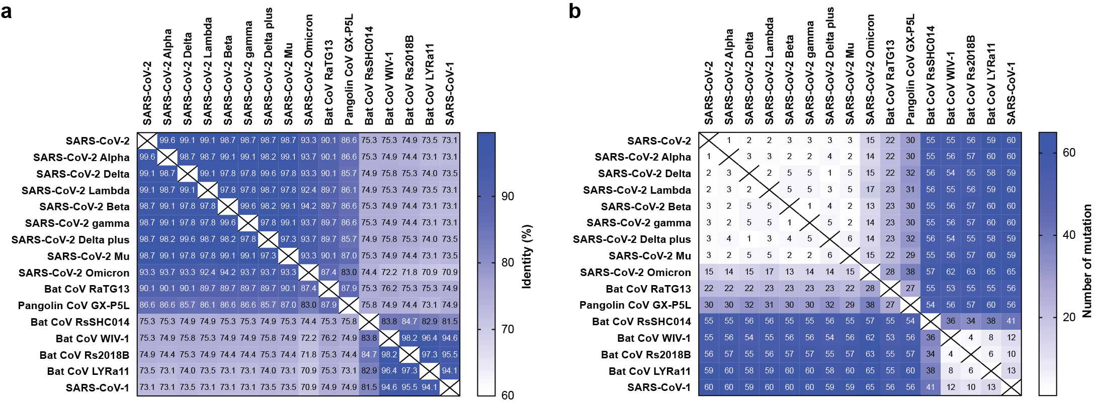

Supplementary Data Fig 1. Amino acid difference between sarbecovirus RBDs. Matrix of (a) amino acid identity (%) and (b) mutation numbers of 16 sarbecovirus RBDs used in multiplex sVNT. RBD sequences are aligned using Geneious alignment with Blosum62 model.

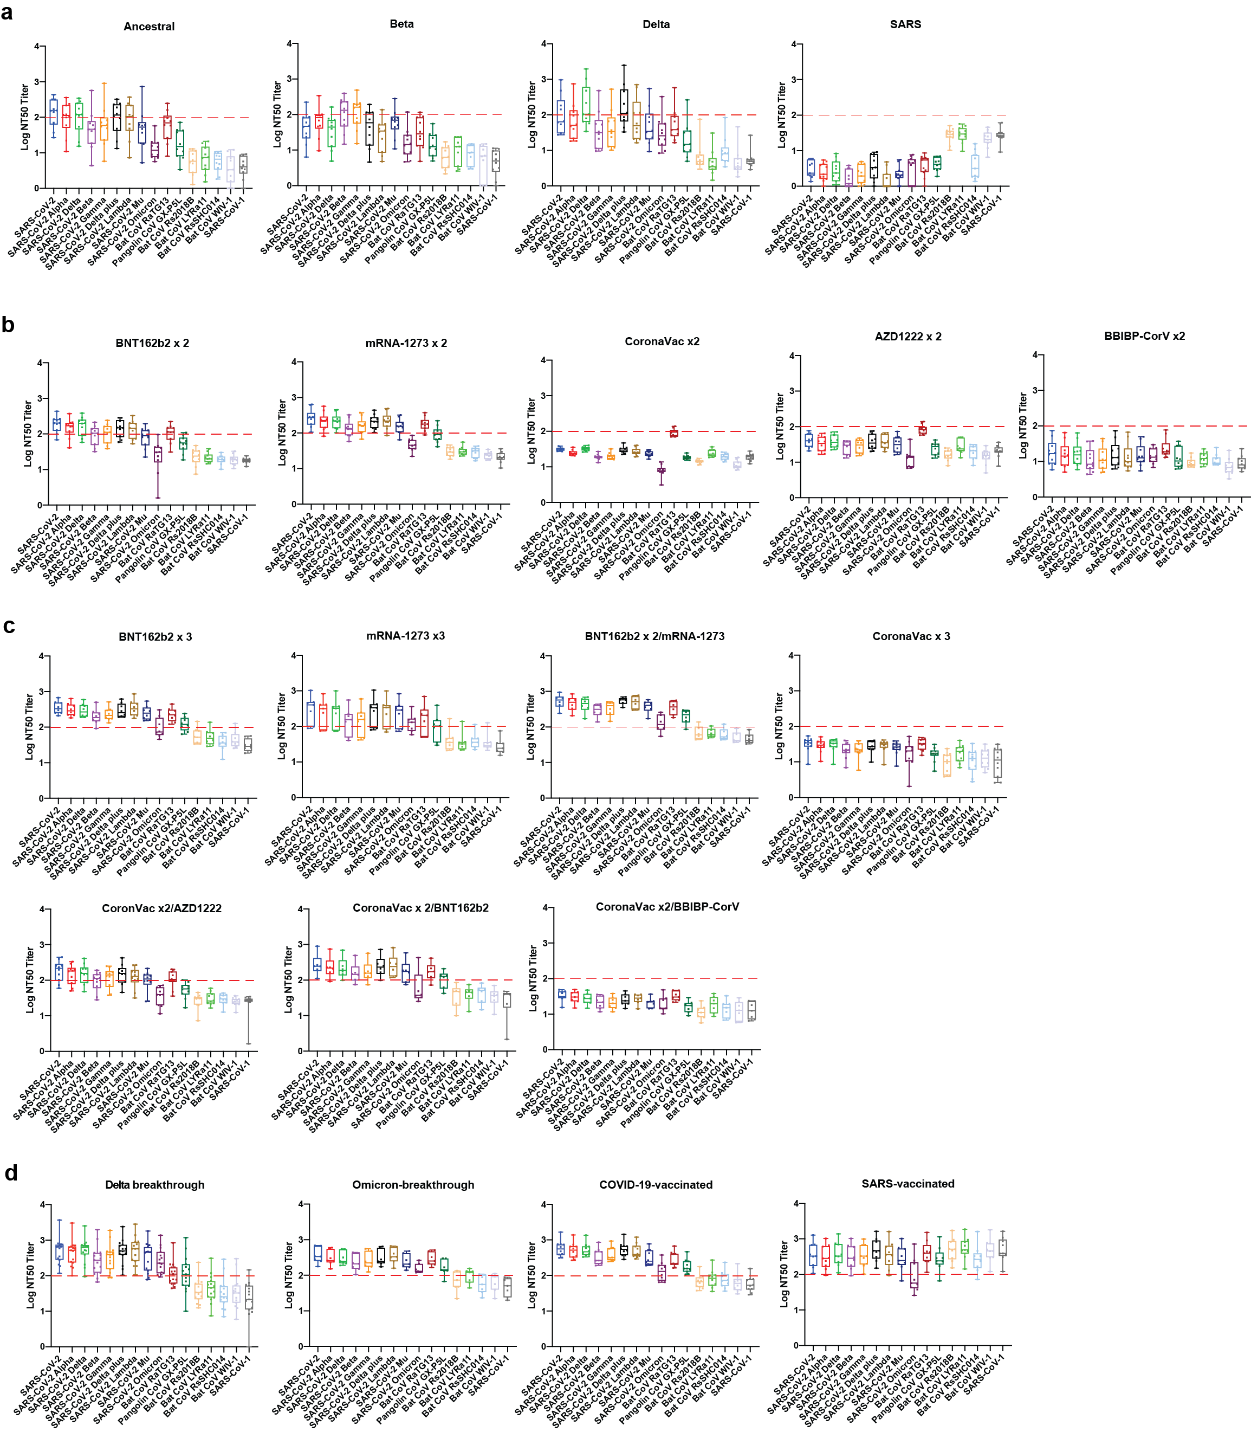

Supplementary Data Fig 2. Neutralization titer 50% (NT50) of 20 serum panels determined using multiplex sVNT. (a) Convalescent serum panels derived from SARS-CoV-2 ancestral, Beta, Delta and SARS-CoV-1 survivors. (B) Vaccinated serum panels derived from individuals received two doses of BNT162b2, mRNA-1273, CoronaVac, AZD1222 and BBIBP-CorV. (C) Boosted serum panels from individuals received homologous booster (BNT162b2 x3, mRNA-1273 x3, CoronaVac x3) and heterologous booster regime (BNT162b2 x2/mRNA-1273, CoronaVac x2/BNT162b2, CoronVac x2/AZD1222 and CoronaVac x 2/BBIBP-CorV). (D) Serum panels derived from individualds with hybrid immunity (SARS-vaccinated, COVID-19-vaccinated, Delta-breakthrough and Omicron-breakthrough).

Supplementary Data Table 1. Serum panel and WHO IU/ml

Group | Serum Panel | Number | Geometric mean inhibition (%)ª | IU/ml
1  (Convalescent) | Ancestral | 10 | 57.03 | 608
 | Beta | 10 | 29.15 | 220
 | Delta | 10 | 41.81 | 357
 | SARS | 11 | 1.00 | 9
2  (Vaccinated) | BNT162b2 x 2 | 10 | 74.61 | 1211
 | mRNA-1273 x 2 | 10 | 83.03 | 1884
 | CoronVac x 2 | 10 | 24.27 | 177
 | BBIBP-CorV x 2 | 10 | 14.87 | 105
 | AZD1222 x 2 | 10 | 26.71 | 198
 | BNT162b2 x 3 | 7 | 90.98 | 3526
 | mRNA-1273 x 3 | 7 | 79.25 | 1520
 | BNT162 x 2/mRNA-1273 | 6 | 94.18 | 5312
 | CoronaVac x 3 | 10 | 23.64 | 172
 | CoronaVac x 2/BBIBP-CorV | 7 | 24.60 | 180
 | CoronaVac x 2/AZD1222 | 10 | 66.42 | 859
 | CoronaVac x 2/BNT162b2 | 6 | 80.11 | 1592
3  (Hybrid) | Delta Breakthrough | 16 | 87.86 | 2644
 | Omicron breakthrough | 7 | 88.98 | 2906
 | COVID-19 vaccinated | 10 | 93.46 | 4768
 | SARS vaccinated | 9 | 83.30 | 1914
ªGeometric mean inhibition (%) of ancestral SARS-CoV-2 at 1:80 dilution.

Supplementary Data Table 2. Serum panels and IRB approval.

Group | Serum Panel | Number | IRB
1  (Convalescent) | Ancestral | 10 | Duke-NUS: LH-20-006EC  NHG DSRB 2012/00917
 | Beta | 10 | University of KwaZulu–Natal BREC/00001275/2020
 | Delta | 10 | Duke-NUS: LH-20-006EC  NHG DSRB 2012/00917  Faculty of Medicine, Chulalongkorn University, Bangkok, Thailand  IRB no 291/63
 | SARS | 11 | Duke-NUS: LH-20-006EC  NHG DSRB E 2020/00091
2  (Vaccinated) | BNT162b2 x 2 | 10 | NUS-IRB-2021-108
 | mRNA-1273 x 2 | 10 | NUS-IRB-2021-108
 | CoronVac x 2 | 10 | Faculty of Medicine, Chulalongkorn University, Bangkok, Thailand  IRB no 170/64
 | BBIBP-CorV x 2 | 10 | NUS-IRB-2021-108
 | AZD1222 x 2 | 10 | Faculty of Medicine, Chulalongkorn University, Bangkok, Thailand  IRB no 170/64
 | BNT162b2 x 3 | 7 | NUS-IRB-2021-108
 | mRNA-1273 x 3 | 7 | NUS-IRB-2021-108
 | BNT162 x 2/mRNA-1273 | 6 | NUS-IRB-2021-108
 | CoronaVac x 3 | 10 | NUS-IRB-2021-108
 | CoronaVac x 2/BBIBP-CorV | 7 | NUS-IRB-2021-108
 | CoronaVac x 2/AZD1222 | 10 | Faculty of Medicine, Chulalongkorn University, Bangkok, Thailand  IRB no 170/64
 | CoronaVac x 2/BNT162b2 | 6 | NUS-IRB-2021-108
3  (Hybrid) | Delta Breakthrough | 16 | Duke-NUS: LH-20-006EC  NHG DSRB 2012/00917
 | Omicron breakthrough | 7 | Duke-NUS: LH-20-006EC  NHG DSRB 2012/00917
 | COVID-19 vaccinated | 10 | Duke-NUS: NUS-IRB-2021-840
 | SARS vaccinated | 9 | Duke-NUS: LH-20-006EC  Duke-NUS: NUS-IRB-2021-840

