Understanding interaction of engineered nanomaterials and dissolved organic matters in river sediments
Chen Zhangª, Xuejun Tanª, Xue Yang^{a,*}, Xingzu Whang^{b,**}
a Shanghai Municipal Engineering Design Institute (Group) Co., LTD., Shanghai 200092, China
b Key Laboratory of Reservoir Aquatic Environment, Chongqing Institute of Green and Intelligent Technology, Chinese Academy of Sciences, Chongqing 400714, China
Dr. XueYang (Corresponding author): Shanghai Municipal Engineering Design Institute (Group) Co., LTD., No. 901 North Zhongshan Road (2nd), Yangpu District, Shanghai, China; E-mail address: yangxue@smedi.com.
Dr. Xingzu Wang (Corresponding author): Key Laboratory of Reservoir Aquatic Environment, Chongqing Institute of Green and Intelligent Technology, No. 266 Fangzheng Avenue, Beibei District, Chongqing, China; E-mail address: wangxingzu@cigit.ac.cn.

Table S1 Fitted results of fluorescence spectra for protein-like substances.
Pollutant | Excitation wavelength (nm) | Temperature(°C) | Equation | R²
TiO₂ | 280 | 15 | y = 0.5578x+1.0175 | 0.996
TiO₂ | 280 | 25 | y = 0.3735x + 1.0283 | 0.978
TiO₂ | 280 | 35 | y = 0.2481x + 1.0325 | 0.948
TiO₂ | 325 | 15 | y = 0.1369x + 0.9834 | 0.926
TiO₂ | 325 | 25 | y = 0.0983x + 1.0007 | 0.985
TiO₂ | 325 | 35 | y = 0.0688x + 0.9977 | 0.983

Table S2 Fitted results of fluorescence spectra for humic-like substances.
Pollutant | Excitation wavelength (nm) | Temperature(°C) | Equation | R²
TiO₂ | 280 | 15 | y = 0.8567x + 2.3297 | 0.992
TiO₂ | 280 | 25 | y = 0.8825x + 2.270 | 0.956
TiO₂ | 280 | 35 | y = 0.8754x + 2.1083 | 0.928
TiO₂ | 325 | 15 | y = 1.1727x + 2.5209 | 0.938
TiO₂ | 325 | 25 | y = 1.1556x + 2.4762 | 0.977
TiO₂ | 325 | 35 | y = 1.1916x + 2.3876 | 0.977

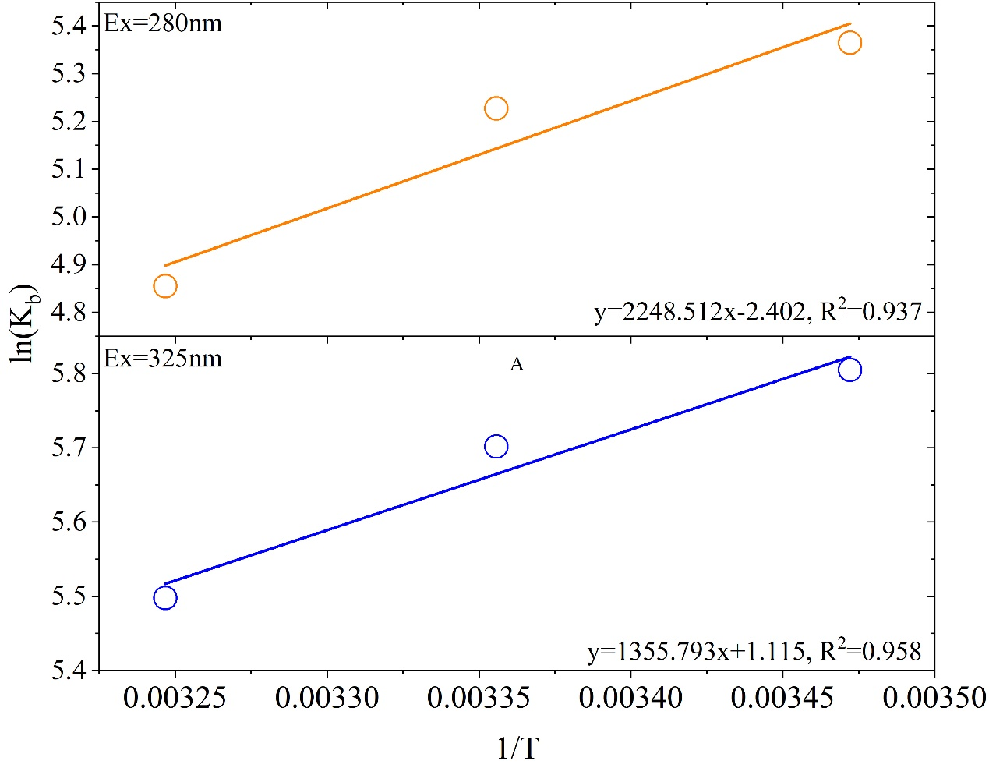
Fig. S1 Fitted results of thermodynamical analysis.

