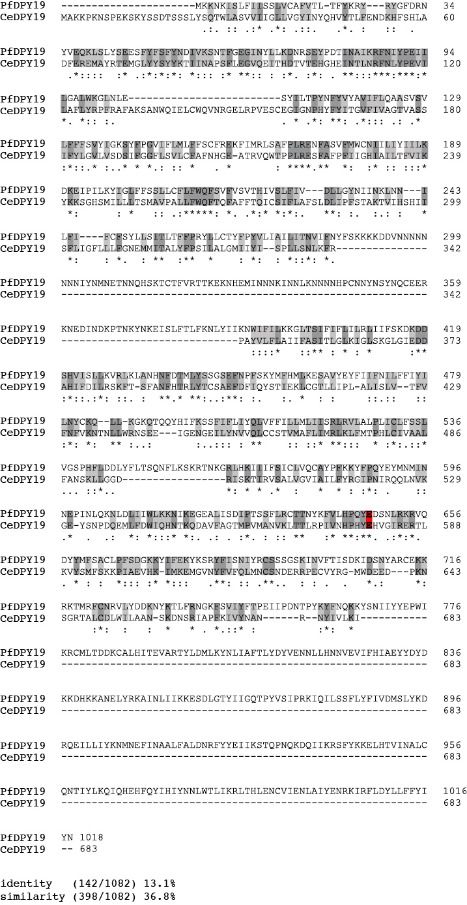

Supplementary Figure 1. Sequence alignment of DPY19 from P. falciparum (PF3D7_0806200) and C. elegans (CCD62139.1), showing identical (dark grey), similar (light grey) and essential residues for enzyme activity (red).
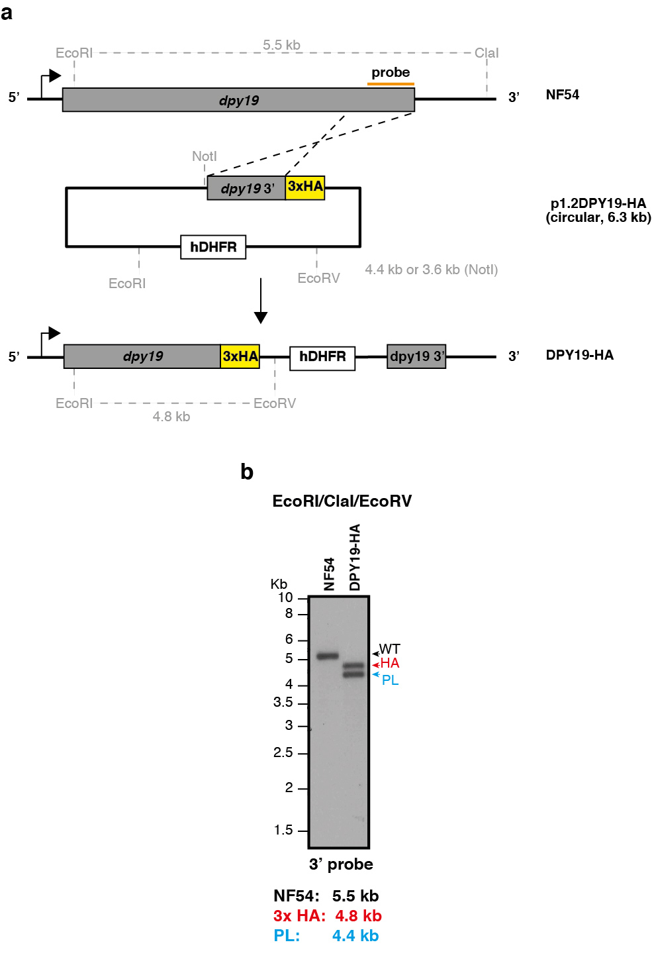

Supplementary Figure 2. (a) Strategy for inserting a C-terminal triple hemagglutinin (HA) epitope tag into the P. falciparum DPY19 locus. (b) Southern blot analysis of parental NF54 and DPY19-HA parasites after digestion of genomic DNA with EcoRI/ClaI/EcoRV. The probe used (orange bar) for genotyping and the expected fragment sizes after digestion of the loci is shown.
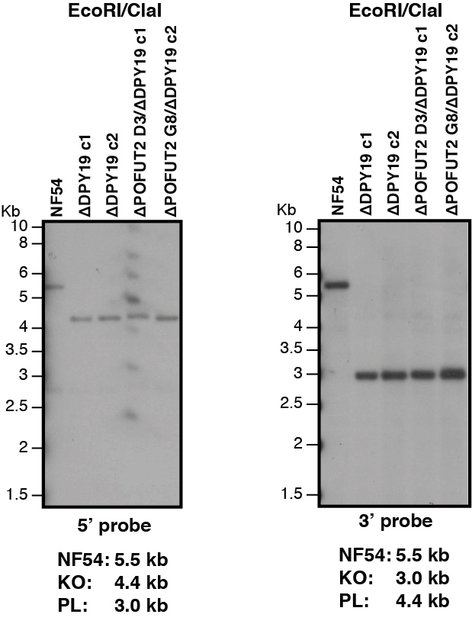

Supplementary Figure 3. Southern blot analysis of parental NF54, ΔDPY19 and ΔPOFUT2/ΔDPY19 clones after digestion of genomic DNA with EcoRI/ClaI. The NF54 and mutant band sizes are as expected indicating all mutant clones have the ΔDPY19 locus.
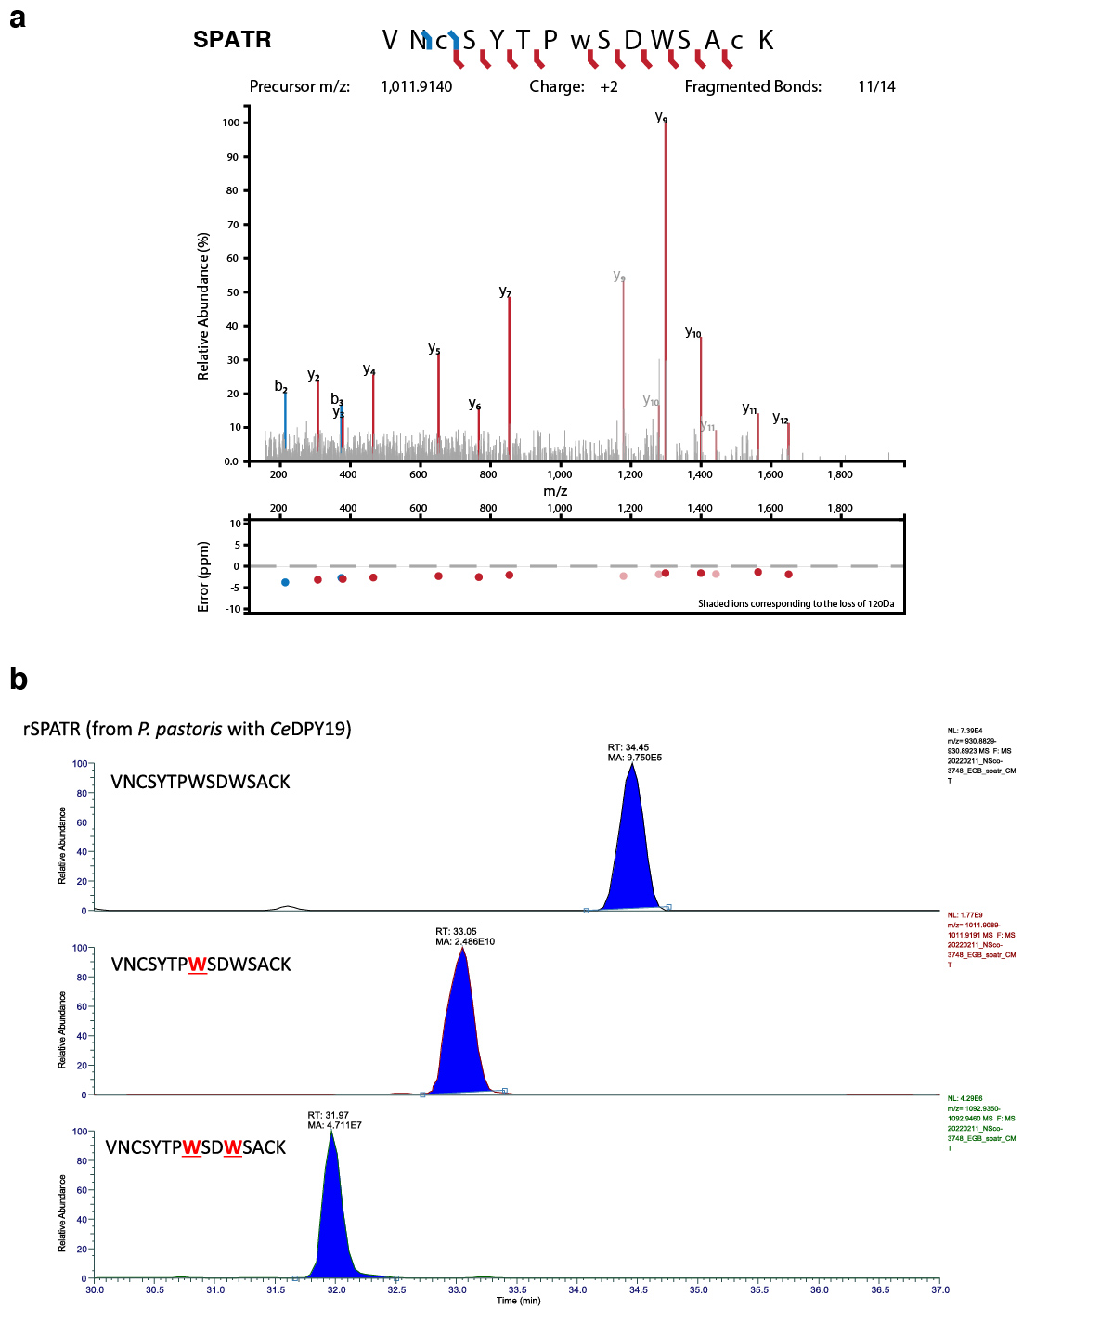
Supplementary Figure 4. Occupancy and localization of tryptophan C-mannosylation on rSPATR. (a) Tandem mass spectra of the most abundant C-mannosylated peptide from rSPATR enabled localization of the modification to first tryptophan of the WxxW motif. (b) The relative abundance of the unglycosylated, mono-glycosylated, and di-glycosylated peptides from rSPATR, as determined by LC-MS.
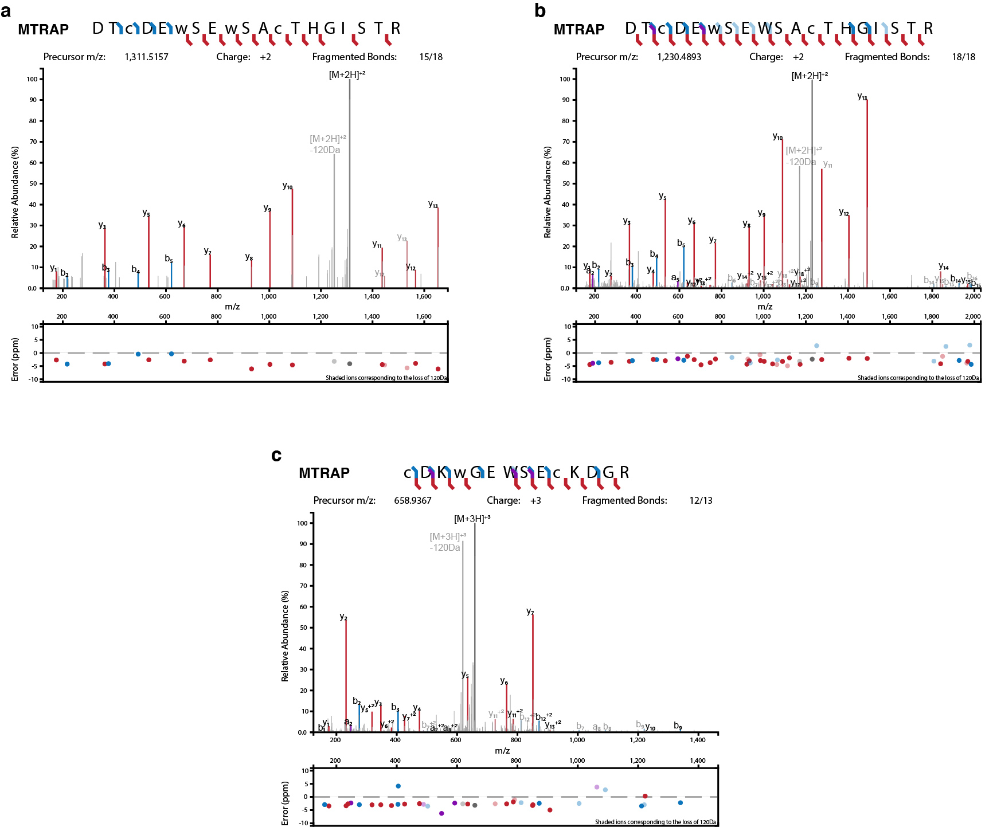

Supplementary Figure 5. Localization of tryptophan C-mannosylation on rMTRAP. Tandem mass spectra of C-mannosylated peptides from rMTRAP for the (a) di-glycosylated peptide DTCDEWSEWSACTHGISTR and (b and c) mono-glycosylated peptides DTCDEWSEWSACTHGISTR and CDKWGEWSECKDGR.

a
b

c
d
Supplementary Figure 6. Occupancy of tryptophan C-mannosylation on rMTRAP. The relative abundance of glycoforms for the DTCDEWSEWSACTHGISTR peptide in rMTRAP was determined by LC-MS for samples expressed (a) with and (b) without CeDPY19. The relative abundance of glycoforms for the CDKWGEWSECKDGR peptide in rMTRAP was determined by LC-MS for samples expressed (c) with and (d) without CeDPY19.

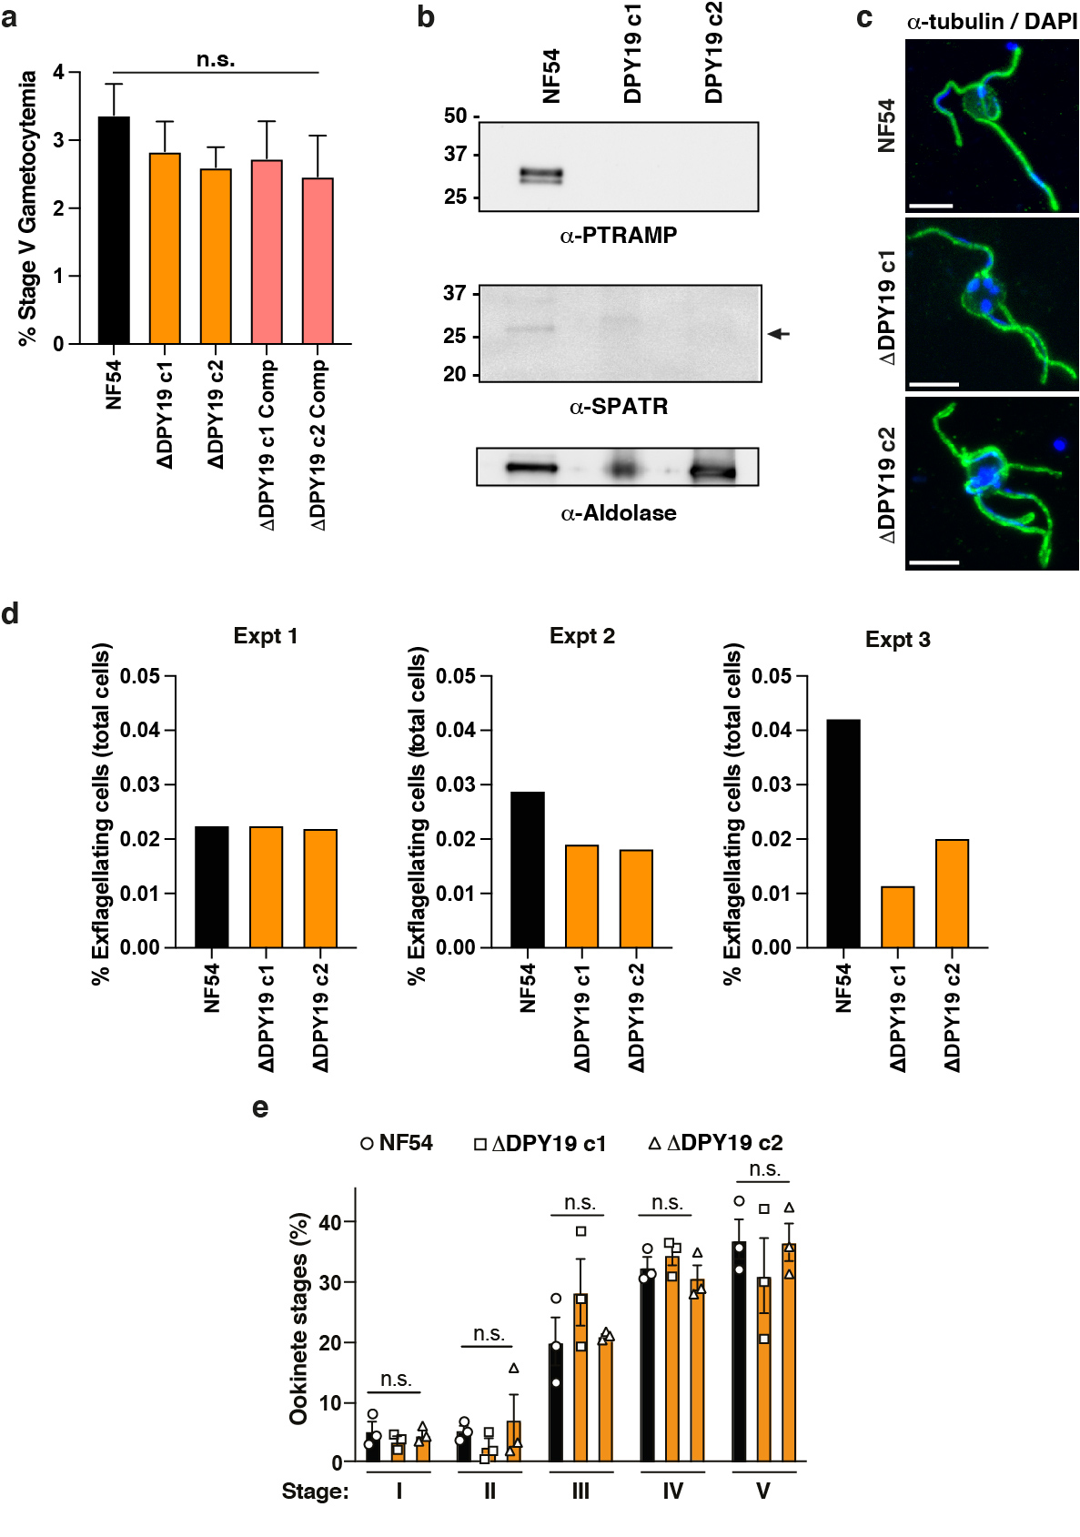

Supplementary Figure 7. (a) No difference in stage V gametocytemia was observed between NF54, ΔDPY19 and ΔDPY19 parasites. Data shown are n=3 experiments. n.s., not significant. (b) SPATR and PTRAMP are not expressed in stage V gametocytes. (c) Exflagellation by NF54 and ΔDPY19 microgametes. Scale bar, 5 μm. (d) Quantification of exflagellation by NF54 and ΔDPY19 microgametes using light microscopy, represented as a percentage of total (infected and uninfected) erythrocytes. n= 3 experiments. (e) Quantification of NF54 and ΔDPY19 ookinetes in the bloodmeal bolus dissected from groups of 20 Anopheles stephensi mosquitoes per parasite strain 23 hours post bloodmeal. n=3 experiments. Data are mean ± s.e.m. and were analyzed by one-way ANOVA (Kruskal-Wallis test). n.s., not significant.
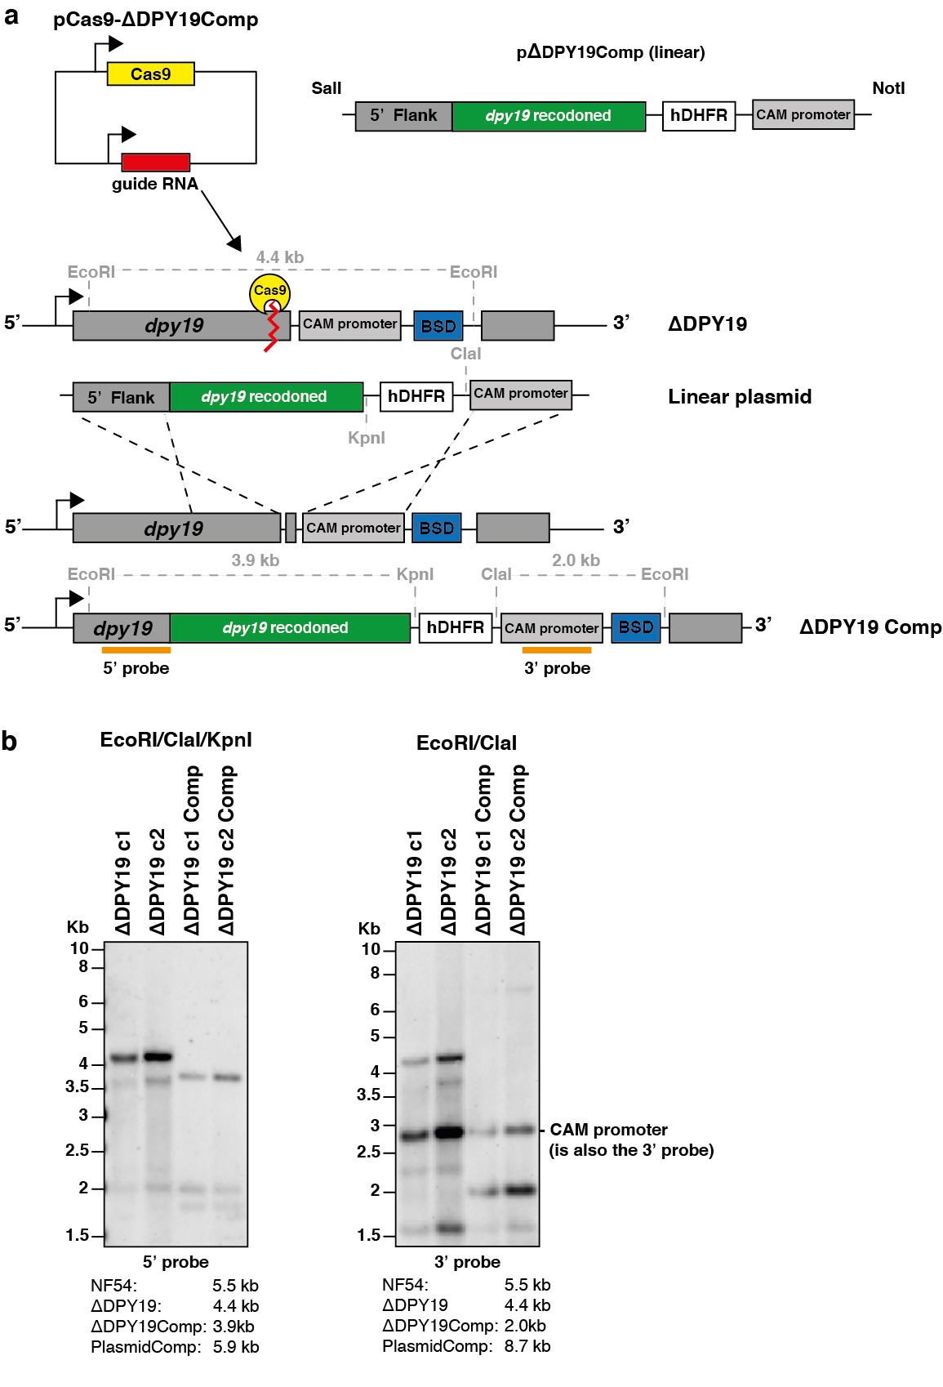

Supplementary Figure 8. Complementation of ΔDPY19 parasites with the DPY19 gene to restore expression. (a) Schematic of the strategy to complement the ΔDPY19 c1 and c2 clones. (b) Southern blot analysis of parental NF54, two clonal ΔDPY19 parasite lines (c1 and c2) and the complemented ΔDPY19 Comp clones after digestion of genomic DNA with EcoRI/ClaI/KpnI. The probe used (orange bar) for genotyping and the expected fragment sizes after digestion of the loci are shown.
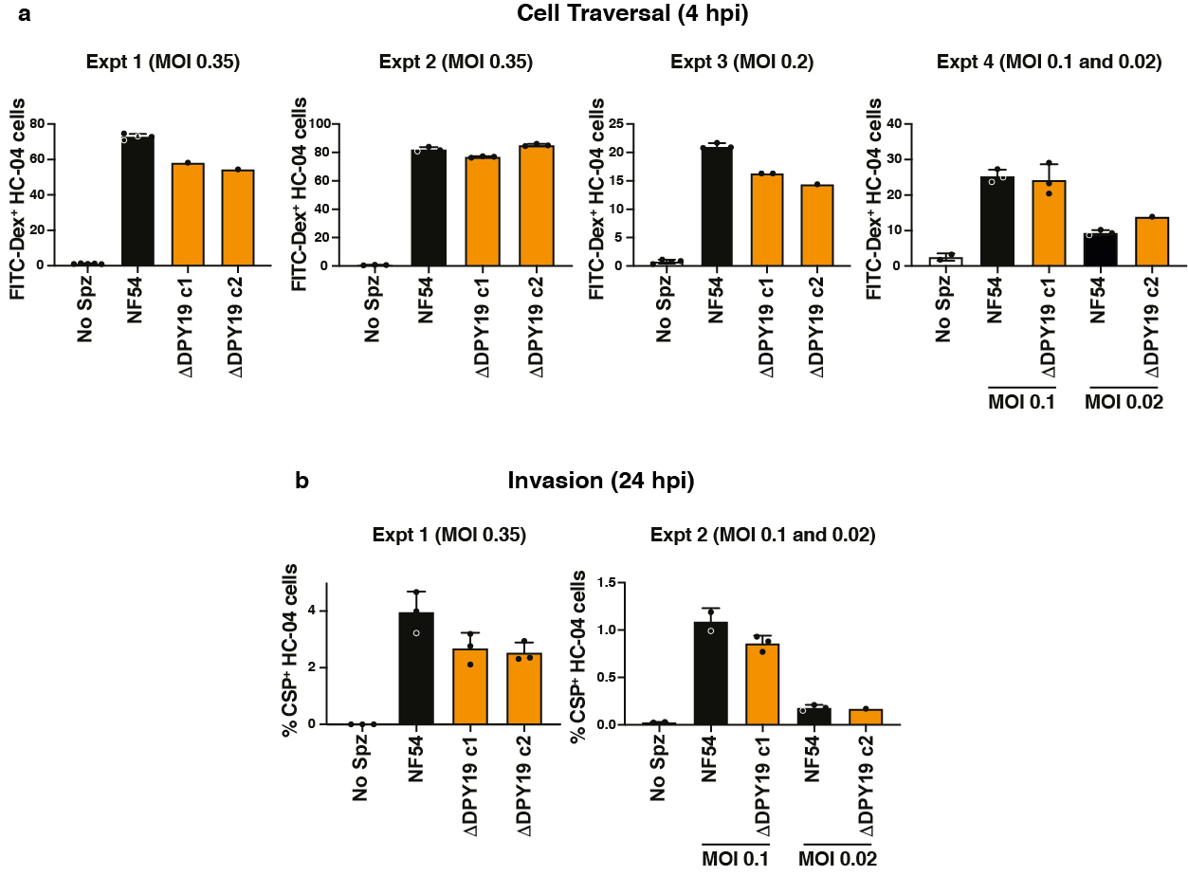

Supplementary Figure 9. Human HC-04 hepatocyte infection assays. (a) Flow cytometric quantification of cell traversal by P. falciparum sporozoites after incubation for 4 hours using FITC-dextran uptake to label the wounded cells. n=4 experiments. (b) Flow cytometric quantification of intracellular P. falciparum liver stages after incubation with sporozoites for 24 hours using CSP-positive antibody staining of fixed, permeabilized cells. n=2 experiments. Variance between assays occurred and was likely due to very low ΔDPY19 sporozoite yields from the low oocyst intensities, which restricted the multiplicity of infection to 0.02-0.35, as indicated. Data are mean ± s.e.m.

