**The evolutionary fate of *rpl32* and *rps16* losses in the *Euphorbia schimperi* ( Euphorbiaceae) plastome**

**Aldanah A Alqahtani1,2, Robert K. Jansen1,3**

1Department of Integrative Biology, University of Texas at Austin, TX, 78712, USA

2Department of Biology, Prince Sattam Bin Abdulaziz University, Al-Kharj 11942, Saudi Arabia

3Centre of Excellence in Bionanoscience Research, Department of Biological Sciences, Faculty of Science, King Abdulaziz University, Jeddah 21589, Saudi Arabia

*Corresponding author

Aldanah A. Alqahtani

[aldanaha2016@utexas.edu](mailto:aldanaha2016@utexas.edu)

[Ald.alqahtani@psau.edu.sa](mailto:Ald.alqahtani@psau.edu.sa)

­­

**Figure S1**

**Figure S2**

**Figure S3**

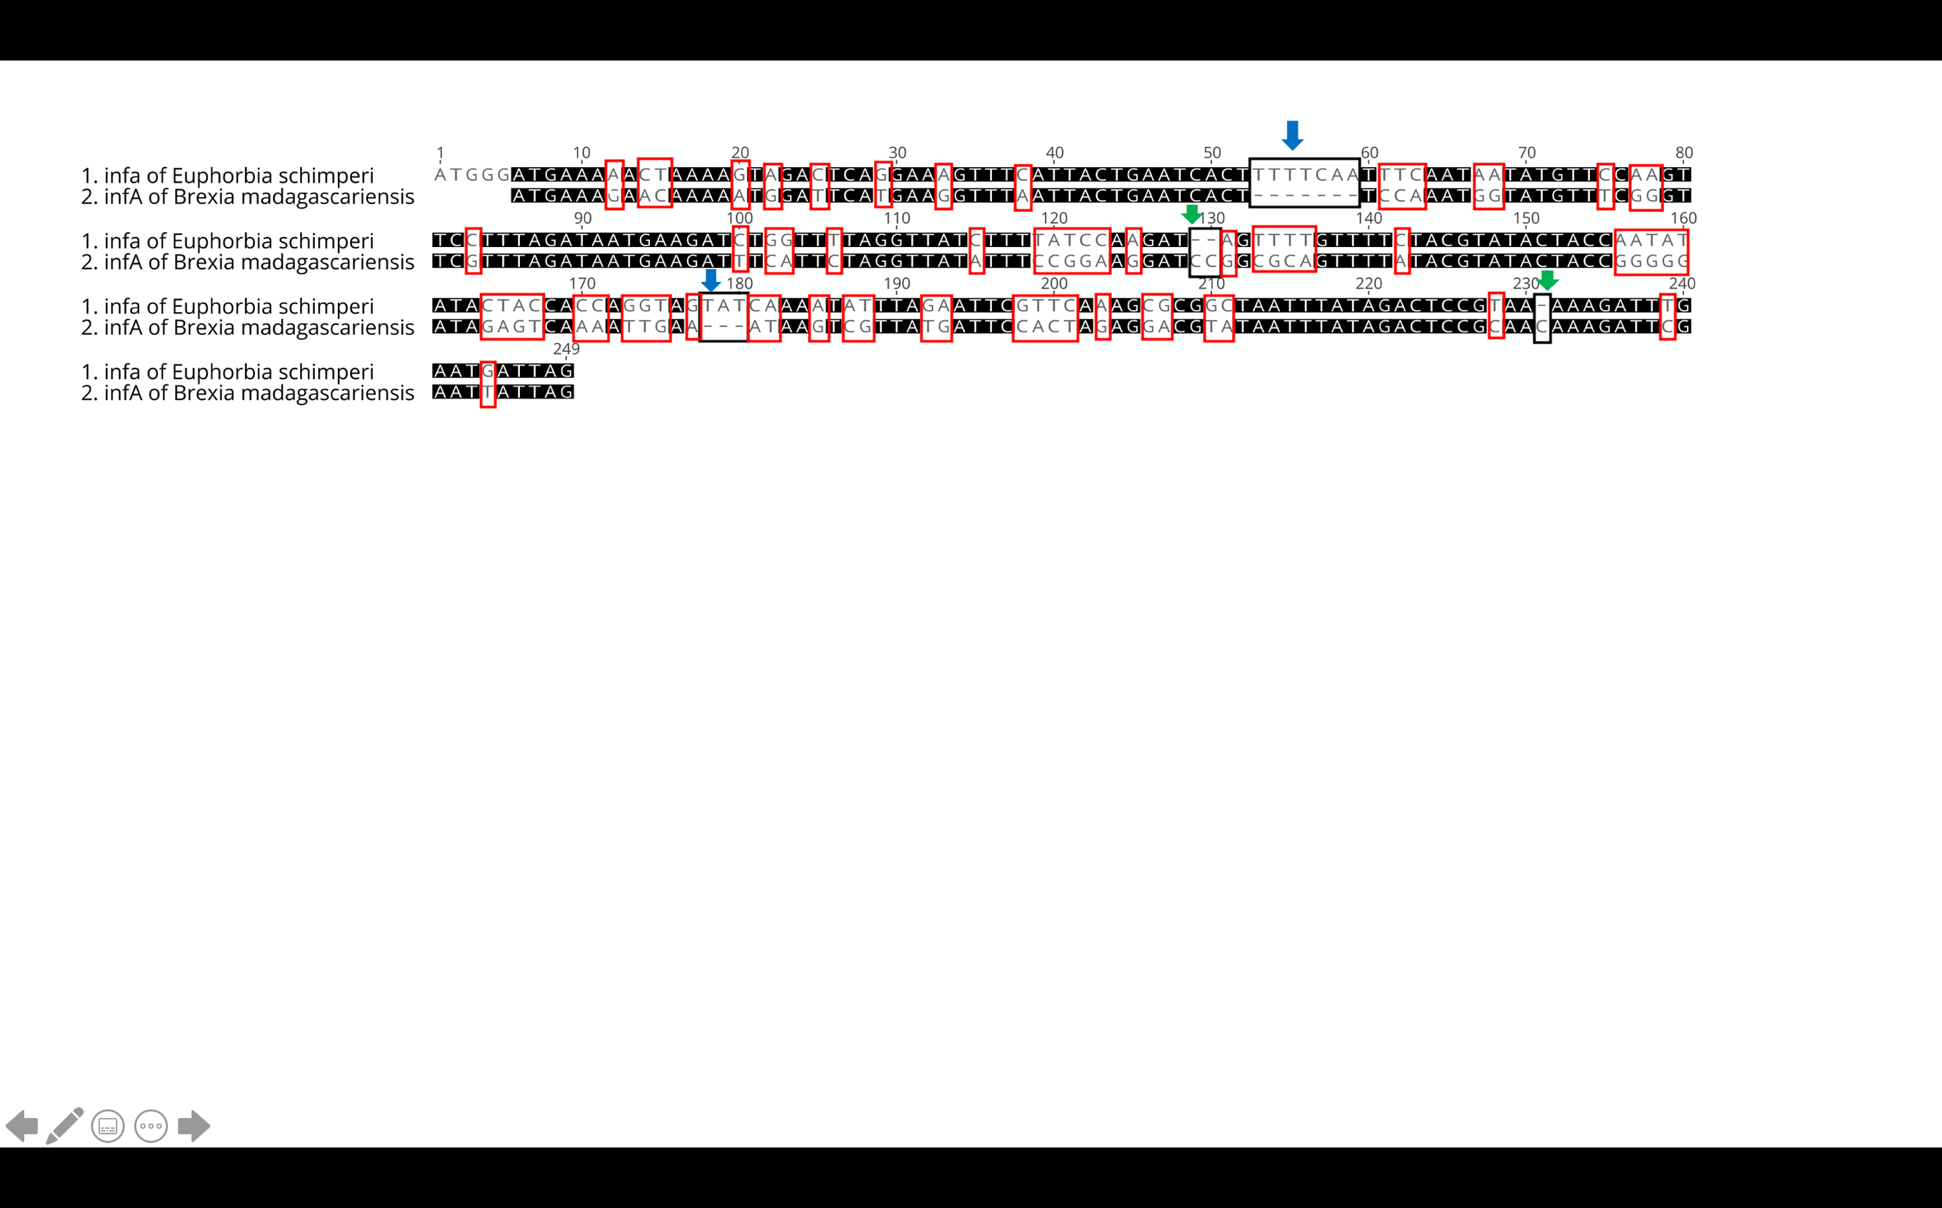

TP

**Figure 4**: Multiple alignments of nuclear **RPL32** of ***E.schimperi*** and **plastid** **RPL32** of other Euphorbiaceae (*E. marginata, Jatropha curcas, Hevea brasiliensis, Manihot esculenta, Ricinus communis, Vernicia fordii), Arabidopsis thaliana* and *Nicotiana tabacum.* Blue boxes indicate plastid transit peptide (TP) predicted using TargetP. Red box indicates a conserved domain of RPL32.

**ribosomal protein L32**