

Figure S1: Showing disease ontology matrix with color gradient based on DO scores

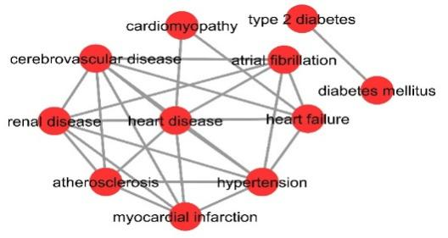

Figure S2: Topological network of Diseases with their disease ontology relationship is constructed in cytoscape using DO scores.



Figure S3: Heatmap showing clustering based on topological values obtained from network.



Figure S4: The plot displays the seasonal decomposition for worldwide collected monthly GT RSV from Jan-2004 to Dec-2020 for comorbid CVDs using TBATS method. Panel consists of observed values, followed by trend, seasonal components 1, 2 and 3 in the lower transect.



Figure S5: The plot displays the seasonal decomposition for worldwide collected monthly collected GT RSV from Jan-2004 to Dec-2020 for comorbid CVDs using LOESS method. The uppermost panel is showing original data, followed by seasonal, trend and the odd values as remainder in the lower panels.