Helicobacter pylori infection increases the incidence of erosive oral lichen planus and alters the oral microbiome composition
Shutong Li^{1,2†}, Zhang Yangheng^{3†}, Jingyuan Li², Ya Li¹, Huanjie Li⁴, Wenjuan Li¹, Jihui Jia¹, Shaohua Ge², Yundong Sun¹ †
¹ Key Laboratory for Experimental Teratology of Ministry of Education and Department of Microbiology, School of Basic Medical Science, Cheeloo College of Medicine, Shandong University, Jinan, Shandong, 250012, China.
² Department of Periodontology, School and Hospital of Stomatology, Cheeloo College of Medicine, Shandong University & Shandong Key Laboratory of Oral Tissue Regeneration & Shandong Engineering Laboratory for Dental Materials and Oral Tissue Regeneration, Jinan, Shandong 250012, China.
³ Department of Periodontology, Nanjing Stomatological Hospital, Medical School of Nanjing University, 30 Zhongyang Road, Nanjing, 210008, China.
⁴ School of Medicine, Cheeloo College of Medicine, Shandong University, Jinan, Shandong, 250012, China.
† Shutong Li and Zhang Yangheng contributed equally to this work.
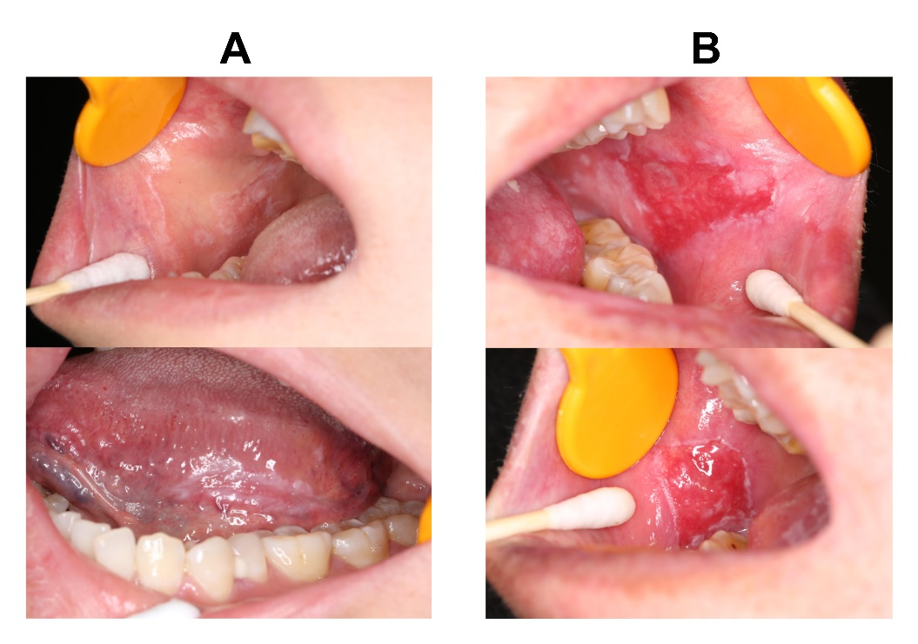
Fig S1 Clinical subtypes of oral lichen planus (OLP). (A) Reticular OLP, which is the most common form of OLP, is often asymptomatic and appears as multiple papules with networks of raised, white lesions called Wickham striae. (B) Erosive OLP presents as erythematous or atrophic lesions caused by inflammation or epithelial thinning with white striae at the periphery, which results in varying degrees of discomfort, including burning sensation and pain.
Fig S2 Comparative analysis of the oral microbiome composition at the phylum (A) and genus (B) levels between NC+ and NC- groups.

