Supplementary Figure 2. Mean tau ¹⁸F-MK6240 SUVR images for the cohort: visually derived EC- versus EC+
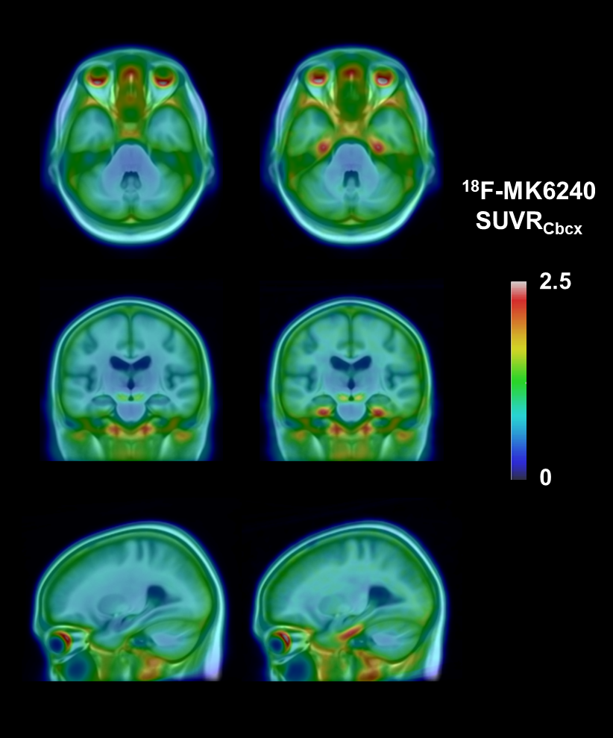
Mean tau ¹⁸F-MK6240 SUVR images overlaid on a T1 MRI template for the cohort, EC- (left) and EC+ (right) showing tau tracer retention confined to Braak stage I-II.

2.5

0

