Supplementary Figure 3. Mean tau ¹⁸F-MK6240 SUVR images for the participants with Centiloid <10: lower 90% versus top 10%
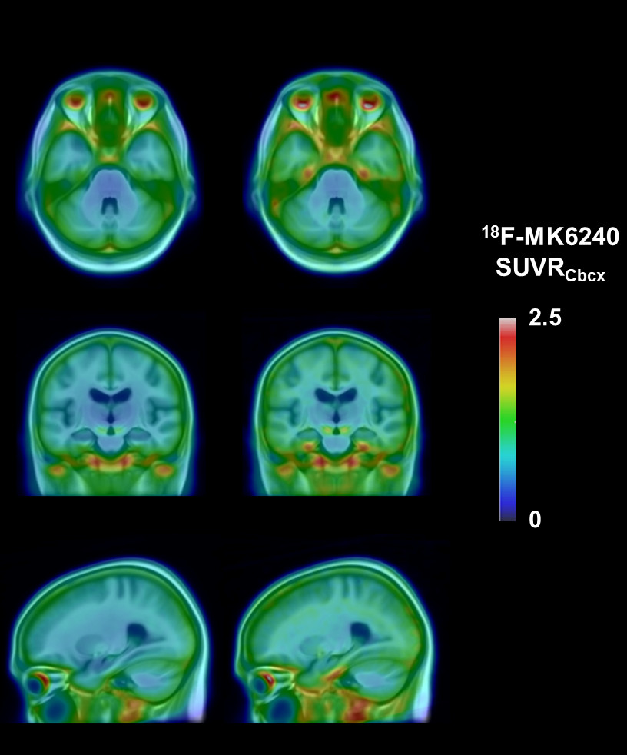

Mean tau ¹⁸F-MK6240 SUVR images overlaid on a T1 MRI template for participants with Centiloid <10, lower 90% (left) (n=157) and top 10% Me SUVR (right) (n=18) showing tau tracer retention confined to Braak stage I-II.

Supplementary Figure 4. Mean tau ¹⁸F-MK6240 SUVR images for the participants with Centiloid <10: lower 95% versus top 5%
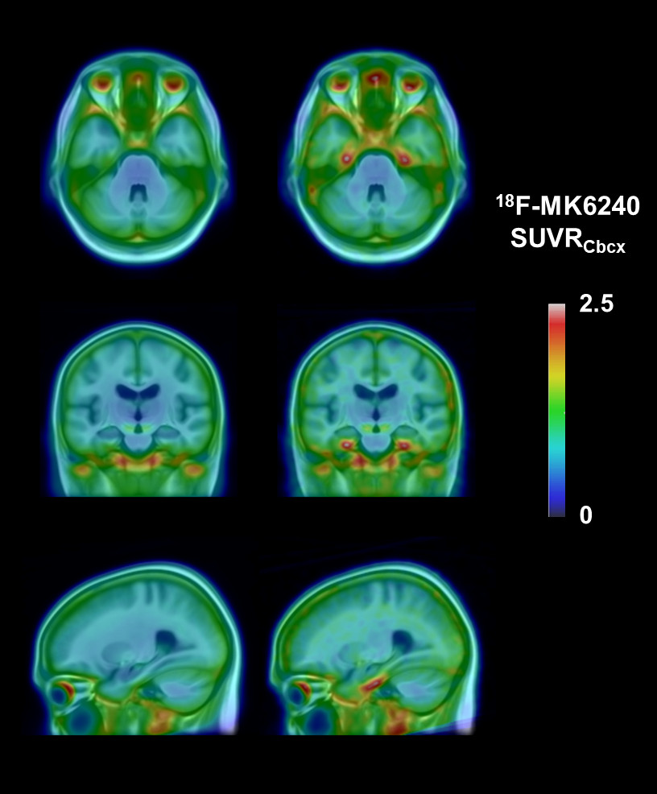

Mean tau ¹⁸F-MK6240 SUVR images overlaid on a T1 MRI template for participants with Centiloid <10, lower 95% (left) (n=166) and top 5% Me SUVR (right) (n=9) showing tau tracer retention confined to Braak stage I-II.

2.5

0

