Supplementary Information
Figure S1 a) Synthesis route of PP₁₂FSI. b) Optical photographs of PP₁₂FSI at room temperature. c)DSC curves of Li_{0.5}(PP₁₂)_{0.5}FSI with different lower limit temperature.
Figure S2 a) Chemical structure and corresponding hydrogen atom of PP₁₂FSI. b) ¹H NMR full spectra of Li_{x}(PP₁₂)_{1-x}FSI (0%≤x≤90%，in molar ratio), c)DMSO-d6 peak and d)N-CH₃ peak in Li_{x}(PP₁₂)_{1-x}FSI.
Figure S3 Raman spectra of Li_{x}(PP₁₂)_{1-x}FSI (0%≤x≤100%，in molar ratio) a) full spectra, b)in the range of 800~ 650 cm⁻¹ and c) in the range of 1500~1400 cm⁻¹.
Figure S4 a) temperature dependance of ionic conductivity of Li_{x}(PP₁₂)_{1-x}FSI (25%≤x≤40%) and (b) amperometric i-t curves of Li/Li_{0.4}(PP₁₂)_{0.6}FSI/Li cells (Insert: the impedance responses of the cell under initial/steady-state conditions)
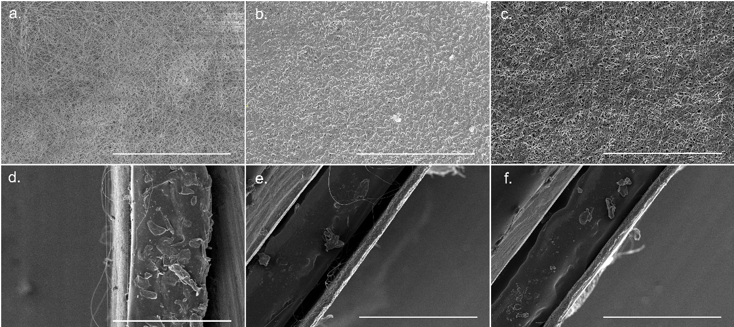
Figure S5 Top-view SEM images of a) PI; b) PI-SN and c) PI-PP₁₂FSI. Side-view SEM images of d) PI; e) PI-SN and f) PI-PP₁₂FSI. (scale bar: 200 μm)
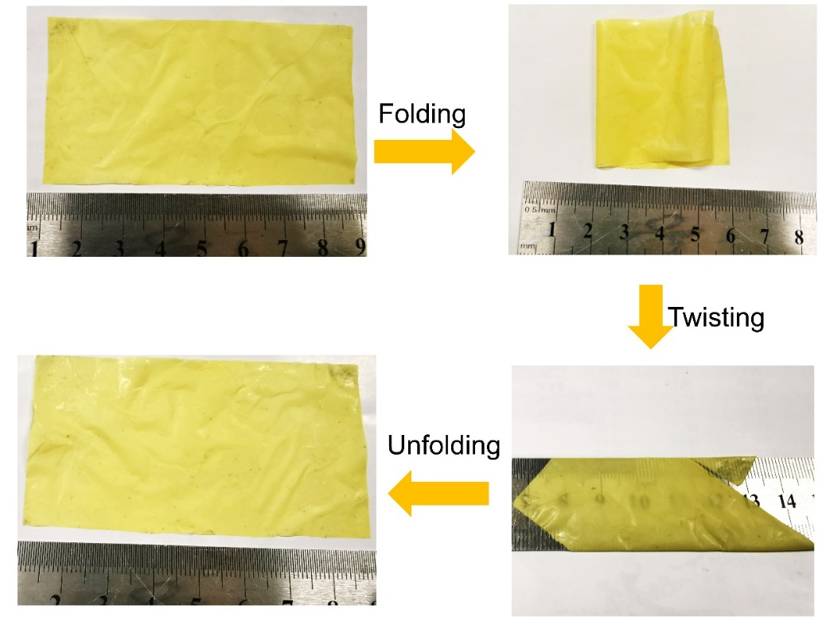
Figure S6 Photo images of 8$×$4 cm² PI-PP₁₂FSI free-standing electrolytes being abused test via folding, twisting and unfolding.
Figure S7 Nyquist plot of a) SS/PI-SN/Cu and b) SS/PI-PP₁₂FSI/Cu at different temperatures. Electrochemical impedance spectra of c) Li/PI-SN/Li and d) Li/PI-PP₁₂FSI/Li cells under initial/steady-state conditions
Figure S8 a) Symmetrical Li cells with PPCEs at virous current densities and the magnified part of Figure a under b)0.2 mA cm⁻², c)0.5 mA cm⁻² and d) 2.0 mA cm⁻². Optical photograph of the compatibility of lithium metal with e) SN, f) and g) PP₁₂FSI.
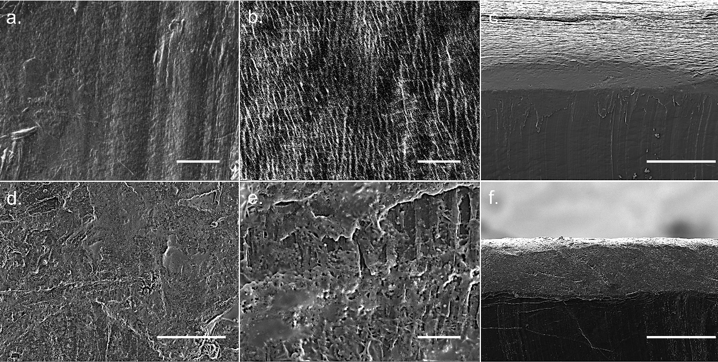
Figure S9 a), b) Top-view and c) cross-section of pristine lithium foil. d), e) Top-view and f) cross-section of pristine lithium foil in symmetric cells with PI-PP₁₂FSI under 1.0 mA cm⁻² after 1000h (Figure 4c). Scale bars for a), b), d), e) are 100 μm and for c), f) is 5 μm.
Figure S10 a) Cross-section SEM image of PI-PP₁₂FSI/NCM622 interface and corresponding EDS mapping of (b)Ni, (c)Mn, (d) S, (e)C and (f) O elements (scale bar: 10μm).
Figure S11 a) Charge-discharge curves of Li/PI-SN/NCM622 cells under different rate corresponding to Figure 5b. b) Galvanostatic rate performances of Li/NCM622 cells with different electrolytes from 0.1 C to 2.0 C (2400 stands for Celgard 2400 and LE represents liquid electrolyte). c) Galvanostatic cycle performances of Li/NCM622 cells with different electrolytes under 1.0 C. d) First charge-discharge curves of Li/PI-PP₁₂FSI/NCM622 cells under different cathode loading (the C-rate for 1.7 and 5.4 mg cm⁻² loading is 0.1C and for 10.6 mg cm⁻² loading is 0.025C).
Figure S12 a) Charge-discharge curves of Li/PI-PP₁₂FSI/LNMO cell under different rate corresponding to Figure 5g. b) Charge-discharge curves of Li/PI-PP₁₂FSI/LNMO cell at different cycles under 1.0C corresponding to Figure 5h.
Figure S13 a) Cell voltage and nail/cell temperature curves during nail penetration test of a) conventional liquid electrolyte and b) PI-PP₁₂FSI.
Figure S14 a) Schematic illustration of the preparation of NCM622 cathode-supported PI-PP₁₂FSI composite and b) corresponding optical photograph of as-prepared sample. c) Nyquist plot of EIS measurements of pouch-type NCM622/PI-PP₁₂FSI/Li cell at 25 ºC. d)Corresponding charge-discharge curves of pouch-type NCM622/PI-PP₁₂FSI/Li cell under different rate referred to Figure 6e.

Table S1 Ionic conductivity and lithium transference number of Li_{x}(PP₁₂)_{1-x}FSI
X_{LiFSI} (mol%) | 5 | 10 | 20 | 25 | 30 | 35 | 40 | 50 | 60
Molarity (mol kg⁻¹) | 0.17 | 0.34 | 0.7 | 0.9 | 1.10 | 1.32 | 1.54 | 2.02 | 2.55
$σ$ (mS cm⁻¹) | 0.12 | 0.35 | 0.56 | 1.20 | 1.18 | 1.45 | 1.11 | 0.49 | 0.46
𝑡_{Li+} | 0.15 | 0.17 | 0.24 | 0.53 | 0.48 | 0.56 | 0.55 | 0.39 | 0.47

Table S2 Ionic conductivity and VTF(Arrhenius) fitting parameters for PPCEs
Electrolytes | $σ$(S cm⁻¹) |  | $σ_{0}($S  cm⁻¹) | E_{a} (eV) | $T_{0}$ (K) | R²
 | 25 ℃ | 80 ℃
PI-SN(20-80℃) | 5.87$×10$⁻⁴ | 1.00$×10$⁻³ | 4.82 | 0.26 | 263.0 | 0.990
PI-PP₁₂FSI (0-40 ºC) | 4.07 $×10$⁻⁴ |  | 0.95 | 2.37 |  | 0.995
PI-PP₁₂FSI (40-80 ºC) |  | 8.18$×$10⁻⁴ | 5.10 | 0.73 | 242.8 | 0.994

Table S3 Corresponding electrochemical impedance spectra of Li/PI-PP₁₂FSI/Li cells after virous current densities
Current densities (mA cm⁻²) | 0 | 0.05 | 0.1 | 0.2 | 0.5 | 1 | 2
R_{b} (Ω) | 12.6 | 11.9 | 10.8 | 10.7 | 10.2 | 11.2 | 9.9
R_{i} (Ω) | 505.3 | 345.5 | 219.2 | 18.32 | 6.2 | 6.1 | 5.8

Table S4 Corresponding electrochemical impedance spectra of Li/PI-PP₁₂FSI/NCM622 cells after different cycles
Cycle number | 0 | 2 | 20 | 100 | 600
R_{b} (Ω) | 9.38 | 8.82 | 10.3 | 8.72 | 8.5
R_{i} (Ω) | 98.9 | 80.9 | 30.8 | 52.6 | 56.6

