Supplementary Information

1.1 Summary of latent class analysis output
Assay result | Assay +ve / Group N | Risk | Risk Ratio
GP ELISA High Titre  Group A  Group B | 11 / 20  3 / 95 | 0.550  0.032 | 17.4  (5.3 – 56.8)
WB GP positive  Group A  Group B | 10 / 20  2 / 95 | 0.500  0.021 | 23.7  (5.6 – 100.2)
WB NP positive  Group A  Group B | 17 / 20  14 / 95 | 0.850  0.147 | 5.8  (3.4 – 9.7)
WB VP40 positive  Group A  Group B | 4 / 20  12 / 95 | 0.042  0.600 | 14.2  (5.1 – 39.7)
WB negative  Group A  Group B | 0 / 20  75 / 95 | 0.789  0 | -
Supplementary table 1: Results of latent class analysis from GP-ELISA

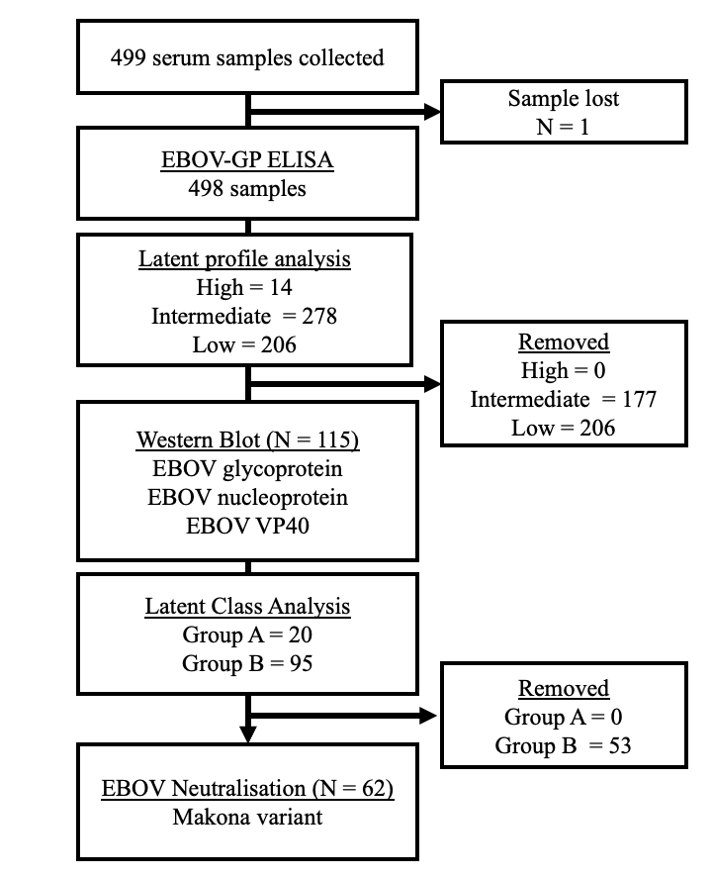
  - Consort diagram of sample processing pipeline and selection process

Supplementary figure 1: Consort diagram of serum sample processing.

  - Outcomes of serological analysis stratified by village status
 | Affected | Unaffected | Overall
 | (N=194) | (N=304) | (N=498)
Anti-GP ELISA
High | 9 (4.6%) | 5 (1.6%) | 14 (2.8%)
Intermediate | 111 (57.2%) | 167 (54.9%) | 278 (55.8%)
Low | 74 (38.1%) | 132 (43.4%) | 206 (41.4%)
Latent class group
Group A | 8 (16.3%) | 12 (18.2%) | 20 (17.4%)
Group B | 41 (83.7%) | 54 (81.8%) | 95 (82.6%)
Not tested | 145 | 238 | 383
Neutralisation data
High | 3 (10.3%) | 2 (6.1%) | 5 (1.0%)
Low | 3 (10.3%) | 2 (6.1%) | 5 (1.0%)
Negative | 23 (79.3%) | 29 (6.1%) | 52 (10.4%)
Not tested | 165 | 271 | 436

Supplementary table 2: Serological outcome data stratified by village status. Villages were classified as affected or unaffected by 2013-2016 EBOV outbreak (see methods).

  - Ecological associations with EBOV immunological outcomes: Sensitivity analysis
Predictors | Odds ratio | 95% CI | p-value
Outcome
LCA group A | 20 / 498
Village status
Affected | Reference |  | 0.86
Unaffected | 1.09 | 0.40 – 2.94
Age
 | 1.03 | 0.99 – 1.06 | 0.12
Closed forest
Shape index (500m) | 0.28 | 0.08 – 0.98 | 0.02
Vegetation
Perimeter area ratio (20,000m) | 0.35 | 0.08 – 0.98 | 0.01
Random Effects
ICC | 0.02
N _{village} | 38

Supplementary table 3: Multivariable generalised linear mixed effects model (binomial family) of immunological group defined by latent class analysis of ELISA and Western Blot analysis (Group A vs Group B). Success defined as Group A. Variables were selected using a forward, stepwise approach using AIC. P-values estimated by likelihood ratio test. Mixed effect models not used due to singular fit from village-level random intercepts.

Predictors | Estimate | 95% CI | p-value
Age
18 – 30 | Reference
31 – 50 | 0.19 | -0.15 – 0.53 | 0.55
51 – 90 | 0.15 | -0.25– 0.55
Closed canopy cover
Perimeter area ratio (500m) | -0.63 | -1.24 – -0.02 | 0.05
Random Effects
ICC | 0.14
N _{village} | 24

Supplementary table 4: Multivariable mixed-effects linear regression of log₂ anti-EBOV-GP total antibody titre excluding all participants from villages with confirmed EBOV cases during 2013-2016 outbreak (195/498; 39.2%). Variables were selected using a forward, stepwise approach using AIC. P-values estimated by likelihood ratio test.

Predictors | Odds ratio | 95% CI | p-value
Outcome
High titre GP-ELISA | 14/498
Village status
Affected | Reference |  | 0.24
Unaffected | 0.35 | 0.14 – 1.56
Age
 | 1.02 | 0.98 – 1.06 | 0.35
Vegetation
Perimeter area ratio (20,000m) | 0.37 | 0.12 – 1.04 | 0.06

Supplementary table 5: Multivariable generalised linear model (binomial family) of log₂ anti-EBOV-GP total antibody titre classified by finite mixture models (high titre individuals vs. intermediate and low titre individuals combined; see figure 1). Success defined as high titre individual. Variables were selected using a forward, stepwise approach using AIC. P-values estimated by likelihood ratio test.

