Supplementary Material
Methods
Preparation of inner MECM and outer MECM
Pig knee meniscus (n = 40) was purchased from abattoir. The meniscus was placed in sterile phosphate buffered saline (PBS) at pH 7.6. The meniscus is cut into the medial and lateral parts（Figure S1）. Cut the inner and outer of the meniscus into pieces about 1 mm in size. The fragments were decellularized using the method described in the previous literature[1]. Briefly, the tissue sections were placed into a hypotonic Tris-HCL buffer solution (10 mM Tris–HCL, pH 8.0) and 6 cycles of freezing (at-80℃) and thawing (at 37℃) were conducted. The tissue sections slurry was homogenized and treated with 0.25% trypsin (Gibco, USA) in PBS for 24 h at 37℃ with vigorous agitation. The trypsin solution was replaced with the fresh one at every 4 h. Trypsinized tissue sections slurry was washed with a hypertonic buffer solution (1.5 M NaCl in 50 mM Tris-HCL, pH 7.6) and treated with nuclease solution (50 U ml-1 DNAse (Sigma) and 1 U ml-1 RNAse A (Sigma) in 10 mM Tris–HCL, pH 7.5) with gentle agitation at 37℃ for 4 h. To remove all the enzymes, the enzyme-treated tissue sections slurry was washed with the hypotonic Tris–HCL solution for 20 h following treatment with 1% Triton X-100 solution(J.T.BAKER) for 24 h. The decellularized meniscus tissue was washed at least for 3 days to remove all the detergent. Inner MECM and outer MECM are stored in sterile glassware and stored at 4℃. Safranin O and TB staining of the outer MECM, inner MECM, and the outer and inner of the native meniscus. The specific operation method shall be carried out according to the manufacturer's plan.

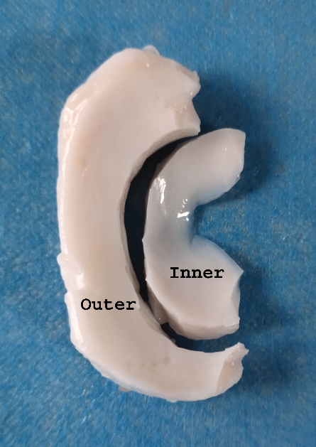
Figure S1: Macroscopic view of the inner and outer of native meniscus.

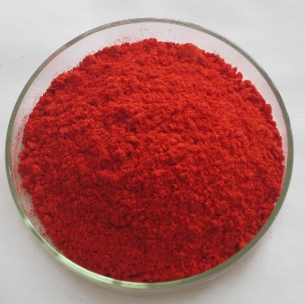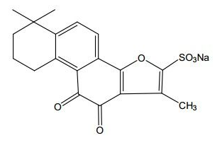
Figure S2: The molecular structure of STS.

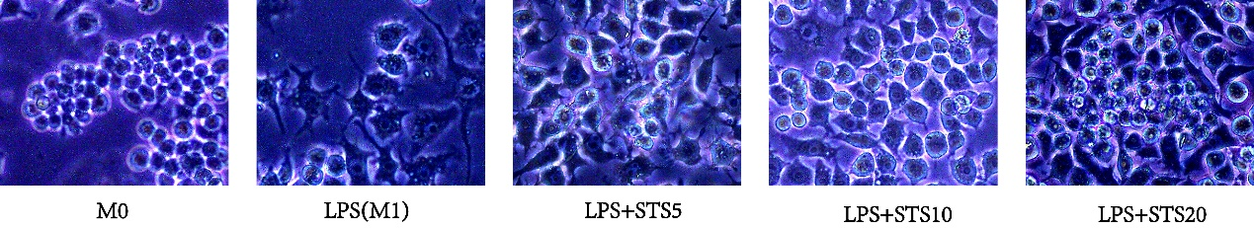
Figure S3: The cell morphology changes after STS treatment

Figure S4: Safranin O and TB staining of the outer MECM, inner MECM, and the outer and inner of the native meniscus.

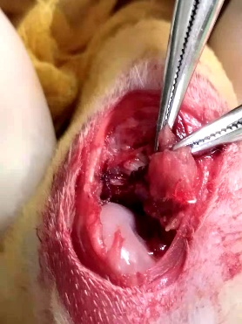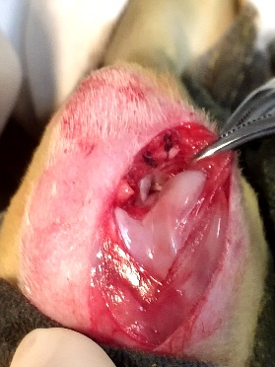
Figure S5. The hybrid scaffold was implanted in a critical-size rabbit meniscal defect model.

Figure S6. Representative macroscopic images of the repaired meniscus and corresponding tibial plateaus.

Gene | Direction of primer | The primer sequences(5′‑3′)
IL-1β（mouse） | FORWARD | TACAGGCTCCGAGATGAACA
 | REVERSE | AGGCCACAGGTATTTTGTCG
iNOS(mouse) | FORWARD | GTTCTCAGCCCAACAATACAAGA
 | REVERSE | GTGGACGGGTCGATGTCAC
CD206(mouse) | FORWARD | ATGGATGTTGATGGCTACTGG
 | REVERSE | TTCTGACTCTGGACACTTGC
Retnal (mouse) | FORWARD | TTGCAACTGCCTGTGCTTAC
 | REVERSE | CTGGGTTCTCCACCTCTTCA
Gapdh（mouse） | FORWARD | CTTTGTCAAGCTCATTTCCTGG
 | REVERSE | TCTTGCTCAGTGTCCTTGC
IL-1β（rabbit） | FORWARD | TAC AAC AAG AGC TTC CGG CA
 | REVERSE | GGC CAC AGG TAT CTT GTC GT
MMP-13(rabbit) | FORWARD | AGGAAGACCTCCAGTTTGCAGAG
 | REVERSE | GCTGCATTCTCCTTCAGGATTC
BCL-2(Rabbit) | FORWARD | CGGAAGGGACTGGACCAGAGA
 | REVERSE | GCTGTCATGGGGATCACCTCC
Caspase-3(Rabbit) | FORWARD | AAGCCACGGTGATGAAGGAGT
 | REVERSE | TCGGCAAGCCTGAATAATGAA
SOD-1(Rabbit) | FORWARD | GCACGGATTCCATGTCCACCA
 | REVERSE | TCACATTACCCAGGTCGCCCA
Gapdh（rabbit） | FORWARD | TTGTCGCCATCAATGATCCAT
 | REVERSE | GATGACCAGCTTCCCGTTCTC
Table S1: The primer sequences

Project | parameter
3D Bioprinter | PanoSpace BioPro
Nozzle 1 | pcl
Moving speed | 5 mm/s
Temperature | 130℃
Air pressure | 470kpa
Platform temperature: | room temperature
FillStyle | Cross lines layer by layer
Effect picture | 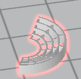

Table S2: Parameters of the designed 3D-printed constructs

1. Pati, F., et al., Printing three-dimensional tissue analogues with decellularized extracellular matrix bioink. Nat Commun, 2014. 5: p. 3935.

