**Supplementary Information**

**Coaxial cell printing of a human glomerular model *in vitro* of the glomerular filtration barrier and its pathophysiology**

Narendra K. Singh, Jae Yun Kim,Jae Yeon Lee, Hyungseok Lee, Ge Gao, Jinah Jang, Yong Kyun Kim,Dong-Woo Cho*

Corresponding author. Email: [dwcho@postech.ac.kr](mailto:dwcho@postech.ac.kr) (D.W.C.)

**The PDF file includes:**

Supplementary Fig. 1. Optimization of customized bioink for the promotion of the cellular behavior of glomerular cells.

Supplementary Fig. 2. Cell viability assessment of glomerular cells with customized bioink for printing of glomerular podocyte and glomerular endothelial tubes.

Supplementary Fig. 3. Expression of glomerular functional markers in bilayer glomerular microvessel-on-a-chip.

Supplementary Fig. 4. Comparative albumin permselectivity.

**Other Supplementary material for this manuscript includes the following:**

Supplementary Table 1. List of primer sequences.

Supplementary Movie 1. Printing.

Supplementary Movie 2. Perfusion.

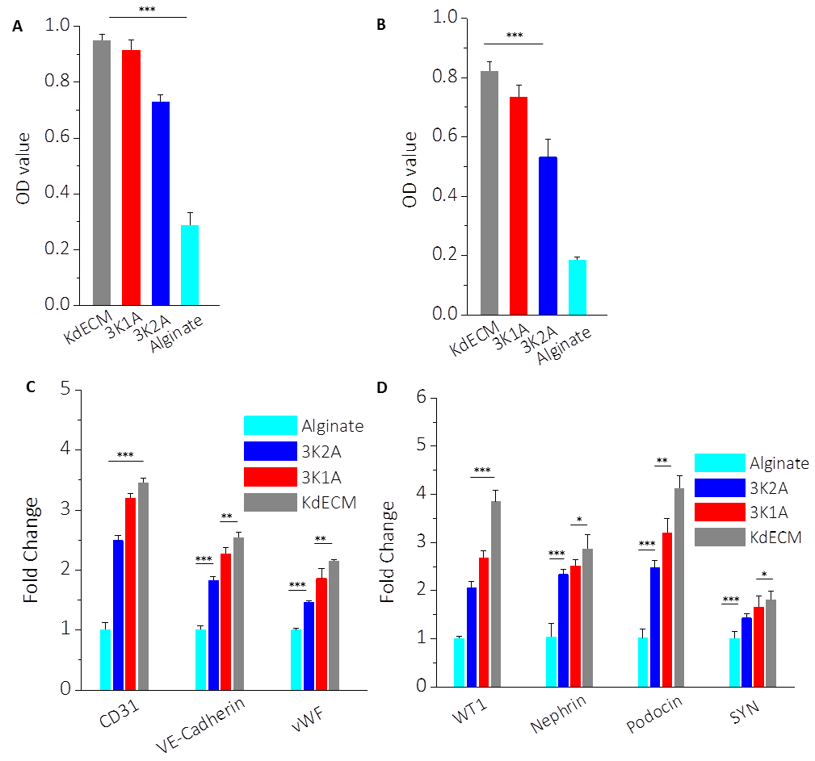

**Supplementary Fig. 1. Optimization of customized bioink for promoting the cellular behavior of glomerular cells.** **(A)** Podocyte and **(B)** glomerular endothelial cells (GEs) in a kidney hybrid bioink (3K1A) with a reduced sodium alginate ratio exhibited significantly higher cell viability. The 3K1A bioink resulted in higher **(C)** vascular endothelial cell-specific marker levels (CD31, VE-Cadherin, vWF) compared with those in GEs, and **(D)** podocyte specific markers (WT1, nephrin, podocin, synaptopodin (SYN) ) from podocytes compared with those in 3K2A and sodium alginate (*p < 0.05, **p < 0.01 and ***p < 0.001).

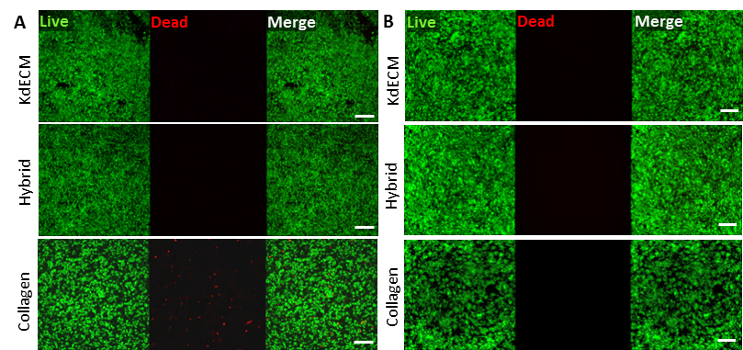

**Supplementary Fig. 2. Cell viability assessment of glomerular cells with customized bioink for the printing of glomerular podocytes and GE tubes. (A)** GEs and **(B)** podocytes showed significantly higher cell viabilities in pure 3% (w/v) kidney decellularized extracellular matrix and hybrid bioink (3K1A), compared with 3% (w/v) collagen type I during a culture period which spanned 7 days (scale bars, 200 µm, 400 µm).

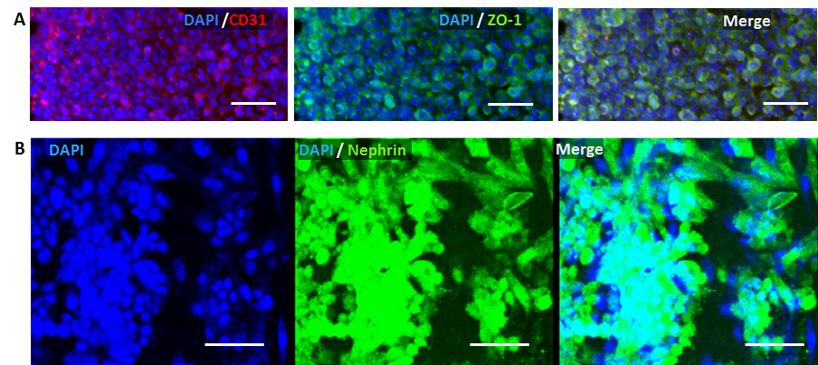

**Supplementary Fig 3. Expressions of glomerular functional markers in bilayer glomerular microvessel-on-a-chip (bGOAC). (A)** CD31 and ZO-1, and **(B)** nephrin expressions after 14 days of culture(scale bar, 50 µm).

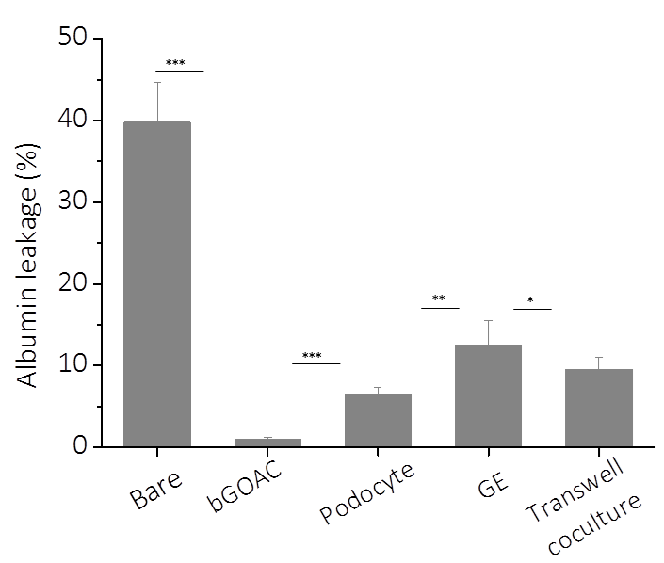

**Supplementary Fig. 4.** **Comparative albumin permselectivity.** Fluorescein isothiocyanate–albumin leakage from bare tube, bGOAC, podocyte tube, GE tube and transwell coculture podocyte–endothelial cell barrier in filtrate after a prolonged perfusion period (*p < 0.05, **p < 0.01, ***p < 0.001).

**Supplementary Table 1.** List of primer sequences.



**Supplementary movies**

**Supplementary Movie** **1.** Printing

**Supplementary Movie 2.** Perfusion