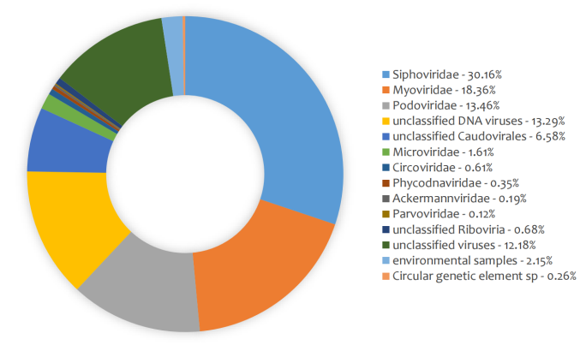
Figure S1. Doughnut chart of the taxonomy classification of all the viral contigs (vOTUs) in the Dataset of Oyster Virome (DOV). The proportion of different viral families and unclassified vOTUs (≥800 bp) in DOV are based on BLAST searches of the results of Diamond (v0.9.14.115) against the NCBI nonredundant protein sequence (nr) database (release November 2019).
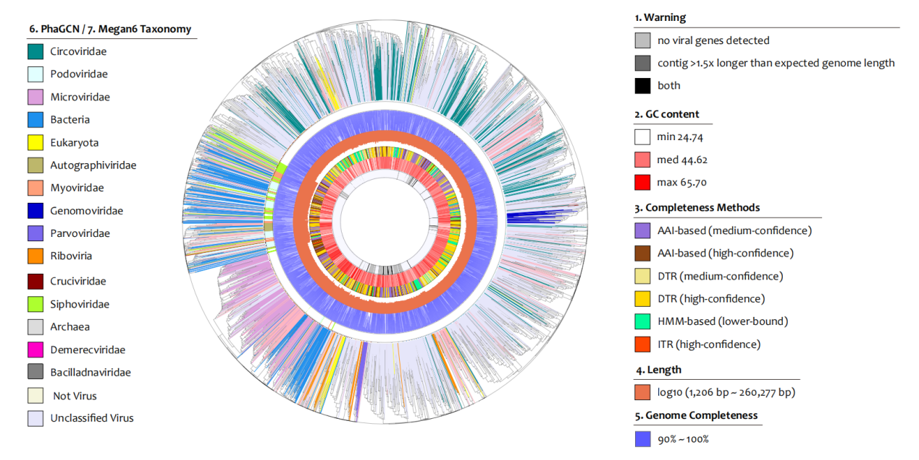
Figure S2. Viral proteomic phylogenetic tree of complete and near-complete viral genomes in the Dataset of Oyster Virome (DOV). The viral genomes were clustered based on their mutual amino acid identity using ViPTreeGen (v1.1.2). The layers from inside to outside show (1) the warning message of CheckV, (2) GC content of the viral genomes, (3) CheckV evaluation methods of genome completeness, (4) log10 value of genomic length, (5) percentage of genome completeness evaluated by CheckV, (6) viral families in order Caudovirales predicted by PhaGCN, and (7) viral families and non-viral annotations of all the genomes obtained by BLAST searches of the results from Diamond (v0.9.14.115) against the NCBI nonredundant protein sequence (nr) database (release November 2019).

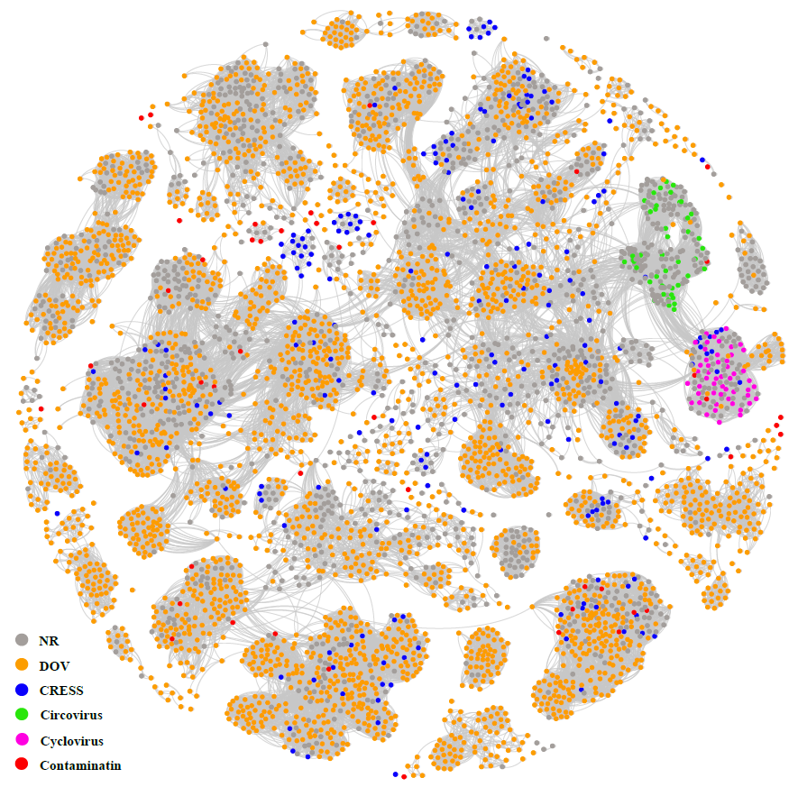
Figure S3. Similarity clustering of circovirus-related replicase proteins in Dataset of Oyster Virome (DOV) and NCBI nr. Dots represent different replicase sequences (n=4,716). Edges represent the score value of the Diamond BlastP results; only scores higher than 185.0 are shown. Network clustering was performed using Gephi (v0.9.2) under the Fruchterman-Reingold model. Colors of dots indicate different data origins: orange, Dataset of Oyster Virome (DOV); blue, CRESS from Ashleigh et al. (2021); green, circoviruses from the International Committee on Taxonomy of Viruses (ICTV); violet, cycloviruses from the ICTV; red, contaminant sequences from Asplund et al. (2019) and Ashleigh et al. (2021); grey, other NCBI nr sequences.
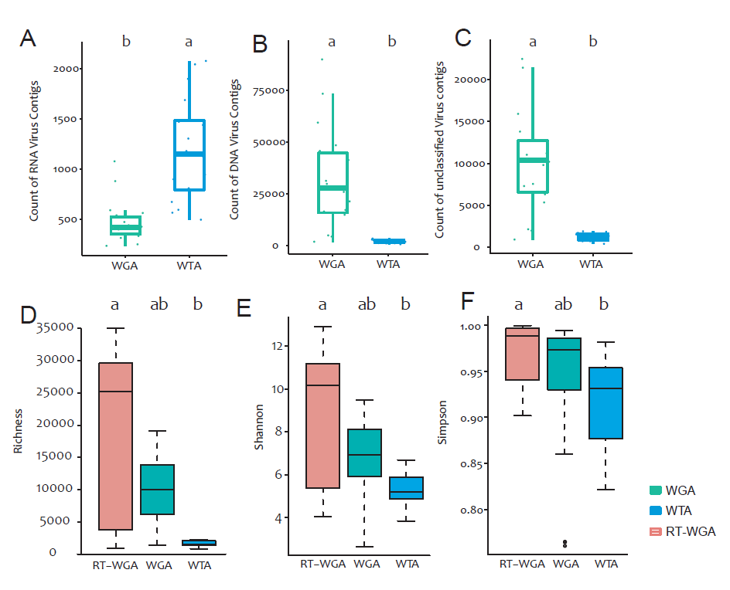
Figure S4. Preference of amplification strategies for the viral community and genome types. (A) Counts of RNA, (B) DNA, and (C) unclassified viral contigs (vOTU) using the WGA and WTA strategies. (D) Richness, (E) Shannon, and (F) Simpson indexes of the three amplification strategies: RT-WGA, reverse transcription and whole genome amplification; WGA, whole genome amplification; WTA whole transcriptome amplification. Different lowercase letters indicate significant differences (P <0.05; one-way ANOVAs and Tukey-Kramer post hoc comparisons).

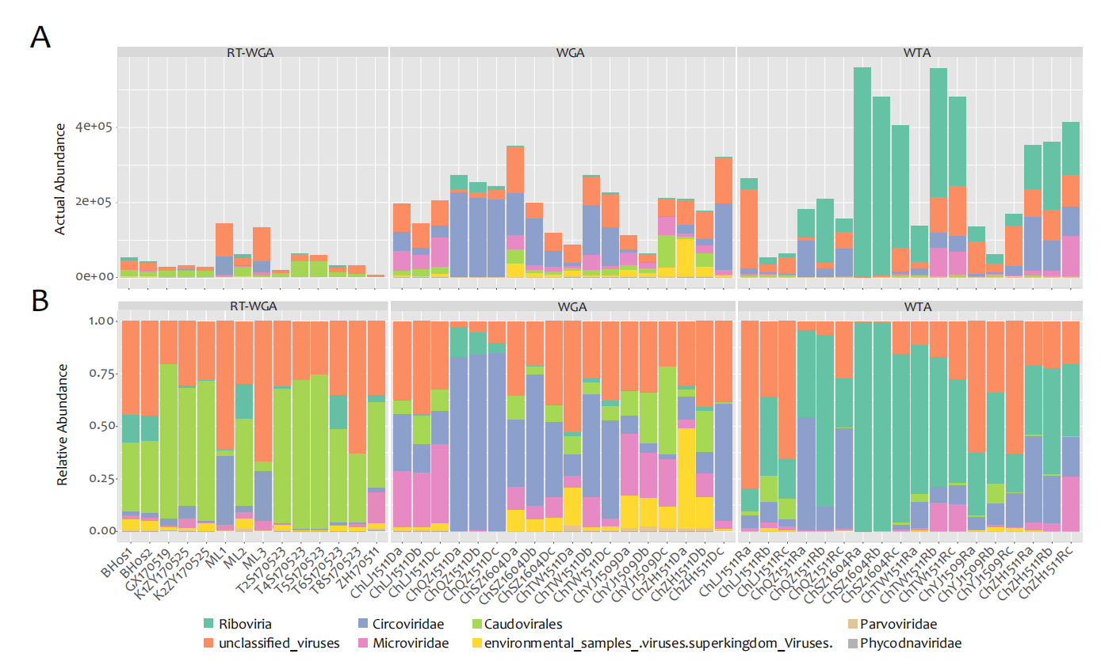
Figure S5. Actual and relative abundances of virus taxons in the Dataset of Oyster Virome (DOV) libraries. (A) Actual abundance and (B) relative abundance of the taxons in the 54 DOV libraries (X-axis). Annotations are based on BLAST searches of the results of Diamond (v0.9.14.115) against the NCBI nonredundant protein sequence (nr) database (release November 2019). To facilitate the display, the classifications were not unified at the same taxonomic levels.
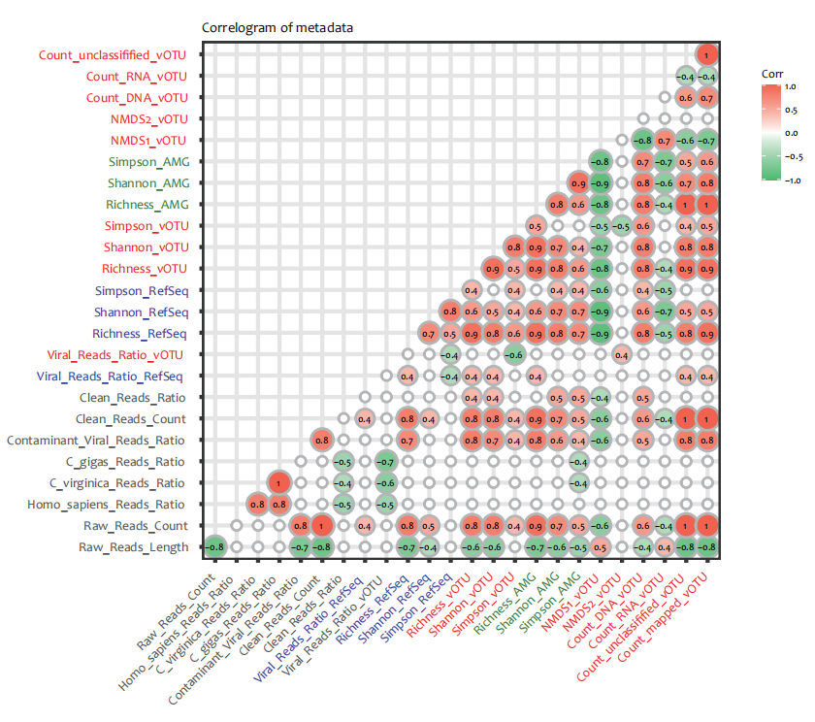
Figure S6. Correlation matrix of oyster viral communities. Red labels (n=10), diversity indexes, viral reads ratio, and vOTU counts based on vOTUs mapping results; black labels (n=7), quality related parameters of library construction and sequencing; blue labels (n=4), diversity indexes and viral ratio based on the reference genomes (RefSeq, GOV, and IMG/VR) mapping results; green labels (n=3): diversity indexes based on the auxiliary metabolic genes (AMGs) mapping results.

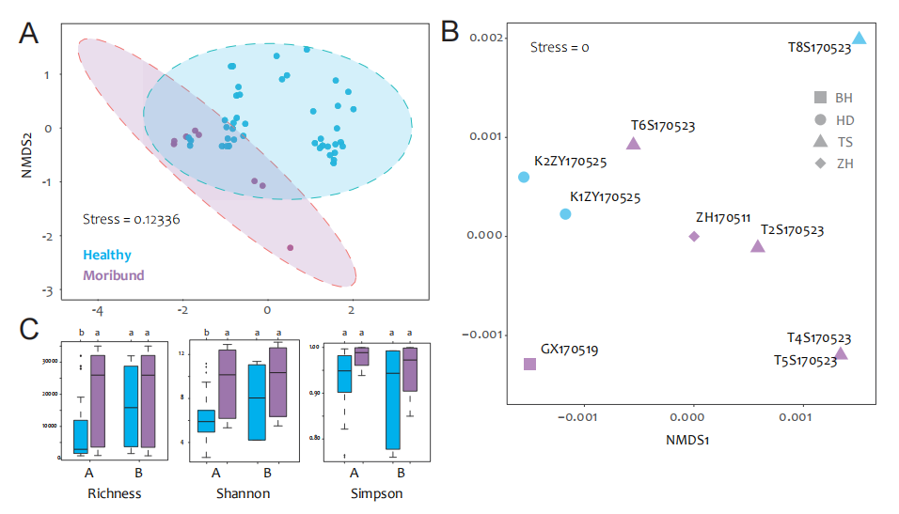
Figures S7. Influences of health status on the viral community in the Dataset of Oyster Virome (DOV). (A) Nonmetric multidimensional scaling (NMDS) plots of all the libraries (n=54) and (B) the seventh batch (May 2017) (n=9). (C) Comparison α-diversities (Richness, Shannon and Simpson indexes) between healthy and moribund samples corresponding to the NMDS plots in (A) and (B). Blue bar, healthy group; purple bar, moribund group. Different lowercase letters indicate significant differences (P <0.05; one-way ANOVAs and Tukey-Kramer post hoc comparisons).

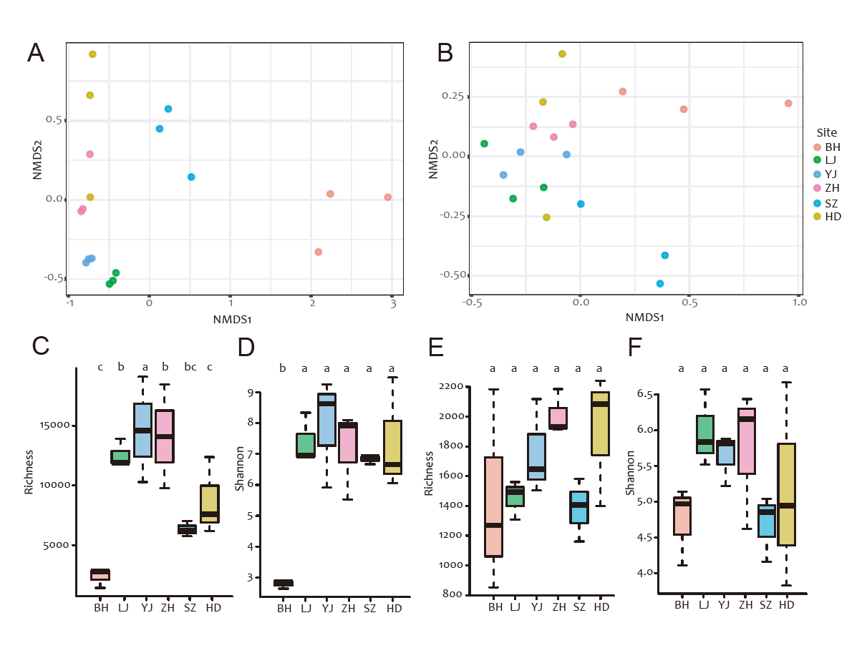
Figure S8. Influences of sampling sites on the viral community in the Dataset of Oyster Virome (DOV). (A, B) Nonmetric multidimensional scaling plots of different sampling sites of the WTA (A) and WGA (B) groups. (C–F) Comparisons of alpha diversity indexes among sampling sites of the WTA (C. D) and WGA (E, F) groups. The colors are used consistently in the figure. Different lowercase letters indicate significant differences (P <0.05; one-way ANOVAs and Tukey-Kramer post hoc comparisons). WGA, whole genome amplification; WTA whole transcriptome amplification.
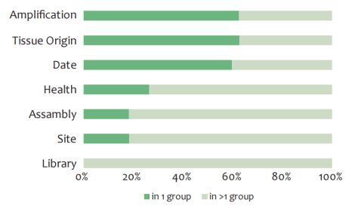
Figure S9. Percentage of unique viral contigs (vOTUs) (detected in only one group) under different grouping methods.
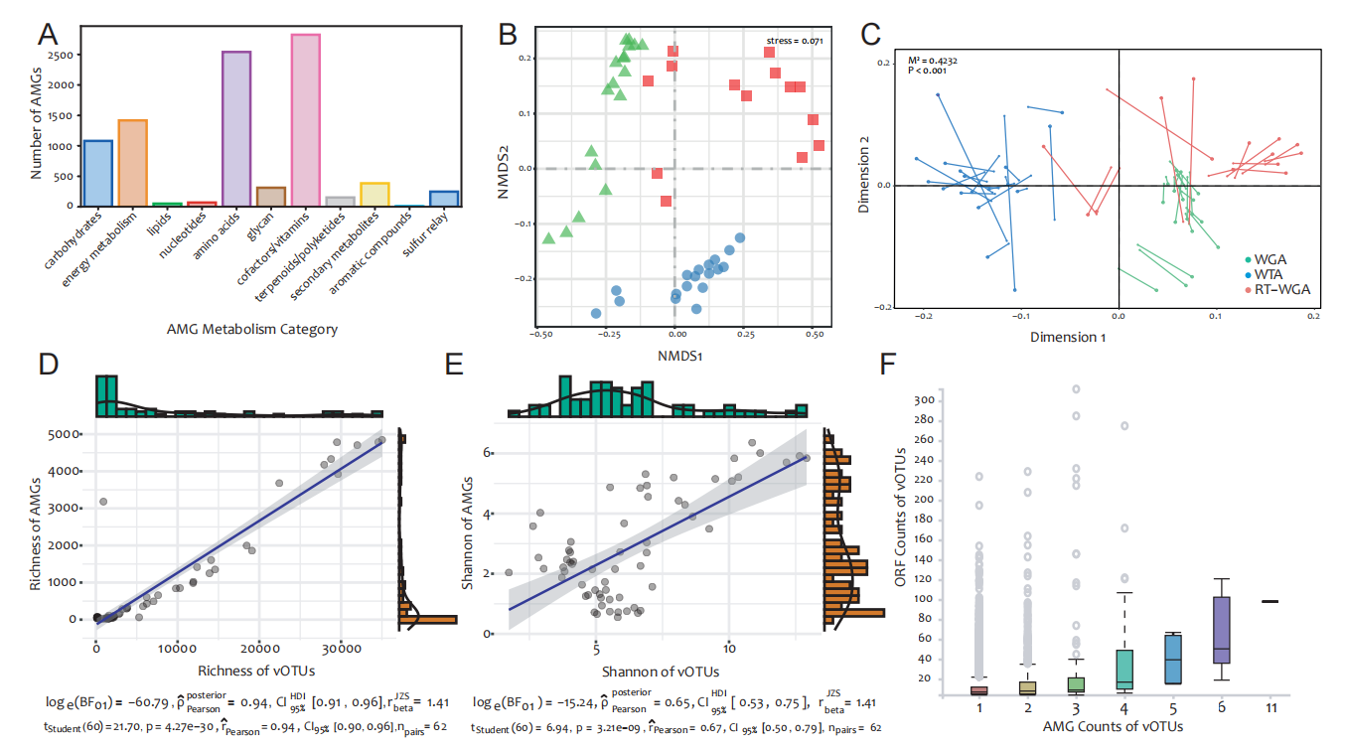
Figure S10. Auxiliary metabolic gene (AMG) diversity in the Dataset of Oyster Virome (DOV). (A) Number of detected AMGs assigned to different KEGG metabolic pathways. (B) Nonmetric multidimensional scaling (NMDS) plot of AMG diversity in the DOV libraries (n = 54). (C) Procrustes analysis of NMDS coordinates between the viral contig (vOTU) and AMG communities. The colors are used consistently in (B) and (C): green, WGA; blue. WTA, red. RT-WGA libraries. RT-WGA, reverse transcription and whole genome amplification; WGA, whole genome amplification; WTA whole transcriptome amplification. (D, E) Correlations and linear correlation curves of the Richness (D) and Shannon (E) indexes between vOTUs and AMGs. (F) Correlation between AMG and open reading frame (ORF) counts on the same vOTU.

Table S1. Detailed library grouping information and corresponding metadata
Table S2. Near-complete viral genomes in the Dataset of Oyster Virome (DOV) identified by CheckV.
Table S3. Counts of auxiliary metabolic genes (AMGs) and corresponding KEGG categories.

