**Supplementary Information for the manuscript**

**Marine Nitrogen Fixation as a Possible Source of Atmospheric Water-Soluble Organic Nitrogen Aerosols in the subtropical North Pacific**

Tsukasa Dobashi1,2, Yuzo Miyazaki2, Eri Tachibana2, Kazutaka Takahashi3, Sachiko Horii3,4, Yoko Iwamoto5, Shu-Kuan Wong6,7, and Koji Hamasaki6

1Graduate School of Environmental Science, Hokkaido University, Sapporo, 060-0810, Japan

2Institute of Low Temperature Science, Hokkaido University, Sapporo, 060-0819, Japan

3Graduate School of Agricultural and Life Sciences, The University of Tokyo, Tokyo, 113-8657, Japan

4Now at Fisheries Resources Institute, Japan Fisheries Research and Education Agency, Nagasaki 851-2213, Japan

5Graduate School of Integrated Sciences for Life, Hiroshima University, Hiroshima, 739-8521, Japan

6Atmosphere and Ocean Research Institute, The University of Tokyo, Kashiwa, 277-8564, Japan

7Now at National Institute of Polar Research, Tokyo, 190-8518, Japan

Correspondence and requests for materials should be addressed to Y. M. (email: yuzom@lowtem.hokudai.ac.jp)

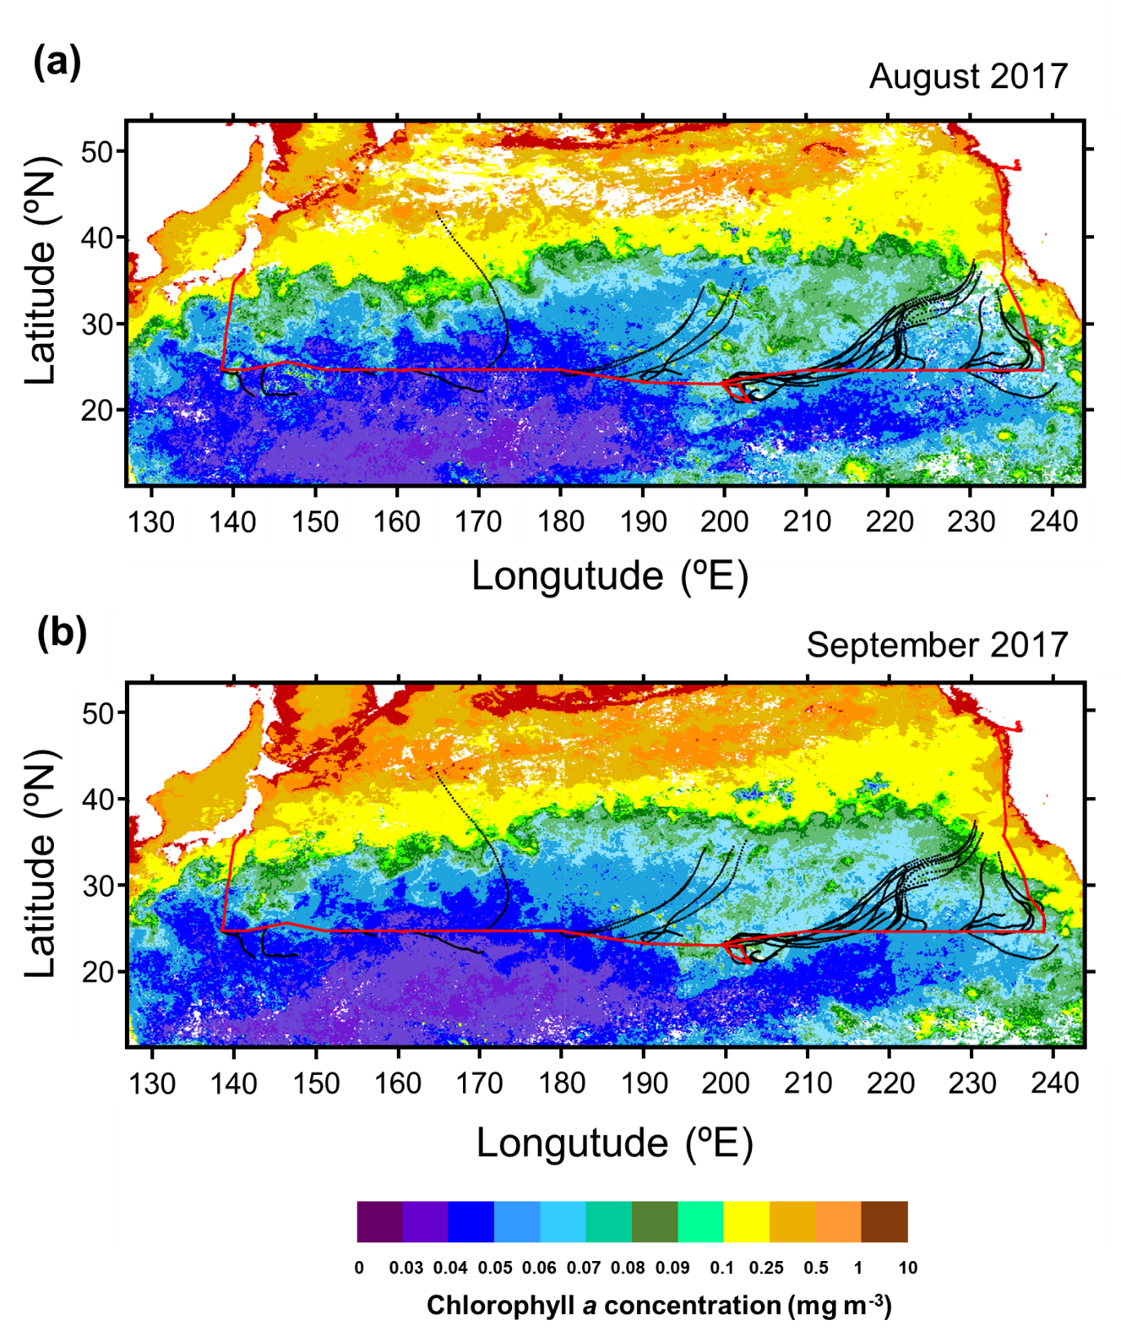

**Figure S1**. R/V *Hakuho* cruise track in the subtropical North Pacific between 12 August and 5 October 2017 (red), together with typical 3-day back trajectories (black). Also shown are monthly averaged concentrations of chl *a* for (a) August and (b) September 2017 derived from the MODIS-Aqua (https://neo.sci.gsfc.nasa.gov/view.php?datasetId=MY1DMM_CHLORA&year=2017). Area in which data is missing is shown in white.

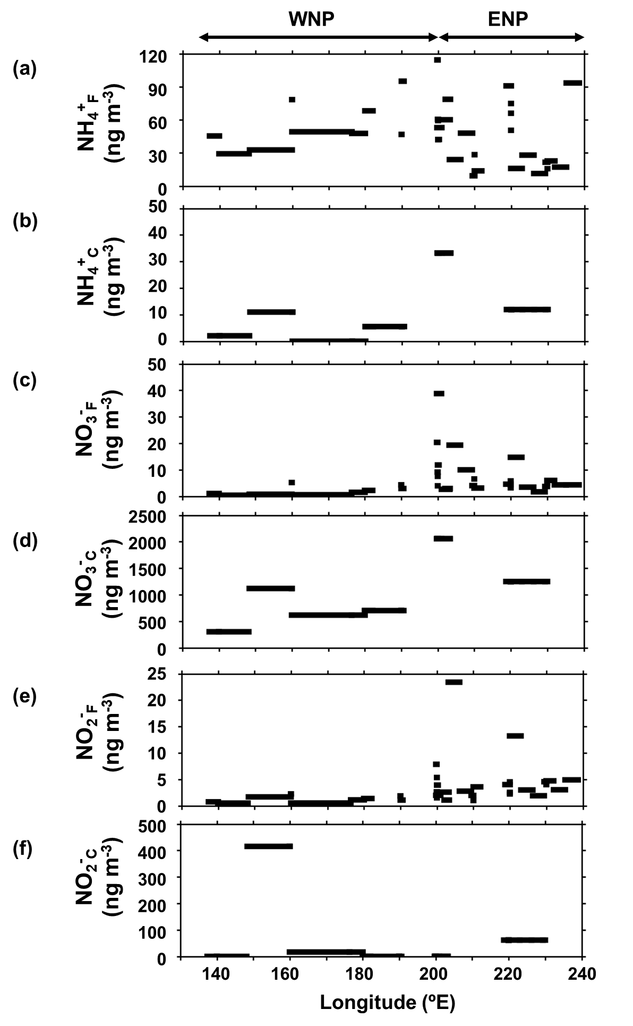

**Figure S2**. Longitudinal distributions of mass concentrations of (a) NH4+F, (b) NH4+C, (c) NO3−F, (d) NO3−C, (e) NO2−F, and (f) NO2−C along 23ºN.

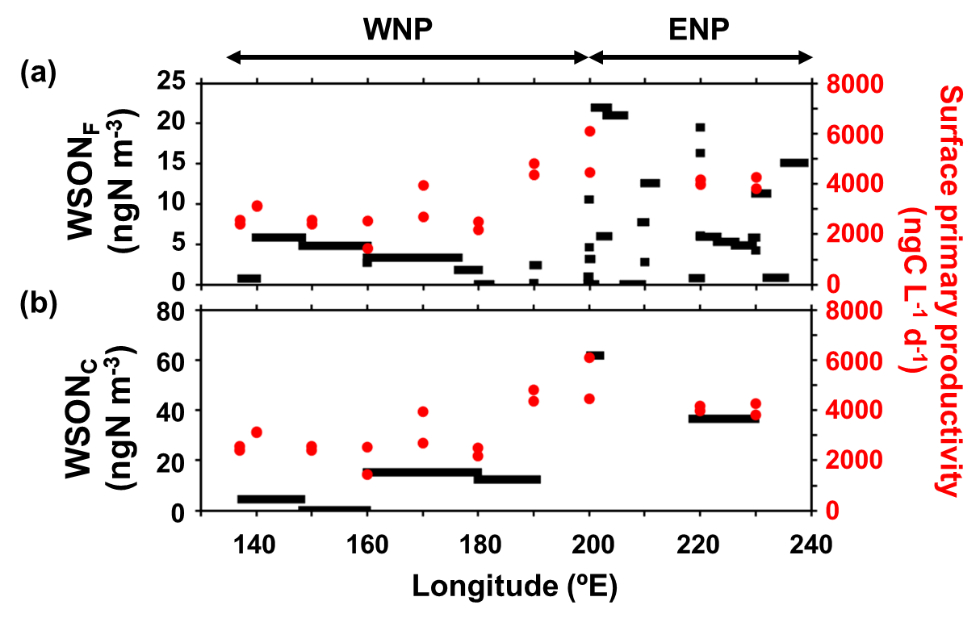

**Figure S3**. Longitudinal distributions of mass concentrations of (a) WSONF and (b) WSONC, together with primary productivity in the SSW samples during the entire cruise.

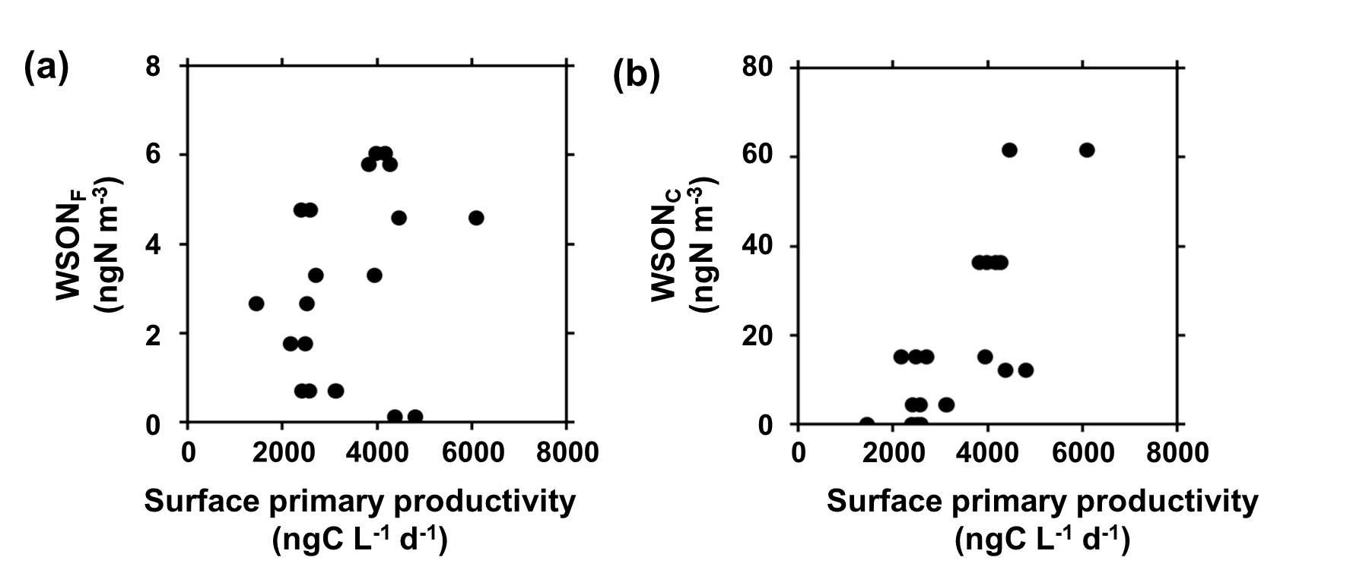

**Figure S4**. The mass concentrations of (a) WSONF and (b) WSONC as a function of primary productivity in SSW.

**Table S1**. The data of fine particles analysed in this study.



**Table S2**. The data of coarse particles.



**Table S3**. The surface seawater data.

