SUPPLEMENTARY MATERIAL

Growth and yield responses of sunflower to drainage in waterlogged saline soil are caused by changes in plant-water relations and ion concentrations in leaves

Mohammad Nazrul Islam^{1,2*}, Richard W. Bell¹, Edward G. Barrett-Lennard^{1,3,4}, Mohammad Maniruzzaman⁵

¹ Centre for Sustainable Farming Systems, Future Food Institute, Murdoch University, WA-6150, Australia
² Soil Science Division, Bangladesh Rice Research Institute, Gazipur-1701, Bangladesh
³ Department of Primary Industries and Regional Development, South Perth, WA-6151, Australia
⁴ School of Agriculture and Environment, The University of Western Australia, Nedlands, WA-6009, Australia
⁵ Irrigation and Water Management Division, Bangladesh Rice Research Institute, Gazipur-1701, Bangladesh

*Corresponding author: nazrulag@gmail.com, Soil Science Division, Bangladesh Rice Research Institute, Gazipur.

Journal name: Plant and Soil
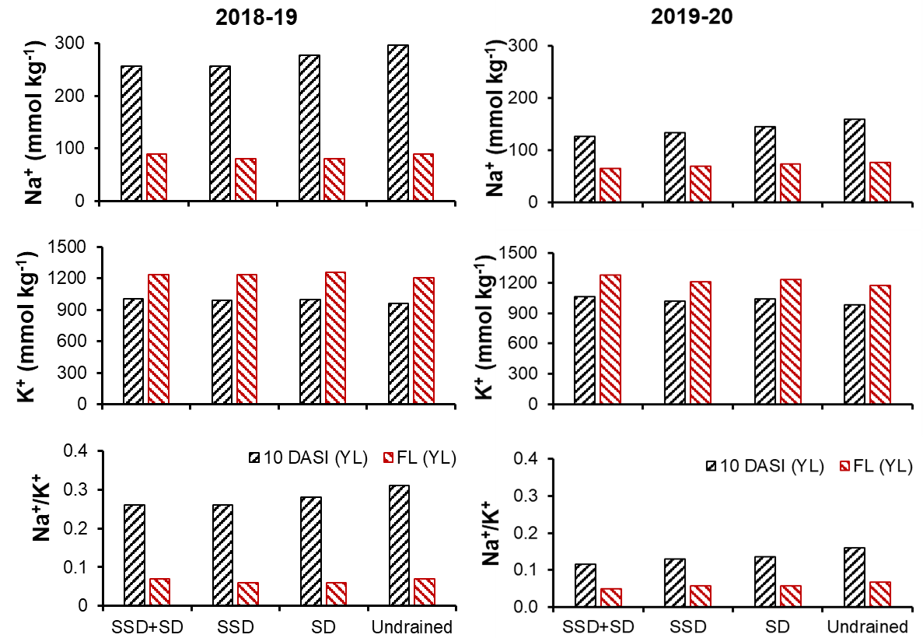
Fig. S1 Effect of drains on the concentration of Na and K ions in younger leaves and its ratio (Na⁺/K⁺) in 2018–19 and 2019–20. Abbreviations: SSD = subsoil drain, SD = surface drain, DASI = days after second inundation, FL = flowering, YL = younger leaves.

Table S1. Effects of drains on leaf chlorophyll content at different times in 2018–19 and 2019–20.*
Treatment | Chlorophyll content (CCI)
 | 2018–19 |  |  |  | 2019–20
 | 3 DASI | 10 DASI | 17 DASI | FL | 3 DASI | 10 DASI | 17 DASI | FL
SSD+SD | 17.2 a | 16.1 a | 14.2 a | 12.0 a | 23.1 a | 17.5 a | 14.7 a | 13.7 a
SSD | 16.2 b | 14.7 b | 13.4 b | 11.1 b | 21.0 b | 16.4 b | 13.3 b | 12.1 b
SD | 16.2 b | 14.8 b | 13.3 b | 11.0 b | 21.4 b | 16.1 b | 13.1 b | 12.2 b
Undrained | 14.8 c | 13.7 c | 12.5 c | 9.0 c | 19.2 c | 15.1 c | 12.2 c | 11.3 b
P-value | <0.001 | <0.001 | <0.001 | <0.001 | <0.001 | <0.001 | <0.001 | <0.01
*The leaf chlorophyll content was measured with a chlorophyll content meter (CCM-200 plus, OPTI-SCIENCE, USA). This instrument reports values of chlorophyll content index (CCI). Means with the same letter are not significantly different at 5% level of significance. Abbreviations: SSD = subsoil drain, SD = surface drain, DASI = days after second inundation, FL = flowering.

Table S2. Significance of effects of g_{s}, Ψ_{leaf} and LCC at different times during the growing season on achene yield in 2018–19 and 2019–20.
Times | Significance level with r² values and direction of the slope (in brackets)
 | 2018–19 |  |  | 2019–20
 | LCC  (CCI) | g_{s}  (mmol m^{–2} s^{–1}) | Ψ_{leaf}  (MPa) | LCC  (CCI) | g_{s}  (mmol m^{–2} s^{–1}) | Ψ_{leaf}  (MPa)
3 DASI | (+) 0.61*** | (+) 0.68*** | (-) 0.65*** | (+) 0.69*** | - | (-) 0.67***
10 DASI | (+) 0.66*** | (+) 0.17* | - | (+) 0.66*** | - | (-) 0.49***
17 DASI | (+) 0.66*** | (+) 0.25* | - | (+) 0.56*** | - | (-) 0.45***
FL | (+) 0.47*** | - | (-) 0.57*** | (+) 0.60*** | - | (-) 0.64***
Abbreviations: g_{s} = stomatal conductance, Ψ_{leaf} = leaf water potential, SEW₃₀ = sum of excess water above 30 cm, LCC = leaf chlorophyll content, DASI = days after second inundation, FL = flowering. For all relationships n = 24.

Table S3. Relationships among different factors (Ψ_{s} and EC_{1:5} at 0–15 cm soil depth, SEW₃₀, g_{s}, LCC and Ψ_{leaf} at different times during the crop growing season in 2018–19 and 2019–20.
Variates | 3 DASI | 10 DASI | 17 DASI | FL
 | Significance level with r² values and direction of the slope (in brackets)
Year 2018–19
SEW₃₀ × g_{s} | (-) 0.80*** | NS | (-) 0.19* | -
EC_{1:5} × g_{s} | - | NS | (-) 0.34** | -
Ψ_{s} × g_{s} | - | NS | (+) 0.45*** | -
SEW₃₀ × LCC | (-) 0.85*** | (-) 0.69*** | (-) 0.73*** | (-) 0.78***
EC_{1:5} × LCC | - | (-) 0.65*** | (-) 0.65*** | (-) 0.59***
Ψ_{s} × LCC | - | (+) 0.35** | (+) 0.33** | (+) 0.49***
SEW₃₀ × Ψ_{leaf} | (+) 0.68*** | - | - | (+) 0.66***
EC_{1:5} × Ψ_{leaf} | - | - | - | (+) 0.63***
Ψ_{s} × Ψ_{leaf} | - | - | - | (-) 0.63***
g_{s} × LCC | (+) 0.63*** | NS | NS | -
g_{s} × Ψ_{leaf} | (-) 0.72*** | - | - | -
Year 2019–20
SEW₃₀ × LCC | (-) 0.90*** | (-) 0.80*** | (-) 0.72*** | (-) 0.57***
EC_{1:5} × LCC | - | (-) 0.68*** | (-) 0.74*** | (-) 0.74***
Ψ_{s} × LCC | - | (+) 0.52*** | (+) 0.60*** | (+) 0.67***
SEW₃₀ × Ψ_{leaf} | (+) 0.55*** | (+) 0.35** | (+) 0.25* | (+) 0.53***
EC_{1:5} × Ψ_{leaf} | - | (+) 0.52*** | (+) 0.42*** | (+) 0.50***
Ψ_{s} × Ψ_{leaf} | - | (-) 0.44*** | (-) 0.51*** | (-) 0.58***
Abbreviations: Ψ_{s} = solute potential, g_{s} = stomatal conductance, LCC = leaf chlorophyll content, Ψ_{leaf} = leaf water potential, SEW₃₀ = sum of excess water within 30 cm, DASI = days after second inundation, FL = flowering, NS = non-significant. For all relationships n = 24.

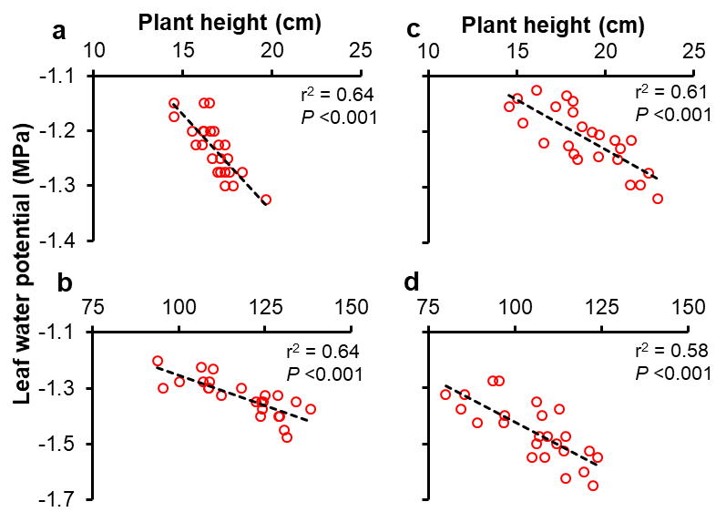
Fig. S2 Correlation between plant height and leaf water potential at 3 DASI (a) and FL (b) in 2018–19 and at 3 DASI (c) and FL (d) in 2019–20. Abbreviations: DASI = days after second inundation, FL = flowering. We selected nine plants randomly from each position to measure plant height (with a ruler).

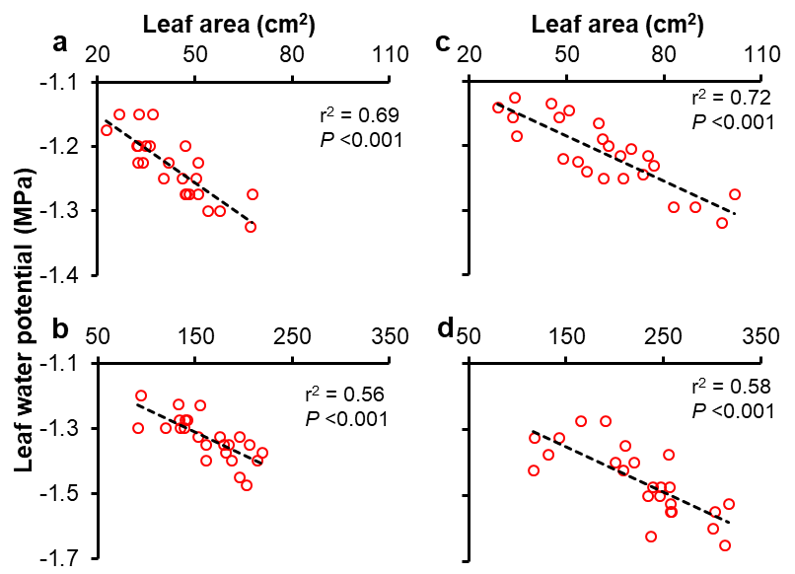
Fig. S3 Correlation between leaf area and leaf water potential at 3 DASI (a) and FL (b) in 2018–19 and at 3 DASI (c) and FL (d) in 2019–20. Abbreviations: DASI = days after second inundation, FL = flowering. Leaf area (LA) was estimated from measurement of lamina length and width according to Islam et al. (2021).

Table S4. Effect of drains on shoot dry weight at different times during the cropping season in 2018–19 and 2019–20.
Treatment | Shoot dry weight (g plant^{–1})
 | 7 DAFI | 14 DAFI | 10 DASI | 17 DASI | FL
Year 2018–19
SSD+SD | 0.09 a | 0.29 a | 4.4 a | 11.7 a | 31.1 a
SSD | 0.07 b | 0.20 b | 3.6 b | 8.0 b | 23.4 b
SD | 0.07 b | 0.18 b | 3.6 b | 7.8 b | 24.5 b
Undrained | 0.05 c | 0.12 c | 2.2 c | 5.1 c | 15.8 c
P-values | <0.01 | <0.001 | <0.001 | <0.001 | <0.001
LSD_{0.05} | 0.012 | 0.046 | 0.46 | 0.64 | 3.24
Year 2019–20
SSD+SD | 0.19 a | 0.66 a | 5.9 a | 13.6 a | 41.8 a
SSD | 0.17 a | 0.48 b | 4.4 b | 9.7 b | 32.2 b
SD | 0.18 a | 0.53 b | 4.5 b | 9.9 b | 33.0 b
Undrained | 0.12 b | 0.26 c | 2.5 c | 5.2 c | 20.7 c
P-values | <0.01 | <0.001 | <0.001 | <0.001 | <0.001
LSD_{0.05} | 0.028 | 0.091 | 0.495 | 1.345 | 2.899
Abbreviations: SSD = subsoil drain, SD = surface drain, DAFI = days after first inundation, DASI = days after second inundation, FL = flowering.

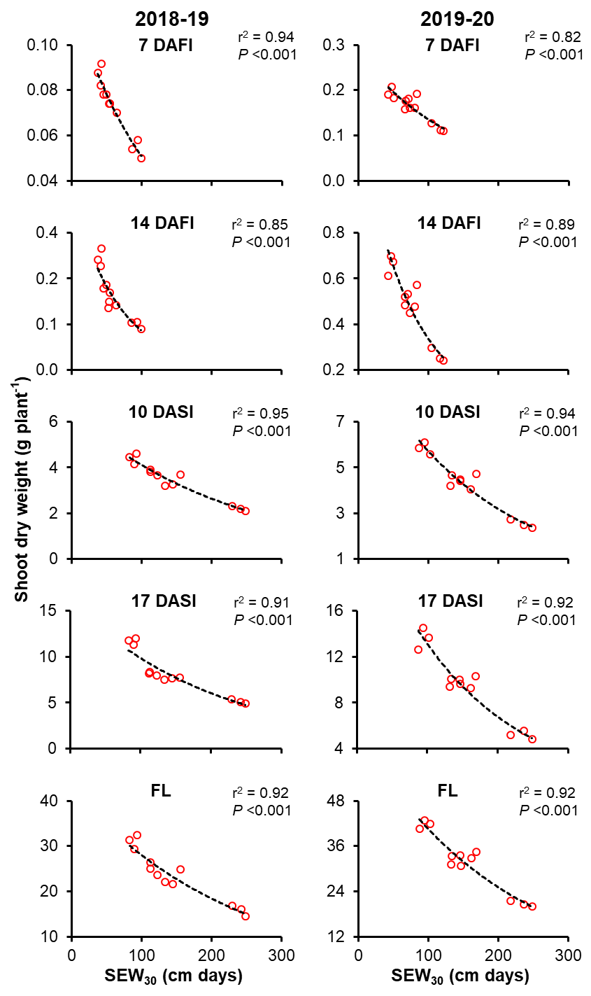
Fig. S4 Correlation between shoot dry weight and SEW₃₀ at different times in 2018–19 and 2019–20. Abbreviations: SEW₃₀ = sum of excess water within 30 cm, DAFI = days after first inundation, DASI = days after second inundation, FL = flowering.

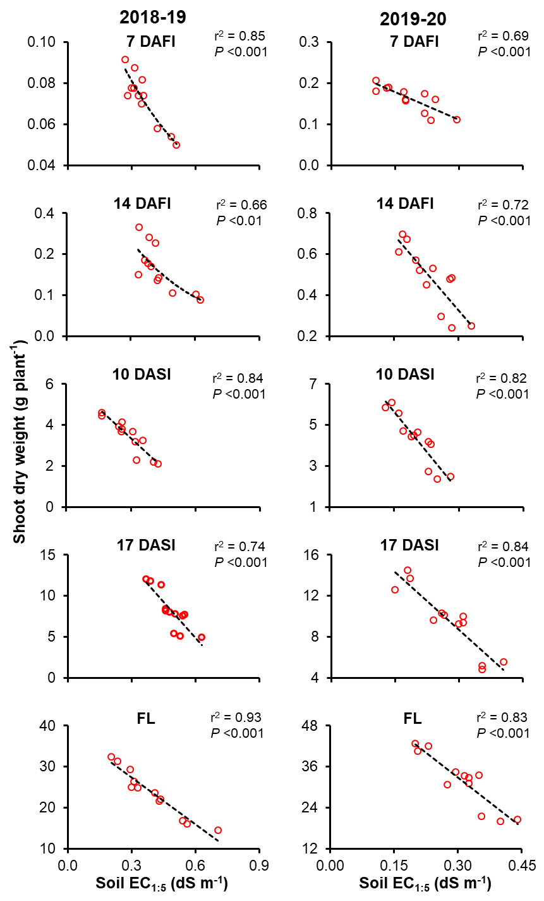
Fig. S5 Correlation between shoot dry weight and soil EC_{1:5} at 0–15 cm at different times in 2018–19 and 2019–20. Abbreviations: DAFI = days after first inundation, DASI = days after second inundation, FL = flowering.

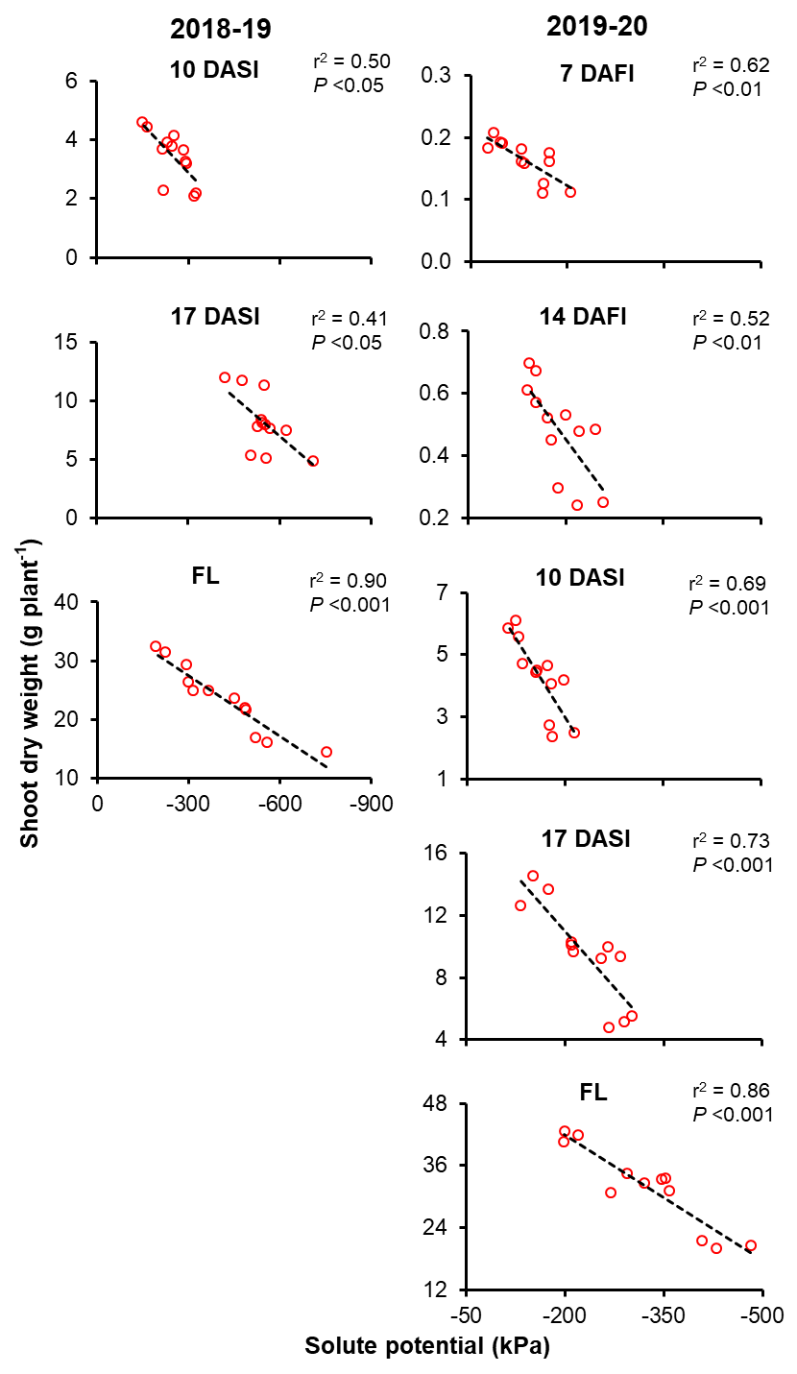
Fig. S6 Correlation between shoot dry weight and solute potential of soil at 0–15 cm at different times in 2018–19 and 2019–20. Abbreviations: DAFI = days after first inundation, DASI = days after second inundation, FL = flowering.

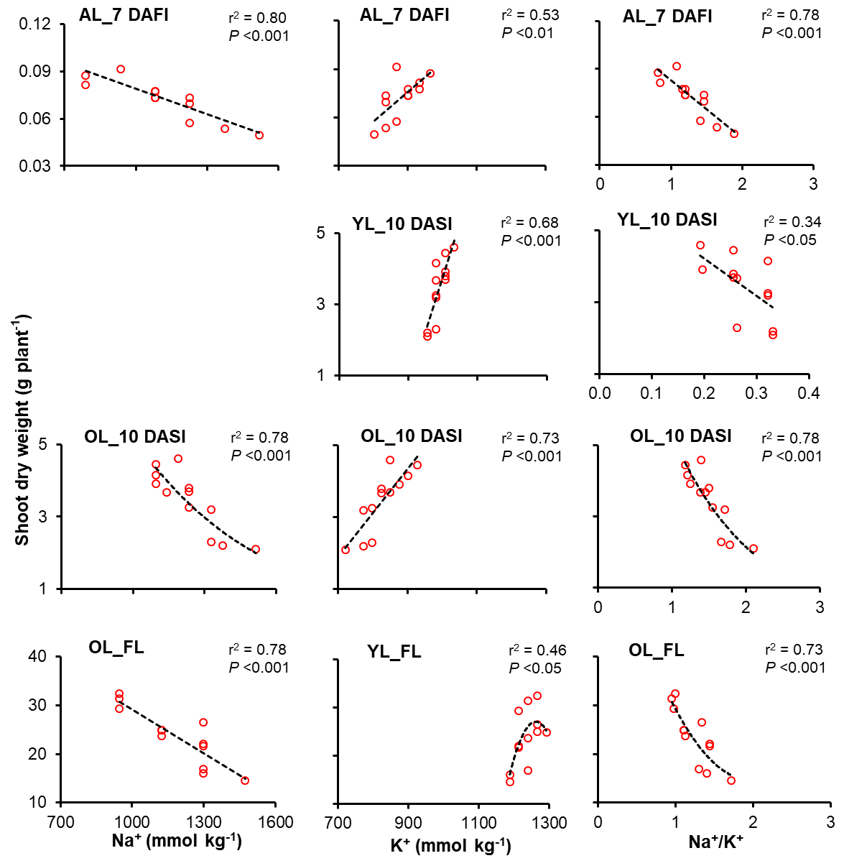
Fig. S7 Correlation between shoot dry weight and Na⁺ or K⁺ or Na⁺/K⁺ in leaves at different times in 2018–19. Abbreviations: DAFI = days after first inundation, DASI = days after second inundation, FL = flowering, AL = all leaves, YL = younger leaves, OL = older leaves.

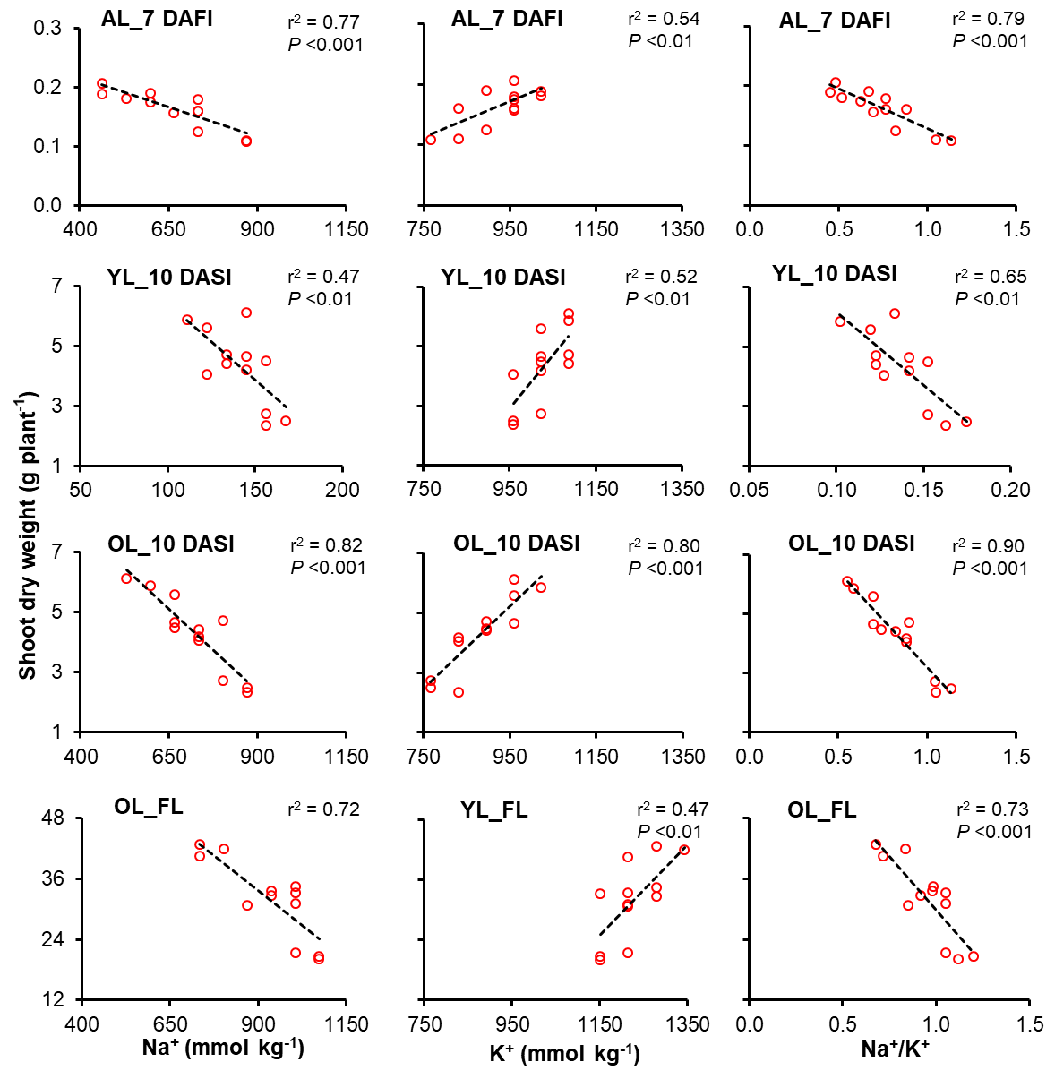
Fig. S8 Correlation between shoot dry weight and Na⁺ or K⁺ or Na⁺/K⁺ in leaves at different times in 2019–20. Abbreviations: DAFI = days after first inundation, DASI = days after second inundation, FL = flowering, AL = all leaves, YL = younger leaves, OL = older leaves.

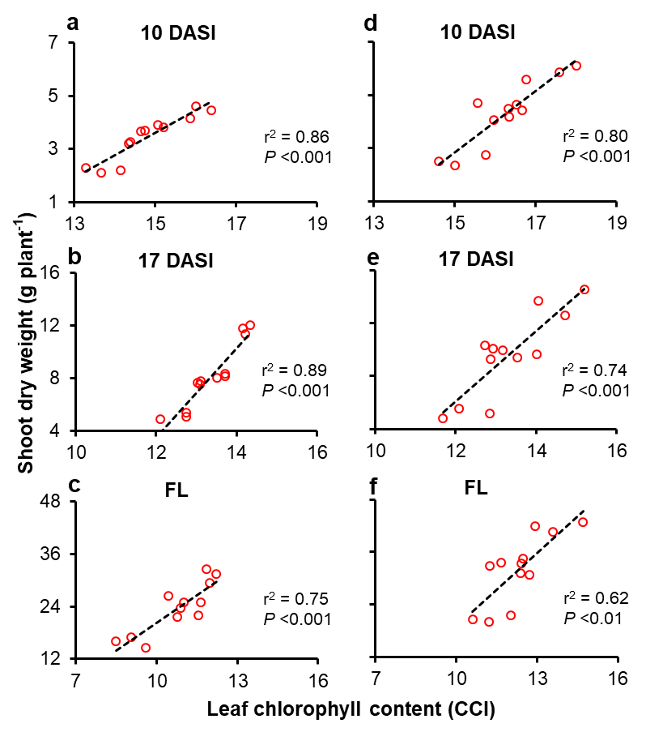
Fig. S9 Correlation between shoot dry weight and leaf chlorophyll content at different times during the growing season in 2018–19 (a–c) and 2019–20 (d–f). Abbreviations: DASI = days after second inundation, FL = flowering.

