Supplementary Material 5 - Global records of (I) Eicchornia crassipes (II) Monochoria vaginalis and (III) Salvinia molesta (A) 100 years ago and (B) at present, representing their rapid and widespread invasion world over (Global Biodiversity Information Facility, GBIF)

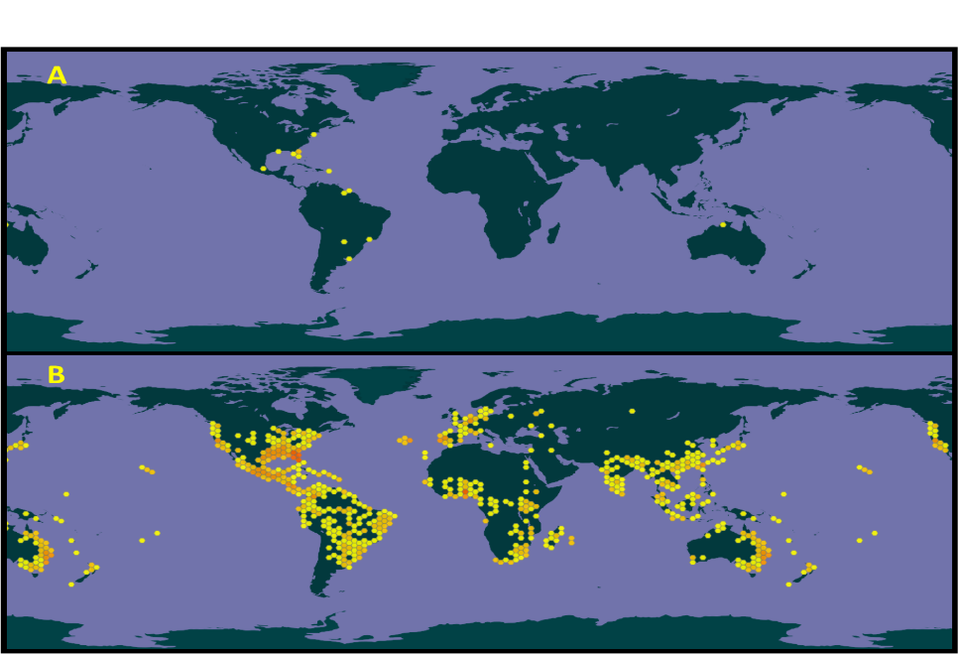
- E. crassipes
- Monochoria vaginalis
(III) Salvinia molesta

