Effectiveness of REGEN-COV Antibody Combination in Preventing Severe COVID-19 Outcomes – A retrospective cohort study

Samah Hayek¹, Yatir Ben-shlomo¹, Noa Dagan^{1,2,3,4}, Ben Y. Reis^{4,5,6}, Noam Barda^{2,3}, Eldad Kepten¹, Alina Roitman⁷, Shachar Shapira^{8,9}, Shlomit Yaron⁷, Ran D.Balicer^{1,4,10,,11}, Doron-Netzer^{7,11}, Alon Peretz^{7,11}

Affiliation
¹ Clalit Research Institute, Innovation Division, Clalit Health Services, Tel Aviv, Israel.
² Software and Information Systems Engineering, Ben Gurion University, Be’er Sheva, Israel.
³ Department of Biomedical Informatics, Harvard Medical School, Boston, MA, USA.
⁴ The Ivan and Francesca Berkowitz Family Living Laboratory Collaboration at Harvard Medical School and Clalit Research Institute, Boston, MA, USA.
⁵ Predictive Medicine Group, Computational Health Informatics Program, Boston Children’s Hospital, Boston, MA, USA.
⁶ Harvard Medical School, Boston, MA, USA.
⁷ Clalit Community Division, Clalit Health Services, Tel Aviv, Israel.
⁸ Israel Defense Forces Medical Corps, Tel Aviv, Israel.
⁹ Department of Military Medicine, Faculty of Medicine, Hebrew University, Jerusalem, Israel.
¹⁰ School of Public Health, Faculty of Health Sciences, Ben Gurion University of the Negev, Be’er Sheva, Israel.
¹¹ These authors contributed equally: Ran.D. Balicer, Doron Netzer, Alon Peretz

Corresponding author:
Samah Hayek, DrPH
Clalit Research Institute
Toval 40, Ramat Gan, Israel
samahha@clalit.org.il
T: +972-3-6925809

Contents

Supplemental Table 1: Outcomes associated with REGEN-COV treatment effectiveness, by age group ……………………………………………………………………………….……………………….3
Supplemental Table 2: Variable definitions…………………………………………………………….4
Supplemental Figure 1: Flow chart for study participants 11
Supplemental Figure 2: Love Plot for the Covariate Balance 12

Supplemental Table 1: Outcomes associated with REGEN-COV treatment effectiveness, by age group
REGEN-COV effectiveness
95%CI
 | Age ≥60 years old | Age <60 years old
Hospitalization due to COVID-19 | 55.3%  (16.0%-75.7%) | 91.5%  (28.2-99.0%)
Severe COVID-19 | 59.4%  (20.2%-79.4%) | 86.3%  (-147.2-99.2%)
Death due to COVID-19 | 93.8%  (54.4%-99.2%) | N/A

Note: Treatment effectiveness was measured as 1-Hazard ratio (HR), derived from the adjusted cox –proportional model that was applied after the matching. Patients were matched for: Age, population sector, sex, SES, BMI, immunosuppression status, pregnancy, and first vaccination dose status (vaccinated vs. unvaccinated; those who were vaccinated were treated as the number of weeks from the beginning of the COVID-19 national vaccination campaign until the first vaccination as an indication for health seeking behavior). The model was then further adjusted for: Age, population sector, sex, SES, BMI, number of flu vaccines received in the 5 years prior to COVID-19 infection, smoking status, number of vaccine doses, recent full vaccination status, first vaccination dose, and chronic diseases (cancer, chronic kidney disease, respiratory diseases, cardiovascular diseases, diabetes, hypertension, immunosuppression, neurological conditions, and liver diseases). Complete variable definitions are found in Supplemental Table 1.
Abbreviation: CI, confidence interval. NA, Not applicable due to rare outcome among the treated patients

Supplemental table 2: Variable defintion
Variable name | Defintion | Timing
Exposure | REGEN-COV (Yes/No) | September 19, 2021 -December 8, 2021
Outcome | Three different outcomes:  - Hospitalization due to COVID-19. Defined as hospitalization that was reported to the Israeli MOH as a hospitalization of a SARS-CoV-2 infected individuals.  - Severe COVID-19 based on the Israeli Ministry of Health definition. As defined by the hospitalizing institution per the Israeli MOH guidelines, consistent with the The first date during the hospitalization in which the individual was flagged as being NIH criteria for severe illness or critical illness: Individuals who have SpO2 30 breaths/min, or lung infiltrates >50%. Critical Illness: Individuals who have respiratory failure, septic shock, and/or  - Death due to COVID-19. A death of a SARS-CoV-2 infected individual reported to the Israeli MOH. | - The start date of the hospitalization  - The first date during the hospitalization in which the individual was flagged as being in a severe or critical state  - The reported date of death
Age | Age at infection date. Defined as continuous and categorical.  Age group:  (1) 20-39; (2) 40-49; (3) 50-59; (4) 60-69; (5) 70-74; (6) ≥75 | Current
Gender | Male/Female | Current
Socio-economic status | For matching – we used it as as a catigorical variable with 20 level. For table 1 we categorized it into 3 levels: Low, medium , and high | Current
Population group | Jewish, Arab, Ultra-Orthodox Jewish | Current
Flu vaccination in the last 5 years | Number of influenza vaccination in the last 5 yeas prior to the index date. It is categorical variable that ranges between 0 –doses up to at least 5 doses of flu vaccine in the last 5 years prior to the index date | Last 5 years
BMI | Body Mass Index :  Under weight <18.5  Normal weight –BMI: 18.5-25.0  Overweight- BMI: >25-30  Obesity – BMI: >30 | Latest measurement in last 5 years not taken during pregnancy
Smoking status | Categorical variable. Current smoker, past smoker, non-smoker
Recent full vaccination status | Defined as two or more vaccination doses, and fewer than 150 days from the most recent vaccination dose until the first positive PCR test
First vaccination dose | the number of weeks from the beginning of the COVID-19 national vaccination campaign until the first vaccination dose
Hypertension | ICD9 Code 401*  ICD9 Code 402*  ICD9 Code 403*  ICD9 Code 404*  ICD9 Code 405* | Ever
Cardiovascular disease | ICD9 Code 410*  ICD9 Code 411*  ICD9 Code 412  ICD9 Code 413*  ICD9 Code 414*  ICD9 Code 429.2, 429.7*  ICD9 Code V45.81, V45.82  ICD9 Procedure Code 36.0*  ICD9 Procedure Code 36.1*  ICD9 Code 428*  ICD9 Code 398.91  ICD9 Code 402._1  ICD9 Code 404._1, ICD9 Code  404._3  ICD9 Code 416.9  ICD9 Code 514  ICD9 Code 425*  ICD9 Code 416* | Ever
Respiratory disease | Having any pulmonary disease (mentioned below) prior to the index date  COPD: ICD9 codes: 491.2*, 492.* 496.*  Asthma: ICD9 code: 493.*  Other respiratory disease: ICD9 Code 277.0* ICD9: Code 494*. ICD9 : Code 515.* | Ever
Neurological conditions | ICD9 Code 290.*  ICD9 Code 294*  ICD9 Code 310.1  ICD9 Code 331*  ATC Codes N06DA02, N06DA03  ICD9 Code 358*  ICD9 Code 332.[0,1]  ICD9 Code 345*  ICD9 Code 340  ATC Codes L03AB07, L03AB08,  L04AA07  ICD9 Code 343*  ICD9 Code 333.4  ICD9 Code 334*  ICD9 Code 356*  ICD9 Code 138  ICD9 Code 335*  ICD9 Code 730.7*  ICD9 V12.02  ICD9 Code 228.02  ICD9 Code 307.23  ICD9 Code 330.9  ICD9 Code 331.3*  ICD9 Code 331.4  ICD9 Code 333*  ICD9 Code 334*  ICD9 Code 336*  ICD9 Code 337  ICD9 Code 335.1*  ICD9 Code 359.0  ICD9 Code 359.21  ICD9 Code 357.0  ICD9 Code 237.7*  ICD9 Code 742.8[1,2] | For diagnosis codes, Ever For drugs, 4 or more dispensed in last 12 months
Cancer | ICD9 Code 174*  ICD9 Code 175*  ICD9 Code 233.0  ICD9 Code V10.3  ICD9 Procedure Code 85.4*  ICD9 Code 153*  ICD9 Code 154*  ICD9 Code V10.5*  ICD9 Code V10.6*  ICD9 Code 185  ICD9 Code V10.46  ICD9 Code 162*  ICD9 Code V10.1*  ICD9 Code 188*  ICD9 Code V10.51  ICD9 Code 183*  ICD9 Code V10.43  ICD9 Code 179  ICD9 Code 182*  ICD9 Code V10.42  ICD9 Code 157*  ICD9 Code 191*  ICD9 Code 192*  ICD9 Code V10.85  ICD9 Code 151*  ICD9 Code V10.04  ICD9 Code 172*  ICD9 Code V10.82  ICD9 Code 201*  ICD9 Code 200*  ICD9 Code 202.4*  ICD9 Code 204*  ICD9 Code 205*  ICD9 Code 206*  ICD9 Code 207.1*  ICD9 Code 208.1*  ICD9 Code 189*  ICD9 Code V10.52  ICD9 Code 160*  ICD9 Code 161*  ICD9 Code 164.0  ICD9 Code 195.0  ICD9 Code V10.21  ICD9 Code V10.22  ICD9 Code 180*  ICD9 Code V10.41  ICD9 Code 140*  ICD9 Code 141*  ICD9 Code 142*  ICD9 Code 143*  ICD9 Code 144*  ICD9 Code 145*  ICD9 Code 150*  ICD9 Code V10.03  ICD9 Code 155*  ICD9 Code 156*  ICD9 Code V10.07  ICD9 Code 170*  ICD9 Code V10.81  ICD9 Code 193  ICD9 Code V10.87  ICD9 Code 171*  ICD9 Code 176*  ICD9 Code 184*  ICD9 Code 186*  ICD9 Code 187*  ICD9 Code V10.4*  ICD9 Code 203*  ICD9 Code 273.3  ICD9 Code 152*  ICD9 Code 158*  ICD9 Code 159*  ICD9 Code 163*  ICD9 Code 164*  ICD9 Code 165*  ICD9 Code 181  ICD9 Code 190*  ICD9 Code 192.8  ICD9 Code 196*  ICD9 Code 197*  ICD9 Code 198* | Last 5 years
Chronic kidney disease | ICD Procedure Code 39.95  ICD Procedure Code 54.98  ICD9 Code 996.81  ICD9 Code V42.0  ICD Procedure Code 55.6*  ICD9 Code 403._1  ICD9 Code 404._2  ICD9 Code 404._3  ICD9 Code 585*  ICD9 Code 586  ICD9 Code 250.4*  ICD9 Code 274.1*  ICD9 Code 440.1  ICD9 Code 581*  ICD9 Code 582*  ICD9 Code 583*  ICD9 Code 587  ICD9 Code 588*  ICD9 Code 589* | Ever
Pregnancy | Internal Clalit Registry | Current
Diabetes | Having type 2 Diabetes or having Type 1 diabetes.  Type 2 diabetes (T2DM):  HbA1C > 6.5  ATC Codes A10[A,B]  ICD9 Code 250*  ICD9 Code 357.2  ICD9 Code 362.0*  And not:  ICD9 Code 250._1, 250._3  Type 1 diabetes (T1DM):  ICD9 Code 250._1, 250._3 | T2DM: For diagnosis codes, Ever For drugs, 4 or more dispensed in last 12 months  T1DM:  Ever
Hypertension | ICD9 Code 401*  ICD9 Code 402*  ICD9 Code 403*  ICD9 Code 404*  ICD9 Code 405* | Ever
Immunosuppression | Any of:  ICD9 Code 042*  ICD9 Code 043*  ICD9 Code 044*  ICD9 Code 795.71  ICD9 Code V08  ICD9 Code V42.8*  ICD9 Proc Code 41.0*  Or at least 2 of:  ATC4 Code H02AB  ATC4 Code H02BX  ATC4 Code M01BA  Or at least 2 of:  ATC2 Code L04 | For diagnosis codes,  Ever  For drugs, 4 or more  dispensed in last 12  months
Liver disease | ICD9 Code 070.22  ICD9 Code 070.23  ICD9 Code 070.32  ICD9 Code 070.33  ICD9 Code 070.44  ICD9 Code 070.54  ICD9 Code V02.61  ICD9 Code V02.62  ICD9 Code 571*  ICD9 Code 275.1  ICD9 Code 277.4  ICD9 Code 452  ICD9 Code 453.0  ICD9 Code 571.8  ICD9 Code 571.9 | Ever

Notes: Additional confirmation of the diagnostic codes was done by checking the matching of the free text within the diagnosis description field.
Abbreviations: CHS: Clalit Health Services; ICD, International Classification of Disease. ATC, Anatomic therapeutic chemical; NDC, National drug code

Supplemental figure 1: Flow chart for study participants

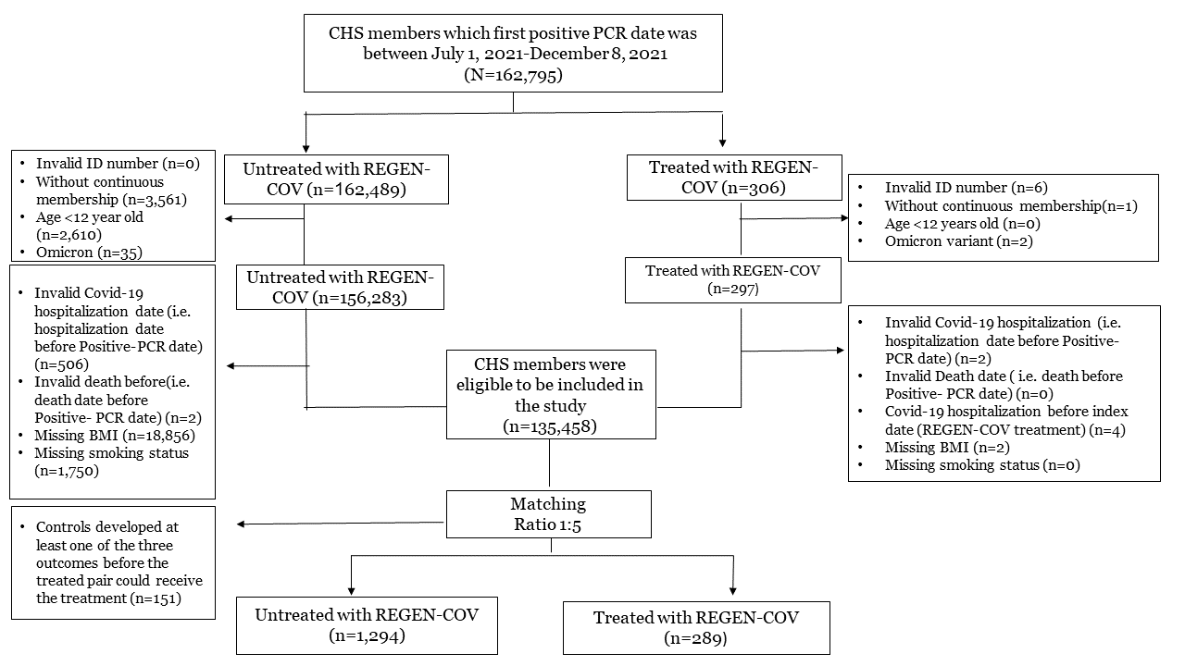

Supplemental Figure 2: Love Plot for the Covariate Balance
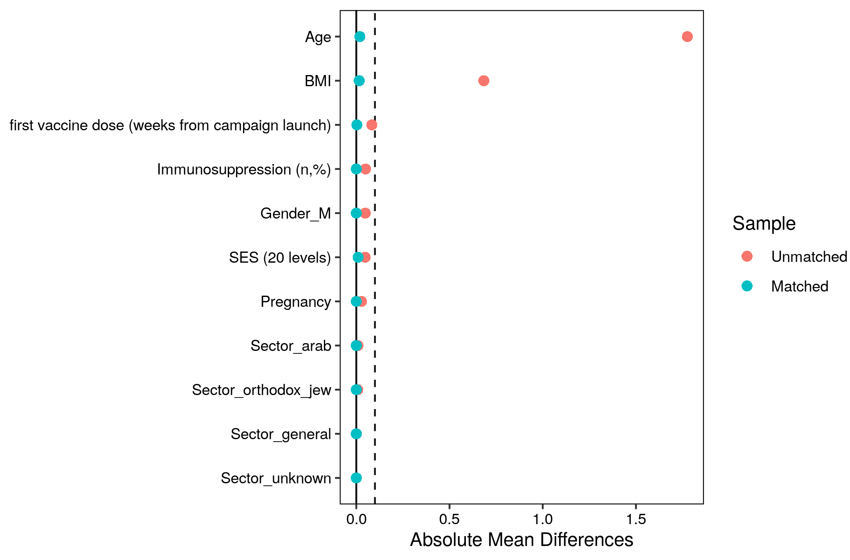
Legend : A covariate balance plot showing the difference in the means for the different matched variables. A strict balance cut-off was set at 0.1.

