Identification of a Six-lncRNA Prognosis Model for Predicting Progression-Free Survival in Patients with Thyroid Cancer

Supplementary Materials

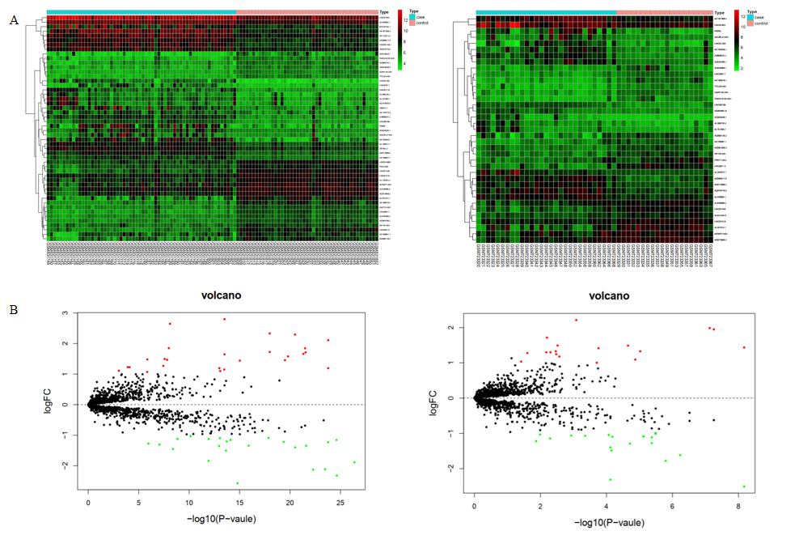
Supplementary Figure 1 Differential expression lncRNAs in GSE33630 and GSE29265. A. Heapmap of differential expression lncRNAs. B.Volcano plot of differential expression lncRNAs.

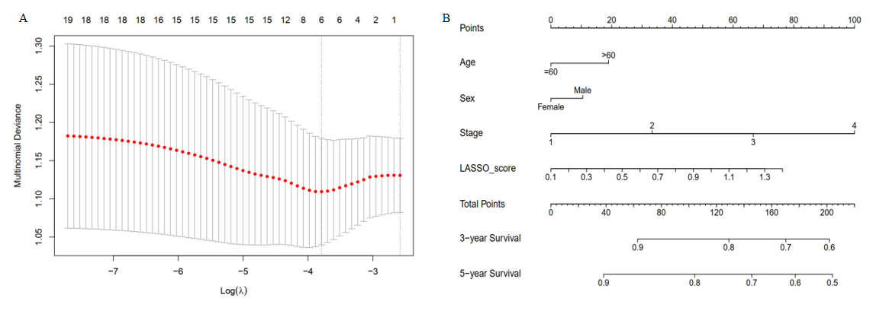
Supplementary Figure 2 Screening of the differential expression lncRNAs by Lasso regression. A The coefficient profile plot was generated against the lambda sequence. Selection of the optimal parameter (lambda) in the LASSO model. B a nomogram integrated with clinical features and risk score to predict progression-free survival probability.
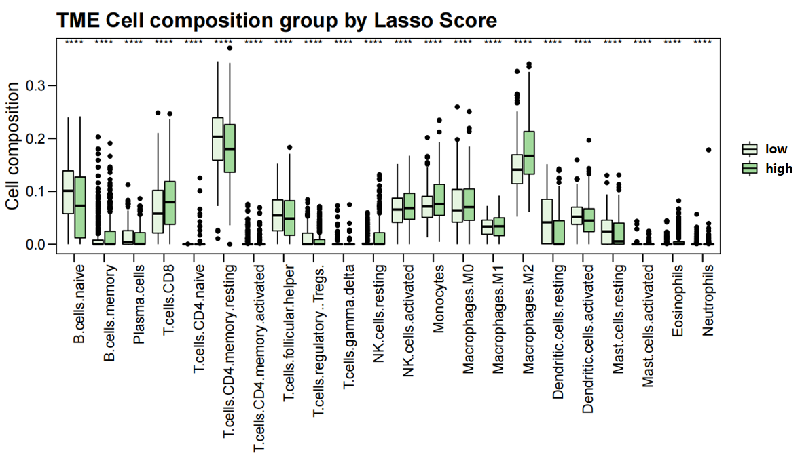
Supplementary Figure 3 Boxplot showing the difference of immune cell type expression between high and low lasso score groups. The low-risk group was marked as light green and the high-risk group was marked as dark green.

